IEEE P802.11
Wireless LANs
TGbe January 2021 Meeting Minutes
Date: 2021-01-14
Author(s):
Name | Affiliation | Address | Phone | email
Dennis Sundman | Ericsson |  |  | dennis.sundman@ericsson.com
Abstract
This document contains the minutes for January 2021 IEEE TGbe interim meeting (held electronically).

Revisions:
- Rev0: First revision of the document. Added minutes of interim meeting call on Thursday 14th of January.
- Rev1: Added references to ad-hoc meetings the 11th and 13th of January.

Monday 11 January 19:00 – 21:00 ET
Split PHY and MAC.
- PHY: https://mentor.ieee.org/802.11/dcn/21/11-21-0074-00-00be-minutes-802-11be-phy-ad-hoc-jan-2021-interim-session.docx
- MAC: https://mentor.ieee.org/802.11/dcn/21/11-21-0119-00-00be-minutes-for-tgbe-mac-jan-2021.docx

Wednesday 13 January 9:00 – 11:00 ET
Split PHY and MAC.
- PHY: https://mentor.ieee.org/802.11/dcn/21/11-21-0074-00-00be-minutes-802-11be-phy-ad-hoc-jan-2021-interim-session.docx
- MAC: https://mentor.ieee.org/802.11/dcn/21/11-21-0119-00-00be-minutes-for-tgbe-mac-jan-2021.docx

Thursday 14 January 9:00 – 11:00 ET

- The Chair, Alfred Asterjadhi (Qualcomm), calls the meeting to order at 10:05 ET. The Chair notifies that the agenda is in 11-20/1983r4 (slide 21).

- IEEE-SA policies and procedures

  - IEEE 802 and 802.11 IPR policy and procedure slides 7-9 in 11-20/1983r4. If anyone in this meeting is personally aware of the holder of any patent claims that are potentially essential to implementation of the proposed standard(s) under consideration by this group please speak up now. Nobody speaks/writes up.

  - The Chair goes through the Copyright Policy (slide 12-14 in 11-20/1983r4).

- Attendance reminder.
- Participation slide: https://mentor.ieee.org/802-ec/dcn/16/ec-16-0180-05-00EC-ieee-802-participation-slide.pptx
- Please record your attendance during the conference call by using the IMAT system:
  - 1) login to imat, 2) select “802.11 Telecons (<Month>)” entry, 3) select “C/LM/WG802.11 Attendance” entry, 4) click “TGbe <MAC/PHY/Joint> conference call that you are attending.
- If you are unable to record the attendance via IMAT then please send an e-mail to Dennis Sundman (dennis.sundman@ericsson.com) and Alfred Asterjadhi (aasterja@qti.qualcomm.com)
- Please ensure that the following information is listed correctly when joining the call:
  - "[voter status] First Name Last Name (Affiliation)"

- Approval of agenda.
  - Approved with unanimous consent.

- TGbe Editor (Edward Au) Status Report/Updates
  - The editor goes through 997r85 doing some live updates.

- Technical Submissions: Run SPs from Previous Topics [50 mins]
  - 1429r5, Enhanced Trigger Frame for EHT Support, Steve Shellhammer [3 SPs]

Straw Poll #4
- Do you agree that B39 in a User Info Field addressed to an EHT STA within a Trigger Frame is the Primary/Secondary 160 (PS160) subfield
  - Note: The PS160 subfield, along with B7-B0 of the RU Allocation subfield, specify the RU/MRU

Discussion:
No discussion.

Straw poll supported with unanimous consent.

Straw Poll #5
- Do you agree that B25 in a User Info Field addressed to an EHT STA within a Trigger Frame is reserved and is set to zero in R1?
  - Note: In 802.11ax B25 is the DCM bit, which is not needed in 802.11be

Discussion:
No discussion.

Straw poll supported with unanimous consent.

Straw Poll #6

- Do you agree to use four bits of a User Info Field addressed to an EHT STA within a Trigger Frame for the Spatial Stream Allocation subfield and to indicate the starting spatial stream, and two bits to indicate the number of per-user spatial streams?
  - Note: This supports up to a total of 16 spatial streams with up to four spatial streams per-user

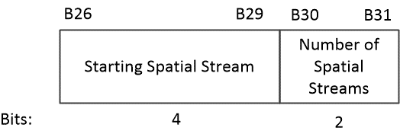

Discussion:
C: I believe you need to remove the and in the …subfield and to…
A: Ok. The revised text will be available in revision 6 in this document.

New text:
- Do you agree to use four bits of a User Info Field addressed to an EHT STA within a Trigger Frame for the Spatial Stream Allocation subfield to indicate the starting spatial stream, and two bits to indicate the number of per-user spatial streams?
  - Note: This supports up to a total of 16 spatial streams with up to four spatial streams per-user

Straw poll supported with unanimous consent.

  - 1808r4, Backward compatible EHT trigger frame follow up, Ming Gan (presented by Ross) [3 SPs]

Straw poll 2:

- Do you agree to define the UL BW Extension field of the Trigger frame in R1?
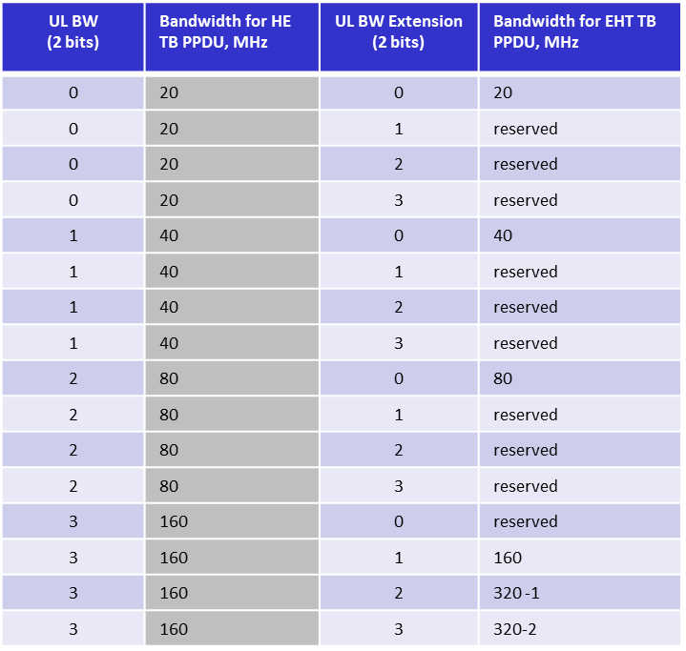
(Note that the text was updated live and does not correspond to the text in r4)

Discussion:
No discussion

Straw poll supported with unanimous consent.

Straw poll 3:
- Do you agree to include 1-bit HE/EHT indication in the common part of the Trigger frame, indicating to the EHT STA whether to transmit an HE or EHT TB PPDU on the primary 160 MHz in R1?
  - Use B54 (the first bit) of UL HE-SIG-A2 Reserved field to carry this HE/EHT indication
- Note: the EHT STA shall not transmit an HE TB PPDU on the secondary 160 MHz

Discussion:
C: I’m not sure you want to transmit different bits for primary and secondary 160.
A: It’s duplicated.
C: Why do we put the 160 here? We don’t have this problem with 80 MHz.
A: If the BW is only 80 MHz, then this bit only applies to the primary 80. Do you want to add a clarification to that part? Updating text.
C: Does it work to use a first 80 MHz to EHT and other parts to HE?
A: Yes that should work.

New text:
- Do you agree to include 1-bit HE/EHT indication in the common part of the Trigger frame, indicating to the EHT STA whether to transmit an HE or EHT TB PPDU within the primary 160 MHz in R1?
  - Use B54 (the first bit) of UL HE-SIG-A2 Reserved field to carry this HE/EHT indication
- Note: the EHT STA shall not transmit an HE TB PPDU on the secondary 160 MHz

Straw poll supported with unanimous consent.

- Technical Submissions: Proposed Draft Text (PDTs) for fixings TBDs

- 0011r1, Spatial Stream and MIMO Protocol Enhancement Part 2, Wook Bong Lee

Summary: This document extends the HE sounding protocol sections from the HE spec and provides updates for them to work for EHT.

- Motions 1982r3 TGbe Motions List For Teleconferences-part 2

  - Motion: Approve TG Minutes

Move to approve TGbe minutes of teleconferences listed below:
  - Teleconferences Nov-Jan: https://mentor.ieee.org/802.11/dcn/20/11-20-1786-08-00be-nov-jan-tgbe-teleconference-minutes.docx

Move: Dennis Sundman, Second: Michael Montemurro

Discussion: None.

Result: Approved with unanimous consent.

  - Motion 150

Move to add to the 11be SFD, candidate specification text in 11-20/1935r10 that is identified with the following tags:
    - SP355, SP356, SP357, SP358, SP359, SP360, SP361, SP362, SP363, SP364,
    - SP365, SP366, SP367, SP368, SP369, SP370, SP371, SP372, SP373, SP374,
    - SP375, SP376, SP377, SP378, SP379, SP380, SP381, SP382, SP383, SP384.

Move: Edward Au, Second: Ross Jian

Discussion: No discussion

Result: Approved with unanimous consent.

Note 1: These are all candidate SFD texts highlighted in yellow that have NOT received a request for further discussion
Note 2: SPs in red are those added on the fly as per discussions during the Joint conf call.

  - Motion 151

Move to accept changes to the TGbe draft as specified in the following documents:
  - 1722r4, 1957r1, 0073r3
  - 1963r1, 1340r6, 1837r5, 1480r3, 0049r1, 1826r7, 0010r1, 0014r1, 0013r2, 0002r2

And instruct the TGbe Editor to create IEEE802.11be D0.3 draft after incorporating these additional changes along with other approved changes as specified in Motion 147.

Move: Edward Au, Second: Bin Tian

Discussion: No discussion

Result: Approved with unanimous consent.

Note: These are all proposed draft texts (PDTs) that obtained ≥ 75% support during the straw poll phase and that have NOT received a request for further discussion

- Guidelines, 1961r1 Release Guidelines-An Overview

  - Alfred goes through uptades to the guidelines document.

Discussion:
C: Slide 6, For the comment collection 0.3. For TBDs we don’t need any comment?
A: TBDs are obvious comments that are present, so we don’t need any comment for them.
C: For the comment collection, the WG chair will start that without a motion. The TG chair request is sufficient.
C: Do we need to have the coexistence assurance document ready for the draft 1.0?
C: Are you going to publish any templates for the comments?
A: Yes.
C: Traditionally we have used draft D1.0 as the one we want to letter ballot? In this proposal it’s rather D3.0. Can you provide some feedback why you wanted to do this?
A: The idea is of course to be as similar as possible to what has done earlier. The reason is because of the split R1/R2.
C: In the last slide the SFD goes into release 2? Will the SFD still be alive when we work on R2?
A: Yes.
C: Can D1.0 and D2.0 be distributed outside IEEE?
A: Under the proposed plan, D1.0 and D2.0 would NOT be made available for sale on the IEEE website (requires 75% approval to forward to SA Ballot). Furthermore D1.0 and D2.0 will not be ready for SA ballot.

Straw poll:

Do you agree to initiate a 14-day WG comment collection process in TGbe D0.3 in January 2021?

Yes/No/Abstain/No-answer: 77/20/31/88

- Adjourned at 11:00.

