IEEE P802.11
Wireless LANs
Comment review on technical report on WLAN interworking to 3GPP 5G network
Date: 2021-01-04
Author(s):
Name | Affiliation | Address | Phone | email
Hyun Seo OH | ETRI | Gajeongro 218 Yusunggu  Daejeon, Korea | +82.42.860.5659 | hsoh5@etri.re.kr
Hanbyeog CHO | ETRI | Gajeongro 218 Yusunggu  Daejeon, Korea | +82.42.860.5531 | hbcho@ etri.re.kr
Hyeong Ho LEE | Netvision Telecom Inc., Korea Univ. | 412, 199, Techno2-ro, Yuseong-Gu, Daejeon, 34025, Korea | +82.42.931.4130 | hhlee@netvisiontel.com

Abstract
There were comments by AANI chair Joseph Levey, Graham Smith and Steve McCann on technical report on WLAN interworking to 3GPP 5G network Rev. 7.0. This contribution is comments review and reflected in technical report on WLAN interworking to 3GPP 5G network Rev. 8.0(marked version) and Rev. 9.0 (clean version).

Review No. 1
Page | 10
Name | Graham Smith
Subclause | 3.1
Relating Text | Therefore, the CN level interworking model in the 5G system is different from the LTE system.
Comment | Don’t understand this. What’s different, the CN level interworking model is different with LTE, so what? Please clarify.
Review | The clause 3.1 describes 3GPP 5G interworking model and there is no explanation on LTE system. It is clarified if the sentence is removed.
Resolution | Editorial update
Notes
Proposed resolution
Section | 3.1
Text | The sentence is removed.

Review No. 2
Page | 13
Name | Graham Smith
Subclause | 4.2.2
Relating Text | and provides the following services in addition to those provided by the IEEE 802.11 DS
Comment | What “following services”? Need to explain.
Review | The next sentence describes R3 interface. It needs to be clarified.  “R3 interface is an IEEE 802.11 DS that connects an ANC incorporated in an Access Point Portal or Mesh Gate to a N3IWF and provides the following services in addition to those provided by the IEEE 802.11 DS.”
Resolution | Editorial update
Notes
Proposed resolution
Section | 4.2.2 R3 interface
Text | The R3 interface is Ethernet protocol between WLAN access network and N3IWF (see Figure 7). An IEEE 802.11 DS within WLAN access network connects an ANC incorporated in an Access Point Portal or Mesh Gate to a N3IWF.

Review No. 3
Page | 13
Name | Graham Smith
Subclause | 4.2.2
Relating Text | The IKEv2 authorization protocol and EAP-5G protocol is applied as shown in Figure 8.
Comment | I think this is what you mean but EAP is not shown in Figure 8.  Probably needs to be clarified.
Review | EAP-5G protocol is used for N2 interface. The text and Fig. 8 are updated.
Resolution | Editorial update
Notes
Proposed resolution
Section | 4.2.2 NWu interface
Text | The IKEv2 authorization protocol and EAP-5G protocol for N2 interface are applied as shown in Figure 8.  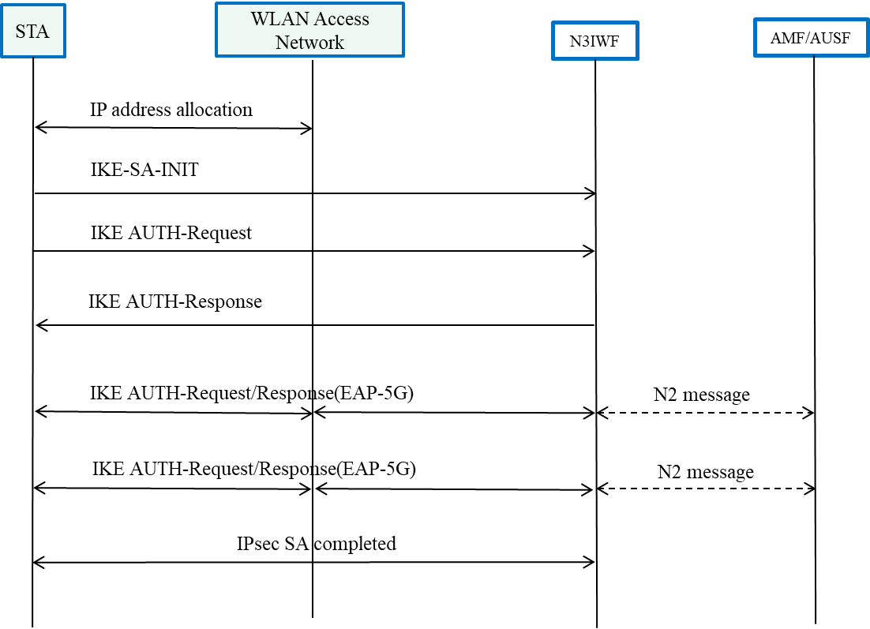

Review No. 4
Page | 19
Name
Subclause | 6.1
Relating Text | It is reported that TSPEC based transmission time scheduling can guarantee low packet latency and that Hybrid ARQ supports PER improvement. To support GBR, data rate and bandwidth control are required.
Comment | It needs to add references
Review | WLAN QoS related papers are included in references.
Resolution | Editorial update
Notes
Proposed resolution
Section | 6.2 Technical recommendations
Text | It is well known that TSPEC based transmission time scheduling can guarantee low packet latency and that Hybrid ARQ supports PER improvement [19-20].  - Lim, L. W., et al. "A QoS scheduler for IEEE 802.11 e WLANs." First IEEE Consumer Communications and Networking Conference, 2004. CCNC 2004. IEEE, 2004.  - Lott, Christopher, Olgica Milenkovic and Emina Soljanin. "Hybrid ARQ: Theory, state of the art and future directions." 2007 IEEE Information Theory Workshop on Information Theory for Wireless Networks. IEEE, 2007.

Review No. 5
Page | 19
Name | Joseph Levy
Subclause | 6.2
Relating Text | Radio scanning and association process is specified in WLAN 802.11 and is capable of supporting WLAN interworking with the 5G core network.
Comment | Is the current capability adequate? If not, what is missing?  [Stephen] I agree. This sentence does not have an action item associated with it.
Review | Radio scanning for ATSS function should be considered.
Resolution | Editorial update
Notes
Proposed resolution
Section | 6.2 Technical recommendations
Text | Radio scanning and association process is specified in WLAN 802.11. However, additional radio scanning for ATSSS function should be supported.

Review No. 6
Page | 19
Name | Joseph Levy
Subclause | 6.2
Relating Text | IKEv2, EAP-5G and IPsec protocol for registration and authentication support should be added in the STA TEC and the WLAN ANC.
Comment | Are these implementation or part of the 802.11 specification?  [Stephen] It may be useful for the authors to add a reference to a 802.11REVmd D5.0 clause. or provide some more detail regarding which parts of the standard need to be amended
Review | These protocols are implementation issues now, it needs further study to find out specification issue.  IKEv2, EAP-5G and IPsec protocol for registration and authentication support should be added in the implementation of STA TEC and the WLAN ANC.
Resolution | Editorial update
Notes
Section | 6.2 Technical recommendations
Text | IKEv2, EAP-5G and IPsec protocol for registration and authentication support should be added in the implementation of STA TEC and the WLAN ANC.

Review No. 7
Page | 19
Name | Levy
Subclause | 6.2
Relating Text | NAS signaling to connect AMF should be added in the STA TEC and the WLAN ANC.
Comment | As in previous comment.
Review | These protocols are implementation issues.  NAS signaling to connect AMF should be added in the implementation of STA TEC and the WLAN ANC.
Resolution | Editorial update
Notes
Proposed resolution
Section | 6.2 Technical recommendations
Text | NAS signaling to connect AMF should be added in the implementation of STA TEC and the WLAN ANC.

Review No. 8
Page | 19
Name | Joseph Levy
Subclause | 6.2
Relating Text | Packet session initiation/modification/termination to connect SMF should be added in the STA TEC and WLAN ANC.
Comment | As in previous comment.
Review | These protocols are implementation issues.  Packet session initiation/modification/termination to connect SMF should be added in implementation of the STA TEC and WLAN ANC.
Resolution | Editorial update
Notes
Section | 6.2 Technical recommendations
Text | Packet session initiation/modification/termination to connect SMF should be added in implementation of the STA TEC and WLAN ANC.

