IEEE P802.11  
Wireless LANs

|  |  |  |  |  |
| --- | --- | --- | --- | --- |
| Resolutions to 32.3.13 NGV receive procedure | | | | |
| Date: 2020-12-01 | | | | |
| Author(s): | | | | |
| Name | Affiliation | Address | Phone | email |
| Yujin Noh | Newracom |  |  | yujin.noh at newracom.com |
|  |  |  |  |  |

Abstract

This submission shows

* Resolutions for comments from TGbd draft 1.0
* 12 CIDs: 1096, 1118, 1238, 1239, 1293, 1475, 1500, 1506, 1513, 1549, 1688 and 1730

Revisions:

* Rev 0: Initial version of the document.

|  |  |  |  |  |
| --- | --- | --- | --- | --- |
| **CID** | **P.L** | **Comment** | **Proposed Change** | **Resolution** |
| 1096 | 86.34 | Resolve the TBD in the plot | as in the comment | Revised.  TGbd Editor: make changes according to this document 11-20-1950-00-00bd Resolutions to 32.3.13 NGV receive procedure. Please find visio file in DCN724 (draft visio for NGV transmit procedure) |
| 1118 | 86.- | There are 2 tbds in the figure 32.15 | replace the tbds with specific information | Same resolution to 1096 applied |
| 1238 | 86.36 | Resolve TBD before bringing to WG letter ballot | resolve the TBD before bringing back to the WG  Possible it should be "A-MSDU" | Same resolution to 1096 applied |
| 1239 | 86.40 | Resolve TBD before bringing to WG letter ballot | resolve the TBD before bringing back to the WG Possiblly it could just be deleted. | Same resolution to 1096 applied |
| 1293 | 86.36 | There are two TBDs in Figure 32-15 - one is at 86.36 and another is at 86.40. | Please replace these two TBDs with appropriate technical descriptions. | Same resolution to 1096 applied |
| 1475 | 86.- | There are two TBDs in Figure 32-115. | Clarify which values should be used (for TBD in the MAC part and for TBD for the tailing bits in the PHY part) | Same resolution to 1096 applied |
| 1500 | 86.36 | There are TBDs in figure 32-15. | If the first TBD is an MPDU, change the label to MPDU. For the 2nd TBD, is the "tail bits TBD" text even needed? | Same resolution to 1096 applied |
| 1506 | 86.35 | There are two TBDs in the Figure 32-15. | Please define what the TBDs are. | Same resolution to 1096 applied |
| 1513 | 86.37 | There are two TBDs on page 86 (Figure 32-15). A draft in a WG LB shouldn't include any TBDs | resolve the TBDs | Same resolution to 1096 applied |
| 1549 | 86.39 | Remove TBD | Remove TBD in the text of Figure 32-15 (right hand side) | Same resolution to 1096 applied |
| 1688 | 86.25 | There are 2 occurances of "TBD" within Figure 32-15 in the top right hand corner. | The TBD needs to be replaced by the following text "tail bits definition". | Same resolution to 1096 applied |
| 1730 | 86.52 | Figure 32-15 holds two TBDs | - A-MPDU - remove | Same resolution to 1096 applied |

***To TGbd Editor:*** ***P62L51*** *update the description as below.*

***Discussion***

* Since BCC is not supported for data portion, the part corresponding to tail bits is removed.
* Given in subclause 9.7.1 (A-MPDU format) as below, 11bd has decided to support A-MPDU format not including EOF padding. TBD in MAC layer in the figure is updated to A-MPDU.

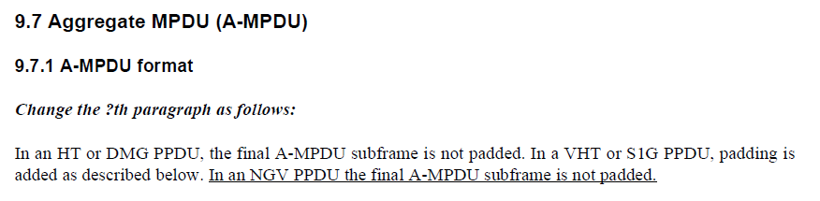

***To TGbd Editor:*** ***P86L52*** *delete the original Figure 32-15 (PHY receive procedure for NGV transmission) and add the new one as below. Please find visio file in DCN724 (draft visio for NGV transmit procedure)*

***------------- Begin Text Changes ---------------***

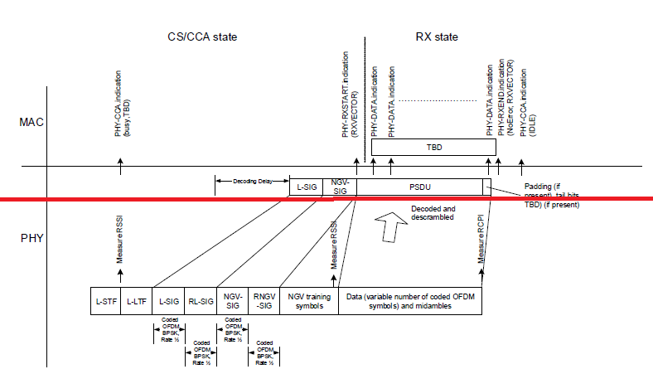



**Figure 32-15—PHY receive procedure for NGV transmission**

***------------- End Text Changes ------------------***