IEEE P802.11
Wireless LANs
Resolutions to 32.3.12 NGV transmit procedure
Date: 2020-12-01
Author(s):
Name | Affiliation | Address | Phone | email
Yujin Noh | Newracom |  |  | yujin.noh at newracom.com
Abstract
This submission shows
- Resolutions for comments from TGbd draft 1.0
- 3 CIDs: 1836, 1598 and 1837

Revisions:
- Rev 0: Initial version of the document.

CID | P.L | Comment | Proposed Change | Resolution
1836 | 83.60 | improve the text | "NON_NGV_10" should be "NON_NGV_10 PPDU) | Accepted.

Discussion

Its intention is to indicate PPDU transmission as below.
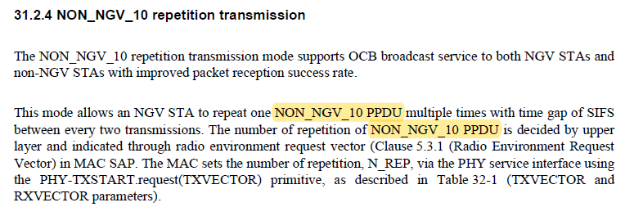

To TGbd Editor: P83L50 update the description as below.
------------- Begin Text Changes ---------------

There are two paths for the transmit PHY procedure.
- The first path, for which typical transmit procedures are shown in Figure 32-13 (PHY transmit procedure for NGV transmission), is selected if the FORMAT parameter of the PHYTXSTART.request(TXVECTOR) primitive is NGV. These transmit procedures do not describe the operation of optional features, such as SU MIMO.
- The second path is selected if the FORMAT parameter of the PHY-TXSTART.request(TXVECTOR) primitive is NON_NGV_10. Transmit parameter N_REP is set via the PHY service interface using the PHY-TXSTART.request(TXVECTOR) primitive, as described in Table 32-1 (TXVECTOR and RXVECTOR parameters) to indicate the number of repetitions of NON_NGV_10 PPDU transmission.

------------- End Text Changes ------------------

CID | P.L | Comment | Proposed Change | Resolution
1598 | 84.49 | Where is TIME_OF_DEPARTURE_REQUESTED defined? | Please clarify and fix as needed. | Revised  TGbd Editor: make changes according to this document 11-20-1949-00-00bd Resolutions to 32.3.12 NGV transmit procedure.
1837 | 84.39 | comma is missed between NGV-MCS and Coding types | "NGV-MCS Coding types" should be "NGV-MCS Coding types, NGV-MCS Coding types" | Revised  TGbd Editor: make changes according to this document 11-20-1949-00-00bd Resolutions to 32.3.12 NGV transmit procedure.

Discussion
In draft 11bd 1.0, TIME_OF_DEPARTURE_REQUESTED is shown in Table 32-4 (TXSTATUS parameters).
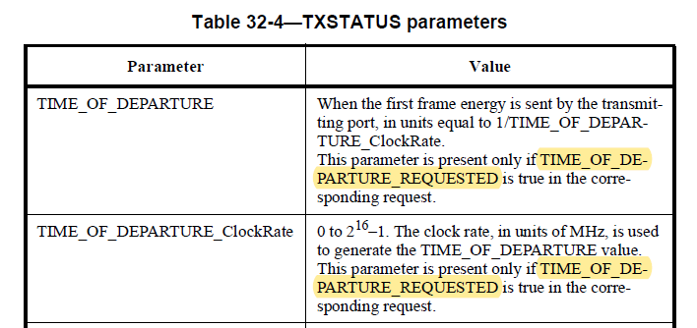

In 11ac, TIME_OF_DEPARTURE_REQUESTED is defined in TXVECTOR and RXVECTOR parameters as below.

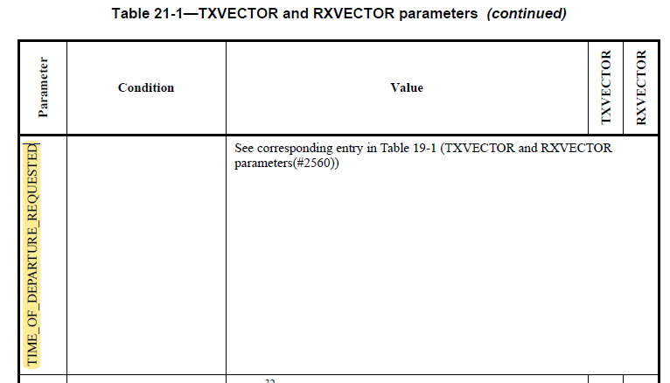

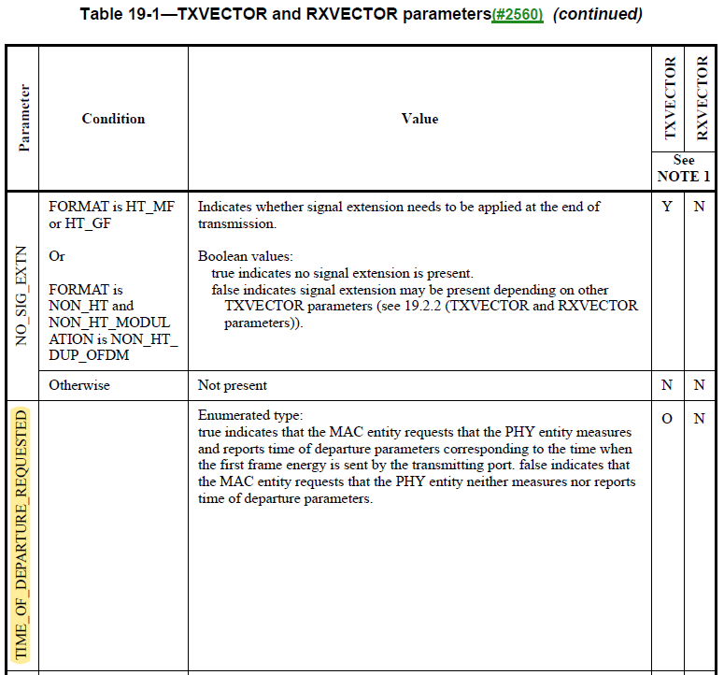

To TGbd Editor: P60L16 update the description as below.
------------- Begin Text Changes ---------------

In both paths, in order to transmit data, the MAC generates a PHY-TXSTART.request primitive, which causes the PHY entity to enter the transmit state. Further, the PHY is set to operate at the appropriate frequency through station management via PLME, as specified in Clause 32.4 (NGV PLME). Other transmit parameters, such as NGV-MCS, Coding types, and transmit power, are set via the PHY SAP using the PHYTXSTART.request(TXVECTOR) primitive, as described in Table 32-1 (TXVECTOR and RXVECTOR parameters). The remainder of the clause applies to the first path.

Transmission of the PPDU shall be initiated by the PHY after receiving the PHYTXSTART.request(TXVECTOR) primitive. The TXVECTOR elements for the PHY-TXSTART.request primitive are specified in Table 32-1 (TXVECTOR and RXVECTOR parameters).

Transmission of the PHY preamble may start if TIME_OF_DEPARTURE_REQUESTED is false, and shall start immediately if TIME_OF_DEPARTURE_REQUESTED is true, based on the parameters passed in the PHY-TXSTART.request primitive.

------------- End Text Changes ------------------

To TGbd Editor: P47L01 update the description as below.
------------- Begin Text Changes ---------------

Table 32-1—TXVECTOR and RXVECTOR parameters
Parameter | Condition | Value | TXVECTOR | RXVECTOR
TIME_OF_DEPARTURE_REQUESTED | See corresponding entry in Table 19-1 (TXVECTOR and RXVECTOR parameters)
Note: In the “TXVECTOR” and “RXVECTOR” columns, the following apply:
Y = ‘Present’;
N = ‘Not present’;
O = ‘Optional’;
------------- End Text Changes ------------------

