IEEE P802.11
Wireless LANs
Resolutions to 32.3.10 Transmit specification
Date: 2020-12-01
Author(s):
Name | Affiliation | Address | Phone | email
Yujin Noh | Newracom |  |  | yujin.noh at newracom.com
Abstract
This submission shows
- Resolutions for comments from TGbd draft 1.0
- 8 CIDs: 1088, 1322, 1586, 1587, 1677, 1089, 1588 and 1589

Revisions:
- Rev 0: Initial version of the document.
- Rev 1: CIDs 1587, 1588 and 1089
  - Updated based on the feedback from teleconference call
- Rev 2: Resolution statement and document link updated

CID | P.L | Comment | Proposed Change | Resolution
1088 | 77.29 | Mask should be based on PPDU BW instead of channel spacing. | "Change to ""For 10 MHz PPDU and 20MHz PPDU, the transmit spectrum masks are defined in 17.3.9.3 (Transmit spectrum mask)." | Revised.  The commentor is technically correct to use PPDU BW instead of channel spacing. However, when it comes to 17 (Orthogonal frequency division multiplexing (OFDM) PHY specification), in terms of terminology, the channel spacing is used to mean PPDU BW. Since it seems to be out of scope here to change the termonology which is widely used through Clause 17, it would be better to remove confusing text unless it does not lead to confusion.  TGbd Editor: Incorporate the changes in https://mentor.ieee.org/802.11/dcn/20/11-20-1948-02-00bd-resolutions-to-32-3-10-transmit-specification.docx
1322 | 77.24 | NOTE 2 is not necessary because there are no figures related to spectral mask in this amendment. | Remove NOTE 2. | Accepted

Discussion

The commentor is technically correct to use PPDU BW instead of channel spacing (named channel width in other amendments). The transmitting PPDU BW is indicated with Bandwidth field in SIG field while channel width is used to indicate maximum operating PPDU BW.

However, when it comes to 17 (Orthogonal frequency division multiplexing (OFDM) PHY specification), in terms of terminology, the channel spacing is used to mean PPDU BW.

For example, terminology “10 MHz channel spacing” is used for 10 MHz transmission as below
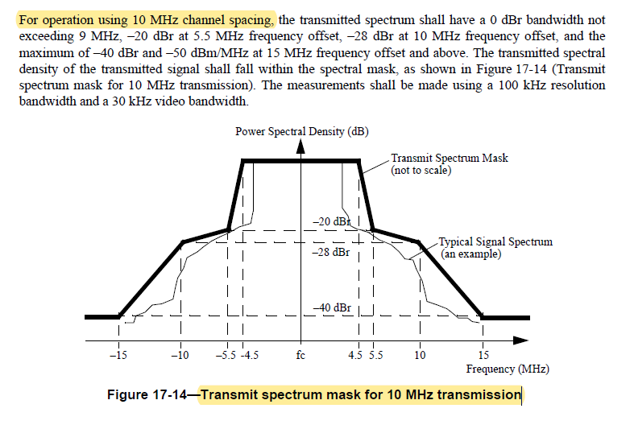

To TGbd Editor: P77L17 update the description as below.
------------- Begin Text Changes ---------------

32.3.10.1 Transmit spectrum mask

The transmit spectrum mask by regulatory domain is defined in Annex D and Annex E.

NOTE 1—In the presence of additional regulatory restrictions, the device has to meet both the regulatory requirements
and the mask defined in this subclause.

NOTE 2—Transmit spectral mask figures in this subclause are not drawn to scale.

NOTE 3—For rules regarding TX center frequency leakage levels, see Clause 32.3.10.4.2 (Transmit center frequency
leakage). The spectral mask requirements in this subclause do not apply to the RF LO.

For operation using 10 MHz channel spacing and 20MHz channel spacing, the The transmit spectrum masks are defined in 17.3.9.3 (Transmit spectrum mask).

------------- End Text Changes ------------------

CID | P.L | Comment | Proposed Change | Resolution
1586 | 78.30 | The subclause numbers shown in this paragraph should be changed to 32.3.10.4.2, 32.3.10.4.3, and 32.3.10.4.4, respectively. | As in the comment. | Accepted
1677 | 78.30 | References for the transmit modulation accuracy specifications are made to the VHT subclauses 21.3.17.4.2, 21.3.17.4.3, and 21.3.17.4.4 although 32.310.4.2, 32.3.10.4.3, and 32.3.10.4.4 contain the NGV specific specifications | Replace the reference to VHT subclauses 21.3.17.4.2, 21.3.17.4.3, and 21.3.17.4.4 with references to NGV subclauses 32.310.4.2, 32.3.10.4.3, and 32.3.10.4.4 . | Accepted

To TGbd Editor: P78L27 update the description as below
------------- Begin Text Changes ---------------

32.3.10.4.1 Introduction to modulation accuracy tests

Transmit modulation accuracy specifications are described in 21.3.17.4.2 32.3.10.4.2 (Transmit center frequency leakage) and 21.3.17.4.3 32.3.10.4.3 (Transmitter constellation error). The test method is described in 21.3.17.4.4 32.3.10.4.4 (Transmitter modulation accuracy (EVM) test).

------------- End Text Changes ------------------

CID | P.L | Comment | Proposed Change | Resolution
1587 | 78.24 | The statement "Each output port of the transmitting STA shall be connected through a cable to one input port of the Device Under Test." coped from 32.3.11 Receiver specifications (P80L17) should be included in the Modulation accuracy tests in 32.3.10.4.  The test procedure that involves channel estimation and equalization (such as step f and g, P79L30) should be removed. | As in the comment. | Revised.  The coment consists of two suggestions. For the first comment, the comment fails to explain why the text in 32.3.11 (Receiver specification) should be reused in Transmit specification. Looking at the 11bd D1.0, there are two sentences with barely different description and there is nothing wrong with it technically. For the second comment, the comment fails to explain why f) and g) should be deleted. Those are general procedures to be described for EVM test through other amendments.  However, reviewing the f), it turned out that estimating channel response coefficient on midamble happens to be missed. The description related to midamble is added to the f) and h)  TGbd Editor: Incorporate the changes in https://mentor.ieee.org/802.11/dcn/20/11-20-1948-02-00bd-resolutions-to-32-3-10-transmit-specification.docx

Discussion on CID1587

For the first comment, the comment fails to explain why the text in 32.3.11 (Receiver specification) should be reused in Transmit specification. Looking at the 11bd D1.0, there are two sentences with barely different description as below and there is nothing wrong with it technically.

For the second comment, the comment fails to explain why f) and g) should be deleted. Those are general procedures to be described for EVM test through other amendments. However, reviewing the f), it turned out that estimating channel response coefficient on midamble happens to be missed.

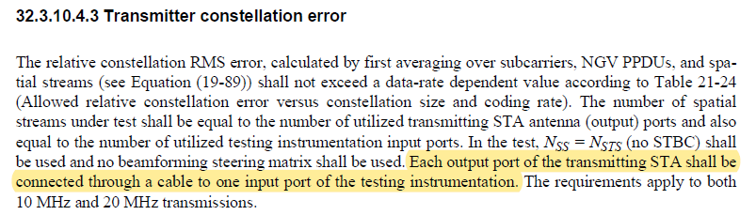

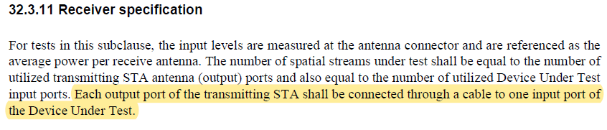

To TGbd Editor: P79L30 update the description as below.
------------- Begin Text Changes ---------------

- Estimate the complex channel response coefficient for each of the subcarriers and each of the transmit streams. If midambles are present in the Data field of the PPDU, the channel response coefficients shall be based upon the most recently received midamble symbols.
- For each of the data OFDM symbols: transform the symbol into subcarrier received values, estimate the phase from the pilot subcarriers, and compensate the subcarrier values according to the estimated phase, group the results from all of the receiver chains in each subcarrier to a vector, and multiply the vector by a zero-forcing equalization matrix generated from the estimated channel.
- For each data-carrying subcarrier in each spatial stream, find the closest constellation point and compute the Euclidean distance from it. If midambles are present in the Data field of the PPDU, the midamble symbols shall not be used to compute the Euclidean distance.

------------- End Text Changes ------------------

CID | P.L | Comment | Proposed Change | Resolution
1089 | 79.09 | EVM requirement is defined in Table 21-24 of VHT. However, VHT doesn't have the DCM modulation. Need to add the EVM requirement for DCM+BPSK | as in the comment | Revised.  A new Table (Allowed relative constellation error versus constellation size and coding rate) including BPSK with DCM is defined.  TGbd Editor: Incorporate the changes in https://mentor.ieee.org/802.11/dcn/20/11-20-1948-02-00bd-resolutions-to-32-3-10-transmit-specification.docx

To TGbd Editor: P79L09 update the description as below.
------------- Begin Text Changes ---------------

In this case, transmit modulation accuracy of each segment shall meet the required value in Table 21-24 32-xx
(Allowed relative constellation error versus constellation size and coding rate) using only the subcarriers
within the corresponding segment.

Table 32-xx—Allowed relative constellation error versus constellation size and coding rate

Modulation | Coding rate | Relative constellation error  (dB)
BPSK with DCM | 1/2 | –5
BPSK | 1/2 | –5
QPSK | 1/2 | –10
QPSK | 3/4 | –13
16-QAM | 1/2 | –16
16-QAM | 3/4 | –19
64-QAM | 2/3 | –22
64-QAM | 3/4 | –25
64-QAM | 5/6 | –27
256-QAM | 3/4 | –30
256-QAM | 5/6 | –32

------------- End Text Changes ------------------

CID | P.L | Comment | Proposed Change | Resolution
1588 | 79.08 | There is no cncept of "segment" in NGV. Change "segment" to "channel width." | As in the comment. | Revised  Agreed in principle. The concept of segment has been used to indicate each 80 MHz frequency segment in 80+80 MHz.  Modifications are applied properly within the sentence.  TGbd Editor: Incorporate the changes in https://mentor.ieee.org/802.11/dcn/20/11-20-1948-02-00bd-resolutions-to-32-3-10-transmit-specification.docx

To TGbd Editor: P79L08 update the description as below.
------------- Begin Text Changes ---------------

In this case, transmit modulation accuracy of each segment shall meet the required value in Table 21-24 (Allowed relative constellation error versus constellation size and coding rate) using only the subcarriers within the corresponding segment the channel width.

------------- End Text Changes ------------------

CID | P.L | Comment | Proposed Change | Resolution
1589 | 79.13 | "... shall have sufficient accuracy ..." This is not verifiable. | Need to provide a verifiable requirement. | Rejected  Since those values are out of scope in the spec, the spec does not need to specify required values to be verified.  Instead, EVM is known for sufficient transmit modulation accuracy test to cover I/Q amplitude and phase blance, phase Noise, and quantization noise, etc in the transmitter.
Discussion on CID1589

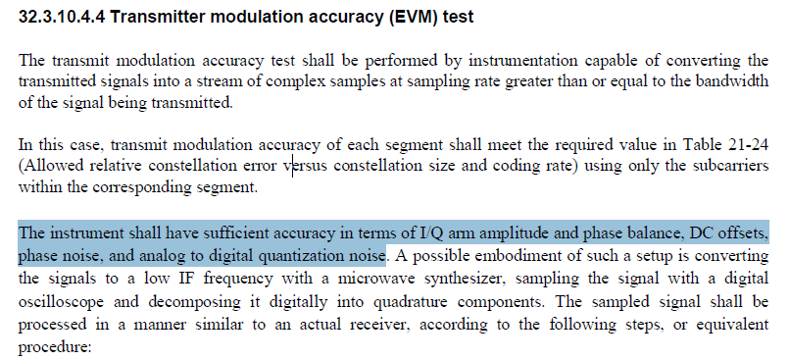

The commentor suggests the spec needs to provide verifiable requirement for I/Q arm amplitude and phase balance, DC offsets, phase noise, and analog to digital quantization noise. Since those values are out of scope in the spec, the spec does not need to specify required values to be verified.

The spec already provides the required value to be met for EVM test in Table 34-xx. The values in this table are verifiable requirement for sufficient transmit modulation accuracy.

