IEEE P802.11
Wireless LANs
Resolutions to 32.3.15 Parameters for NGV-MCS
Date: 2020-12-01
Author(s):
Name | Affiliation | Address | Phone | Email
Yujin Noh | Newracom |  |  | yujin.noh at newracom.com

Abstract
This submission shows
- Resolutions for comments from TGbd draft 1.0
- 2 CIDs: 1075 and 1685

Revisions:

- Rev 0: Initial version of the document.
- Rev 1: CID 1075
  - Table 32-18 – Table 32-21 updated based on feedback from the teleconference call
- Rev 2: Resolution statement and document link updated

CID | P.L | Comment | Proposed Change | Resolution
1075 | 89.63 | Rename BPSK+DCM from MCS10 to MCS15 to be consisent with EHT | as commented | Revised.  Agreed in principle. MCS 10 is replaced with MCS 15 in Table 32-18, Table 32-19, Table 32-20, and Table 32-21. On top of this modification, MCS 10 to 14 are defined as Reserved based on the discussion.  TGbd Editor: Incorporate the changes in https://mentor.ieee.org/802.11/dcn/20/11-20-1946-02-00bd-resolutions-to-32-3-15-parameters-for-ngv-mcss.docx
1685 | 89.31 | Subclause 32.3.15 Parameters for NGV-MCSs should be placed at the end of clause 32 similar to HT, VHT, and HE | Move subclause 32.3.15 to end of subclause 32 and renumber 32.5 | Accepted.

Discussion on CID1075

As commenter mentioned, 11ax and 11be use MCS 10 to indicate 1024-QAM with ¾ as below.

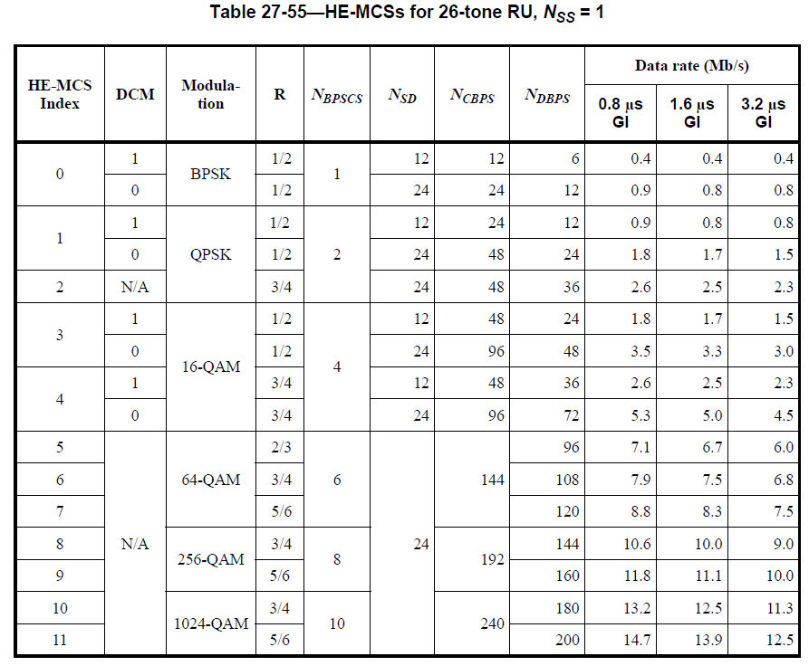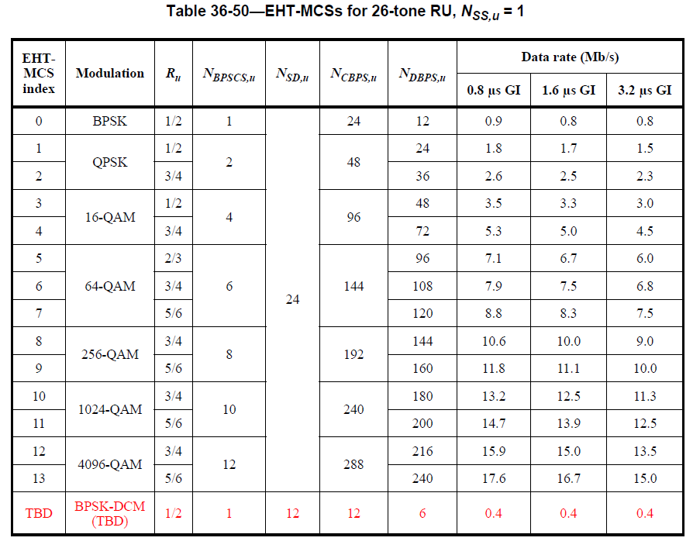

DCM has a DCM field separately in HE PPDU while it is indicated with MCS 15 as one of MCS indices in 11be where the corresponding descriton is going to be shown in the next version of 11be draft spec. Considering 11bd supports the same size of 4-bit MCS field, it is reasonable to have the same meaning of MCS indices through different amendments.

Discussion on CID1685

As commenter mentioned, classification to Parameters for NGV-MCSs is different as shown below.
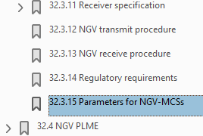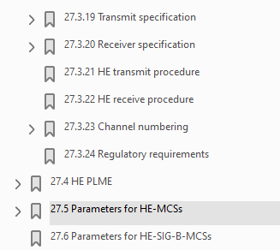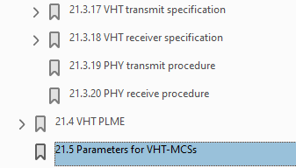

To TGbd Editor: P89L31 update the description as below.
------------- Begin Text Changes ---------------

32.3.15 32.5 Parameters for NGV-MCSs

The rate-dependent parameters for 10 MHz and 20 MHz are given in Table 32-18 (NGV-MCSs for 10 MHz,
NSS=1) to Table 32-21 (NGV-MCSs for 20 MHz, NSS=2). ,
Table 32-18—NGV-MCSs for 10 MHz, NSS = 1
NGV-MCS Index | Modula-  tion | R | N_{BPSCS} | N_{SD} | N_{CBPS} | N_{DBPS} | Data rate (Mb/s)  1.6 μs GI  NGV-LTF-2x
0 | BPSK | 1/2 | 1 | 52 | 52 | 26 | 3.3
1 | QPSK | 1/2 | 2 | 52 | 104 | 52 | 6.5
2 | QPSK | 3/4 | 2 | 52 | 104 | 78 | 9.8
3 | 16QAM | 1/2 | 4 | 52 | 208 | 104 | 13.0
4 | 16QAM | 3/4 | 4 | 52 | 208 | 156 | 19.5
5 | 64QAM | 2/3 | 6 | 52 | 312 | 208 | 26.0
6 | 64QAM | 3/4 | 6 | 52 | 312 | 234 | 29.3
7 | 64QAM | 5/6 | 6 | 52 | 312 | 260 | 32.5
8 | 256QAM | 3/4 | 8 | 52 | 416 | 312 | 39.0
9 | Not valid
10-14 | Reserved
1015 | BPSK with DCM | 1/2 | 1 | 26 | 26 | 13 | 1.6

Table 32-19—NGV-MCSs for 10 MHz, NSS = 2
NGV-MCS Index | Modula-  tion | R | N_{BPSCS} | N_{SD} | N_{CBPS} | N_{DBPS} | Data rate (Mb/s)  1.6 μs GI  NGV-LTF-2x
0 | BPSK | 1/2 | 1 | 52 | 104 | 52 | 6.5
1 | QPSK | 1/2 | 2 | 52 | 208 | 104 | 13.0
2 | QPSK | 3/4 | 2 | 52 | 208 | 156 | 19.5
3 | 16QAM | 1/2 | 4 | 52 | 416 | 208 | 26.0
4 | 16QAM | 3/4 | 4 | 52 | 416 | 312 | 39.0
5 | 64QAM | 2/3 | 6 | 52 | 624 | 416 | 52.0
6 | 64QAM | 3/4 | 6 | 52 | 624 | 468 | 58.5
7 | 64QAM | 5/6 | 6 | 52 | 624 | 520 | 65.0
8 | 256QAM | 3/4 | 8 | 52 | 832 | 624 | 78.0
9 | Not valid
10-14 | Reserved
1015 | BPSK with DCM | 1/2 | 1 | 26 | 52 | 26 | 3.3

Table 32-20—NGV-MCSs for 20 MHz, NSS = 1
NGV-MCS Index | Modula-  tion | R | N_{BPSCS} | N_{SD} | N_{CBPS} | N_{DBPS} | Data rate (Mb/s)  1.6 μs GI  NGV-LTF-2x
0 | BPSK | 1/2 | 1 | 108 | 108 | 54 | 6.8
1 | QPSK | 1/2 | 2 | 108 | 216 | 108 | 13.5
2 | QPSK | 3/4 | 2 | 108 | 216 | 162 | 20.3
3 | 16QAM | 1/2 | 4 | 108 | 432 | 216 | 27.0
4 | 16QAM | 3/4 | 4 | 108 | 432 | 324 | 40.5
5 | 64QAM | 2/3 | 6 | 108 | 648 | 432 | 54.0
6 | 64QAM | 3/4 | 6 | 108 | 648 | 486 | 60.8
7 | 64QAM | 5/6 | 6 | 108 | 648 | 540 | 67.5
8 | 256QAM | 3/4 | 8 | 108 | 864 | 648 | 81.0
9 | 256QAM | 5/6 | 8 | 108 | 864 | 720 | 90.0
10-14 | Reserved
1015 | BPSK with DCM | 1/2 | 1 | 54 | 54 | 27 | 3.4

Table 32-21—NGV-MCSs for 20 MHz, NSS = 2
NGV-MCS Index | Modula-  tion | R | N_{BPSCS} | N_{SD} | N_{CBPS} | N_{DBPS} | Data rate (Mb/s)  1.6 μs GI  NGV-LTF-2x
0 | BPSK | 1/2 | 1 | 108 | 216 | 108 | 13.5
1 | QPSK | 1/2 | 2 | 108 | 432 | 216 | 27.0
2 | QPSK | 3/4 | 2 | 108 | 432 | 324 | 40.5
3 | 16QAM | 1/2 | 4 | 108 | 864 | 432 | 54.0
4 | 16QAM | 3/4 | 4 | 108 | 864 | 648 | 81.0
5 | 64QAM | 2/3 | 6 | 108 | 1296 | 864 | 108.0
6 | 64QAM | 3/4 | 6 | 108 | 1296 | 972 | 121.5
7 | 64QAM | 5/6 | 6 | 108 | 1296 | 1080 | 135.0
8 | 256QAM | 3/4 | 8 | 108 | 1728 | 1296 | 162.0
9 | 256QAM | 5/6 | 8 | 108 | 1728 | 1440 | 180.0
10-14 | Reserved
1015 | BPSK with DCM | 1/2 | 1 | 54 | 108 | 54 | 6.8

------------- End Text Changes ------------------

