IEEE P802.11
Wireless LANs
Resolutions to 32.3.5 NGV modulation and coding schemes
Date: 2020-12-01
Author(s):
Name | Affiliation | Address | Phone | email
Yujin Noh | Newracom |  |  | yujin.noh at newracom.com
Abstract
This submission shows
- Resolutions for comments from TGbd draft 1.0
- 8 CID: 1785, 1304, 1155, 1631, 1173, 1548, 1795 and 1570

Revisions:
- Rev 0: Initial version of the document.
- Rev 1: more description on MCS indices based on feedback from the teleconference call
7 CIDs reassigned
- Rev 2: Resolution statement and document link updated
- Rev 3: Statement in resolutions updated

CID | P.L | Comment | Proposed Change | Resolution
1785 | 57. 65 | MCS10 is used to indicate 1024-QAM 3/4 in 11ax and 11be. Using MCS10 to indicate BPSK 1/2 w/ DCM in 11bd can be confusing | Use MCS15 to indicate BPSK 1/2 DCM. | Revised.  Agreed in principle. MCS 10 is replaced with MCS 15 in 32.3.5 (NGV modulation and coding schemes) and Table 32-10 (Fields in the NGV-SIG field). On top of this modification, MCS 10 to 14 are defined as Reserved in description of Table 32-10 based on the discussion.  TGbd Editor: Incorporate the changes in https://mentor.ieee.org/802.11/dcn/20/11-20-1945-03-00bd-resolutions-to-32-3-5-ngv-modulation-and-coding-schemes.docx

Discussion

As the commenter mentioned, 11ax and 11be use MCS 10 to indicate 1024-QAM with ¾ as below.

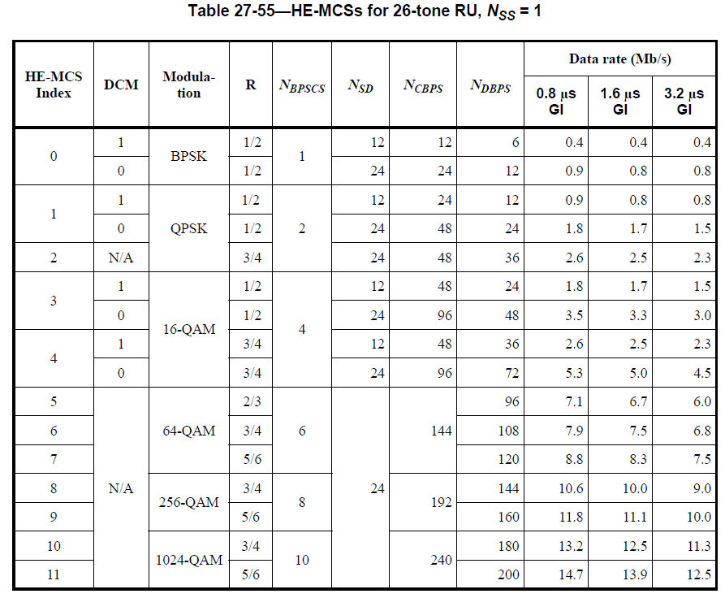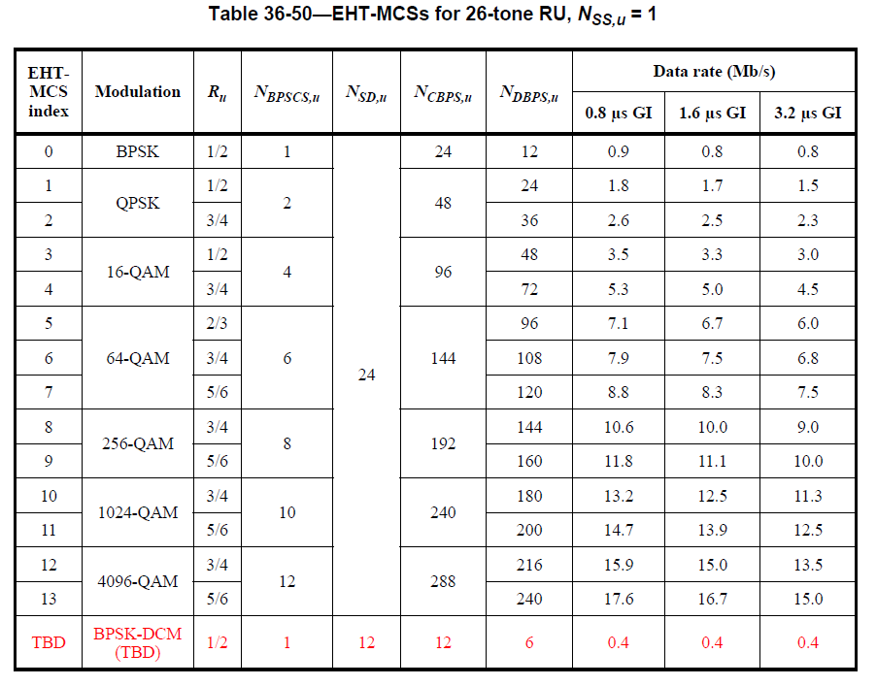

DCM has a DCM field separately in HE PPDU while it is indicated with MCS 15 as one of MCS indices in 11be where the corresponding descriton is going to be shown in the next version of 11be draft spec. Considering 11bd supports the same size of 4-bit MCS field as in 11ax and 11be, it is reasonable to have the same meaning of MCS indices through different amendments.

To TGbd Editor: P57L50 update the description as below.
------------- Begin Text Changes ---------------

32.3.5 NGV modulation and coding schemes

The NGV-MCS is a value that determines the modulation and coding used in the Data field of the PPDU. It is a compact representation that is carried in the NGV-SIG field and RNGV-SIG filed for NGV PPDUs. Rate-dependent parameters for the full set of NGV-MCSs are shown in Table 32-18 (NGV-MCSs for 10 MHz, NSS=1) to Table 32-21 (NGV-MCSs for 20 MHz, NSS=2) (Clause 32.3.15 (Parameters for NGVMCSs)). These tables give rate-dependent parameters for NGV-MCSs with indices 0 to 10 n, where n = 0, …, 15, with number of spatial streams from 1 to 2 and bandwidth options of 10 MHz and 20 MHz. Equal modulation (EQM) is applied to all streams.

DCM is only applied to BPSK modulation. The use of DCM on the Data field of an NGV PPDU is indicated as MCS1015 in NGV-SIG field.

------------- End Text Changes ------------------

To TGbd Editor: P63L43 update the description as below.
------------- Begin Text Changes ---------------

$${\text{η}}_{\text{L-STF}}\text{= }\left\{\begin{matrix}\sqrt{\text{2}}\text{, when MCS 0 or MCS}\text{10}\text{15 }\text{is used for Data field} \\ \text{ 1, otherwise }\end{matrix}\right.$$

------------- End Text Changes ------------------

To TGbd Editor: P66L58 update the description as below.

------------- Begin Text Changes ---------------
Table 32-10—Fields in the NGV-SIG field
Bit | Field | Number of bits | Description
B3-B6 | MCS | 4 | For 10 MHz PPDU, set to n for MCS n, where n = 0, 1, 2, …, 8 and 1015. Values 9 and 11-15 MCS 9 is not valid and MCS 10 - 14 are reserved.  For 20 MHz PPDU, set to n for MCS n, where n = 0, 1, 2, …, 10 9 and 15. Values 11-15 MCS 10 - 14 are reserved.

------------- End Text Changes ------------------

CID | P.L | Comment | Proposed Change | Resolution
1304 | 44.18 | There are 11 MCSs from MCS 0 to MCS 10. Integer range of 0 to 9 is not sufficient to cover them. | Replace "0 to 9" with "0 to 10". | Revised.  Agreed in principle. However, BPSK with DCM is indicated with MCS 15 to be consistent with other amendments.  TGbd Editor: Incorporate the changes in https://mentor.ieee.org/802.11/dcn/20/11-20-1945-03-00bd-resolutions-to-32-3-5-ngv-modulation-and-coding-schemes.docx
1155 | 44.37 | NGV PHY supports MCS 0 to 10 | change "range 0 to 9" to "range 0 to 10" | Revised.  At page 44 line 53, change as follows.  ‘Integer: range 0 to 9’ to  ‘Integer in the range:  0 to 8 and 15 for 10 MHz PPDU  0 to 9 and 15 for 20 MHz PPDU’  Note to editor: Same resolution for CIDs 1304, 1155, 1631, 1173, 1548 and 795.
1631 | 44.37 | According to Table 31-1 MCS has values 0 to 10, but the MCS parameter in Table 32-1 is only defined in the range 0 to 9 | Replace "range 0 to 9" with "range 0 to 10" | Revised.  At page 44 line 53, change as follows.  ‘Integer: range 0 to 9’ to  ‘Integer in the range:  0 to 8 and 15 for 10 MHz PPDU  0 to 9 and 15 for 20 MHz PPDU’  Note to editor: Same resolution for CIDs 1304, 1155, 1631, 1173, 1548 and 795.
1173 | 44.38 | Inconsistent MCS - Text states NGV PPDU can take on the MCS values 0-9. As stated in 32.3.15, NGV PPDU can take on the MCS values 0-10, with exceptions. MCS 9 is not allowed for 10MHz channels, and MCS 10 is not allowed for 2 spatial streams, at least according to Table 31-1 | Make MCS values consistent across Nss and bandwitdths in Tables 31-1 and Tables 32-18/19/20/21. | Revised.  At page 44 line 53, change as follows.  ‘Integer: range 0 to 9’ to  ‘Integer in the range:  0 to 8 and 15 for 10 MHz PPDU  0 to 9 and 15 for 20 MHz PPDU’  Note to editor: Same resolution for CIDs 1304, 1155, 1631, 1173, 1548 and 795.
1548 | 44.38 | According to 32.1.1, NGV supports NGV-MCS 0 to 10. Hence, the Parameter "MCS" in the TX/RXVECTOR should support integers in the range 0 to 10. | Change to range 0 to 10. Otherwise, if not all MCSs 0-10 are supported, indicate which MCSs are not supported and how they are mapped to the integers. | Revised.  At page 44 line 53, change as follows.  ‘Integer: range 0 to 9’ to  ‘Integer in the range:  0 to 8 and 15 for 10 MHz PPDU  0 to 9 and 15 for 20 MHz PPDU’  Note to editor: Same resolution for CIDs 1304, 1155, 1631, 1173, 1548 and 795.
1795 | 44.38 | NGV-MCS indices suppport up to 10 | "range 0 to 9" should be "range 0 to 10" | Revised.  At page 44 line 53, change as follows.  ‘Integer: range 0 to 9’ to  ‘Integer in the range:  0 to 8 and 15 for 10 MHz PPDU  0 to 9 and 15 for 20 MHz PPDU’  Note to editor: Same resolution for CIDs 1304, 1155, 1631, 1173, 1548 and 795.

To TGbd Editor: P44L35 update the description as below.

------------- Begin Text Changes ---------------

MCS | FORMAT is NGV | Indicates the modulation and coding scheme used in the transmission of the PPDU.  Integer: range 0 to 9  Integer in the range:  0 to 8 and 15 for 10 MHz PPDU  0 to 9 and 15 for 20 MHz PPDU | Y | Y
 | Otherwise | Not present | N | N

------------- End Text Changes ------------------

CID | P.L | Comment | Proposed Change | Resolution
1570 | 45.24 | When MCS10 is in use, NGV_LTF_2X_repeat must be used regardless of this value. Need to add a note to show this rule. | Add "when the NGV-MCS index is not 10" following "NGV_LTF." Also add a note after two "Set ..." statements to indicate what MGV_LTF to use when MCS10 is in use. | Revised.  Agreed in principle. Add NOTE as the commenter proposed. However, BPSK with DCM is indicated with MCS 15 to be consistent with other amendments.  TGbd Editor: Incorporate the changes in https://mentor.ieee.org/802.11/dcn/20/11-20-1945-03-00bd-resolutions-to-32-3-5-ngv-modulation-and-coding-schemes.docx

To TGbd Editor: P44L35 update the description as below.

------------- Begin Text Changes ---------------

NGV_LTF_TYPE | FORMAT is NGV | Indicates the type of NGV-LTF.  Set to 0 to indicate NGV_LTF_1X is used in the transmitted  PPDU.  Set to 1 to indicate NGV_LTF_2X is used in the transmitted  PPDU.  NOTE— When NGV-MCS 15 is indicated in 10 MHz, Repeated NGV-LTF-2x is used in the transmitted PPDU. See 32.3.8.3.6 (NGV-LTF definition). | Y | Y
 | Otherwise | Not present | N | N

------------- End Text Changes ------------------

