IEEE P802.11
Wireless LANs
Resolutions to 32.3.5 NGV modulation and coding schemes
Date: 2020-12-01
Author(s):
Name | Affiliation | Address | Phone | email
Yujin Noh | Newracom |  |  | yujin.noh at newracom.com
Abstract
This submission shows
- Resolutions for comments from TGbd draft 1.0
- 1 CID: 1785

Revisions:
- Rev 0: Initial version of the document.

CID | P.L | Comment | Proposed Change | Resolution
1785 | 57. 65 | MCS10 is used to indicate 1024-QAM 3/4 in 11ax and 11be. Using MCS10 to indicate BPSK 1/2 w/ DCM in 11bd can be confusing | Use MCS15 to indicate BPSK 1/2 DCM. | Revised.  TGbd Editor: make changes according to this document 11-20-1945-00-00bd Resolutions to 32.3.5 NGV modulation and coding schemes.

Discussion

As the commenter mentioned, 11ax and 11be use MCS 10 to indicate 1024-QAM with ¾ as below.

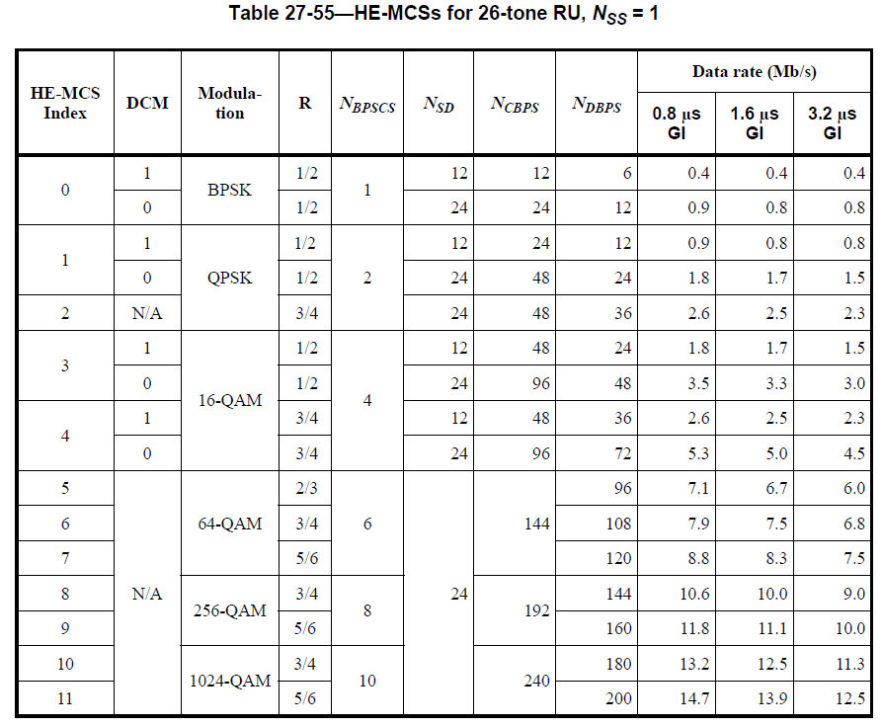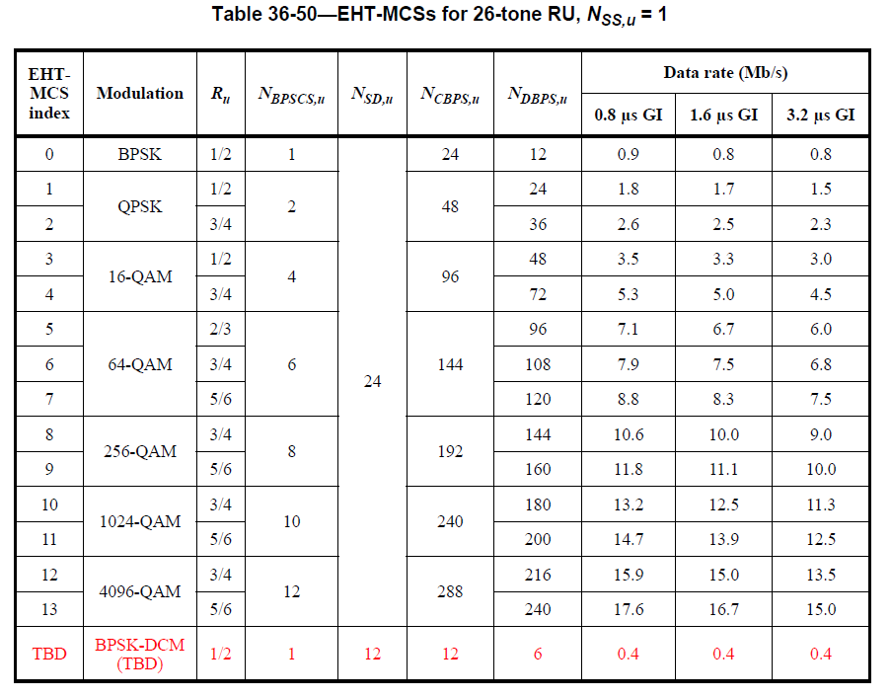

DCM has a DCM field separately in HE PPDU while it is indicated with MCS 15 as one of MCS indices in 11be where the corresponding descriton is going to be shown in the next version of 11be draft spec. Considering 11bd supports the same size of 4-bit MCS field as in 11ax and 11be, it is reasonable to have the same meaning of MCS indices through different amendments.

To TGbd Editor: P57L50 update the description as below.
------------- Begin Text Changes ---------------

32.3.5 NGV modulation and coding schemes

The NGV-MCS is a value that determines the modulation and coding used in the Data field of the PPDU. It is a compact representation that is carried in the NGV-SIG field and RNGV-SIG filed for NGV PPDUs. Rate-dependent parameters for the full set of NGV-MCSs are shown in Table 32-18 (NGV-MCSs for 10 MHz, NSS=1) to Table 32-21 (NGV-MCSs for 20 MHz, NSS=2) (Clause 32.3.15 (Parameters for NGVMCSs)). These tables give rate-dependent parameters for NGV-MCSs with indices 0 to 1015, with number of spatial streams from 1 to 2 and bandwidth options of 10 MHz and 20 MHz. Equal modulation (EQM) is applied to all streams.

DCM is only applied to BPSK modulation. The use of DCM on the Data field of an NGV PPDU is indicated as MCS1015 in NGV-SIG field.

------------- End Text Changes ------------------

To TGbd Editor: P63L43 update the description as below.
------------- Begin Text Changes ---------------

$${\text{η}}_{\text{L-STF}}\text{= }\left\{\begin{matrix}\sqrt{\text{2}}\text{, when MCS 0 or MCS}\text{10}\text{15 }\text{is used for Data field} \\ \text{ 1, otherwise }\end{matrix}\right.$$

------------- End Text Changes ------------------

To TGbd Editor: P66L58 update the description as below.

------------- Begin Text Changes ---------------
Table 32-10—Fields in the NGV-SIG field
Bit | Field | Number of bits | Description
B3-B6 | MCS | 4 | For 10 MHz PPDU, set to n for MCS n, where n = 0, 1, 2, …, 8 and 1015. Values 9 and 11-15 9 - 14 are reserved.  For 20 MHz PPDU, set to n for MCS n, where n = 0, 1, 2, …, 10 9 and 15. Values 11-15 10 - 14 are reserved.

------------- End Text Changes ------------------

