IEEE P802.11
Wireless LANs
Discussion on the sensing threshold in unlicensed spectrum
Date: 2020-11-04
Author(s):
Name | Affiliation | Address | Phone | email
Shubhodeep Adhikari | Broadcom |  |  | shubhodeep.adhikari@broadcom.com
Sindhu Verma | Broadcom |  |  | sindhu.verma@broadcom.com
Abstract
This document discusses the factors that should influence the choice of any sensing threshold in the unlicensed spectrum. In particular, it compares the performance of an ED threshold of -62dBm with that of an ED threshold of -72dBm in relation to these factors.

Introduction

Clear Channel Assessment through channel sensing is a mechanism used by 802.11, LAA and NR-U to determine the busy/idle status of a channel in the unlicensed spectrum and consequently, its availability for transmission.

Any channel sensing scheme uses a sensing threshold. Signals/Energy received above the threshold make the device that is sensing the channel consider the channel as busy, while signals/energy received below the threshold make the device consider the channel as idle.

In this contribution, we discuss Energy Detection (ED) which is a commonly used channel sensing scheme and its performance with respect to two specific thresholds, ED = -62dBm and ED = -72dBm.

Some of the salient metrics to evaluate a sensing threshold are the a) spectral efficiency b) coverage and fairness c) robustness of detection and d) implementation complexity corresponding to the threshold. The robustness of detection and implementation complexity of ED = -62dBm and ED = -72dBm are expected to be similar. So, in this contribution we focus on the remaining two metrics i.e. spectral efficiency and coverage and fairness.

- Spectral Efficiency:
  - A higher sensing threshold will lead to higher “spatial reuse” i.e. a higher percentage of parallel transmissions in a network compared to a lower sensing threshold. This doesn’t automatically lead to higher spectral efficiency, since the higher number of parallel transmissions cause higher interference and consequently, lower the SINRs of the parallel transmissions. So, whether a higher sensing threshold leads to higher spectral efficiency depends on the RSSI distribution of the links (both serving links as well as interfering links) in the network. This is discussed in more detail in later sections of this presentation.

- Coverage and Fairness:
  - Fairness to weak links is the extent to which the sensing threshold allows links with low RSSI to operate in a network. The extent of operation of such low RSSI links also determines the coverage of a network corresponding to the sensing threshold.
    - A lower sensing threshold will generally be fairer to links with low RSSI and will also lead to higher coverage than a higher sensing threshold.
    - However, a network operator may choose to trade lower fairness with higher spectral efficiency, especially in configurations where there are only a small percentage of low RSSI links. This is discussed in more detail in later sections of this presentation.
  - Fairness to incumbent devices is also an important consideration that should determine the choice of the sensing threshold. For example, 802.11 is widely deployed in 5GHz and uses an additional sensing mechanism of PD with a detection threshold of -82dBm or lower. To such incumbent devices, an ED threshold of -72dBm will always be fairer than an ED threshold of -62dBm.

Spectral efficiency

We consider the following simple schematic diagram to illustrate the relationship between the sensing threshold and spectral efficiency. This schematic was also used in 3GPP RAN4 during discussions to define coexistence tests between 802.11ac and LAA.

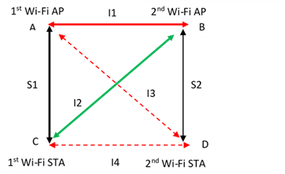

Here, AC and BD are the serving links with received RSSIs of S1 and S2 respectively. AB, BC, AD and CD and the interfering links with the received RSSIs I1, I2, I3 and I4 respectively.

For simplicity, let us consider AP->STA data transmissions only. In this case, I1 is the only sensing link, while I2 and I3 are the interfering links.

If ED = -62dBm and ED = -72dBm are the two thresholds of interest, there can be the following three cases for evaluating the spectral efficiency:
- I1 > -62dBm
- I1 < -72dBm
- -62dBm > I1 > -72dBm.

The spectral efficiencies of ED = -62dBm and ED = -72dBm are the same whenever I1 is higher -62dBm or lower than -72dBm. So, the relative spectral efficiency of ED = -62dBm and ED = -72dBm will depend only on the case where I1 is between -62dBm and -72dBm. So, we discuss this case in more detail as below.

- When ED = -72dBm: AP1 and AP2 will take turns transmitting to STA1 and STA2 resulting in SINRs (S1-N) and (S2-N) respectively, where N is the noise floor of STA1 and STA2 (assumed to be the same).
- When ED = -62dBm: AP1 and AP2 will transmit in parallel to STA1 and STA2 resulting in SINRs (S1-I2-N) and (S2-I3-N) respectively.

If AP1 and AP2 always have data to transmit, the average data rates corresponding ED = -62dBm and ED = -72dBm will be:
- ED = -62dBm: data rate at SINR (S1-I2-N) + data rate at SINR (S2-I3-N).
- ED = -72dBm: 1/2[ data rate at SINR (S1-N) + data rate at SINR (S2-N)]

As noted, whether the data rate at -62dBm is higher/similar/lower than the data rate at -72dBm depends on the RSSI profiles of the serving and interfering links in the network i.e. S1, S2, I2 and I3 and the SINR -> data rate map supported by STA1 and STA2.

Let us consider a template SINR -> data rate map for 802.11ac (for 2Tx-2Rx 2 spatial streams at a noise floor of approximately -96dBm)

 |  | Sensitivity (dBm) | Rate per spatial stream (Mbps) | SINR (dB)
RX sensitivity IEEE 802.11ac (10% PER for 4096 octet PSDU). Defined for default parameters: normal GI, and non-STBC. 20 MHz channel spacing | MCS9 | -68 | 86.67 | 28
 | MCS8 | -71 | 78 | 25
 | MCS7 | -75 | 65 | 21
 | MCS6 | -76 | 58.5 | 20
 | MCS5 | -78 | 52 | 18
 | MCS4 | -82 | 39 | 14
 | MCS3 | -86 | 26 | 10
 | MCS2 | -89 | 19.5 | 7
 | MCS1 | -92 | 13 | 4
 | MCS0 | -94 | 6 | 2

Let us assume that the RSSI of the interfering link is -67dBm i.e. midway between the two sensing thresholds of -62dBm and -72dBm.

Let us also consider two cases: a) where the serving links are strong i.e. higher than the RSSI of -68dBm that is required to sustain the highest MCS at each STA and b) where the serving links are weak, say -80dBm or lower.

Case 1: Serving links are stronger than -68dBm RSSI

In this case, the average data rate while using ED = -72dBm is 86.67 Mbps per spatial stream.

Referring to the table above, it can be seen that for ED = -62dBm to be more spectrally efficient than ED = -72dBm, the average data rate while using ED = -62dBm has to be greater than or equal to MCS 5 (52Mbps). This would mean that the interfering links I2 and I3 have to be at least 18dB lower than the serving links S1 and S2 (assuming that the noise floor N is negligible compared to the signal and interference).

So, ED = -62dBm will lead to a higher spectral efficiency than ED = -72dBm only if the serving links are 18dB or stronger than the interfering links. Else, ED = -72dBm will have a higher spectral efficiency than ED = -62dBm.

Thus, “blindly” using a higher ED threshold without any additional information about the rise in interference in the network will not lead to higher spectral efficiency; on the contrary it may lead to a lower spectral efficiency even though a higher ED will enable higher spatial reuse.

Case 2: Serving links are weak, equal to -80dBm

In this case:
- The average data rate using ED = -72dBm is about 39 Mbps.
- The average data rate using ED = -62dBm will be higher than 39Mbps only if the interference is lower by at least 7dB compared to the signal. If this is not the case, ED = -62dBm will have a lower average data rate than ED = -72dBm.

So, in general, a higher ED would only serve those networks well where the serving links are much stronger than the interference links. However, it is common to have 802.11 networks where the signal and interference overlap over a wide range. This is true even in the case of optimized enterprise grade 802.11 networks that have been planned, deployed and administered by a single entity and which are relatively isolated from external interference.

For example, please refer to the RSSI data below (provided by HPE) from a facility in San Francisco Bay Area that covers an area of 37,680 m² with 2,800 employees and 203 APs. For each AP, the RSSIs of own/my BSS and OBSS packets were measured over a period of 15 minutes. The graph shows the distribution of such RSSIs. Note that there is significant overlap in own/my BSS and OBSS RSSIs even in such optimized enterprise network.

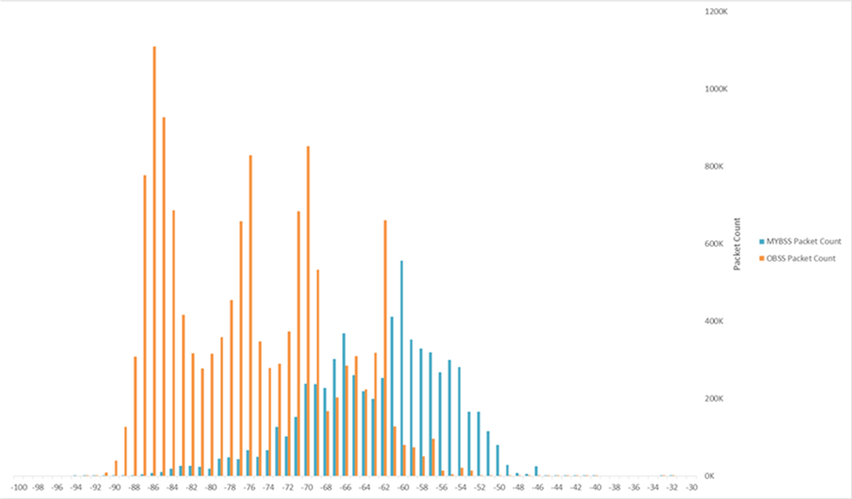

Fairness and Coverage of a Sensing Threshold

A higher sensing threshold increases parallel transmissions and thus increases the interference in the network. This may not matter much if the serving links in the network are strong. On the contrary, if there are a significant percentage of serving links that are weak, the increase in interference due to a higher threshold risks making such links weaker and even inoperable.

We again consider some template data from deployed Wi-Fi networks.

The following data was collected (by Boingo Wireless) from Wi-Fi networks of large North American airports handling nearly 600 million customers annually. The networks were owned and operated by Boingo. The RSSI was measured for serving links for Indoor APs at 5 GHz. The data was measured over more than 6 months.

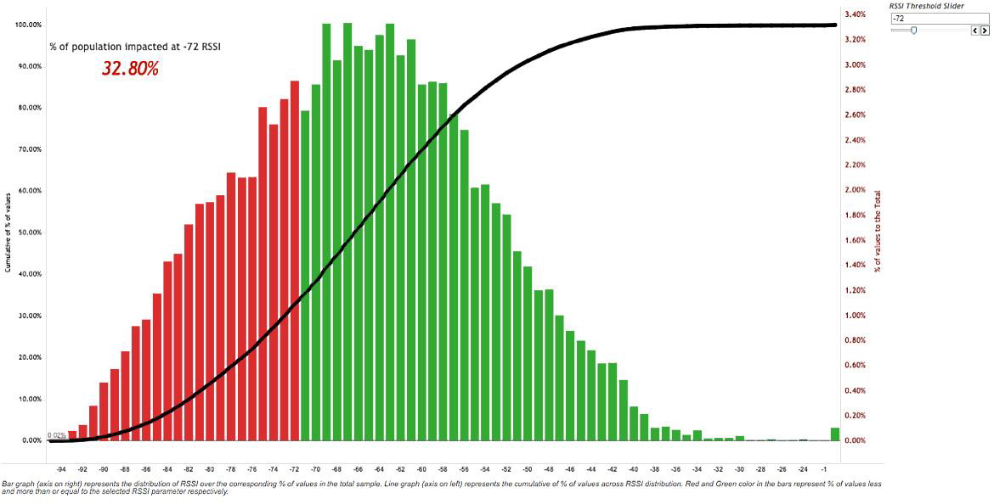

Observation: Even for such an optimized enterprise grade single operator network, about 33% of serving links are below -72dBm and 58% of serving links are below -62dBm. The weaker links of such a network are expected to perform poorly with both ED = -72dBm and ED = -62dBm, but much more so for ED = -62dBm.

The following data was collected by Cisco from a Wi-Fi network of a North American university with 500 APs and a maximum of 3000 clients. The data was measured over 6 weeks and consists of RSSIs of only the serving links.

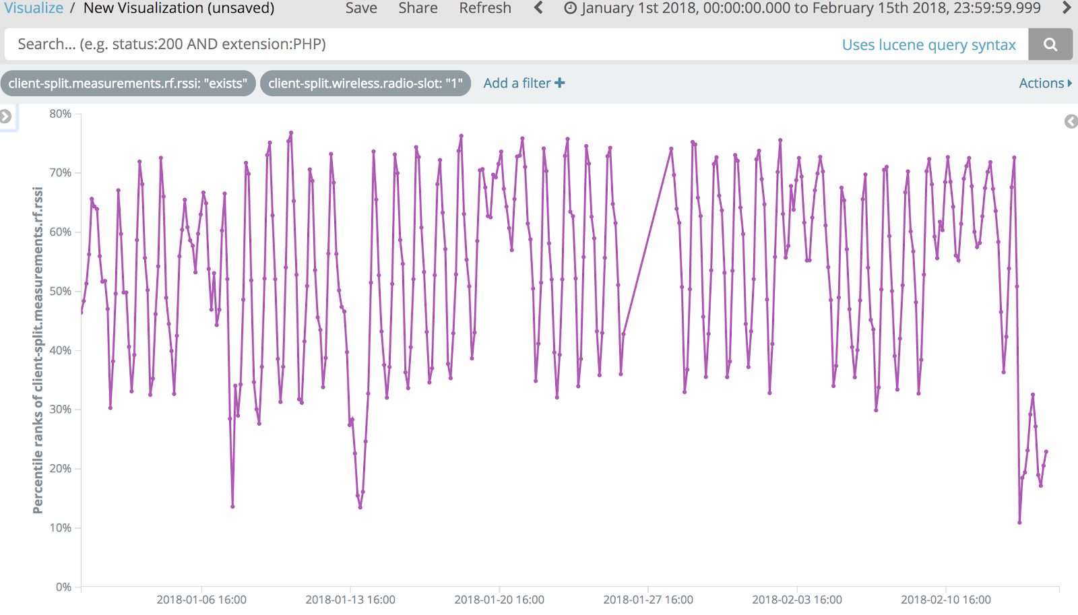

Observation: Between 30% and 73% of serving links were below -70dBm with a median of 50% of serving links below -70dBm. From the perspective of fairness to weaker links and coverage, this network too is expected to perform worse in presence of both ED = -72dBm and ED = -62dBm, much more so for ED = -62dBm.

Note that the concern is about a “blind” increase of the detection threshold. Had there been a way to “intelligently” use a higher threshold selectively only on those links that are strong and not use them on links that are weak and hence susceptible to higher interference, it is possible to get higher spectral efficiency and acceptable fairness and coverage in both of the above networks, even while using a higher detection threshold.

Blind use of an increased threshold is feasible only in networks where the RSSI of the serving links are generally all very strong. For example, consider the following data collected by Ericsson from an Indoor enterprise Wi-Fi network spanning 20,250m², consisting of a maximum of 500 concurrent associated clients. The data was measured over 7 days.

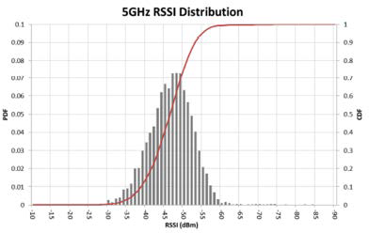

The median RSSI of this network is between -45dBm and -50dBm and there are insignificant percentage of links below -62dBm. Such a network is expected to gain in spectral efficiency from a higher detection threshold.

Additionally, as mentioned earlier, fairness to incumbent 802.11 devices in 5GHz should also be a consideration in choosing the sensing threshold. Given that these devices use a PD threshold of -82dBm or lower, an ED threshold of -72dBm will be fairer to such devices than an ED threshold of -62dBm.

Conclusion

In this contribution we discussed the pros and cons of using Energy Detection (ED) as a channel sensing scheme with two different thresholds ED = -62dBm and ED = -72dBm. These thresholds were evaluated with respect to two important network metrics: spectral efficiency and fairness/coverage. It is concluded that:

- Spectral Efficiency:
  - ED = -62dBm can lead to higher spectral efficiency than ED = -72dBm only if the serving links are significantly stronger than the interfering links. Otherwise, ED = -62dBm is expected to have lower spectral efficiency than ED = -72dBm.
  - It is further shown that even in enterprise grade Wi-Fi networks that are deployed and managed by a single entity and are relatively free from external interference, there is a significant overlap between the serving links and the interfering links. Both ED = -62dBm and ED = -72dBm can lower the spectral efficiency of such a network. However, for such networks, ED = -62dBm is expected to have lower spectral efficiency compared to ED = -72dBm.
  - Hence, a higher ED threshold has to be used judiciously and in a case to case basis, where a higher ED threshold is used when the serving links are strong and a lower ED threshold is used when the serving links are weak.
  - If such a judicious choice can’t be made, a higher ED threshold should not be used.

- Fairness/Coverage:
  - ED = -62dBm is expected to have lower coverage and less fairness towards weak links in a network than ED = -72dBm.
  - Additionally, ED = -62dBm will be less fair towards incumbent 802.11 devices in 5GHz compared to ED = -72dBm.

