IEEE P802.11 Wireless LANs
Proposed text for TGbb MAC supporting the LC HE PHY
Date: 2020-12-12
Author(s):
Name | Affiliation | Address | Phone | Email
Chong Han | pureLiFi |  |  | chong.han@purelifi.com
Nikola Serafimovski |  |  |  | nikola.serafimovski@purelifi.com
Stephan Berner |  |  |  | stephan.berner@purelifi.com
Mostafa Afgani |  |  |  | Mostafa.afgani@purelifi.com
Tamas Weszely |  |  |  | Tamas.weszely@purelifi.com
Abstract
This document provides text to be incorporated in the TGbb draft for the MAC supporting the LC HE PHY mode.

Table of Contents
Table of Contents 2
1 MAC sublayer functional description 3
1.1 Introduction 3
1.2 MAC for the Common Mode PHY 3
1.3 MAC for the LC HE PHY 3
1.3.1 Introduction 3
1.3.2 MU operation 3
1.3.3 Virtual CCA support 4

1 MAC sublayer functional description

1.1 Introduction
This clause defines the light communications (LC) MAC. The subclause (1.2 MAC for the Common Mode PHY) describes the minimum requirements of the MAC that supports the common mode PHY. Optional MAC functions for LC HE PHY mode are introduced in 1.3 MAC for the LC HE PHY.

1.2 MAC for the Common Mode PHY

1.3 MAC for the LC HE PHY

1.3.1 Introduction
The MAC is meant to support the LC HE PHY defined in doc.11-20/0571r3. On top of the MAC functions for IEEE 802.11ax, this MAC enhances the UL Random Access taking the nature of the use cases of LC into account. The section shall be the same except modifications made to 26.5 as described in 1.3.2 MU operation; the support to virtual CCA mechanism as described in 1.3.3 Virtual CCA support;and 26.16 Midamble parameter setting rules does not apply to the standard.

1.3.2 MU operation
The subclause shall be the same as in section 26.5 except 26.5.2 UL MU operation as described in 1.3.2.1 UL MU operation and 26.5.4 UL OFDMA-based random access (UORA) as desbied in 1.3.2.2 UL OFDMA-based random access (UORA).

1.3.2.1 UL MU operation
The subclause shall be the same as in section 26.5.2 except the following changes.

1.3.2.1.1 General
The subclause shall be the same as in section 26.5.2.1.

1.3.2.1.2 Rules for soliciting UL MU frames
The subclause shall be the same as in section 26.5.2.2 except the following changes.

Append the text to Line 9 Page 369:
For LC AP, the AID12 subfield for RU1 is reserved for the random access by non-AP LC STAs that are unselected for any other RUs. Multiple RUs may be allocated for random access if needed in the future.

Append the text to Line 9 Page 371:
This does not apply to the IEEE 802.11bb.

Append the text to Line 25 Page 373:
This does not apply to the IEEE 802.11bb.

Append the text to Line 9 Page 369:
For LC AP, the AID12 subfield for RU1 is set to 0 if the User Info field is addressed to non-AP LC STAs that are unselected for any other RUs. As illustrated in Figure 1, the RU1 is fixed and reserved to random access. LC STAs may utilise the RU to access the UL channel randomly if their IDs are not selected in any other RUs in the same trigger frame.
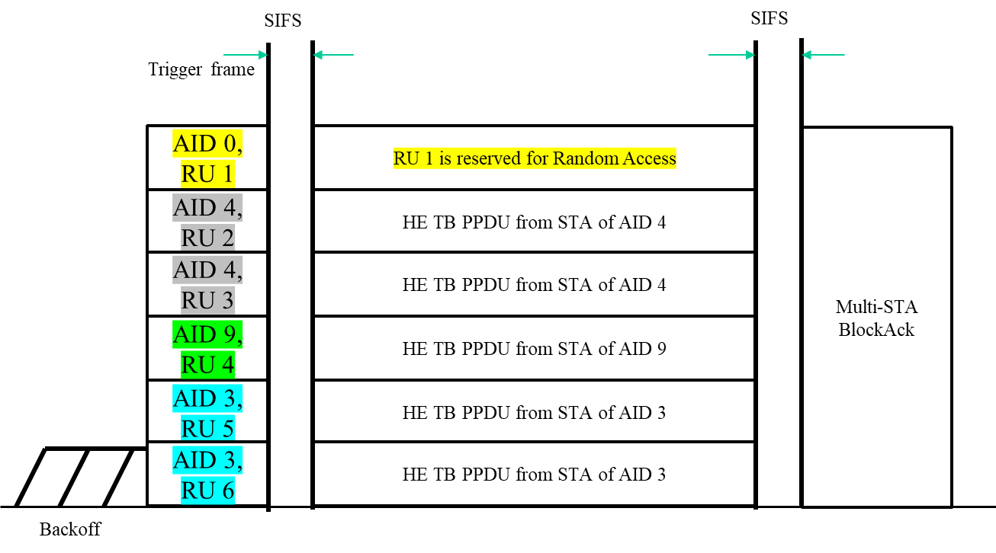
Figure 1 UL MU operation in the LC HE MAC

1.3.2.1.3 Non-AP STA behavior for UL MU operation
The subclause shall be the same as in section 26.5.2.3 except the following changes.

Append the text to Line 49 Page 375:
This does not apply to the IEEE 802.11bb.

Append the text to Line 55 Page 375:
This does not apply to the IEEE 802.11bb.

Append the text to Line 55 Page 375:
The AID12 subfield for RU1 indicates the RU is reserved for non-AP LC STAs that are unselected for any other RUs.

1.3.2.1.4 A-MPDU contents in an HE TB PPDU
The subclause shall be the same as in section 26.5.2.4.

1.3.2.1.5 UL MU CS mechanism
The subclause shall be the same as in section 26.5.2.5.

1.3.2.2 UL OFDMA-based random access (UORA)
The subclause shall be the same as in section 26.5.4. LC HE STAs set the OFDMA RA Support subfield to 0.

1.3.3 Relayed CCA support

1.3.3.1 STA side: additional check before accessing to the medium
A STA checks if there is relayed CCA session on the DL channel all the time. An ongoing relayed CCA session initiated by the AP means the medium is “CCA busy”. The STA marks the medium “busy” in the PHY-CCA indication if relayed CCA session presents. The STA will stop backoff procedure when the relayed CCA session is valid and defer to the end of the relayed CCA session.

1.3.3.2 AP side: retransmission of received packet
When relayed CCA session starts, AP retransmits the received signals from the RX immediately, with a few nano seconds delay.

