IEEE P802.11 Wireless LANs
Proposed text for TGbb MAC supporting the mandatory PHY
Date: 2021-02-14
Author(s):
Name | Affiliation | Address | Phone | Email
Chong Han | pureLiFi |  |  | chong.han@purelifi.com
Nikola Serafimovski |  |  |  | nikola.serafimovski@purelifi.com
Stephan Berner |  |  |  | stephan.berner@purelifi.com
Mostafa Afgani |  |  |  | Mostafa.afgani@purelifi.com
Tamas Weszely |  |  |  | Tamas.weszely@purelifi.com
Abstract
This document provides text to be incorporated in the TGbb draft for the MAC supporting the common PHY mode.

Summary of the changes to D0.2

- To add the Logical service interfaces to 4.4.
- To integrate the content of the Introcudtion in the MAC sublayer functional description to 31.1.
- To add the content of Light Communication (LC) MAC specification to 31.2.
- Decide where to put the Security subclause.

1 MAC sublayer functional description

1.1 Introduction
This clause defines the light communications (LC) MAC. The subclause (1.2 MAC for the Common Mode PHY) describes the minimum requirements of the MAC that supports the common mode PHY.

1.2 Light Communication (LC) MAC specification

1.2.1 Introduction
An LC STA supports the MAC and MLME functions defined in Clause 31 (Light Communication (LC) MAC specification) in addition to the MAC functions defined in Clause 10 (MAC sublayer functional description), the MLME functions defined in Clause 11 (MLME), and the security functions defined in Clause 12 except when the functions in Clause 31 (Light Communication (LC) MAC specification) supersede the functions in Clause 10 (MAC sublayer functional description) or Clause 11 (MLME).

1.2.6 Logical service interfaces

1.2.6.1 General
When using LC, the general requirements for the logical service interface shall be the same as in 4.4.1 except the following are not required: 1) PCPS; 2) the services of DFS, TPC, Radio measurement and DSE.

1.2.6.2 SS
When using LC, the requirements for SS shall be the same as in 4.4.2 except the following services are not required: DFS, TPC, Radio measurement and DSE.

1.2.6.3 DSS
When using LC, the requirements for DSS shall be the same as in 4.4.4 except the following services are not required: DSE and Interworking with the DS (mesh facility only).

1.2.7 Security

1.2.7.1 Authentication service
When using LC, the requirements for the authentication service shall be the same as in 8.1 in IEEE Std. 802.11-2020.
TE Note: Please check in 802.11-2020 if this is still the correct reference.

1.2.7.2 Security methods
When using LC, the following security protocols are adopted:
- CCMP as described in 12.5.3.
- GCMP as described in 12.5.5.
- Open authentication.

Annex

4.4 Logical service interfaces

4.4.1 General
IEEE Std 802.11 explicitly does not specify the details of implementations. Instead, IEEE Std 802.11 specifies services to aid understanding how the architectural components are logically organized. The services are associated with different components of the architecture. There are three categories of IEEE 802.11 service—the station service (SS), the PCP service (PCPS), and the distribution system service (DSS). These categories of service are used by the IEEE 802.11 MAC sublayer.

The complete set of IEEE 802.11 architectural services are as follows:
a) Authentication
b) Association
c) Deauthentication
d) Disassociation
e) Distribution
f) Integration
g) Data confidentiality
h) Reassociation
i) MSDU delivery
j) DFS
k) TPC
l) Higher layer timer synchronization (QoS facility only)
m) QoS traffic scheduling (QoS facility only)
n) Radio measurement
o) DSE

This set of services is divided into three groups: the SS, the PCPS, and the DSS. The SS is part of every STA. The PCPS is provided by the PCP of a PBSS. The DSS is provided by the DS.

4.4.2 SS
The service provided by STAs is known as the SS.

The SS is present in every IEEE 802.11 STA (including APs, as APs include STA functionality). The SS is specified for use by MAC sublayer entities. All STAs provide the SS.
The SS is as follows:
a) Authentication (not used when dot11OCBActivated is true)
b) Deauthentication (not used when dot11OCBActivated is true)
c) Data confidentiality (not used when dot11OCBActivated is true)
d) MSDU delivery
e) DFS (not LC facility)
f) TPC (not LC facility)
g) Higher layer timer synchronization (QoS facility only)
h) QoS traffic scheduling (QoS facility only)
i) Radio measurement (not LC facility)
j) DSE (not LC facility)

4.4.3 PBSS control point service (PCPS)
The service provided by the PCP of a PBSS is known as the PCPS. Since each STA within a PBSS can operate as a PCP, each STA in the PBSS is capable of providing the PCPS, if it becomes the PCP of the PBSS. Non-PCP STAs do not provide the PCPS.

The services that comprise the PCPSs are the following:
a) Association
b) Disassociation
c) Reassociation
d) QoS traffic scheduling

The PCPS is specified for use by MAC sublayer entities.

4.4.4 DSS

The service provided by the DS is known as the DSS. IEEE Std 802.11 explicitly does not specify the details of DS implementation structure. Instead, IEEE Std 802.11 specifies the services that are provided by a DS implementation. A DS can be created from many different technologies including current IEEE 802 wired LANs. IEEE Std 802.11 does not constrain the DS to be either data link or network layer based. Nor does IEEE Std 802.11 constrain a DS to be either centralized or distributed in nature.

This service is represented in the IEEE 802.11 architecture by arrows within APs and mesh gates, indicating that the service is used to cross media and possibly address space logical boundaries. An AP and a mesh gate are logical entities, and the functions described might be shared by one or more physical entities.

The services that comprise the DSS are as follows:
a) Association (not mesh facility)
b) Disassociation (not mesh facility)
c) Distribution
d) Integration
e) Reassociation (not mesh facility)
f) QoS traffic scheduling (QoS facility only)
g) DSE (not LC facility)
h) Interworking with the DS (mesh facility only)

DSSs are specified for use by MAC sublayer entities.

Figure 4-17 (IEEE 802.11 architecture for infrastructure BSS and PBSS(#1571)) combines the components from previous figures with the three types of services to show the IEEE 802.11 architecture for infrastructure BSS and PBSS.
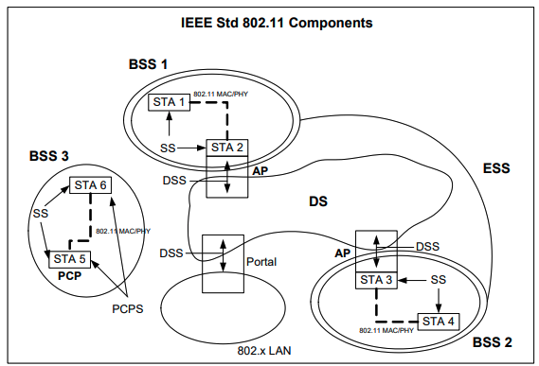
Figure 4-17 IEEE 802.11 architecture for infastructure BSS and PBSS

