IEEE P802.11  
Wireless LANs

|  |  |  |  |  |
| --- | --- | --- | --- | --- |
| Proposed TBD Resolutions  NSEP Priority Access | | | | |
| Date: 2020-12~~0~~-~~28~~1~~5~~7 2021-01-03 | | | | |
| Author(s): | | | | |
| Name | Affiliation | Address | Phone | email |
| Subir Das  John Wullert  Kiran Rege | Perspecta Labs |  |  | (sdas,jwullert, krege) @perspectalabs.com |
| An Nguyen ,  Frank Suraci | DHS/CISA/ECD |  |  | (an.p.nguyen, frank.suraci) @cisa.dhs.gov |
| Chittabrata Ghosh | Intel |  |  | Chittabrata.ghosh@intel.com |
| Leif Wilhelmsson | Ericsson |  |  | leif.r.wilhelmsson@ericsson.com |
| Matthew Fischer | Broadcom |  |  | matthew.fischer@BROADCOM.COM |
| Gaurav Patwardhan | Hewlett Packard Enterprise (HPE) |  |  | gaurav.patwardhan@hpe.com |

Abstract

This submission proposes draft text address three of the TBDs in the 802.11be Draft 0.1 related to NSEP Priority access.

Revisions:

* Rev 0: Initial version of the document.
* Rev 1: Updated version reflecting the comments from several members.
* Rev 2: Added co-author and one editorial fix.
* Rev3: Addressed comments from several members

35. Extreme High Throughput (EHT) MAC specification

35.8 NSEP Priority Access

A STA with a value of true for dot11EHTNSEPPriorityAccessActivated shall set to 1 the NSEP Priority Access Supported subfield of the EHT Capabilities element that it transmits and is capable of invoking NSEP priority access. A STA with a value of false for dot11EHTNSEPPriorityAccessActivated shall set to 0 the NSEP Priority Access Supported subfield of the EHT Capabilities element that it transmits and is not capable of invoking NSEP priority access.

**TGbe editor: Please change the paragraph below as follows:**

During the (re)association process, the AP obtains information required to verify the authority of the non-AP STA to use NSEP priority access. An AP that has dot11SSPNInterfaceActivated ~~set~~ equal to true may use the interworking procedures described in ~~Clause~~ 11.22.5 (Interworking procedures: interactions with SSPN) to retrieve permission for a non-AP STA to use the NSEP ~~P~~priority ~~A~~access ~~authorization information~~ from an NSEP Service Provider via the SSPN interface during association by the non-AP STA. To support this exchange, ~~the~~ a non-AP STA with dot11EHTNSEPPriorityAccessActivated equal to true shall provide the home realm information of the NSEP provider and necessary authentication parameters as described in ~~Clause~~ 11.22.5 (Interworking procedures: interactions with SSPN). ~~If the~~ An AP with dot11SSPNInterfaceActivated equal to true that successfully obtains ~~the authorization information~~ permission for a non-AP STA to use NSEP priority access for the non-AP STA~~, it~~ shall include the ~~create and set the value of~~ dot11NonAPStationAuthNSEPPriorityAccesstype for the non-AP STA in the dot11InterworkingEntry. ~~for the non-AP STA. Other methods of obtaining this authorization information are vendor specific.~~ ~~As described in Clause 11.22.5.3 (Reporting and session control with SSPN),~~ ~~t~~The  ~~is~~ authorization information included in the dot11InterworkingEntry is passed from the ~~old~~ prior AP to the new AP in the same ~~BSS or IBSS~~ ESS during re-association as described in ~~Clause~~ 11.22.5.3 (Reporting and session control with SSPN). Other methods of obtaining this authorization information are vendor specific and thus out of scope.

TGbe editor: Add the following entry to the list in ~~Section~~ 3.4 (Abbreviations and acronyms)

AN Access Network

TGbe editor: Add the following entry to Table R-3 in R.4.2.1 (General)

|  |  |  |  |
| --- | --- | --- | --- |
| Information or Permission name | From AN to SSPN | From SSPN to AN | Per non-AP STA ~~E~~entry |
| Authorized NSEP Priority Access Type |  | + | + |

**TGbe editor: Please revise text in Section R.4.2.4 (Non-AP STA Interworking Capability) as below:**

R.4.2.4 Non-AP STA Interworking Capability

This parameter is derived from the non-AP STA’s Extended Capabilities element, which is included in (Re)Association Request frames. This parameter is also derived from the non-AP STA’s EHT Capabilities element when the non-AP STA supports the NSEP priority access. The AP SME obtains this information from the MLME SAP, e.g., MLMEASSOCIATE.indication primitive. This information needs to be passed over the SSPN interface since the service authorization decisions can depend on the non-AP STA capabilities.

The following (M101) is used:

* dot11NonAPStationInterworkingCapability

TGbe editor: Add the following text in ~~Section~~ R.4.2 **(SSPN interface parameters)**

R.4.2.x Authorized NSEP Priority Access Type

This per-non-AP STA parameter indicates the priority type allocated to the non-AP STA as determined by the SSPN. The AP ~~will~~ uses this information to authorize requests for NSEP Priority Access.

The following is used:

- dot11NonAPStationAuthNSEPPriorityAccesstype is used to authorize a non-AP STA to enable NSEP Priority Access

TGbe Editor: Please modify the following paragraph as follows (including the creation of new subclauses):

35.8.1 NSEP Priority Access operation

35.8.1.1 Introduction

NSEP Priority Access is ~~set up~~ established at the MAC (See 9.6.34a for NSEP Priority Access Action frame details) by the initiation of SME. The setup and deletion of NSEP Priority Access of the SME are described in this subclause.

NSEP Priority Access frames shall be protected management frames that are exchanged in an RSNA.

35.8.1.2 Setup procedures for enabling and disabling the NSEP Priority Access

35.8.1.2.1 General

The procedures for enabling and disabling the NSEP priority access are described in 35.8.1.2.2 (Procedure at the originator) and 35.8.1.2.3 (Procedure at the recipient), and illustrated in Figure 35.xx (NSEP Priority Access Setup).

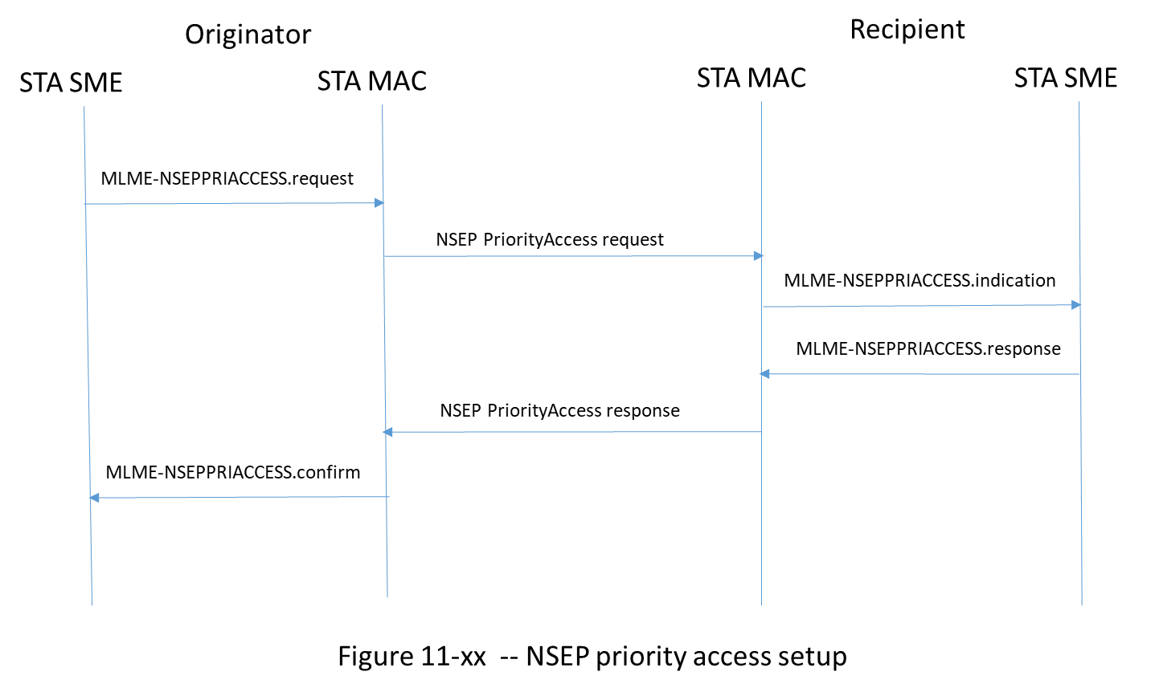

35.8.1.2.2 Procedure at the originator

When instructed to do so by a higher-layer function and upon receipt of an MLME-NSEPPRIACCESS.request primitive with a RequestType of Enable, a STA with dot11EHTNSEPPriorityAccessActivated equal to true and with NSEP priority access disabled shall enable NSEP priority access using the following procedure:

1. The initiating STA shall transmit an NSEP Priority Access Request frame 9.6.34a.2 (NSEP Priority Access Request frame format) with a value of Enable in the Request Type field to an associated ~~AP~~ STA with dot11EHTNSEPPriorityAccessActivated set to true.
   1. If the initiating STA is a non-AP STA, the destination of the NSEP Priority Access Request frame is the AP ~~to~~ with which the initiating non-AP STA is associated.
   2. If the initiating STA is an AP, the destination of the NSEP Priority Access Request frame is the non-AP STA indicated by the value of the PeerSTAAddress parameter in the MLME-NSEPPRIACCESS.request primitive.
2. If the initiating STA receives an NSEP Priority Access Response frame 9.6.34a.3 (NSEP Priority Access Response frame format) with a matching dialog token and with a value of SUCCESS in the Status Code field, then the initiating STA shall issue an MLME-NSEPPRIACCESS.confirm primitive with a value of SUCCESS in the Status Code field indicating successful enabling of NSEP priority access. The initiating STA shall enable NSEP priority access so that subsequently transmitted traffic receives NSEP priority access treatment using a procedure defined in ~~subclause~~ 35.8.3 (NSEP Priority Access procedure).
3. If the initiating STA receives an NSEP Priority Access Response frame 9.6.34a.3 (NSEP Priority Access Response frame format) with a matching dialog token and with a value not equal to SUCCESS in the Status Code field, the initiating STA shall issue an MLME-NSEPPRIACCESS.confirm primitive with the ~~S~~status ~~C~~code from the response frame indicating the failure to enable NSEP priority access. The initiating STA shall not apply NSEP priority access procedure.

When instructed to do so by a higher-layer function and upon receipt of an MLME-NSEPPRIACCESS.request primitive with a RequestType equal to Disable, a ~~non-AP~~ STA with dot11EHTNSEPPriorityAccessActivated set to true and with NSEP priority access enabled shall disable NSEP priority access using the following procedure:

1. The initiating STA shall transmit ~~send~~ an NSEP Priority Access Request frame 9.6.34a.2 (NSEP Priority Access Request frame format) with the value of Disable in the Request Type field to an associated ~~AP~~ STA with dot11EHTNSEPPriorityAccessActivated set to true. The initiating STA shall disable NSEP priority access so that subsequently transmitted traffic does not receive NSEP priority access treatment.
   1. If the initiating STA is a non-AP STA, the destination of the NSEP Priority Access Request frame is the AP ~~to~~ with which the initiating non-AP STA is associated.
   2. If the initiating STA is an AP, the destination of the NSEP Priority Access Request frame is the non-AP STA indicated by the value of the PeerSTAAddress parameter in the MLME-NSEPPRIACCESS.request primitive.
2. If the initiating STA receives an NSEP Priority Access Response frame 9.6.34a.3 (NSEP Priority Access Response frame format) with a matching dialog token and with a value of SUCCESS in the Status Code field, then the initiating STA shall issue a MLME-NSEPPRIACCESS.confirm primitive with a value of SUCCESS in the Status Code field indicating successful disabling of NSEP priority access.

35.8.1.2.3 Procedure at the recipient

Upon receipt of an NSEP Priority Access Request frame 9.6.34a.2 (NSEP Priority Access Request frame format) with a value of Enable in the Request Type field, a STA with dot11EHTNSEPPriorityAccessActivated equal to true and with NSEP priority access disabled shall enable NSEP priority access using the following procedure:

1. The receiving STA shall issue an MLME-NSEPPRIACCESS.indication primitive with a value of Enable in the Request Type field.
2. Upon receipt of the MLME-NSEPPRIACCESS.response primitive, the receiving STA shall reply to the initiating STA with an NSEP Priority Access Response frame 9.6.34a.3 (NSEP Priority Access Response frame format) with a ~~S~~status ~~C~~code using the following procedure:
   1. If the receiving STA is an AP, the AP verifies the authority of the requesting non-AP STA to use NSEP priority access and the ~~S~~status ~~C~~code shall reflect the results of the authorization as described below:
      1. If the requesting non-AP STA is verified for NSEP priority access, the AP shall set the Status code field with a value of SUCCESS.
      2. If the requesting non-AP STA is not verified for NSEP priority access, the AP shall set the Status ~~c~~Code field with a value of NSEP_DENIED_UNAUTHORIZED. ~~as defined in 9.4.1.9.~~
      3. If the receiving AP cannot support NSEP priority access for the initiating non-AP STA for any other reason, the receiving AP shall set the Status ~~c~~Code field with a value of NSEP_DENIED_OTHER_REASON as defined in 9.4.1.9.
   2. If the receiving STA is a non-AP STA, the receiving non-AP STA should set the Status ~~c~~Code field with a value of SUCCESS.
3. If the Status Code in the MLME-NSEPPRIACCESS.response primitive is equal to SUCCESS, the receiving STA shall enable NSEP priority access so that subsequently transmitted traffic receives NSEP priority access treatment using a procedure defined in ~~s~~Subclause 35.8.3 (NSEP Priority Access procedure).
4. If the Status Code in the MLME-NSEPPRIACCESS.response primitive is equal to a value other than SUCCESS, the receiving STA shall not apply NSEP priority access to subsequently transmitted NSEP traffic.

Upon receipt of an NSEP Priority Access Request frame 9.6.34a.2 (NSEP Priority Access Request frame format) with a value of Disable in the Request Type field, a STA with dot11EHTNSEPPriorityAccessActivated equal to true and with NSEP priority access enabled shall use the following procedure to disable NSEP priority access:

1. The receiving STA shall issue an MLME-NSEPPRIACCESS.indication primitive with the value of Disable in the Request Type field.
   1. Upon receipt of the MLME-NSEPPRIACCESS.response primitive, the receiving STA shall respond with an NSEP Priority Access Response frame 9.6.34a.3 (NSEP Priority Access Response frame format) with a value of SUCCESS in the Status Code field.
   2. The receiving STA shall disable NSEP priority access so that subsequently transmitted traffic does not receive NSEP priority access treatment.

_____________________________________________________________________________________________

TGbe editor: Add the following row to Table 11-16 (Default QMF Policy)

|  |  |  |  |  |
| --- | --- | --- | --- | --- |
| Description | Management Frame Subtype Value from Table 9-1 (Valid type and subtype combinations) | Category value from Table 9;51 (Category values) | Action Field | QMF Access category |
| NSEP Priority Service | 1101 | <ANA> | 1-2 | AC_VO |

~~send an NSEP Priority Access Request frame 9.6.34a.2 (NSEP Priority Access Request frame format) with the value of Disable in the Request Type field to an associated AP with dot11EHTNSEPPriorityAccessActivated set to true.~~

~~The AP verifies the authority of the requesting non-AP STA to use NSEP priority access. If the requesting non-AP STA is verified for NSEP priority access, the AP responds to the request by transmitting an NSEP Priority Access Response frame 9.6.34a.3 (NSEP Priority Access Response frame format)] with a value of SUCCESS in the Status Code field. Alternatively, to enable NSEP Priority Access when instructed to do so by a higher-layer function, an AP with dot11EHTNSEPPriorityAccessActivated set to true shall transmit an NSEP Priority Access Request frame 9.6.34a.2 (NSEP Priority Access Request frame format) with a value of Enable in the Request Type field to a non-AP STA with dot11EHTNSEPPriorityAccessActivated set to true. The non-AP STA responds to the request by transmitting an NSEP Priority Access Response Action frame 9.6.34a.3 (NSEP Priority Access Response frame format) with a value of SUCCESS in the Status Code field~~

~~NOTE—The mechanism by which the AP verifies the authority to use NSEP priority access is outside the scope of this Standard.~~

**35.8.3 NSEP priority access procedure**

If the NSEP Priority Access Response frame transmitted by the ~~AP or the non-AP~~ STA that successfully completes the negotiation to enable the NSEP ~~P~~priority ~~A~~access, ~~contains a status code of SUCCESS,~~ then the ~~AP and non-AP~~ STA shall apply NSEP priority access to NSEP traffic using a TBD procedure. The AP is responsible for ensuring that only authorized non-AP STAs can invoke NSEP priority access.

~~To disable NSEP priority access when instructed to do so by a higher-layer function, a non-AP STA with dot11EHTNSEPPriorityAccessActivated set to true shall send an NSEP Priority Access Request frame 9.6.34a.2 (NSEP Priority Access Request frame format) with the value of Disable in the Request Type field to an associated AP with dot11EHTNSEPPriorityAccessActivated set to true. The AP that receives an NSEP Priority Access Request frame with the value of ISABLE in the Request Type field from an associated non-AP STA shall transmit an NSEP Priority Access Response frame to the non-AP STA with a value of SUCCESS in the Status Code field. Alternatively, to disable NSEP Priority Access when instructed to do so by a higher-layer function, an AP with dot11EHTNSEPPriorityAccessActivated set to true shall transmit an NSEP Priority Access Request frame 9.6.34a.2 (NSEP Priority Access Request frame format) with a value of Disable in the Request Type field to a non-AP STA with dot11EHTNSEPPriorityAccessActivated set to true. The non-AP STA responds to the request by transmitting an NSEP Priority Access Response Action frame 9.6.34a.3 (NSEP Priority Access Response frame format) with a value of SUCCESS in the Status Code field.~~

**Straw Poll:**

Do you support incorporating the changes proposed in this document (11-20/1772r~~2~~3) into the TGbe Draft?