IEEE P802.11
Wireless LANs
D7.0 Editorial CR Part 2
Date: 2020-10-27
Author(s):
Name | Affiliation | Address | Phone | email
Robert Stacey | Intel |  |  | robert.stacey@intel.com
Abstract
Ready for motion: 25037, 25010, 25092, 25091, 25100, 25022, 25021, 25083, 25097, 25072, 25042

Ready to review: 25024, 25057, 25081, 25055, 2567, 25123, 25106

Revision history
R0 initial version
R1 updates as reviewed on 10/27 telecon. Green highlighting shows proposed resolution with no further input.
R2 further updates
R3 Added Alfted’s suggested resolution for #25106. Removed comments resolved by Youhan.

CID 25037

CID 25037 was discussed in 20/1598 but, for whatever reason, not motioned. Repeated here.

CID | Page | Clause | Comment | Proposed Change
25037 | 116.14 | 9.3.1.19 | The comment requested by a non-member of this TGax SA Ballot (Young-hoon Kwon). "STA Info subfield" should be "STA Info field". | Modify the text "STA Info subfield" to "STA Info field"

Discussion
9.3.1.19 VHT/HE NDP Announcement frame

Inconsistent used of “field” and “subfield”:
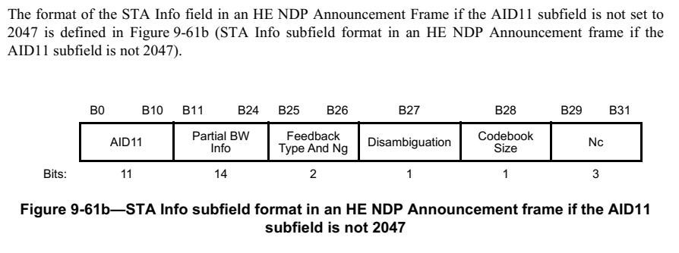

The rest of this subclause refers to fields at this level as “fields” (not “subfields”).

Proposed Resolution
ACCEPTED

CID 25010

CID 25010 was discussed in 20/1598. I took an action to revisit in light of REVmd changes.

CID | Page | Clause | Comment | Proposed Change
25010 | 698.4 | 27.3.22 | On behalf of Brian Hart: References to equations (27-132) and (27-133) in figure 27-63 are stale | Change to (27-133) and (27-134)

Discussion
Figures that have numbering references:
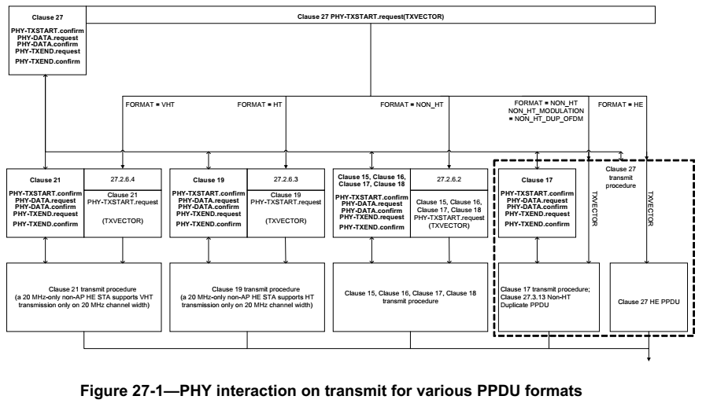
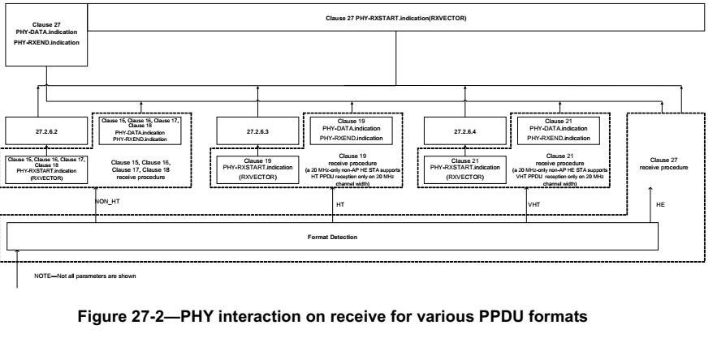
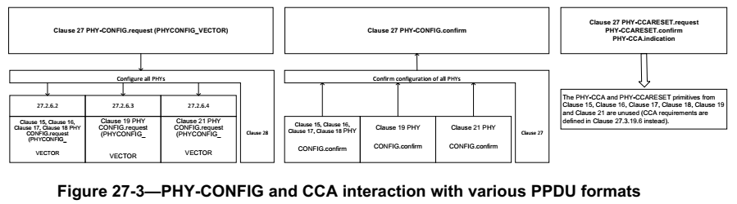

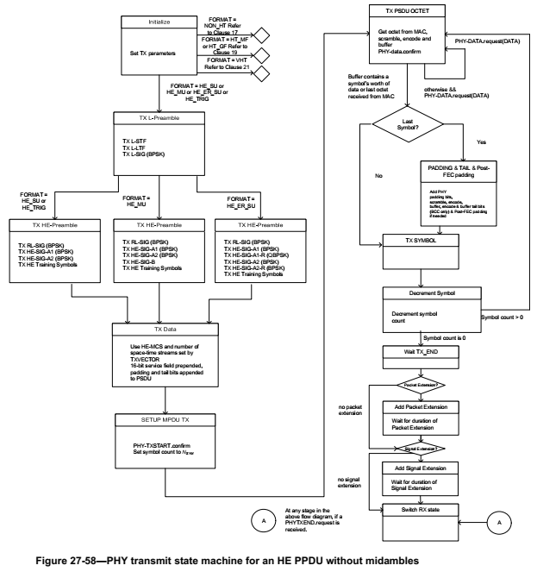
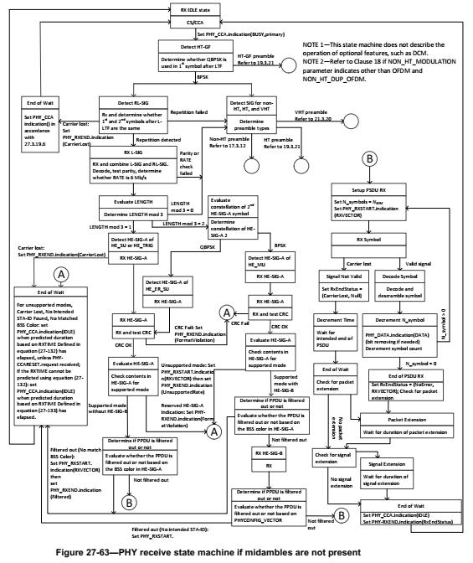

Proposed Resolution
REVISED
Where possible, remove references from figures to minimize manual updates. If it is not possible to remove the reference, then add the subclause title.
Numbering references are present in Figures 27-1, 27-2, 27-3, 27-58, 27-63.
In Figure 27-1 and Figure 27-2:
- change “27.2.6.2” to “27.2.6.2 Support for non-HT format”
- change “27.2.6.3” to “27.2.6.3 Support for HT format”
- change “27.2.6.4” to “27.2.6.4 Support for VHT format”
In Figure 27-1, change “Clause 27.3.13 Non-HT Duplicate PPDU” to “Clause 27 non-HT duplicate transmission”
In Figure 27-3, change “The PHY-CCA and PHY-CCARESET primitives from Clause 15, Clause 16, Clause 17, Clause 18, Clause 19 and Clause 21 are unused (CCA requirements are defined in Clause 27.3.19.6 instead)” to “The PHY-CCA and PHY-CCARESET primitives from Clause 15, Clause 16, Clause 17, Clause 18, Clause 19 and Clause 21 are not used; CCA requirements are defined in Clause 27”

In Figure 27-58, delete “Refer to Clause 17”, “Refer to Clause 19”, “Refer to Clause 21”

In Figure 27-63:
- change “Set PHY_CCA indication() in accordance with 27.3.19.6” to “Set PHY_CCA.indication()”
- delete “Refer to 17.3.12”, “Refer to 19.3.21” (2x), “Refer to 21.3.20”, “Refer to 21.3.20”
- change “For unsupported modes, Carrier Lost, No Intended STA‐ID Found, No Matched BSS Color: set PHY_CCA.indication(IDLE) when predicted duration based on RXTIME Defined in equation (27‐132) has elapsed, unless PHY‐CCARESET.request received; If the RXTIME cannot be predicted using equation (27‐132): set PHY_CCA.indication(IDLE) when predicted duration based on RXTIME Defined inequation (27‐133) has elapsed” to “For unsupported modes, Carrier Lost, No Intended STA‐ID Found, No Matched BSS Color, set PHY_CCA.indication(IDLE) after the expected RXTIME has elapsed”

CID 25092 and 25091
We previously discussed a resolution for 25092, but this applies to 25091 as well.

CID | Page | Clause | Comment | Proposed Change
25092 | 0 |  | There are references to “soliciting PPDU” but this term is not clear and not defined | Change "soliciting PPDU" to "triggering PPDU" throughout
25091 | 0 | 3.2 | There are references to “soliciting PPDU” but this term is not clear and not defined. It’s apparently more than “triggering PPDU”, so maybe it means “PPDU that contains a frame that solicits an immediate response”? | Add a definition in 3.2: "soliciting physical layer (PHY) protocol data unit (PPDU): a PPDU that contains frames that solicit a response from the receiver"

Discussion
26.4.4.3 Responding to an HE MU PPDU with an SU PPDU
…
361.5:
An AP that sends an HE MU PPDU shall not set the Ack Policy Indicator subfield to Normal Ack or Implicit BAR for any of the MPDUs carried in the HE MU PPDU if the solicited PPDU containing a control response would occupy one or more 20 MHz channels where pre-HE modulated fields of the soliciting PPDU are not located.

26.4.4.4 Responding to an HE MU PPDU, HE SU PPDU or HE ER SU PPDU with an HE TB
PPDU

361.20:
A non-AP STA that receives an HE MU PPDU, HE SU PPDU or HE ER SU PPDU with an A-MPDU that contains a QoS Data frame addressed to it and with HETP Ack ack policy, or a Management frame that solicits an immediate acknowledgment shall not respond if it has not received the UL resource allocation information either through TRS Control subfield or a Trigger frame in the soliciting PPDU.

26.5.2.3.4 TXVECTOR parameters for HE TB PPDU response to TRS Control subfield
…
379.1:
NOTE 2—The only permissible values for CH_BANDWIDTH are CBW20, CBW40, CBW80, CBW80+80, and CBW160 if the soliciting PPDU is an HE SU PPDU or HE MU PPDU. The only permissible value for CH_BANDWIDTH is CBW20 if the soliciting PPDU is an HE ER SU PPDU.

26.15.2 PPDU format selection

- A Control frame shall not be sent in an HE ER SU PPDU if the channel bandwidth of the soliciting PPDU is greater than 20 MHz.
…
An HE STA should send an Ack frame in the same PPDU format as the soliciting PPDU if the soliciting PPDU is a VHT PPDU or HT PPDU containing a Fine Timing Measurement frame.

Proposed Resolution for 25092 and 25091
REVISED
For the sentence at 361.5, change “solicited PPDU” to “PPDU” and change “soliciting PPDU” to “HE MU PPDU”

At 361.20, change
“A non-AP STA that receives an HE MU PPDU, HE SU PPDU or HE ER SU PPDU with an A-MPDU that contains a QoS Data frame addressed to it and with HETP Ack ack policy, or a Management frame that solicits an immediate acknowledgment shall not respond if it has not received the UL resource allocation information either through TRS Control subfield or a Trigger frame in the soliciting PPDU”
To
“A non-AP STA that receives an HE MU PPDU, HE SU PPDU or HE ER SU PPDU with an A-MPDU that contains a QoS Data frame addressed to it and with HETP Ack ack policy, or a Management frame that solicits an immediate acknowledgment shall not respond unless it has also received a triggering frame in the A-MPDU”

At 379.1, change “soliciting PPDU” to “triggering PPDU” (2x)

At 469.46, change
“A Control frame shall not be sent in an HE ER SU PPDU if the channel bandwidth of the soliciting PPDU is greater than 20 MHz”
To
“A control response frame shall not be sent in an HE ER SU PPDU if the channel bandwidth of the PPDU containing the frame that elicited the response is greater than 20 MHz”

At 469.56, change
“An HE STA should send an Ack frame in the same PPDU format as the soliciting PPDU if the soliciting
PPDU is a VHT PPDU or HT PPDU containing a Fine Timing Measurement frame.”
To
“An HE STA should send an Ack frame that is the response to a Fine Timing Measurement frame carried in a VHT PPDU or HT PPDU in the same PPDU format as the PPDU carrying the Fine Timing Measurement frame”

CID 25100
CID | Page | Clause | Comment | Proposed Change
25100 | 0 |  | "in multiple BSSID set" should be "in a multiple BSSID set" | Fix at 307.47, 365.60. Also at 400.15 change "An HE AP may aggregate MPDUs from any TIDs in multi-TID A-MPDU for DL HE MU PPDU transmis- sion and the number of TIDs in multi-TID A-MPDU shall not be more than the Multi-TID Aggregation Rx Support announced by the recipient." to "An HE AP may aggregate MPDUs from any TIDs in a multi-TID A-MPDU for DL HE MU PPDU transmis- sion and the number of TIDs in the multi-TID A-MPDU shall not be more than the Multi-TID Aggregation Rx Support announced by the recipient."

Discussion
The proposed change would affect the text as follows:
307.47:
Among all AP STAs in a multiple BSSID set, only the AP corresponding to the transmitted BSSID shall transmit a Beacon frame.
365.60:
A broadcast RU corresponding to parameter STA_ID equal to the BSSID Index of a BSSID in a multiple BSSID set to carry information intended for STAs associated with the AP corresponding to that BSSID and not the recipient of an individually addressed RU.
400.15:
An HE AP may aggregate MPDUs from any TIDs in a multi-TID A-MPDU for DL HE MU PPDU transmission and the number of TIDs in the multi-TID A-MPDU shall not be more than the Multi-TID Aggregation Rx Support announced by the recipient.

Proposed Resolution
ACCEPTED

CID 25122
CID | Page | Clause | Comment | Proposed Change
25122 | 0 | 3.1 | RE: CID # 24154 of the SA Ballot #1. The comment resolution is not complete. It appears that the CRC agress that there is an issue on how it is worded, but still rejected. | Implement the change discussed in the "Resolution" field of the document 11-20/0241r17, row 155

Discussion
Referenced comment:
CID | Page | Clause | Comment | Proposed Change | Resolution
24154 | 38.11 | 3.1 | "data MAC protocol data units" does not sound correct. The first "data" is superflous. | Delete the word "data" in front of "MAC protocol data units" | REJECTED (EDITOR: 2020-04-01 21:25:43Z) - It is not superfluous (although it is weird). There are three (actually four) categories of MPDU: control , data, management and extra. We could change it to QoS Data frame, which is more accurate, since an A-MSDU cannot be sent in some of the other data MPDU subtypes.

Cited text:
aggregate medium access control (MAC) service data unit (A-MSDU): A structure that contains one or more MSDUs and is transported within a single (unfragmented) transmitted in one or more data medium access control (MAC) MAC protocol data units (MPDUs) with the same sequence number.

Proposed resolution
REVISED
The original comment states that the first “data” is superfluous, but this is not true. As pointed out in the REJECTED resolution, a data MPDU is a specific type of MPDU: an MPDU where the Type subfield in the Frame Control field indicates Data. Deleting “data” from “data MPDU” would generalize MPDU to include the other types (control, management, etc.). The REJECTED resolution, however, also identified alternate wording that is even more specific than “data MPDUs”, i.e., QoS Data frames. This is arguably preferable since there is some ambiguity in the term Data MPDU since it could refer to an MPDU of type Data any subtype (as intended) or an MPDU of type Data subtype Data (not intended).

Change “data MAC protocol data units (MPDUs)” to “QoS Data frames”

CID 25021
CID | Page | Clause | Comment | Proposed Change
25021 | 43.50 | 3.2 | It is not clear from the definition that this beast only exists in the 5 GHz | Change "A non-AP HE STA that indicates" to "A non-AP HE STA that operates in the 5 GHz band and indicates"

Discussion
The comment refers to the following definition:
20 MHz-only non-access-point (non-AP) high efficiency station (HE STA): A non-AP HE STA that indicates in the Supported Channel Width Set subfield in the HE PHY Capabilities Information field in the HE Capabilities element that it supports only 20 MHz channel width for the frequency band in which it is operating.

The commenter is suggesting that this definition and the description in the HE Capabilities element are not consistent.

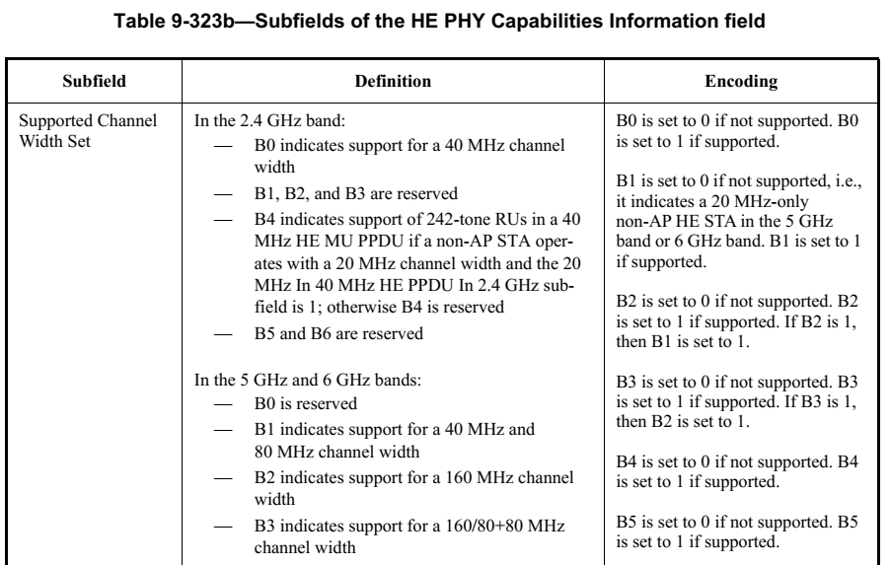

The commenters statement about only exists in 5 GHz band is incorrect: a 20 MHz-only non-AP HE STA can operate in the 6 GHz band. Also, a 20 MHz-only non-AP HE STA could be one that operates in the 2.4 GHz band with B0 set to 0. And this seems to be consistent with the other areas of the draft.

Proposed resolution
REVISED
Change the definition at the cited location to (so that it does not use the imprecise “supports only 20 MHz”):
“A non-AP HE STA that, for the frequency band in which it is operating, indicates in the Supported Channel Width Set subfield in the HE PHY Capabilities Information field in the HE Capabilities element that it does not support operating with a channel width greater than 20 MHz.”

Change
“B1 is set to 0 if not supported, i.e., it indicates a 20 MHz-only non-AP HE STA in the 5 GHz and 6 GHz band”
To
“B1 is set to 0 if not supported”

CID 25022

CID | Page | Clause | Comment | Proposed Change
25022 | 50.09 | 4.3.15a | The terminology used in this paragraph should be aligned with its use elsewhere. "UL MU transmissions" is "UL MU operation". "OFDMA transmissions in the uplink direction" is "UL OFDMA". "MU-MIMO transmissions" in the UL direction is "UL MU-MIMO" | Replace first two sentences with "UL MU operation is coordinated by an HE AP using a Trigger frame or a frame that includes a TRS Control subfield. A Trigger frame allocates RUs (for UL OFDMA) and/or spatial streams (for UL MU-MIMO) to one or more non-AP HE STAs for the transmission of data and/or control information (e.g., acknowledgements, PS-Poll frame, operating mode changes). A frame carrying a TRS Control field, which can only be in an HE MU PPDU, allocates an RU for the acknowledgement of that frame. Multiple frames carrying a TRS Control field might be present in the HE MU PPDU, each addressing a different non-AP HE STA, and the responses are frequency separated (UL OFDMA)."

Discussion

The proposed change replaces:

An HE AP sends a Trigger frame to initiate OFDMA or MU-MIMO transmissions in the uplink direction or a TRS Control subfield to initiate OFDMA transmissions in the uplink direction. The Trigger frame or TRS Control subfield identifies non-AP STAs participating in the UL MU transmissions and assigns RUs and/or spatial streams to these STAs. Multi-STA BlockAck frames can be used by the AP to acknowledge the frames transmitted by multiple non-AP STAs.

With

UL MU operation is coordinated by an HE AP using a Trigger frame or a frame that includes a TRS Control subfield. A Trigger frame allocates RUs (for UL OFDMA) and/or spatial streams (for UL MU-MIMO) to one or more non-AP HE STAs for the transmission of data and/or control information (e.g., acknowledgements, PS-Poll frame, operating mode changes). A frame carrying a TRS Control field, which can only be in an HE MU PPDU, allocates an RU for the acknowledgement of that frame. Multiple frames carrying a TRS Control field might be present in the HE MU PPDU, each addressing a different non-AP HE STA, and the responses are frequency separated (UL OFDMA).

Editing instructions for CID 25022

An HE AP sends a Trigger frame to initiate UL MU operation using UL OFDMA or UL MU-MIMO transmissions in the uplink direction or a frame containing a TRS Control subfield to initiate UL OFDMA. The frame initiating these transmissions in the uplink direction is a triggering frame. The triggering frame identifies non-AP STAs participating in UL MU operation and assigns RUs and/or spatial streams to these STAs. Multi-STA BlockAck frames can be used by the AP to acknowledge the frames transmitted by multiple non-AP STAs. The scheduling of these Trigger frames can be set up between a non-AP STA and the AP using TWT operation to save power and reduce collisions.(#25126, #25068)

Proposed resolution
REVISED
Use the aligned terms as suggested in the proposed change.

TGax editor: make changes under the heading “Editing instructions for CID 25022” in <this document>

CID 25083
CID | Page | Clause | Comment | Proposed Change
25083 | 91.4 | 9.2.4.6a.1 | It is not clear what a non-AP STA should do if the AP requests in triggering frame a tx power from the STA that would violate regulatory (inc. SAR) constraints, or a tx power that the STA cannot achieve. There’s a NOTE—It is possible that a STA is unable to satisfy the target RSSI due to its hardware or regulatory limitation (see 27.3.14.2 (Power pre-correction)). but that doesn’t answer the question | Add to the end of the NOTE "A STA does not transmit it this would violate regulatory limitations. A STA might not transmit if the transmission power would otherwise be too high or too low."

The proposed change in context

The UL Target Receive Power subfield indicates the expected receive signal power, measured at the AP's antenna connector and averaged over the antennas, for the HE portion of the HE TB PPDU transmitted on the assigned RU as defined in Table 9-24a (UL Target Receive Power subfield in TRS Control field).

NOTE—It is possible that a STA is unable to transmit the HE TB PPDU at a transmit power that will meet the expected receive signal power due to its hardware or regulatory limitation (see 27.3.15.2 (Power pre-correction)). A STA does not transmit it this would violate regulatory limitations. A STA might not transmit if the transmission power would otherwise be too high or too low.

Proposed resolution
REVISED
The intent of the note was not to suggest that the STA might not transmit. In fact, the STA is required to transmit under certain circumstances. The note is suggesting that the transmit power might be less than that needed to achive the expected receive signal power.

TGax editor to replace the note with the following:
NOTE—A STA might transmit the HE TB PPDU at a transmit power that is below the transmit power needed to achieve the expected receive signal power due to hardware or regulatory limits (see 27.3.15.2 (Power pre-correction)).

CID 25097

CID | Page | Clause | Comment | Proposed Change
25097 | 118 | 9.3.1.19 | The baseline term is "BSS bandwidth" not "BSS width" | Change as suggested (2x)

Context
At 118.34:
The Disallowed Subchannel Bitmap subfield indicates the 20 MHz subchannels and the 242-tone RUs that are present in HE sounding NDPs announced by the HE NDP Announcement frame and the 242-tone RUs that are to be included in requested sounding feedback. A 20 MHz subchannel is as defined in Clause 17 (Orthogonal frequency division multiplexing (OFDM) PHY specification) for the portions of the PPDU that use a tone plan as specified in Clause 17 (Orthogonal frequency division multiplexing (OFDM) PHY specification) and a 242-tone RU is as defined in 27.3.2 (Subcarrier and resource allocation)). The lowest numbered bit of the Disallowed Subchannel Bitmap subfield corresponds to the 20 MHz subchannel that lies within the BSS width and that has the lowest frequency of the set of all 20 MHz subchannels within the BSS width. Each successive bit in the bitmap corresponds to the next higher frequency 20 MHz subchannel. A bit in the bitmap is set to 1 to indicate that for the corresponding 20 MHz subchannel, no energy is present in the HE sounding NDP associated with this HE NDP Announcement frame. For each disallowed 20 MHz subchannel, the 242-tone RU that is most closely aligned in frequency with the 20 MHz subchannel is disallowed for PPDUs that use a tone plan as specified in Clause 27 (High Efficiency (HE) PHY specification). STAs addressed by the HE NDP Announcement frame do not include tones from disallowed 242-tone RUs when determining the average SNR of space time streams 1 to Nc and when generating requested sounding feedback. If a 20 MHz subchannel and its corresponding 242-tone RU is not disallowed, the corresponding bit in the bitmap is set to 0.

Proposed resolution
ACCEPTED

CID 25072

CID | Page | Clause | Comment | Proposed Change
25072 | 122.38 | 9.3.1.22.1 | This is explained better in the other place for the field of the same name | Change "The transmit power is reported with a resolution of 1 dB, with values in the range 0 to 60 representing –20 dBm / 20 MHz to 40 dBm / 20 MHz, respectively. Values above 60 are reserved." to "The transmit power, PTX, is calculated as PTX = –20 + FVal, where FVal is the value of the AP Tx Power subfield, except for the values above 60, which are reserved." with PTX and FVal formatted as at 91.11. In the previous sentence change "Trigger frame" to "triggering PPDU"

Editing instructions for CID 25072
At 122.38, change as follows:
The AP Tx Power subfield of the Common Info field indicates the AP’s combined transmit power at the
transmit antenna connector of all the antennas used to transmit the triggering PPDU in units of dBm / 20 MHz. The transmit power in dBm / 20 MHz, PTX, is calculated as PTX = –20 + FVal, where FVal is the value of the AP Tx Power subfield, except for the values above 60, which are reserved.

At 91.9, change as follows:
The AP Tx Power subfield indicates the AP’s combined transmit power at the transmit antenna connector of all the antennas used to transmit the triggering PPDU in units of dBm / 20 MHz. The transmit power in dBm / 20 MHz, PTX, is calculated as PTX = –20 + 2×FVal, where FVal is the value of the AP Tx Power subfield, except for the value 31, which is reserved.

Proposed resolution
REVISED

TGax editor: make the changes under the heading Editing instrucitons for 25072 in <this document>. These instructions align with the proposed change, but change “transmit power” to “transmit power in dBm /20 MHz”

CID 25042
CID | Page | Clause | Comment | Proposed Change
25042 | 216.06 | 9.4.2.249 | The comment requested by a non-member of this TGax SA Ballot (Young-hoon Kwon). "The Channel Center Frequency Segment 0 field indicates the channel center frequency index for the 20 MHz, 40 MHz, or 80 MHz, or 80+80 MHz channel on which the BSS operates in the 6 GHz band" -> does not describe the case 160MHz. | Modify the text "… 20 MHz, 40 MHz, or 80 MHz, or 80+80 MHz channel" to "20 MHz, 40 MHz, 80 MHz, 160 MHz, or 80+80 MHz channel".

Context

9.4.2.249 HE Operation element
…
The Channel Center Frequency Segment 0 field indicates the channel center frequency index for the 20 MHz, 40 MHz, or 80 MHz, 160 MHz, or 80+80 MHz channel on which the BSS operates in the 6 GHz band. If the BSS channel width is 80+80 MHz or 160 MHz then the Channel Center Frequency Segment 0 field indicates the channel center frequency index of the primary 80 MHz.

Proposed resolution
REVISED
In addition to the proposed change, change “80+80 MHz or 160 MHz” in the second sentence to “160 MHz or 80+80 MHz” to make the channel width lists consistent.

CID 25024

CID | Page | Clause | Comment | Proposed Change
25024 | 247.08 | 9.7.3 | "For a non-HE STA:" is imprecise. (sent to or sent by or both?) Are we preventing an HE STA from sending this to a non-HE STA? | At 247.8, .11 and .19: Change "For a non-HE STA:" to "If sent to a non-HE STA, " At 247.23: change "For an HE AP:" to "If sent by an HE AP, " At 247.31, 248.34: change "For an HE STA:" to "If sent to an HE STA, "

Discussion
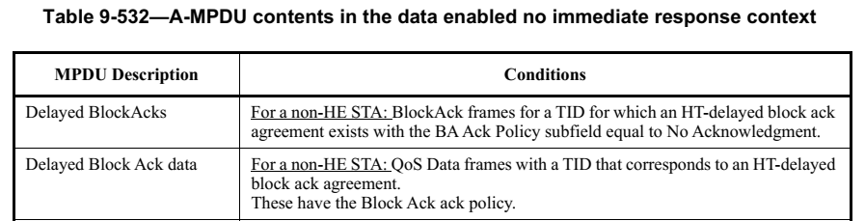

Editing instructions for CID 25024
In Table 9-531, delete rows for “HT-delayed block ack”, “HT-delayed block ack data” and “HT-delayed BlockAckReqs” to align with REVmd/D5.0.
In Table 9-532, delete rows for “HT-delayed BlockAcks”, “HT-delayed block ack data” and “HT-delayed BlockAckReqs”

At 247.23, change as follows:
If sent by an HE AP, Trigger frames where the Trigger Type field indicates Basic Trigger
frame, BSRP Trigger frame, or BQRP Trigger frame.

At 247.31 and 248.34, change as follows:
If sent to an HE STA, QoS Null frames with No Ack ack policy.

Proposed resolution
REVISED

TGax editor: make the changes under the heading “Editing instrucitons for CID 25024” in <this document>

CID 25057
CID | Page | Clause | Comment | Proposed Change
25057 | 251.26 | 9.7.3 | The precedence of "One tagged MPDU that is either a QoS Data frame with Normal Ack or HETP Ack ack pol- icy, or a Management frame that solicits an immediate response, one or more untagged MPDUs, each of which is a QoS Null frame with No Ack ack policy, or a Trigger frame. The Trigger frame is a Basic Trigger, BSRP Trigger or BQRP Trigger frame." is not clear | Change to "One of the following: * a tagged MPDU that is a QoS Data frame with Normal Ack or HETP Ack ack pol- icy * a tagged MPDU that is a Management frame that solicits an immediate response * one or more untagged MPDUs, each of which is a QoS Null frame with No Ack ack policy * a Basic Trigger, BSRP Trigger or BQRP Trigger frame"

Context (with proposed change):

One tagged MPDU that is either a QoS Data frame with Normal Ack or HETP Ack ack policy, or a Management frame that solicits an immediate response, one or more untagged
MPDUs, each of which is a QoS Null frame with No Ack ack policy, or a Trigger frame.
The Trigger frame is a Basic Trigger, BSRP Trigger or BQRP Trigger frame

To

One of the following:
- a tagged MPDU that is a QoS Data frame with Normal Ack or HETP Ack ack policy
- a tagged MPDU that is a Management frame that solicits an immediate response
- one or more untagged MPDUs, each of which is a QoS Null frame with No Ack ack policy
- a Basic Trigger, BSRP Trigger or BQRP Trigger frame

Proposed change
REVISED
Change the cited sentence to

One of the following:
- A tagged MPDU that is a QoS Data frame with Normal Ack or HETP Ack ack policy
- A tagged MPDU that is a Management frame that solicits an immediate response
And at least one untagged MPDU that is a QoS Null frame with No Ack ack policy, Basic Trigger frame, BSRP Trigger frame, or BQRP Trigger frame.

CID 25081
CID | Page | Clause | Comment | Proposed Change
25081 | 397.57 | 26.6.2.1 | "NOTE—While it is recommended that the STA adds EOF padding immediately after the last A-MPDU subframe with a nonzero Length field, the STA might still add non-EOF padding or not add any EOF padding at all." is duplication of the immediately preceding sentence "In an HE PPDU, a STA should add an A-MPDU subframe with the EOF/Tag field set to 1 and with the MPDU Length field set to 0 (i.e., EOF padding) immediately after the last A-MPDU subframe with a nonzero MPDU Length field." | Delete the NOTE

Context
26.6.2 A-MPDU padding in an HE PPDU
26.6.2.1 General
In an HE PPDU, a STA shall not add an A-MPDU subframe with the EOF/Tag field set to 1 and with the MPDU Length field set to 0 before an A-MPDU subframe with a nonzero MPDU Length field. In an HE PPDU, a STA should add an A-MPDU subframe with the EOF/Tag field set to 1 and with the MPDU Length field set to 0 (i.e., EOF padding) immediately after the last A-MPDU subframe with a nonzero MPDU Length field.
NOTE—While it is recommended that the STA adds EOF padding immediately after the last A-MPDU subframe with a nonzero Length field, the STA might still add non-EOF padding or not add any EOF padding at all.

Discussion
It is silly to have an informative note that clarifies the meaning of “should”. The meaning of “should” is quite fundamental to IEEE SA specifications and does not need clarification for this specific instance.

Proposed resolution
ACCEPTED

CID 25055
CID | Page | Clause | Comment | Proposed Change
25055 | 0 | 3.2 | Puncturing has broken the definition of "frequency segment: A contiguous block of spectrum used by a transmission." | Change the definition to end "or a block of spectrum used by a transmission that would be contiguous were it not punctured"

Context with proposed change
frequency segment: A contiguous block of spectrum used by a transmission or a block of spectrum used by a transmission that would be contiguous were it not punctured.

Proposed resolution
REJECTED
The definition is not dependent on the transmission itself being contiguous.

CID 25067
CID | Page | Clause | Comment | Proposed Change
25067 | 0 |  | Sometimes the pre-correction requirements are described as (a) synchronisation requirement(s) (“A non-AP STA that transmits a CTS frame in response to an MU-RTS Trigger frame shall follow the syn- chronization requirement”; “true indicates that the MAC entity requests that the PHY entity do synchronization as defined in 27.3.14.3 (Pre-cor- rection accuracy requirements). false indicates that the MAC entity does not request that the PHY entity do synchronization as defined in 27.3.14.3 (Pre- correction accuracy requirements).”, “transmission time, frequency, sampling symbol clock, and power pre-correction (in the case of an HE TB PPDU) by the non-AP STAs is necessary to mitigate synchronization and interference issues”). Better to talk of pre-correction in all cases | At 345.33 change "syn- chronization requirement" to "pre-correction requirements" (note plural). On page 518 change " do synchronization as defined" to " follow the pre-correction requirements defined"

Context with proposed change
26.2.6.3 CTS frame response to an MU-RTS Trigger frame
At 345.33:
A non-AP STA that transmits a CTS frame in response to an MU-RTS Trigger frame shall follow the pre-correction requirements defined in 27.3.15.3 (Pre-correction accuracy requirements).

Table 27-1
At 518.10:
Boolean value:
true indicates that the MAC entity requests that the PHY entity follow the pre-correction requirements defined in 27.3.15.3 (Pre-correction accuracy requirements).
false indicates that the MAC entity does not request that the PHY entity follow the pre-correction requirements defined in 27.3.15.3 (Pre-correction accuracy requirements).

Proposed resolution
ACCEPTED

CID 25123
CID | Page | Clause | Comment | Proposed Change
25123 | 0 | 9.3.1.8.2 | RE: CID #24163 of the SA Ballot #1. The explanation provided on why those some of the values are left reserved is vague. It talks about some optimization but yet does not provide a possible optimization for compressed block ack. Why is it thought using only 16 octets for BA bitmap is not desirable? | Please provide more concrete justification or implement the proposed change in CID #24163

Context
CID | Page | Clause | Comment | Proposed Change | Resolution
24163 | 109.08 | 9.3.1.8.2 | Table 9-30c has allowed values for Block Ack Bitmap Subfield length for all values of B2, B1 (with the exception of when B3 is set to 1) where as Table 9-30a has it reserved for values of B1 set to 1. Is there a reason why some entries are allowed for Multi-STA BA but not for single TID BA. If anytyhing, i would think it is more likely to aggregate 128 of single TID than of multi-TID | Clarify or, use the same encoding for both single-TID and Mult-STA BA | REJECTED (EDITOR: 2020-07-02 15:20:59Z) - Reason for M-BA to have more entries is because of overhead optimization, given that this control response contains informaiton for multiple STAs. This is not the case for Compressed BlockAck, where overhead is not a big concern.
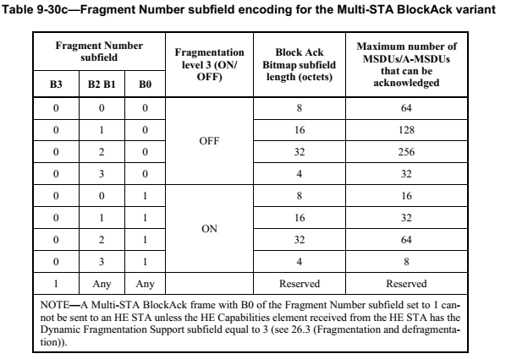
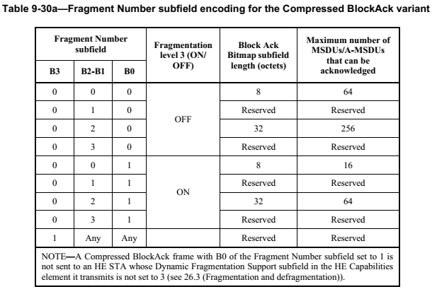

Proposed resolution
REJECTED
The comment does not identify a problem with the draft. Regarding the reasoning in the rejected resolution for 25163, consider the following. A Compressed BlockAck frame will have a single bitmap with a length of either 8 octets or 32 octets. A MultiSTA BlockAck frame can have multiple bitmaps (for different STAs or different TIDs) each with 4, 8, 16 or 32 octets. The greater fidelity in the MultiSTA BlockAck frame better optimizes the overall length when multiple bitmaps are present because the MAC header + FCS is a smaller percentage of the overall frame length.

CID 25086
Work in progress…

CID | Page | Clause | Comment | Proposed Change
25086 | 454.01 | 26.11.1 | "parameter STA_IDs" -- no such parameter | Change to "parameter STA_ID"

Context
At 454.01:
If an RU is intended for multiple STAs for MU-MIMO then multiple STAs identified by STA-IDs in the parameter STA_IDs will use the same resource unit (see 26.5.2 (UL MU operation)).

Discussion
The parameter STA_ID has multiple entries in this case.

Editing instructions for CID 25086

26.11 Rules for setting some TXVECTOR parameters for PPDUs transmitted by an
HE STA
26.11.1 STA_ID
The TXVECTOR parameter STA_ID is present when an HE MU PPDU is transmitted.

For an HE MU PPDU with the TXVECTOR parameter UPLINK_FLAG set to 1 (i.e., intended for an AP) the parameter STA_ID contains one entry that is set to the 11 LSBs of the AID of the non-AP STA transmitting the PPDU.
NOTE—A non-AP STA can transmit an UL HE MU PPDU to help the AP identify the transmitter of a failed PPDU so that the AP can allocate resources for that non-AP STA in a later TXOP. All unassociated STAs share the same parameter STA_ID value (i.e., 2045), which doesn’t uniquely identify the transmitter. Therefore an unassociated STA is not allowed to transmit an UL HE MU PPDU.

For an HE MU PPDU with the TXVECTOR parameter UPLINK_FLAG set to 0 the number of entries in the parameter STA_ID depends on the TXVECTOR parameter RU_ALLOCATION.

If the TXVECTOR parameter RU_ALLOCATION indicates that the number of users allocated to an RU is 1, there is a single entry in the STA_ID parameter that corresponds to that RU and the entry identifies the STA or group of STAs that is the recipient of the RU. For an individually addressed RU the entry is set to the 11 LSBs of the AID of the STA receiving the PSDU contained in that RU. If an RU is intended for one or more unassociated non-AP STAs, then the parameter STA_ID for that RU is set to 2045. If an RU is intended for no user, then the parameter STA_ID for that RU is set to 2046.

If for a particular RU, the TXVECTOR parameter RU_ALLOCATION indicates that the number of users allocated to that RU is greater than 1, then the following apply

If the TXVECTOR parameter RU_ALLOCATION indicates that the number of users allocated to an RU is greater than 1 (meaning the RU is intended for multiple STAs for MU-MIMO) then each of the STAs is identified by an entry STA-IDs in the parameter STA_IDs will use the same resource unit (see 26.5.2 (UL MU operation)).

If an RU is intended for multiple associated STAs and carries a single A-MPDU then the parameter STA_ID is set as follows:
— For an AP with dot11MultiBSSIDImplemented equal to false, if the RU is intended for more than one associated STA in the BSS that is not a recipient of an individually addressed RU, the parameter STA_ID is set to 0.
— For an AP with dot11MultiBSSIDImplemented equal to true, if the RU is intended for more than one associated STA in any of its BSSs that is not a recipient of an individually addressed RU, the parameter STA_ID is set to 0 for transmitted BSSID or to the value of the BSSID Index field corresponding to that BSS (see 9.4.2.73 (Multiple BSSID-Index element)) for a nontransmitted BSSID. The number of such elements shall not exceed the maximum number of BSSs of the multiple BSSID set.
— For an AP with dot11MultiBSSIDImplemented equal to true, if the RU is intended for more than one associated STA on any of its BSSs that is not the recipient of an individually addressed RU or another broadcast RU corresponding to parameter STA_ID equal 0 or equal to the BSSID Index of a BSSID in a multiple BSSID set, the parameter STA_ID is set to 2047.
The parameter STA_ID values between 2008 and 2044 are reserved.
A non-AP STA shall not transmit an HE MU PPDU where the TXVECTOR parameter STA_ID includes
more than one entry in the range 1 to 2007.

Proposed resolution
REVISED

TGax editor: make the changes under the heading “Editing instructiosn for CID 25086 in <this document>

CID 25106

CID | Page | Clause | Comment | Proposed Change
25106 | 0 | 26.5.6 | It's not clear which 20M subchannels a non-AP STA reports BQR on. Clearly it can't be expected to report on more than its operating width. I see a hint of this in the format clause (Clause 9), where it says: Availability of each 20 MHz subchannel is based on the ED-based CCA defined in 27.3.20.6.5 (Per 20 MHz CCA sensitivity) and is reported for the 20 MHz subchannels located in the operating channel of the report- ing STA when the WM is idle as defined in 10.3.2.1 (CS mechanism) and in 26.5.2.5 (UL MU CS mecha- nism). but there does not appear to be an actual behavioural specification, i.e. that the non-AP STA is not required to provide information on subchannels outside its operating width, and that the corresponding bits are reserved in that case (so the AP ignores them). I see nothing about this in 26.5.6 Bandwidth query report operation. | As it says in the comment

Context with resolution below
The HE STA may report the channel availability information as specified in 27.3.20.6.5 (Per 20 MHz CCA sensitivity) in the BQR Control subfield of frames it transmits if the AP has indicated its support in the BQR Support subfield of its HE Capabilities element; otherwise the STA shall not report the channel availability information in the BQR Control subfield.

The availability of each 20 MHz subchannel reported in the BQR Control field shall be reported for the 20 MHz subchannels located in the operating channel of the reporting STA (see 9.2.4.6a.6 (BQR Control)).
NOTE—The STA can send an unsolicited BQR in response to certain Trigger frames except NFRP, MU-RTS and
BQRP (with or without RA-RUs, as defined in 26.5.2.3 (Non-AP STA behavior for UL MU operation) and in 26.5.4
(UL OFDMA-based random access (UORA))) or it can send the unsolicited BQR after accessing the WM using EDCA.

Proposed resolution
REVISED
TGax editor: Insert the following after the 3rd paragraph in 26.5.6:

The availability of each 20 MHz subchannel reported in the BQR Control field shall be reported for the 20 MHz subchannels located in the operating channel of the reporting STA (see 9.2.4.6a.6 (BQR Control)).

