IEEE P802.11
Wireless LANs
D7.0 Editorial CR
Date: 2020-10-16
Author(s):
Name | Affiliation | Address | Phone | email
Robert Stacey | Intel |  |  | robert.stacey@intel.com
Abstract
Proposed resolutions for 25004, 25010, 25011, 25014, 25019, 25033, 25023, 25028, 25041, 25098, 25103, 25062, 25082, 25061, 25068

CID 25004
CID | Page | Clause | Comment | Proposed Change
25004 | 527.1 | 27.2.6.1 | In Figure 27-3, "Configure all PHYs" should include clause 27 instead of clause 28 | replace "clause 28" with "clause 27"

Discussion
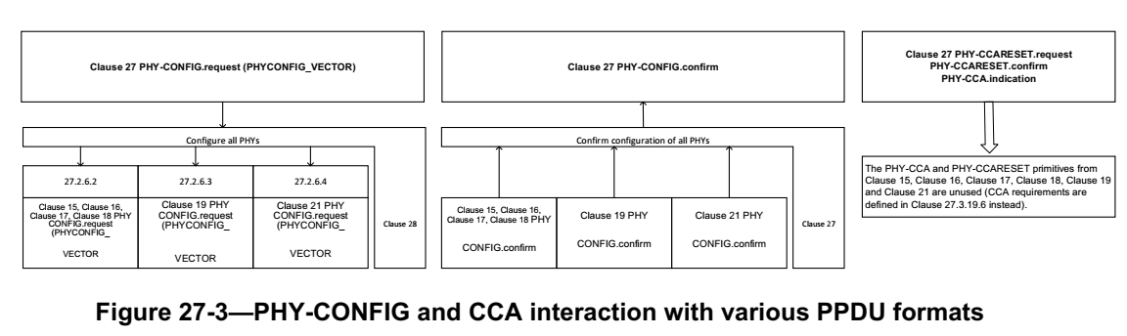

Proposed Resolution
ACCEPTED

CID 25010
CID | Page | Clause | Comment | Proposed Change
25010 | 698.4 | 27.3.22 | On behalf of Brian Hart: References to equations (27-132) and (27-133) in figure 27-63 are stale | Change to (27-133) and (27-134)

Discussion
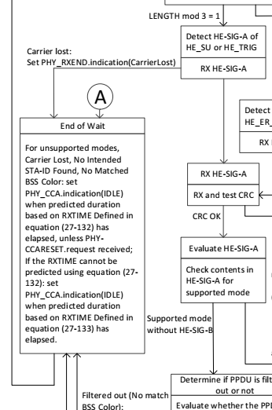

Proposed Resolution
REVISED
Change “equation (27-132)” to “Equation (27-133)” (2x)
Change “equation (27-133)” to “Equation (27-134)”

Note:
Look at what 11md does.

CID 25011
CID | Page | Clause | Comment | Proposed Change
25011 | 557.59 | 27.3.6.4 | In REVmd D4.0, 17.3.5.7 title is "Data interleaving" | Change "17.3.5.7 (BCC interleavers)" to "17.3.5.7 (Data interleaving)" at P557L59 and P558L39.

Proposed Resolution
ACCEPTED

CID 25014
CID | Page | Clause | Comment | Proposed Change
25014 | 168.54 | 9.4.2.36 | On behalf of Pooya Monajemi First reference to "the 6GHz AP" is not known. | Change to "a 6GHz AP" : "The Co-Located With 6 GHz AP subfield is set to 1 to indicate that the AP reported by the Neighbor Report element is in the same co-located AP set as a 6 GHz AP and that the 6 GHz AP can be discovered ..."

Discussion
Cited text:
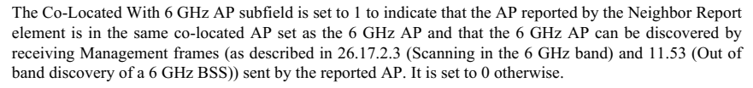

The commenter is correctly suggesting that the definite article be replaced with an indefinite article

Proposed Resolution
ACCEPTED

CID 25019 and 25033
CID | Page | Clause | Comment | Proposed Change
25019 | 242.32 | 9.7.1 | EOF in first column should be EOF/Tag | Change "EOF" in the first column to "EOF/Tag"
25033 | 242.31 | 9.7.1 | EOF field name should be changed to EOF/Tag field. It seems that TGba tagged TGax. You know TGba are just waiting that TGax will finish the CR. Now, isn't that TGax chases TGba fair? | As in comment.

Discussion
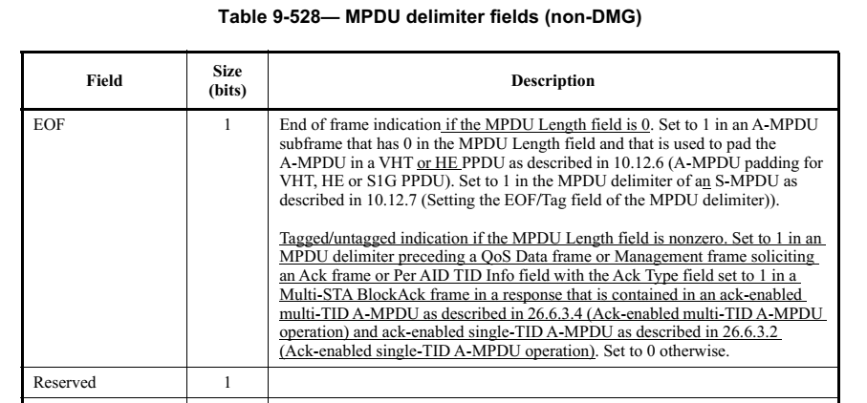
The “EOF” field name was changed to “EOF/Tag” in the last round of comment resolution

Proposed Resolution for 25019
ACCEPTED

Proposed Resolution for 25033
REVISED
Change "EOF" in the first column to "EOF/Tag"

CID 25023
CID | Page | Clause | Comment | Proposed Change
25023 | 249.16 | 9.7.3 | In third column: missing article | "an Ack"

Discussion
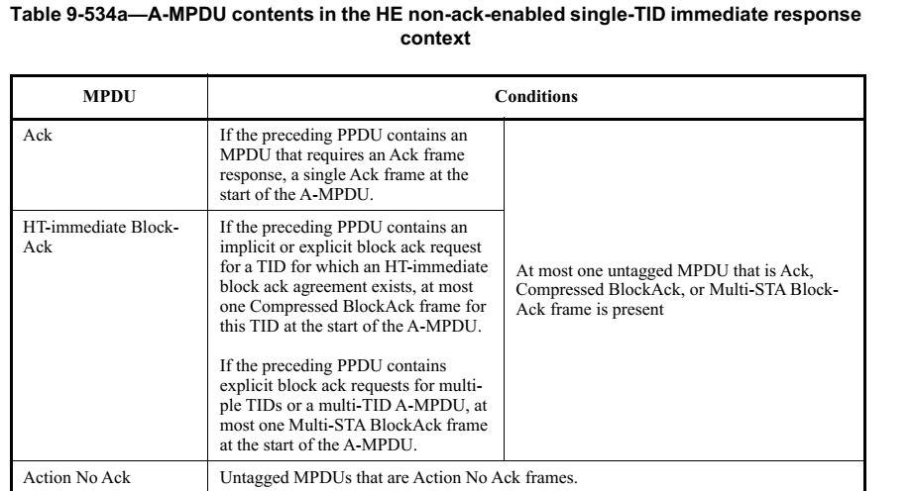

Proposed Resolution
ACCEPTED

CID 25025
CID | Page | Clause | Comment | Proposed Change
25025 | 250.08 | 9.7.3 | Missing space between MPDU and search | Add space

Discussion
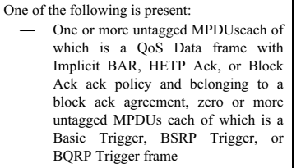

Proposed Resolution
REVISED
Change “MPDUsearch” to “MPDUs, each”
Change “MPDUs each” to “MPDUs, each” 5 lines below cited location

CID 25028
CID | Page | Clause | Comment | Proposed Change
25028 | 39.32 | 3.1 | "orthogonal frequency division multiple access (OFDMA): An orthogonal frequency division multiple (OFDM)-based multiple access technique..." "multiple" should be "multiplexing" | Change "multiple" to "multiplexing"

Proposed Resolution
REVISED
The commenter is referring to “multiple” in OFDM (and not the multiple in OFDMA). Change “multiple (OFDM)” to “multiplexing (OFDM)”.

CID 25037
CID | Page | Clause | Comment | Proposed Change
25037 | 116.14 | 9.3.1.19 | The comment requested by a non-member of this TGax SA Ballot (Young-hoon Kwon). "STA Info subfield" should be "STA Info field". | Modify the text "STA Info subfield" to "STA Info field"

Discussion
9.3.1.19 VHT/HE NDP Announcement frame

Inconsistent used of “field” and “subfield”:
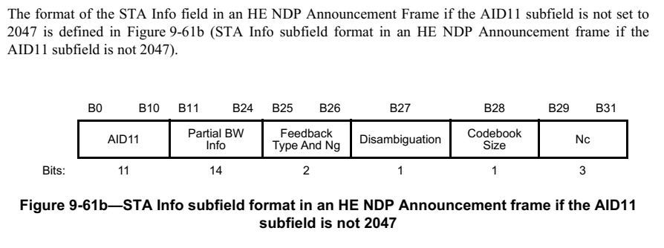

The rest of this subclause refers to fields at this level as “fields” (not “subfields”).

Proposed Resolution
ACCEPTED

CID 25041
CID | Page | Clause | Comment | Proposed Change
25041 | 180.30 | 9.4.2.170.2 | The comment requested by a non-member of this TGax SA Ballot (Young-hoon Kwon). It looks there's a typo: "it" should be "if". | Modify the text " It is set to 0 it the reported AP is a nontransmitted BSSID." to " It is set to 0 if the reported AP is a nontransmitted BSSID.".

Discussion

Proposed Resolution
ACCEPTED

CID 25098
CID | Page | Clause | Comment | Proposed Change
25098 | 191.22 | 9.4.2.248.2 | "If +HTC-HE Support is 1:" and similar is missing "subfield" | Change "+HTC-HE Support is" to "the +HTC-HE Support subfield is" throughout (6x)

Proposed Resolution
REVISED
Change “+HTC-HE Support is” to “the +HTC-HE Support subfield is” (6x)
Change “+HTC-HE Support field” to “+HTC-HE Support subfield” (2x)

CID 25103
CID | Page | Clause | Comment | Proposed Change
25103 | 341.22 | 26.2.4 | "(see 26.11.5 (TXOP_DURATION)" is missing a closing parenthesis at the end | As it says in the comment

Proposed Resolution
ACCEPTED

CID 25062
CID | Page | Clause | Comment | Proposed Change
25062 | 405.09 | 26.7.2 | "NDPP" should be "NDP" | As it says in the comment
Discussion

Proposed Resolution
ACCEPTED

CID 25082
CID | Page | Clause | Comment | Proposed Change
25082 | 442.06 | 26.10.1 | "Class B device should" -- bad grammar | Change to "A Class B device should"

Context

Proposed Resolution
ACCEPTED

CID 25061
CID | Page | Clause | Comment | Proposed Change
25061 | 0 | 9.7.3 | "Ack Policy subfield set to No Ack" -- the ack policy is more than the Ack Policy subfield, which anyway is now the Ack Policy Indicator subfield | Change to "No Ack ack policy" (6 instances)

Proposed Resolution
ACCEPTED

CID 25068
CID | Page | Clause | Comment | Proposed Change
25068 | 0 |  | "Trigger frame or frame containing a TRS Control subfield" should be just "triggering frame" | Change at 370.25, 370.28, 371.21, 376.48

Proposed Resolution
ACCEPTED

[Assign to Alfred]

