IEEE P802.11
Wireless LANs
SA2 Misc PHY CIDs
Date: 2020-10-7
Author(s):
Name | Affiliation | Address | Phone | email
Youhan Kim | Qualcomm |  |  | youhank@qti.qualcomm.com

Abstract
This submission proposes resolutions for the following comments from the SA2 on P802.11ax D7.0:

25104, 25117, 25101, 25073, 25105

NOTE – Set the Track Changes Viewing Option in the MS Word to “All Markup” to clearly see the proposed text edits.

Revision History:

R0: Initial version.
R1: Fixed document number in heading.
R2: Updated resolution to CID 25104 during CRC teleconference on 10/8/2020

CID 25104

CID | Clause | Page.Line | Comment | Proposed Change
25104 | 27.3.1.1 | 530.44 | "The transmission within an  RU in a PPDU may be a single stream to one user, multiple streams spatially multiplexed to one user (SU-  MIMO), or multiple streams spatially multiplexed to multiple users (MU-MIMO)."  is missing a distinguishing abbreviation for the first case | Change to  "The transmission within an  RU in a PPDU may be a single stream to one user (SISO), multiple streams spatially multiplexed to one user (SU-  MIMO), or multiple streams spatially multiplexed to multiple users (MU-MIMO).".  Add a definition in 3.1:  "single input, single output (SISO): A technique by which a station (STA) transmits to or receives from a single STA a single space-time stream.(#4777)"

Background

D7.0 P530
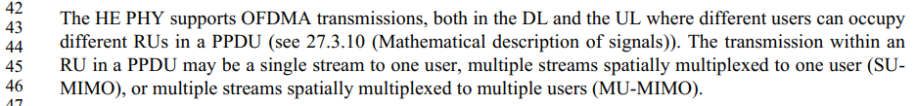

SP during CRC teleconference on 10/8/2020:
Which option do you prefer as the resolution to CID 25104?
- Rejected
- Accepted
Result:
1 = 5
2 = 6

Proposed Resolution: CIDs 25104
Accepted

CID 25117

CID | Clause | Page.Line | Comment | Proposed Change
25117 | 27.3.2.8 | 542.18 | There is a description of RU restrictions for 20 MHz operating non-AP HE STAs, but not for 40 MHz operating non-AP HE STA | Add a subclause describing the RU restrictions that pertain to 40 MHz operating non-AP HE STAs

Background

D7.0 P542
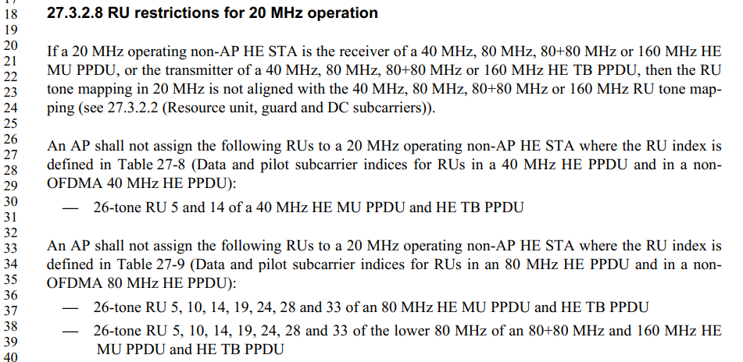
…

P7.0 P498-499
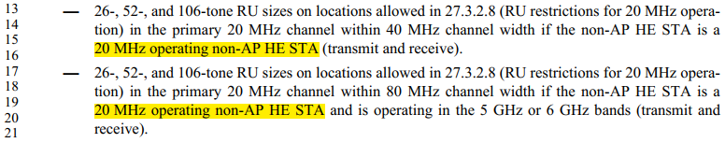

Proposed Resolution: CIDs 25117
Rejected
D7.0 P499L13-21 and 27.3.2.8 requires that a 20 MHz operating non-AP HE STA needs to be able to receive/transmit some RUs in DL/UL OFDMA (using HE MU/TB PPDU) with bandwidth greater than 20 MHz. For this to work, there are certain RU restrictions that must be put in place, hence 27.3.2.8 is written.
There is, however, no requirement that a 40 MHz operating non-AP HE STA needs to receive/transmit some RUs in DL/UL OFDMA with bandwith greater than 40 MHz. This is because first, all non-AP STAs in 5 or 6 GHz must be at least 80 MHz capable (except for the 20 MHz-only STAs). And if those 80 MHz (or 160 MHz) capable non-AP STAs want to reduce operating bandwidth to reduce power consumption, then they are expected to reduce to 20 MHz bandwidth. Hence, TGax did not see a need to burden the 11ax standard by requiring and/or defining how a 40 MHz operating STA would participate in wider bandwidth OFDMA, and thus there is no need to write a section on RU restrictions for 40 MHz operating STAs.

CID 25101

CID | Clause | Page.Line | Comment | Proposed Change
25101 | 27.3.15.2 | 666.29 | It may be necessary to have a different uplink power headroom for responses to triggering frames in punctured PPDUs than for those in non-punctured ones (because meeting spectral emissions limits may require power back-off). This should be NOTEd, i.e. the AP should not assume that the power headroom advertised in a response to a punctured PPDU is applicable to a non-punctured one, or vice-versa | At the end of 27.3.15.2 Power pre-correction add a para "NOTE---The UPH advertised in response to a punctured PPDU might not be applicable to the subsequent transmission of an HE TB PPDU in response to a PPDU that is not punctured, and vice-versa."

Background

D7.0 P666
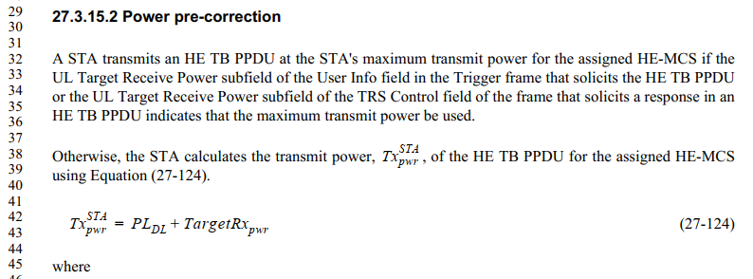
…

Proposed Resolution: CIDs 25101
Rejected
Preamble puncturing is defined only for HE MU PPDUs. HE TB PPDU does not have ‘puncturing’. Yes, some spectrum may be left unoccupied, either by the AP not scheduling users, or some STAs failing to transmit (e.g. did not receive the Trigger frame). However, from each non-AP STA transmission point of view, any HE TB PPDU transmission has only one contiguous segment of spectrum used (except for 80+80, but which is not ‘puncturing’ anyway), and does not have any ‘puncturing’ in the spectrum.

CID 25073

CID | Clause | Page.Line | Comment | Proposed Change
25073 | 27.3.15.2 | 666.48 | The units for TargetRx_pwr are not given, unlike those for Tx^AP_pwr and Rx_pwr below | Change  "is the expected receive signal power indicated in"  to  "is the expected receive signal power, in units of dBm, as indicated by"

Background

D7.0 P666
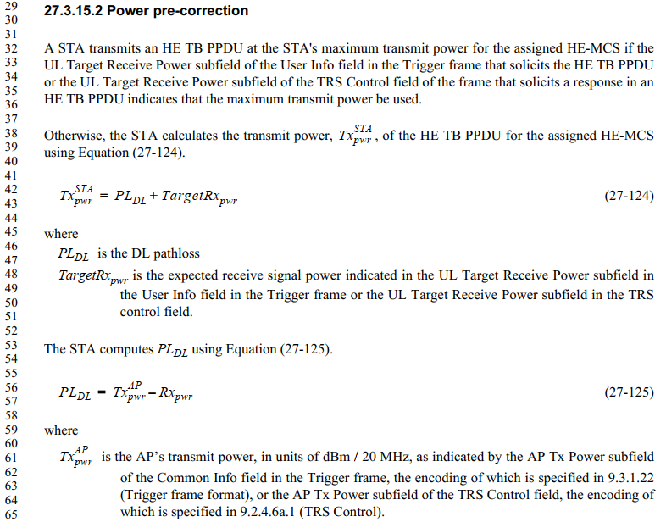

Proposed Resolution: CIDs 25073
Accepted

CID 25105

CID | Clause | Page.Line | Comment | Proposed Change
25105 | 27.3.15.3 | 667.33 | "A STA transmitting at and above the minimum power, but below Pmax,MCS7, shall support the EVM requirements for  HE-MCS 7 even if the HE-MCS used for the transmission is lower than HE-MCS 7, where Pmax,MCS7 is the  maximum transmit power supported by the STA for HE-MCS 7 in an HE TB PPDU."  is confusing.  For example, it suggests that only the HE-MCS 7 EVM requirements have to be met, even if the actual HE-MCS is higher. And "shall support" is vague. | Change to  "A STA transmitting using HE-MCS 7 or lower, at or above the minimum power, but below Pmax,MCS7, shall meet the EVM requirements for HE-MCS 7 even if the HE-MCS used for the transmission is lower than HE-MCS 7, where Pmax,MCS7 is the maximum transmit power supported by the STA for HE-MCS 7 in an HE TB PPDU."

Background

D7.0 P667
Redline version of the proposed text change by the commenter:
27.3.15.3 Pre-correction accuracy requirements

A STA that transmits an HE TB PPDU shall support per chain max(P–32, –10) dBm as the minimum transmit power, where P is the maximum power, in dBm, that the STA can transmit at the antenna connector of
that chain using HE-MCS 0 while meeting the transmit EVM and spectral mask requirements. A STA transmitting using HE-MCS 7 or lower, at or above the minimum power, but below Pmax,MCS7, shall meet the EVM requirements for HE-MCS 7 even if the HE-MCS used for the transmission is lower than HE-MCS 7, where Pmax,MCS7 is the maximum transmit power supported by the STA for HE-MCS 7 in an HE TB PPDU.

Proposed Resolution: CIDs 25105
Accepted

[End of File]

