IEEE P802.11
Wireless LANs
PHY Intro CID 25001, 25013, 25026
Date: 2020-09-21
Author(s):
Name | Affiliation | Address | Phone | email
Youhan Kim | Qualcomm |  |  | youhank@qti.qualcomm.com

Abstract
This submission proposes resolutions for the following comments from the SA2 on P802.11ax D7.0:

25001, 25013, 25026

NOTE – Set the Track Changes Viewing Option in the MS Word to “All Markup” to clearly see the proposed text edits.

Revision History:

R0: Initial version.

CID 25001

CID | Clause | Page.Line | Comment | Proposed Change
25001 | 27.1.1 | 495.00 | 802.11ax allows for a 20 MHz only STA as defined in 27.1.1. The clause states  "Clause 27 (High Efficiency (HE) PHY specification) specifies the PHY entity for a high efficiency (HE) orthogonal frequency division multiplexing (OFDM) system. In addition to the requirements in Clause 27 (High Efficiency (HE) PHY specification), an HE STA shall be capable of transmitting and receiving PPDUs that are compliant with the mandatory requirements of the following PHY specifications:  "Clause 19 (High Throughput (HT) PHY specification) and Clause 21 (Very High Throughput (VHT) PHY specification) transmission and reception on 20 MHz channel width (see 26.17.1 (Basic HE BSS operation)) if the HE STA is a 20 MHz-only non-AP HE STA and is operating in the 5 GHz band."  However, clause 19 does not allow operation as a 20 MHz only STA and the PICS declaration in Annex B does not provide the option to declare 20 MHz only support for clause 19. | Update clause 19 to allow operation as a 20 MHz only STA  Update Annex B section B.4.25.2 to enable decleration for 20 MHz support for VHT

Background

REVmd D4.0 P1177
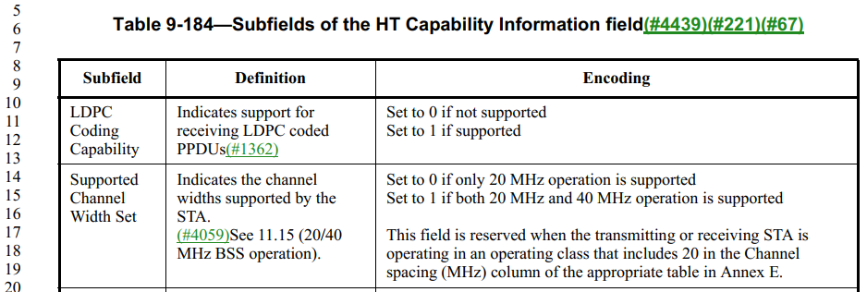

REVmd D4.0 P3718
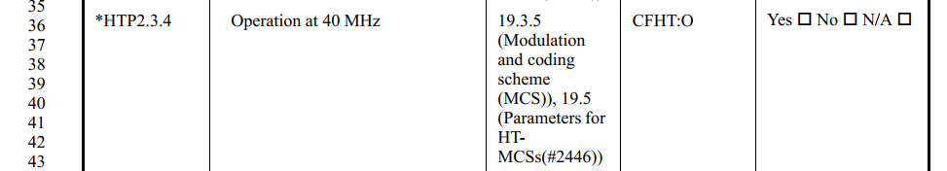

Proposed Resolution: CIDs 25001
Rejected
An HT STA can declare support for 20 MHz channel width only using the “Supported Channel Width Set” subfield in the HT Capabilities element (REVmd D4.0 P1177L14). The corresponding PICS is HTP2.3.4 (Operation at 40 MHz) at REVmD D4.0 P3718L36.

It is mandatory for a VHT STA to support at least 80 MHz channel width. Hence, while a 20 MHz-only non-AP HE STA in the 5 GHz band supports transmitting and receiving VHT PPDUs in 20 MHz channel width, the 20 MHz-only non-AP HE STA is not a VHT STA strictly speaking. The 20 MHz-only non-AP HE STA is primarily designed to operate with an HE AP which understands the limitations of the 20 MHz-only non-AP HE STA. The 20 MHz-only non-AP HE STA may attempt to communicate with a non-HE VHT AP by sending an Operating Mode Notification upon association, but that is outside the scope of the P802.11ax.

CID 25026

CID | Clause | Page.Line | Comment | Proposed Change
25026 | 27.1.1 | 495.28 | An HE STA is required to transmit OFDM PPDUs in any band; not just the 6 GHz band | Delete "if the HE STA is operating in the 6 GHz band"

Background

D7.0 P495
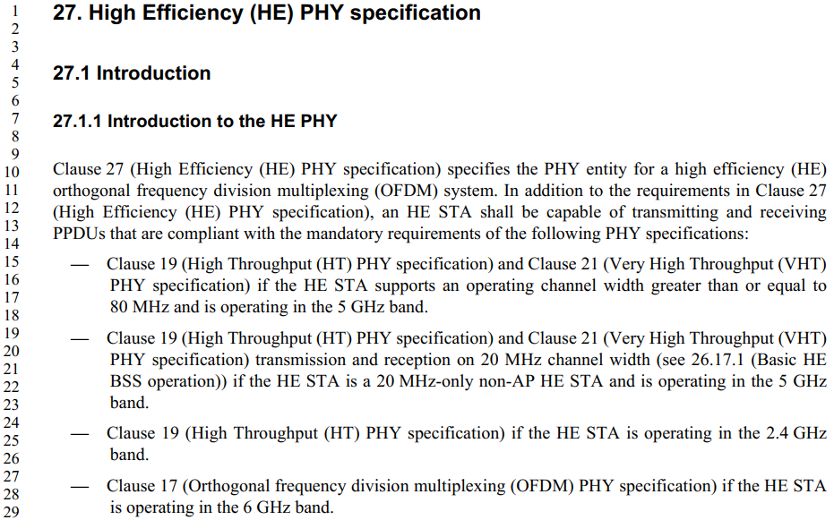

Proposed Resolution: CIDs 25026
Rejected
The commenter is correct ‘in spirit’ that an HE STA needs to support transmission and reception of OFDM PPDUs in all bands (2.4, 5 and 6 GHz). However, note that a VHT STA in 5 GHz is required to support HT, and an HT STA is required to support OFDM STA (Clause 17). Hence, it is not necessary to ‘spell out’ support for Clause 17 in the 5 GHz.
In case of 2.4 GHz, the HE STA supports Clause 18 (ERP), not Clause 17, strictly speaking. And again, support for ERP is implied in the support for HT in the 2.4 GHz.
In case of 6 GHz, however, HT and VHT PPDUs are not allowed. Hence, it is required to explicitly state the support for Clause 17 in the 6 GHz.

CID 25013

CID | Clause | Page.Line | Comment | Proposed Change
25013 | 27.1.1 | 499.13 | 20 MHz operating HE non-AP STA receiving RUs in the Primary 20 MHz in a 40 MHz HE MU PPDU is optional (see "20 MHz In 40 MHz HE PPDU In 2.4 GHz Band" in HE PHY capabilities at P206L822). | Delete at P499L13 "26-, 52-, and 106-tone RU sizes on locations allowed in 27.3.2.8 (RU restrictions for 20 MHz operation) in the primary 20 MHz channel within 40 MHz channel width if the non-AP HE STA is a 20 MHz operating non-AP HE STA (transmit and receive)"

Background

D7.0 P498L30, P499L13
…

P7.0 P200
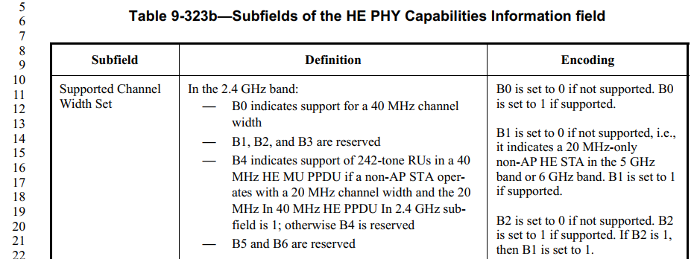

P7.0 P206
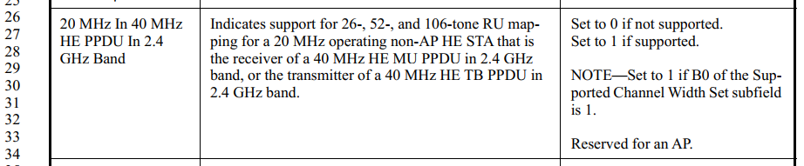

P7.0 P500
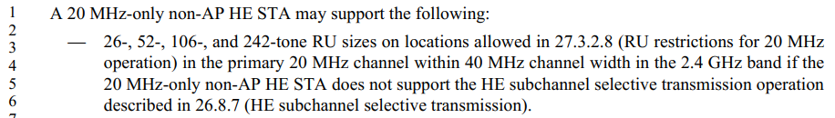

P7.0 P541
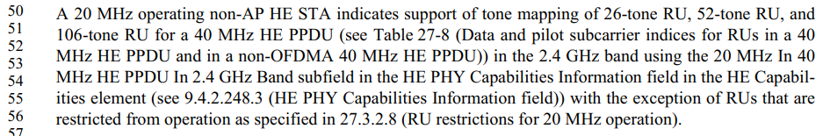

Proposed Resolution: CIDs 25013
Revised.
Note to Commenter:
Per D7.0 P206L26 (“20 MHz In 40 MHz HE PPDU In 2.4 GHz Band” capability bit), P500L3 and P541L50, it is optional for a 20 MHz-only STA in the 2.4 GHz band to receive and transmit RUs within the primary 20 MHz in 40 MHz HE MU and HE TB PPDUs, respectively. Hence the commenter is correct that P499L13 is in error.

Note also that P206L29 states that a 40 MHz capable HE STA in the 2.4 GHz band must support receiving and transmiting RUs within the primary 20 MHz in 40 MHz HE MU and HE TB PPDUs when in a 20 MHz operating mode. That is what P499L13 should have indicated, but did so erroneously.

Instruction to Editor below clarifies that P499L13 applied only to 40 MHz capable STAs.

Instruction to Editor:
Implement the proposed text updates for CID 25013 in https://mentor.ieee.org/802.11/dcn/20/11-20-1519-00-00ax-phy-intro-cid-25001-25013-25026.docx

Proposed Text Updates: CIDs 25013

Instruction to Editor: Update D7.0 P499L13 as shown below.

A non-AP HE STA shall support the following features:

…

— 26-, 52-, and 106-tone RU sizes on locations allowed in 27.3.2.8 (RU restrictions for 20 MHz operation) in the primary 20 MHz channel within 40 MHz channel width if the non-AP HE STA is a 20 MHz operating non-AP HE STA that is capable of supporting 40 MHz channel width (B0 of the Supported Channel Width Set subfield in the HE PHY Capabilities Information field in the HE Capabilities element is 1) (transmit and receive).

[End of File]

