IEEE P802.11
Wireless LANs
S1G GEN Resolution to CID5018
Date: 2020-09-15
Author(s):
Name | Affiliation | Address | Phone | email
David Goodall | Morse Micro |  |  | dave@morsemicro.com
Abstract
This submission shows
- 1 CID: 5018

Revisions:
- Rev 0: Initial version of the document.
- Rev 1: Replaced e.i.r.p with EIRP in Table D-4. Modified new Note 5.

CID 5018

CID | Clause | Page.Line | Comment | Proposed Change
5018 | D2.2 | 4379.30 | Table D-4 needs to be updated with recent S1G regulatory changes. These include removal of 700 MHz band in China, 1 MHz BW in Europe, new channels in Europe etc. Commenter will provide a list of known changes. | As per comment

Background

Table D-4 (Maximum STA transmit power and maximum BW allowed) is out of date due to recent changes in various regulatory domains, including China and Europe. Also, the name of the table should be made specific to sub 1 GHz.

China
China MIIT announced a change of the usage of 700 MHz band, in particular 703 - 743 MHz and 758 - 798 MHz will be dedicated for FDD-based mobile communications systems (http://www.miit.gov.cn/n1146295/n7281315/c7845717/content.html).

Europe
EU 802.11ah devices are covered by the following: DECISION (EU) 2017/1483 (See References [1])
This document contains the Annex: Harmonised frequency bands and technical parameters for short-range devices with the legal requirements for the SRDs in the European Union.

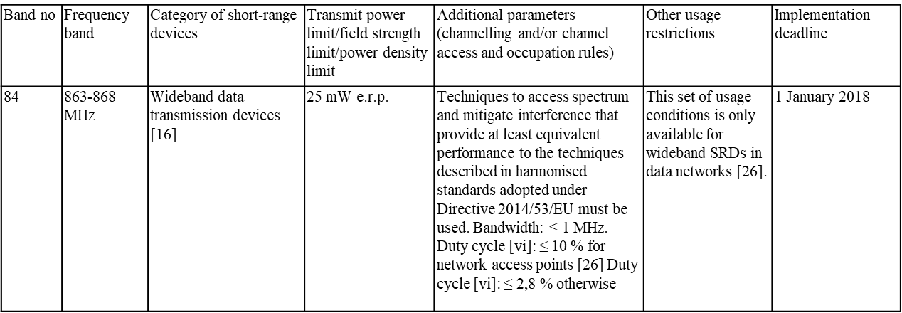

EU 917.4 – 919.4 MHz is covered by:
DECISION (EU) 2018/1538 (See References [2])
See band 2 for wideband data transmission devices. Same conditions as for 863-868MHz

Proposed Resolution: CID 5018

Revised.

Instructions to Editor:

Remove the entry for China from Table D-4 at D4.0 P4379L39.

At D4.0 P4379L26, remove the modify the original text as shown below:

------------- Begin Text Changes ---------------

(11ah)The maximum allowed transmit power and maximum bandwidth (BW) limits for an S1G STA are shown by country in Table D-4 (Maximum STA transmit power and maximum BW allowed for the Sub 1 GHz band(11ah)).
- Maximum STA transmit power and maximum BW allowed for the Sub 1 GHz band (11ah)
Geographic  area | Frequency  (MHz) | Maximum BW allowed  (MHz) | Maximum STA transmit power  (Max EIRP (mW) except where noted)
Australia | 915–928 | 8 | (Ed)See NOTE 1
China | 775–779 | 1 | 5
 | 779–787 | Not defined | 10
Europe | 863–868 | 1 | See NOTE 5
 | 917.4-919.4
Japan | 915.9–929.7 | 1 | (Ed)See NOTE 2
 | 920.5–923.5 |  | (Ed)See NOTE 3
New Zealand | 915–928 | 8 | (Ed)See NOTE 4
United States | 902–928 | Not defined | 1000
Singapore | 866–869, 920–925 | 8 | 500
South Korea | 917–923.5 | Not defined | 3, 10
NOTE 1—Max EIRP <= 30 dBm and PSD <= 25 mW/3 kHz
NOTE 2—1 or 20 mW transmitter output power plus up to 3 dBi antenna gain (maximum power is 1 or 20 mW + 3 dBi)
NOTE 3—250 mW transmitter output power plus up to 3 dBi antenna gain (maximum power is 250 mW + 3 dBi)
NOTE 4—Max EIRP <= 5 dBm (915 MHz(Ed) to 928 MHz) for general sensor-type devices and Max EIRP <= 36 dBm (921.5 MHz to 928 MHz) for digital modulation transmitters
NOTE 5—Maximum Effective Radiated Power <= 25 mW

------------- End Text Changes ------------------

References:

[1] DECISION (EU) 2017/1483
https://op.europa.eu/en/publication-detail/-/publication/ed3648d1-83e0-11e7-b5c6-01aa75ed71a1

[2] Decision (EU) 2018/1538
https://op.europa.eu/en/publication-detail/-/publication/7aa9ee9d-d053-11e8-9424-01aa75ed71a1/language-en/format-PDF/source-142398249

