IEEE P802.11
Wireless LANs
Subcarriers and Resource Allocation for Multiple RUs
Date: 2020-09-06
Author(s):
Name | Affiliation | Address | Phone | Email
Jianhan Liu | Mediatek |  |  | jianhan.liu@mediatek.com
Srinath Puducheri Sundaravaradhan | Broadcom |  |  | srinath.puducheri@broadcom.com
Myeongjin KIM | Samsung |  |  | mj1108.kim@samsung.com
Oded Redlich | Huawei |  |  | oded.redlich@HUAWEI.COM

Abstract:

This document contains draft text of the following motions in [1]:

6, 76, 91, 69, 78, 79, 80, 118, 81, 112(#SP21), 87, 86, 97, 98, 115 (SP#71, SP#73, SP#74, SP#72 ), 93, 94, 95, 96.

34.3.3 Subcarriers and Resource Allocation for Multiple RUs

34.3.3.1 General

An EHT STA shall be allowed to be assigned with more than one Resource Unit (RU). RUs in this context are RUs of size RU26, RU52, RU106, RU242, RU484, RU996, RU 2x996 and RU 4x996.
The tones indices of the various RUs have been updated in relation to RUs defined for HE STAs (see Table 27-7 Data and pilot subcarrier indices for RUs in a 20 MHz HE PPDU and in a non-OFDMA
20 MHz HE PPDU and Table 27-8 Data and pilot subcarrier indices for RUs in a 40 MHz HE PPDU and in a non-OFDMA 40 MHz HE PPDU) and are defined in 34.3.x.x.x. [34.3.x.x.x should be replaced by a reference to “Subcarrier and resource allocation” sub-clause]

RUs with equal to or more than 242 tones are defined as large-size RUs and RUs with less than 242 tones are defined as small-size RUs.

Small-size RUs can only be combined with small-size RUs to form small-size Multiple RUs (MRU). The supported small-size MRUs are defined in 34.3.3.2.1.

Large-size RUs can only be combined with large-size RUs to form large-size MRUs. The supported large-size MRUs are defined in 34.3.3.2.2.

34.3.3.2 Multiple RUs

34.3.3.2.1 Small-Size Multiple RUs

The small-size multiple-RUs (MRU) defined for DL and UL transmissions in OFDMA format are as follows: 26+52 tone MRU, 26+106 tone MRU.

The 26+52 tone MRU is obtained by combining a certain 26-tone RU and a certain 52-tone RU that both fall within a 20MHz channel boundary. The data subcarriers of a 26+52 tone MRU consist of the data subcarriers of the 26-tone and 52-tone RUs that make up the 26+52 tone MRU. The pilot subcarriers of a 26+52 tone MRU consist of the pilot subcarriers of the 26-tone and 52-tone RUs that make up the 26+52 tone MRU.

The 26+106 tone MRU is obtained by combining a certain 26-tone RU and a certain 106-tone RU that both fall within a 20MHz channel boundary. The data subcarriers of a 26+106 tone MRU consist of the data subcarriers of the 26-tone and 106-tone RUs that make up the 26+106 tone MRU. The pilot subcarriers of a 26+106 tone MRU consist of the pilot subcarriers of the 26-tone and 106-tone RUs that make up the 26+106 tone MRU.

The allowed 26+52 tone MRUs in a 20MHz EHT PPDU are indicated in Fig. 34-X1
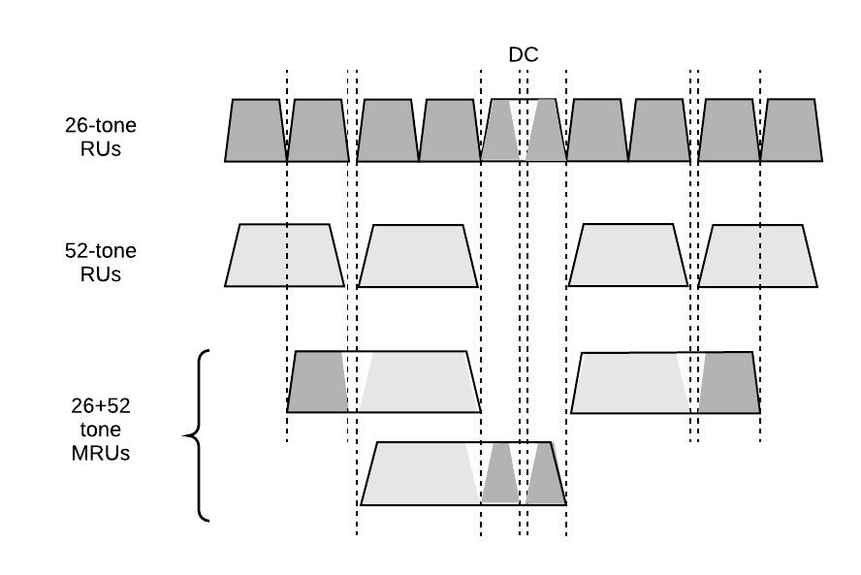
Figure 34-X1 – Allowed 26+52 tone MRUs in a 20MHz EHT PPDU

The allowed 26+52 tone MRUs in a 40MHz EHT PPDU are indicated in Fig. 34-X2
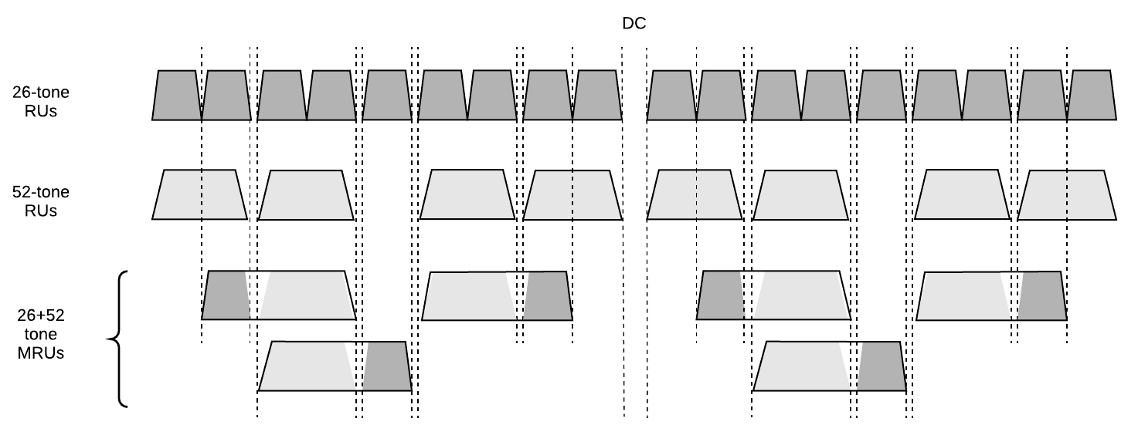
Figure 34-X2 – Allowed 26+52 tone MRUs in a 40MHz EHT PPDU

The allowed 26+52 tone MRUs in each 80MHz segment of an 80MHz, 160MHz or 320MHz EHT PPDU are indicated in Fig. 34-X3.

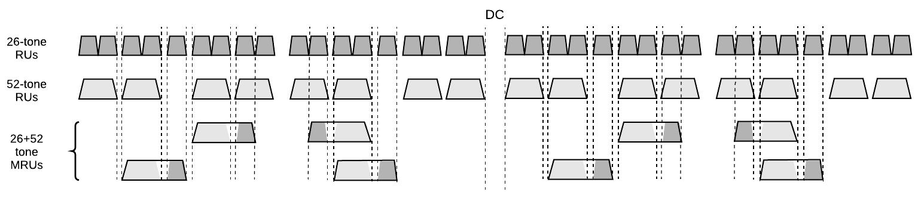
Figure 34-X3 – Allowed 26+52 tone MRUs in each 80MHz segment of an 80MHz, 160MHz, or 320MHz EHT PPDU

The allowed 26+106 tone MRUs in a 20MHz EHT PPDU are indicated in Fig. 34-X4.
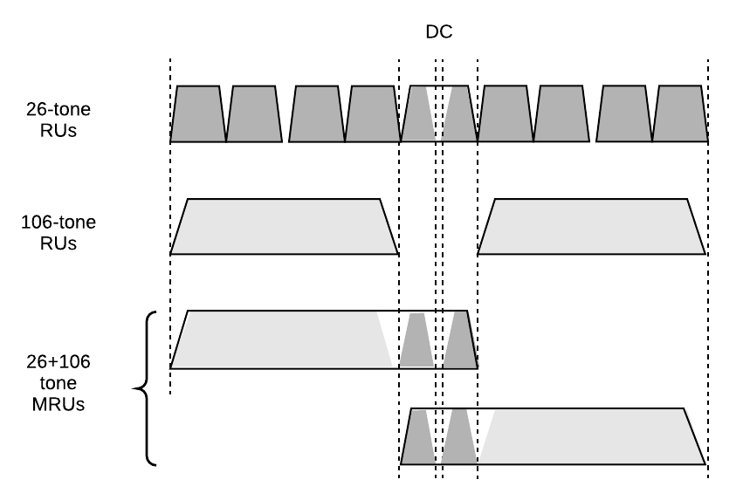
Figure 34-X4 – Allowed 26+106 tone MRUs in a 20MHz EHT PPDU

The allowed 26+106 tone MRUs in a 40MHz EHT PPDU are indicated in Fig. 34-X5.
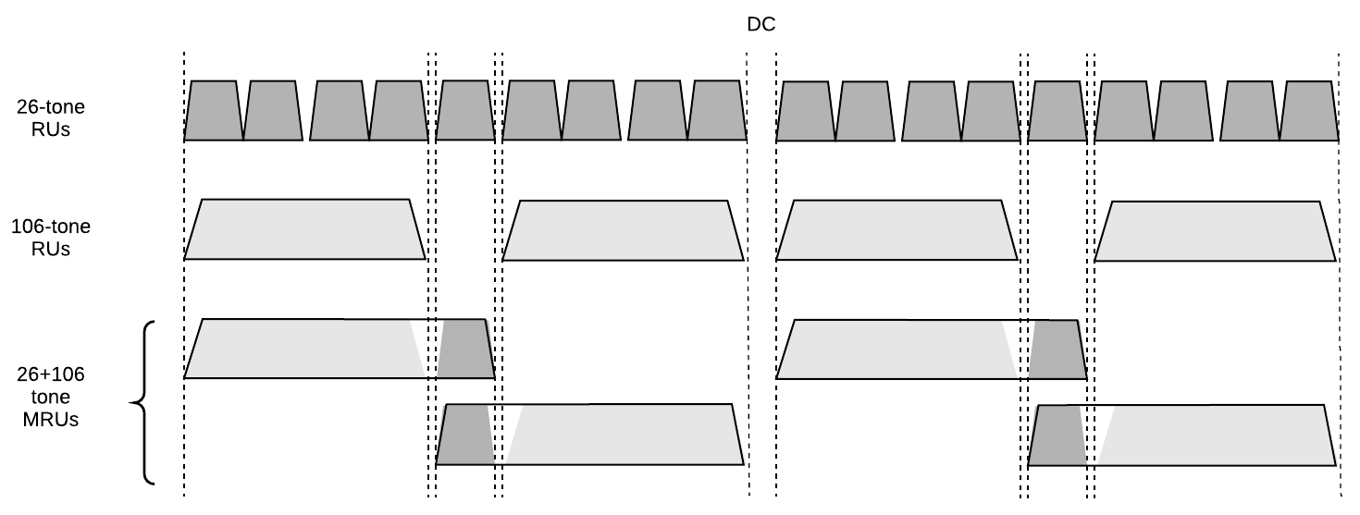
Figure 34-X5 – Allowed 26+106 tone MRUs in a 40MHz EHT PPDU

The allowed 26+106 tone MRUs in each 80MHz segment of an 80MHz, 160MHz or 320MHz EHT PPDU are indicated in Fig. 34-X6.
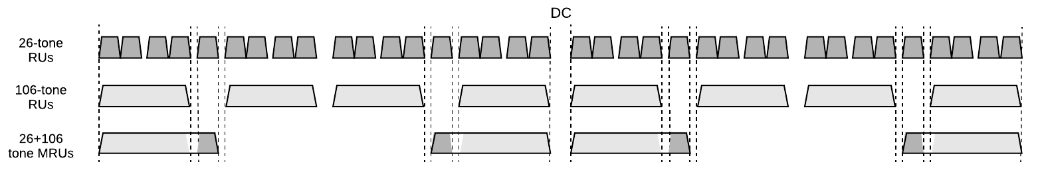
Figure 34-X6 – Allowed 26+106 tone MRUs in each 80MHz segment of an 80MHz, 160MHz, or 320MHz EHT PPDU

Not every possible combination of small-size MRUs and RUs is allowed in a DL OFDMA transmission. The allowed combinations of small-size MRUs and RUs in a DL OFDMA transmission are restricted according to Table XX (RU allocation subfield) in sub-clause 34.3.10.7.

It is mandatory for a non-AP STA to support the transmission and reception of 26+52 tone and 26+106 tone MRUs in OFDMA.

34.3.3.2.1 Large-Size Multiple RUs

The large-size multiple-RUs (MRU) defined for DL and UL transmissions in non-OFDMA format are as follows: 484+242 tone MRU, 996+484 tone MRU, 996+484+242 tone MRU, 2×996+484 tone MRU, 3×996-tone MRU, and 3×996+484 tone MRU.

The 484+242 tone MRU is allowed in non-OFDMA 80 MHz EHT PPDU. The 484+242 tone MRU is obtained by puncturing any one of four 242-tone RUs in the 80 MHz EHT PPDU. The data subcarriers of a 484+242 tone MRU consist of the data subcarriers of the 484-tone and 242-tone RUs that make up the 484+242 tone MRU. The pilot subcarriers of a 484+242 tone MRU consist of the pilot subcarriers of the 484-tone and 242-tone RUs that make up the 484+242 tone MRU. The 4 allowed 484+242 tone MRUs in non-OFDMA 80MHz EHT PPDU are shown in Figure 34-X7.

Figure 34-X7 – Allowed 484+242 tone MRUs in non-OFDMA 80 MHz EHT PPDU

The 996+484 tone MRU is allowed in non-OFDMA 160/80+80 MHz EHT PPDU. The 996+484 tone MRU is obtained by puncturing any one of four 484-tone RUs in the 160/80+80 MHz EHT PPDU. The data subcarriers of a 996+484 tone MRU consist of the data subcarriers of the 996-tone and 484-tone RUs that make up the 996+484 tone MRU. The pilot subcarriers of a 996+484 tone MRU consist of the pilot subcarriers of the 996-tone and 484-tone RUs that make up the 996+484 tone MRU. The 4 allowed 996+484 tone MRUs in non-OFDMA 160/80+80 MHz EHT PPDU are shown in Figure 34-X8.

Figure 34-X8 – Allowed 996+484 tone MRUs in non-OFDMA 160/80+80 MHz EHT PPDU

The 996+484+242 tone MRU is allowed in non-OFDMA 160/80+80 MHz EHT PPDU. The 996+484+242 tone MRU is obtained by puncturing any one of eight 242-tone RUs in the 160/80+80 MHz EHT PPDU. The data subcarriers of a 996+484+242 tone MRU consist of the data subcarriers of the 996-tone, 484-tone, and 242-tone RUs that make up the 996+484+242 tone MRU. The pilot subcarriers of a 996+484+242 tone MRU consist of the pilot subcarriers of the 996-tone, 484-tone, and 242-tone RUs that make up the 996+484+242 tone MRU. The 8 allowed 996+484+242 tone MRUs in non-OFDMA 160/80+80 MHz EHT PPDU are shown in Figure 34-X9.

Figure 34-X9 – Allowed 996+484+242 tone MRUs in non-OFDMA 160/80+80 MHz EHT PPDU

The 2×996+484 tone MRU is allowed in non-OFDMA 320/160+160 MHz EHT PPDU. The 2×996+484 tone MRU is obtained by puncturing any one of six 484-tone RUs in 240 MHz transmission defined as 320 MHz EHT PPDU with 80MHz punctured. The data subcarriers of a 2×996+484 tone MRU consist of the data subcarriers of the two 996-tone and 484-tone RUs that make up the 2×996+484 tone MRU. The pilot subcarriers of a 2×996+484 tone MRU consist of the pilot subcarriers of the two 996-tone and 484-tones RUs that make up the 2×996+484 tone MRU. The 12 allowed 2×996+484 tone MRUs in non-OFDMA 320/160+160 MHz EHT PPDU are shown in Figure 34-X10.

Figure 34-X10 – Allowed 2×996+484 tone MRUs in non-OFDMA 320/160+160 MHz EHT PPDU

The 3×996-tone MRU is allowed in non-OFDMA 320/160+160 MHz EHT PPDU. The 3×996-tone MRU is obtained by puncturing any one of four 996-tone RUs in the 320/160+160 MHz EHT PPDU. The data subcarriers of a 3×996-tone MRU consist of the data subcarriers of the three 996-tone RUs that make up the 3×996-tone MRU. The pilot subcarriers of a 3×996-tone MRU consist of the pilot subcarriers of the three 996-tone RUs that make up the 3×996-tone MRU. The 4 allowed 3×996-tone MRUs in non-OFDMA 320/160+160 MHz EHT PPDU are shown in Figure 34-X11.

Figure 34-X11 – Allowed 3×996-tone MRUs in non-OFDMA 320/160+160 MHz EHT PPDU

The 3×996+484 tone MRU is allowed in non-OFDMA 320/160+160 MHz EHT PPDU. The 3×996+484 tone MRU is obtained by puncturing any one of eight 484-tone RUs in the 320/160+160 MHz EHT PPDU. The data subcarriers of a 3×996+484 tone MRU consist of the data subcarriers of the three 996-tone and 484-tone RUs that make up the 3×996+484 tone MRU. The pilot subcarriers of a 3×996+484 tone MRU consist of the pilot subcarriers of the three 996-tone and 484-tones RUs that make up the 3×996+484 tone MRU. The 8 allowed 3×996+484 MRUs in non-OFDMA 320/160+160 MHz EHT PPDU are shown in Figure 34-X12.

Figure 34-X12 – Allowed 3×996+484 tone MRUs in non-OFDMA 320/160+160 MHz EHT PPDU

It is mandatory for AP and STA to support the transmission and reception of 484+242 tone MRU in 80MHz PPDU, 996+484 tone MRU in 160MHz PPDU, 996+484+242 tone MRU in 160MHz PPDU, 2×996+484 tone MRU in 320MHz PPDU, 3×996-tone MRU in 320MHz PPDU, and 3×996+484 tone MRU in 320MHz PPDU in non-OFDMA unless the MRU size is larger than its supported bandwidth.

The large-size multiple-RU (MRU) defined for DL and UL in OFDMA format are as follows: 484+242 tone MRU, 996+484 tone MRU, 2×996+484 tone MRU, 3×996-tone MRU, and 3×996+484 tone MRU.

The 484+242 tone MRU is allowed in OFDMA 80 MHz, 160/80+80 MHz, and 320MHz EHT PPDU. The 484+242 tone MRU is obtained by combining a 484-tone RU and a 242-tone RU. The data subcarriers of a 484+242 tone MRU consist of the data subcarriers of the 484-tone and 242-tone RUs that make up the 484+242 tone MRU. The pilot subcarriers of a 484+242 tone MRU consist of the pilot subcarriers of the 484-tone and 242-tone RUs that make up the 484+242 tone MRU. For OFDMA 80MHz EHT PPDU, the 4 allowed 484+242 tone MRUs are shown in Figure 34-X13.
Figure 34-X13 – Allowed 484+242 tone MRUs in OFDMA 80 MHz EHT PPDU

For OFDMA transmission in 160/80+80 MHz and 320/160+160 MHz, the allowed combinations for a 484+242 tone MRU in OFDMA 80 MHz EHT PPDU are allowed in each 80MHz segment of OFDMA 160/80+80 MHz and 320/160+160 MHz EHT PPDU.

The 996+484 tone MRU is allowed in OFDMA 160/80+80 MHz and 320MHz EHT PPDU. The 996+484 tone MRU is obtained by combining a 996-tone RU and a 484-tone RU. The data subcarriers of a 996+484 tone MRU consist of the data subcarriers of the 996-tone and 484-tone RUs that make up the 996+484 tone MRU. The pilot subcarriers of a 996+484 tone MRU consist of the pilot subcarriers of the 996-tone and 484-tone RUs that make up the 996+484 tone MRU. For OFDMA 160/80+80 MHz EHT PPDU, the 4 allowed 996+484 tone MRUs are shown in Figure 34-X14.

Figure 34-X14 – Allowed 996+484 tone MRUs in OFDMA 160/80+80 MHz EHT PPDU

For OFDMA transmission in 320/160+160 MHz, the allowed combinations for a 996+484 tone MRU in OFDMA 160/80+80 MHz EHT PPDU are allowed only within primary 160 MHz channel or secondary 160 MHz channel, repectively.

The 2×996+484 tone MRU is allowed in OFDMA 320/160+160 MHz EHT PPDU. The 2×996+484 tone MRU is obtained by combining two 996-tone RUs and a 484-tone RU. The data subcarriers of a 2×996+484 tone MRU consist of the data subcarriers of the two 996-tone and 484-tone RUs that make up the 2×996+484 tone MRU. The pilot subcarriers of a 2×996+484 tone MRU consist of the pilot subcarriers of the two 996-tone and 484-tones RUs that make up the 2×996+484 tone MRU. The 12 allowed 2×996+484 tone MRUs in OFDMA 320/160+160 MHz EHT PPDU are shown in Figure 34-X15.

Figure 34-X15 – Allowed 2×996+484 tone MRUs in OFDMA 320/160+160 MHz EHT PPDU

The 3×996-tone MRU is allowed in OFDMA 320/160+160 MHz EHT PPDU. The 3×996-tone MRU is obtained by combining three 996-tone RUs. The data subcarriers of a 3×996-tone MRU consist of the data subcarriers of the three 996-tone RUs that make up the 3×996-tone MRU. The pilot subcarriers of a 3×996-tone MRU consist of the pilot subcarriers of the three 996-tone RUs that make up the 3×996-tone MRU. The 4 allowed 3×996-tone MRUs in OFDMA 320/160+160 MHz EHT PPDU are shown in Figure 34-X16.
Figure 34-X16 – Allowed 3×996-tone MRUs in OFDMA 320/160+160 MHz EHT PPDU

The 3×996+484 tone MRU is allowed in OFDMA 320/160+160 MHz EHT PPDU. The 3×996-tone MRU is obtained by combining three 996-tone RUs and a 484-tone RU. The data subcarriers of a 3×996+484 tone MRU consist of the data subcarriers of the three 996-tone and 484-tone RUs that make up the 3×996+484 tone MRU. The pilot subcarriers of a 3×996+484 tone MRU consist of the pilot subcarriers of the three 996-tone and 484-tones RUs that make up the 3×996+484 tone MRU. The 3×996+484 MRUs in OFDMA 320/160+160 MHz EHT PPDU are shown in Figure 34-X17.

Figure 34-X17 – Allowed 3×996+484 tone MRUs in OFDMA 320/160+160 MHz EHT PPDU

It is mandatory for non-AP STA to support the transmission and reception of 484+242 tone MRU in each 80MHz segment, 996+484 tone MRU in the primary 160MHz channel and the secondary 160MHz channel, 2×996+484 tone MRU, 3×996-tone MRU, and 3×996+484 tone MRU in 80/160/320MHz PPDU in OFDMA unless the MRU size is larger than its supported bandwidth.
.

References:

[1]. 11-20-0566-44-00be-compendium-of-straw-polls-and-potential-changes-to-the-specification-framework-document, Edward Au.

