IEEE P802.11
Wireless LANs
S1G PHY resolution to CID5021
Date: 2020-09-08
Author(s):
Name | Affiliation | Address | Phone | email
Yujin Noh | Newracom |  |  | yujin.noh at newracom.com
Abstract
This submission shows
- 1 CID: 5021

Revisions:
- Rev 0: Initial version of the document.
- Rev 1: typo fixed

CID 5021

CID | Clause | Page.Line | Comment | Proposed Change
5021 | 23.3.11 | 3403.8 | With respect to transmission of an S1G NDP, there is no Length/Duration field in the SIG_SHORT. There is a length field. Is the duration meant to be the response indication field? | Please clarify the Length/Duration field.

Background

At P3401L1 in 11Rev D3.4,
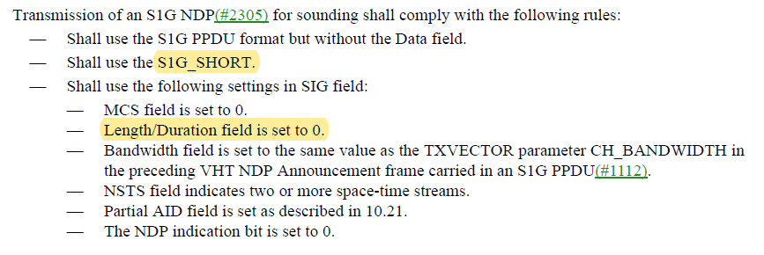
At 3362L46 in 11Rev D3.4,
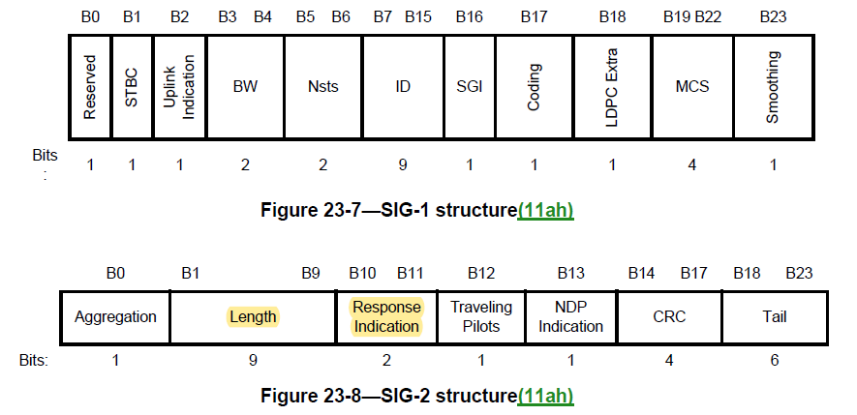

Commenter’s confusion comes from different name between Length field in SIG field of S1G SHORT preamble and Length/Duration field mentioned in S1G NDP PPDU description. In the comment, Response Indication field is defined as a separate field which is set to Long Response for S1G NDP PPDU as below.

At 1949L47 in 11Rev D3.4,
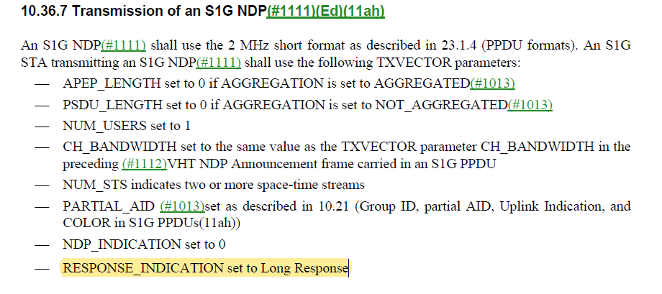
At P3329L26 in 11Rev D3.4, TXVECTOR parameter RESPONSE_INDICATION is shown below
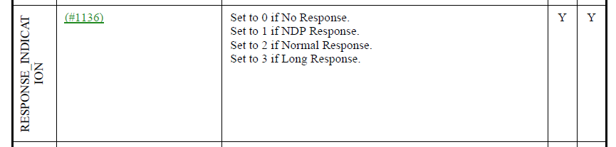

Proposed Resolution: CID 5021
Revised.

Instruction to Editor:
At D3.4 P3401L1, modify the original text as below
------------- Begin Text Changes ---------------

Transmission of an S1G NDP(#2305) for sounding shall comply with the following rules:
- Shall use the S1G PPDU format but without the Data field.
- Shall use the S1G_SHORT.
- Shall use the following settings in SIG field:
  - MCS field is set to 0.
  - Length/Duration field is set to 0.
  - Bandwidth field is set to the same value as the TXVECTOR parameter CH_BANDWIDTH in the preceding VHT NDP Announcement frame carried in an S1G PPDU(#1112).
  - NSTS field indicates two or more space-time streams.
  - Partial AID field is set as described in 10.21.
  - The NDP indication bit is set to 0.
  - Response Indication field is set to Long Response (see TXVECTOR parameter RESPONSE_INDICATION)

------------- End Text Changes ------------------

