IEEE P802.11
Wireless LANs

Proposed Draft Text for MAC STA ID
Date: 2020-09-16
Author(s):
Name | Affiliation | Address | Phone | email
Yongho Seok | MediaTek Inc. | 2840 Junction Ave, San Jose, CA 95134 |  | yongho.seok@mediatek.com

Abstract

This submission proposes draft text for STA ID based on the following portions of the SFD:

Revisions:
Rev 0: Initial version of the document.
Rev 1: Updated based on comments from Young-Hoon, Sang-Hyun, Sharan, and Alfred.
Rev 2: Received a request to check whether the EHT SU PPDU also uses the EHT_MU format. Please refer the following in https://mentor.ieee.org/802.11/dcn/20/11-20-1403-03-00be-pdt-phy-txvector-rxvector-trigvector-config-vector.doc. The EHT PHY does not have the EHT SU format.

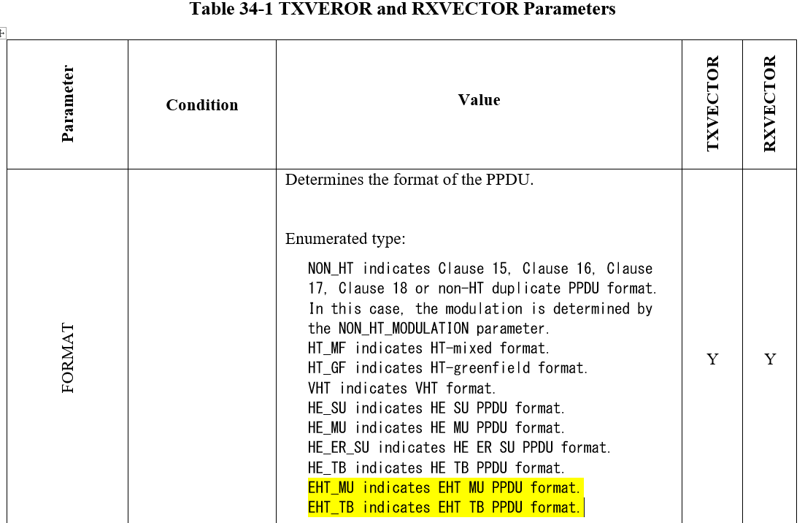

- 802.11be supports that the STA ID field in a downlink EHT SU PPDU sent from an EHT AP to an EHT STA identifies the recipient EHT STA.
- NOTE- The size and encoding of the STA ID field in the downlink EHT SU PPDU is TBD.
[Motion 122, #SP160, [10] and [181]]

- 802.11be supports that the STA ID field in an uplink EHT SU PPDU sent from an EHT STA to an EHT AP identifies the transmitter EHT STA.
- NOTE- The size and encoding of the STA ID field in the uplink EHT SU PPDU is TBD.
[Motion 122, #SP161, [10] and [181]]

Editing instructions formatted like this are intended to be copied into the TGbe Draft (i.e. they are instructions to the 802.11 editor on how to merge the text with the baseline documents).

TGbe Editor: Editing instructions preceded by “TGbe Editor” are instructions to the TGbe editor to modify existing material in the TGbe draft. As a result of adopting the changes, the TGbe editor will execute the instructions rather than copy them to the TGbe Draft.
Insert new Clause 33 following Clause 32 as follows:
33. Extremely High Throughput (EHT) MAC specification
33.x Setting TXVECTOR parameters for an EHT PPDU
33.x.y1 STA_ID
For an individually addressed RU that is addressed to an associated non-AP STA the parameter STA_ID is set to is set to the TBD value that identifies the STA receiving the PSDU contained in that RU. If an RU is intended for an AP (i.e., the TXVECTOR parameter UPLINK_FLAG is 1), then the parameter STA_ID contains only one element that is set to the TBD value that identifies the non-AP STA transmitting the PPDU.

(#Motion 122, SP160)

Straw Poll: Do you support to incorporate the proposed draft text in this document 11-20/1409r2 to the TGbe Draft 0.1?
Result: Yes/No/Abstain

