IEEE P802.11
Wireless LANs
Comment Resolutions on REVmd draft 4.0
Date: September 4, 2020
Author(s):
Name | Affiliation | Address | Phone | email
Menzo Wentink | Qualcomm | Utrecht, The Netherlands | +31-65-183-6231 | mwentink  @qti.qualcomm.com

Abstract
This document contains comment resolutions for REVmd draft 4.0, addressing the following CIDs:

- '4725', '4761'

4725: max retry limit
4761: dec operator

(The CID numbers in r0 of this document are with reference to the ballot on draft 3.0.)

The baseline for this document is Draft P802.11REVmd D4.0.

CID Identifiers | Comment | Proposed Change | Proposed Resolution

Based on CID 4725 on draft 3.0. | At 1753.45 the lifetime is missing.  The retry limit MIB variables currently have a maximum of 255, which is too small. 255 retries of an RTS may take only in the order of 10 ms, but a period of temporary interference might take much longer than that, and it is not always smart to discard a packet that soon.  (This comment is related to CID 4725 on REVmd draft 3.0.) | 1753.45 add "or lifetime" after "retry limit", to read  "Error recovery shall be attempted by retrying transmissions for frame exchange sequences that the initiating STA infers have failed. Retries shall continue, for each failing frame exchange sequence, until the transmission is successful, or until the relevant retry limit or lifetime is reached, whichever occurs first. A STA shall maintain an SRC and an LRC for each MSDU or MMPDU awaiting transmission. These counts are incremented and reset independently of each other."  4124.62 change "255" to "65535"  (in dot11ShortDEIRetryLimit).  4125.30 change "255" to "65535"  (in dot11UnsolicitedRetryLimit).  4164.4 change "255" to "65535"  (in dot11ShortRetryLimit). | Accepted

Based on CID 4761 from draft 3.0:  CID 4761  10.19  1816.41  Sun, Li-Hsiang | The formula dec(BSSID[39:47]) is  1) inconsistent with the definition on p152: "dec(A[b:c]) is the cast from binary to decimal operator, where c is the least significant bit in binary value [b:c]". Bit 47 should be MSB not LSB  2) inconsistent with NOTE1 on p1817, where bit 47 is indeed calculated as MSB  (This comment is related to CID 4761 on REVmd draft 3.0.) | Either fix all the dec() on p1816 and p1817, or revise the definition on p152 and NOTE1 on p1817 | Revised  Make changes as specified in <this document> under CID 4761, which are changes in the direction suggested by the commenter.

Discussion

From 1.5 (Terminology for mathematical, logical, and bit operations):

dec(A[b:c]) is the cast from binary to decimal operator, where c is the least significant bit in binary value [b:c].

From 9.2.2 (Conventions):

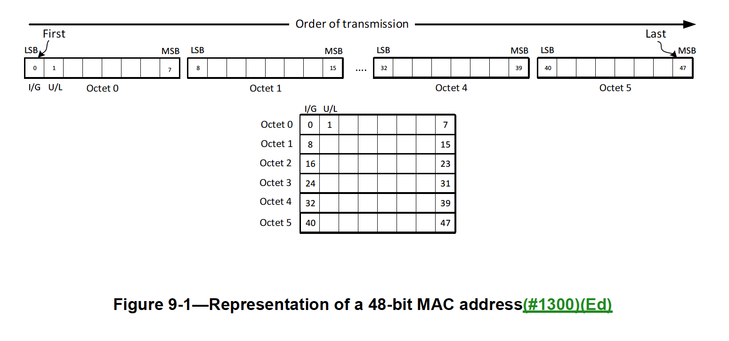

From 9.4.2.45 (Multiple BSSID element):

This clause has the following example:

8c:fd:0f:7f:1e:f5 & ZERO[45:47] = 8c:fd:0f:7f:1e:f0 (A0:A1:A2:A3:A4:A5)

So f5 is changed to f0 by setting bits [45:47] to 0. This implies that bit 47 is considered the LSB of A5, contrary to the address convention in 9.2.2, which has the LSB of A5 numbered as bit 40, but it would be in line with the current definition of the dec operator.

Therefore, in Multiple BSSID, the bit numbering inside the address octets is assumed to be MSB to LSB (lower bit number to higher bit number inside the address octets).

In this definition, bit 39 is the LSB of A4, which is appended as an MSB to bits [40:47] of A5, implying that in Multiple BSSID, A0-A5 are assumed to be ordered MSO to LSO.

(MSO is the most significant octet (A0) and LSO is the least significant octet (A5).)

From 10.19 (Group ID and partial AID in VHT and CMMG PPDUs):

The Partial AID for a packet addressed to the AP is defined as dec(BSSID[39:47]) (see Table 10-13).

There is an example for BSSID = 00-21-6A-AC-53-52 (A0:A1:A2:A3:A4:A5), for which the Partial AID for packets to the AP is 164.

So the 9 bits [39:47] have decimal value 164:

dec 164 = 0b010100100 (MSB to LSB) = 001001010 (LSB to MSB, numbered [39:47]).

A4 = 0x53 = 0b01010011 = 11001010 (LSB to MSB, numbered 32:39)
A5 = 0x52 = 0b01010010 = 01001010 (LSB to MSB, numbered 40:47)

The LSB to MSB ordering is as defined in 9.2.2, where the LSB is on the left, has the lower bit number, and is transmitted first.

164 is obtained as follows (in 9.2.2 LSB to MSB notation):

1100101001001010

Therefore, in Partial AID, the bit numbering inside the address octets is assumed to be LSB to MSB (lower bit number to higher bit number inside the address octets).

In this definition, bit 39 is the MSB of A4, which is appended as an LSB to bits 40:47 of A5, implying that in Partial AID, A0-A5 are assumed to be ordered LSO to MSO.

(LSO is the least significant octet (A0) and MSO is the most significant octet (A5).)

Therefore, both the bit numbering and the octet significance ordering appear to be different in the definitions of Multiple BSSID and Partial AID.

The intent of the proposed changes is to remove this inconsistency, by clarifying the dec and [b:c] operators and by removing the dependency of the Multiple BSSID description on a bit numbering. The Multiple BSSID definition is rewritten as an operation on the hexadecimal representation of the MAC address. The Multiple BSSID definition is also limited to an operation only on A5, because the

--- Start of changes for CID 4761 ---

1.5 Terminology for mathematical, logical, and bit operations

151.63 change as shown

A[b:c] is the bit string consisting of bits b to c of A, where bit 0 of the output is the value of bit b. This operator is not used in this standard with b larger than c.

dec(S) is the decimal value of bit string S, where bit 0 of S is the least significant bit, using the IEEE 802.11 bit conventions from 9.2.2 (Conventions).

9.2.2 Conventions

782.62 change as shown

MAC addresses are assigned as ordered sequences of bits. The Individual/Group bit is always transferred first and is bit 0 of the MAC address. Bit 47 of the MAC address is always transferred last. This is illustrated in Figure 9-1 (Representation of a 48-bit MAC address). Also see clause 8 of IEEE Std 802-2014.

A MAC address can be represented using hexadecimal values separated by hyphens, as described in IEEE Std 802.

783.26 delete

MAC_ADDR[b:c] represent bits b to c inclusive of MAC address MAC_ADDR.

9.4.2.45 Multiple BSSID element

1163.32 change as shown

The MaxBSSID Indicator field contains a value assigned to n, where 2^{n} is the maximum number of BSSIDs in the multiple BSSID set, including the reference BSSID (see 11.10.14 (Multiple BSSID set)). The maximum value of n is 8. The actual number of BSSIDs in the multiple BSSID set is not explicitly signaled. BSSID(i) corresponding to the i^{th} BSSID in the multiple BSSID set is derived as follows:

A₀-A₁-A₂-A₃-A₄-A₅ = Reference BSSID

B = A₅ mod 2^{n}

A₅(i) = A₅ – B + ( (B + i) mod 2^{n} )

BSSID(i) = A₀-A₁-A₂-A₃-A₄-A₅(i)

Note—For example, for n = 3 and Reference BSSID = 8c-fd-0f-7f-1e-f5:

A₅ = f5

B = 5

A₅(5) = f2 and BSSID(5) = 8c-fd-0f-7f-1e-f2

A₅(2) = f7 and BSSID(2) = 8c-fd-0f-7f-1e-f7

10.19 Group ID and partial AID in VHT and CMMG PPDUs

1808.3 change as shown

The partial AID is a nonunique STA identifier defined in Table 10-13 (Settings for the TXVECTOR parameters GROUP_ID and PARTIAL_AID for VHT STAs) and Table 10-14 (Settings for the TXVECTOR parameter PARTIAL_AID for CMMG STAs). The partial AID is carried in the TXVECTOR parameter PARTIAL_AID of a VHT SU PPDU or a CMMG PPDU and is limited to 9 bits.

1808.12 change as shown

BSSID[b:c] and RA[b:c] are defined as A[b:c] in 1.5 (Terminology for mathematical, logical, and bit operations) and 9.2.2 (Conventions).

1809.49 change as shown

As an example of the GROUP_ID and PARTIAL_AID setting, consider the case of a BSS with BSSID 00-21-6A-AC-53-52³² that has as a member a non-AP STA assigned AID 5. In VHT PPDUs sent to an AP, the GROUP_ID is set to 0 and the PARTIAL_AID is set to 164. In VHT PPDUs sent by the AP to the non-AP STA associated with that AP, the GROUP_ID is set to 63 and PARTIAL_AID is set to 229.

As an example of the PARTIAL_AID setting, consider the case of a BSS with BSSID 00-21-6A-AC-53-52 that has as a member a non-AP CMMG STA assigned AID 5. In CMMG PPDUs sent to an AP, the PARTIAL_AID is set to 165. In CMMG PPDUs sent by the AP to the non-AP STA associated with that AP, the PARTIAL_AID is set to 37.

10.21 Group ID, partial AID, Uplink Indication, and COLOR in S1G PPDUs

1812.30 change as shown

The S1G partial AID is a nonunique identifier of an S1G STA as defined in Table 10-14 (Settings for the TXVECTOR parameter PARTIAL_AID for NDP frames) and Table 10-15 (Settings for the TXVECTOR parameter PARTIAL_AID for non-1 MHz PPDUs and non-NDP frames). The partial AID is carried in the TXVECTOR parameter PARTIAL_AID of an S1G SU PPDU with the TXVECTOR parameter CH_BANDWIDTH set to CBW2, CBW4, CBW8, or CBW16 and is limited to 9 bits.

1814.14 change as shown

As an example of the PARTIAL_AID setting, consider the case of a BSS with BSSID 00-21-6A-AC-53-52 that has as a member a non-AP S1G STA assigned AID 5. In an NDP frame sent by the non-AP S1G STA to the S1G AP, the PARTIAL_AID is equal to 165. In an NDP frame sent by the S1G AP to the non-AP S1G STA associated with that S1G AP, the PARTIAL_AID is equal to 229. In a non-1 MHz S1G PPDU that is not an NDP frame and that is sent by the non-AP S1G STA to the S1G AP, the PARTIAL_AID is set to 165. In a non-1 MHz S1G PPDU that is not an NDP frame that is sent by the S1G AP to the non-AP S1G STA associated with that S1G AP, the PARTIAL_AID is set to 37.

10.47.6 NDP Paging Setup

2081.60 change as shown

If the Direction field of the NDP Paging frame is equal to 1, the subfields of the APDI field of the NDP Paging frame shall be set as follows:

— The PTSF subfield is set to TSF[Partial TSF Offset + 4 : Partial TSF Offset + 11], where TSF is the 8-octet value of the TSF timer and Partial TSF Offset is the value of the Partial TSF Offset field in the NDP Paging Request.

11.10.14 Multiple BSSID set

2310.12 change as shown

A multiple BSSID set is characterized as follows:

— All members of the set use a common operating class, channel, channel access functions, and antenna connector.

— The set has a maximum range of 2^{n} for at least one n, where 1 ≤ n ≤ 8.

— Members of the set have the same 48-n bits (BSSID[0:(47-n)]) in their BSSIDs.

— All BSSIDs within the multiple BSSID set are assigned in a way that they are not available as MAC addresses for STAs using a different operating class, channel or antenna connector.

--- End of changes for CID 4761 ---

