IEEE P802.11
Wireless LANs
Proposed comment resolution regarding CID 10,11, 12, 105 in comment collection sheet(11-20-1262r2)
Date: 2020-08-31
Author(s):
Name | Affiliation | Address | Phone | email
Hyun Seo OH | ETRI | Gajeongro 218 Yusunggu  Daejeon, Korea | +82.42.860.5659 | hsoh5@etri.re.kr
Hanbyeog CHO | ETRI | Gajeongro 218 Yusunggu  Daejeon, Korea | +82.42.860.5531 | hbcho@ etri.re.kr
Yoohwa Kang | ETRI | Gajeongro 218 Yusunggu  Daejeon, Korea | +82.42.860.6364 | yhkang@etri.re.kr
Chang Han OH | allRadio Co. Ltd | 280, Seobusaet-gil, Geumcheon-gu, Seoul, Korea | +82.2.801.1310 | choh@allradio.co.kr
Si Young HEO | KT | KT R&D Center, 151, Taebong-ro, Seocho-gu, Seoul, Korea | +82.10.266.4569 | siyoung.heo@kt.com
Yangseok Jeong | KT | KT R&D Center, 151, Taebong-ro, Seocho-gu, Seoul, Korea | +82.10.9530.0856 | Yangseok.jeong@  kt.com
Hyeong Ho LEE | Nevision Telecom Inc., Korea Univ. | 412, 199, Techno2-ro, Yuseong-Gu, Daejeon, 34025, Korea | +82.42.931.4130 | hhlee@netvisiontel.com
Youngjae KIM | TTA | 47, Bundang-ro, Bundang-gu, Seongnam-city, Gyeonggi-do, 13591, Korea | +82.10.5110,2895 | yjkim@tta.or.kr
Choon Sik Yim | RCN | 199, Techno2-ro, Yuseong-Gu, Daejeon | +82.10.9531.3610 | Yim253@hnamail.net

Abstract
This contribution is a proposed comment resolution on technical report on WLAN interworking to 3GPP 5G network. It described the table of contents, the revised clause 5 and 6 to propose comment resolution.

Table of Contents in the technical report on interworking between 3GPP 5G network & WLAN is as follows:

- Definition, acronyms and abbreviations
  - Definitions
  - Acronyms and abbreviations

- Introduction
  - Objective
  - Scope

- WLAN interworking reference model
  - WLAN Interworking types
  - WLAN interworking functional model in 5G system

- Interworking function and procedures
  - WLAN radio channel sharing method
  - Registration and authentication and its message procedures
  - IP Tunneling function and its message procedures

- 5GS QoS management
  - 5GS QoS model
  - ATSSS function support

- Gap analysis and Recommendations
  - Gap Analysis
  - Technical Recommendations
  - TSN topics

- Conclusions

- 5GS QoS management

5.1 5GS QoS model

The 3GPP QoS flow is access agnostic, when the traffic is distributed between 5G access network and WLAN access network, the same QoS should be supported as long as the WLAN access network can support the same QoS treatment as the 5G access network. QoS flows on GBR traffic and Non-GBR traffic are specified in 3GPP TS 23.501and QoS flows are defined as follows:

- GBR QoS Flow: A QoS Flow using the GBR resource type or the Delay-critical GBR resource type and requiring guaranteed flow bit rate.

- Non-GBR QoS Flow: A QoS Flow using the Non-GBR resource type and not requiring guaranteed flow bit rate.

Table 1 shows the characteristics of GBR and delay critical GBR QoS flows from 3GPP. Therefore, it is necessary that GBR flows are supported by the WLAN in both directions, e.g. non-AP STA to AP and AP to non-AP STA.
Table 1. QoS characteristics (3GPP TS 23.501)
Resource Type | Default Priority Level | Packet Delay Budget | Packet Error  Rate | Default Maximum Data Burst Volume | Default  Averaging Window | Example Services
GBR | 20 | 100 ms | 10⁻² | N/A | 2000 ms | Conversational Voice
 | 40 | 150 ms | 10⁻³ | N/A | 2000 ms | Conversational Video (Live Streaming)
 | 30 | 50 ms | 10⁻³ | N/A | 2000 ms | Real Time Gaming, V2X messages  Electricity distribution – medium voltage, Process automation - monitoring
 | 50 | 300 ms | 10⁻⁶ | N/A | 2000 ms | Non-Conversational Video (Buffered Streaming)
 | 7 | 75 ms | 10⁻² | N/A | 2000 ms | Mission Critical user plane Push To Talk voice (e.g., MCPTT)
 | 20 | 100 ms | 10⁻² | N/A | 2000 ms | Non-Mission-Critical user plane Push To Talk voice
 | 15 | 100 ms | 10⁻³ | N/A | 2000 ms | Mission Critical Video user plane
 | 56 | 150 ms | 10⁻⁶ | N/A | 2000 ms | "Live" Uplink Streaming (e.g. TS 26.238 [y])
 | 56 | 300 ms | 10⁻⁴ | N/A | 2000 ms | "Live" Uplink Streaming (e.g. TS 26.238 [y])
 | 56 | 300 ms | 10⁻⁸ | N/A | 2000 ms | "Live" Uplink Streaming (e.g. TS 26.238 [y])
 | 56 | 500 ms | 10⁻⁸ | N/A | 2000 ms | "Live" Uplink Streaming (e.g. TS 26.238 [y])
 | 56 | 500 ms | 10⁻⁴ | N/A | 2000 ms | "Live" Uplink Streaming (e.g. TS 26.238 [y])
Delay Critical GBR | 19 | 10 ms | 10-4 | 255 bytes | 2000 ms | Discrete Automation (see TS 22.261 [x])
 | 22 | 10 ms | 10-4 | 1354 bytes | 2000 ms | Discrete Automation (see TS 22.261 [x])
 | 24 | 30 ms | 10-5 | 1354 bytes | 2000 ms | Intelligent transport systems (see TS 22.261 [x])
 | 21 | 5 ms | 10-5 | 255 bytes | 2000 ms | Electricity Distribution- high voltage (see TS 22.261 [x])

The SMF assigns QoS profile to AN in WLAN domain with QoS Flow Identification (QFI), which defines the QoS parameters for a QoS flow in the PDU session. And the QoS flow is then mapped to AN resources for the assigned QFI.

Figure 11. QoS flows and mapping to AN resources in user plane (3GPP TS 23.501)
  - ATSSS function support

Traffic data shall be transmitted over the WLAN access channel and/or 3GPP access channel by using ATSSS function. In this subclause, the terminal UE type is assumed to support ATSSS function in the loosely coupled interworking model.

- 3GPP supports ATSSS between 3GPP and non-3GPP access networks
- ATSSS can enable traffic selection, switching and splitting between 5G-AN and WLAN

Figure 12. Architecture reference model for ATSSS support (3GPP TS 23.501)

Figure 12 shows the reference architecture for supporting ATSSS which handles either Guaranteed Bit Rate flow (GBR) QoS flow or Non-GBR QoS flow traffic.

- Gap analysis and Recommendations

6.1 Gap Analysis

In the technical gap analysis, the terminal STA type is assumed to figure out new functionalities and communication protocol to interwork with 5G core network in WLAN domain. The new functionalities and communication protocols can be assigned and implemented in STA and WLAN access network.

In the view of higher layer control and protocol to interwork with 3GPP 5G core network, IKEv2, EAP-5G, IPsec and GRE protocol are referred to IETF specification and modified for interworking. And these protocols can be implemented in TEC of the STA and ANC of WLAN access network.

NAS signaling to AMF and packet session control to SMF are referred to 3GPP specification and can be implemented in TEC and ANC of WAN access network. And WLAN QoS management is referred to IEEE 802.11e and should be adapted to support fine granularity of QoS levels.

3GPP specification provides GBR, Non-GBR and delay critical GBR. Delay critical GBR needs lower latency (less than 30msec) and higher packet error rate (PER) (less than 10⁻⁴). And 3GPP have more characterized QoS management so as to support packet delay, PER, default maximum data burst volume and default average window for the service types.

3GPP resource types and QoS related parameters shall be shared with WLAN using R8 and R9 interfaces. WLAN will support QoS function and related message procedures. QoS management functions need to cover QoS mapping, scheduling algorithm and MAC interface. TEC of STA and ANC of WLAN access network will deal with them.

In QoS management, the current IEEE 802.11-2016 EDCA covers four classes: background, best effort, audio and video. And EDCA QoS is managed according to service class, contention window and AIFS value. Thus, WLAN using EDCA currently can support some kinds of GBR as well as non-GBR services, but it is contention based. HCCA relies upon TSPECs to allocate controlled access and does have the potential to provide low latency and GBR, but has a low level of implementation. 3GPP system specifies QoS profile and characteristics in following area.

- Service priority level
- Packet latency
- Packet error rate
- Guaranteed data rate
- Averaging window

The STA TEC andWLAN ANC should process QoS management according to QoS profile provided by 3GPP 5G core network.

Table 2. Service categories to interwork with 3GPP core network

Service Categories | Related WLAN function | Related WLAN Specification
Non-GBR | 4 service classes; Background, Best effort, audio and video | IEEE 802.11e
GBR | To be defined in fine granularity of service classes and QoS management | Shall specify QoS mapping and scheduling. And IEEE 802.1 TSN is for deterministic Ethernet network.

Table 3. Gap analysis of GBR service between 3GPP 5G network and WLAN

Resource Type | Services Examples | Packet Delay Budget | PER | Default Maximum Data Burst Volume | Gap Analysis of WLAN specification
GBR | Conversational Voice | 100 ms | 10⁻² | N/A | . 802.11ax MAC cannot support 3GPP GBR service requirements of deterministic packet latency, PER and data rate because EDCA is CSMA based MAC and supports only 4 service types of best effort, back ground, voice and video by controlling TXOP, AIFSN & contention window size.  . Enhanced MAC (802.11be) should consider QoS mapping, packet scheduling and related management procedures to support GBR. And PHY and MAC should be improved to control packet latency and reliability.  . QoS flow identification and service priority shall be mapped to have fine granularity of service types and QoS parameters.
 | Conversational Video | 150 ms | 10⁻³ | N/A
 | Real Time Gaming, V2X messages | 50 ms | 10⁻³ | N/A
 | Non-Conversational Video | 300 ms | 10⁻⁶ | N/A
 | MCPTT | 75 ms | 10⁻² | N/A
 | Non-MCPTT | 100 ms | 10⁻² | N/A
 | MC-Video | 100 ms | 10⁻³ | N/A
 | "Live" Uplink Streaming | 150 ms | 10⁻⁶ | N/A
 | "Live" Uplink Streaming | 300 ms | 10⁻⁴ | N/A
 | "Live" Uplink Streaming | 300 ms | 10⁻⁸ | N/A
 | "Live" Uplink Streaming | 500 ms | 10⁻⁸ | N/A
 | "Live" Uplink Streaming | 500 ms | 10⁻⁴ | N/A
Delay Critical GBR | Discrete Automation | 10 ms | 10-4 | 255 bytes | . 802.11ax MAC cannot guarantee 3GPP delay critical GBR service requirements of latency, PER and guaranteed data rate.  . Enhanced MAC (802.11be) should consider QoS mapping, packet scheduling and related management procedures to support GBR. And PHY and MAC should be improved to control packet latency and reliability.  . 802.11bd NGV should consider ITS service requirement.
 | Discrete Automation | 10 ms | 10-4 | 1354 bytes
 | Intelligent transport systems | 30 ms | 10-5 | 1354 bytes
 | Electricity Distribution- high voltage | 5 ms | 10-5 | 255 bytes

3GPP QoS flow in SMF defines QoS identification and its priority according to resource types and QoS information is transferred to AP and STA. At first, QoS mapping from 3GPP QoS to WLAN QoS is necessary. WLAN shall support fine granularity of QoS and priority because 5G QoS ID has 6bits and specifies QoS parameters involving GBR (Guaranteed Bit Rate), latency and PER. Secondly, packet scheduling in STA and AP shall control MAC operation to meet required QoS. AP QoS profile and STA DRB (Data Radio Bearers) contains service QoS identification and its parameters to define data rate, packet latency and PER value. Packet scheduler configures data rate, packet latency, PER and packet size for MSDU packet. And QoS mapping to WLAN domain needs to specify R9 and N1 interface to send QoS profile and QoS DRB information, respectively. Alternatively, QoS DRB may be delivered from the AP to the STA over R8 interface if QoS DRB through NAS signaling is not available.

It is reported that transmission time scheduling can guarantee low packet latency and that Hybrid ARQ supports PER improvement. To support GBR, data rate and bandwidth control is required.

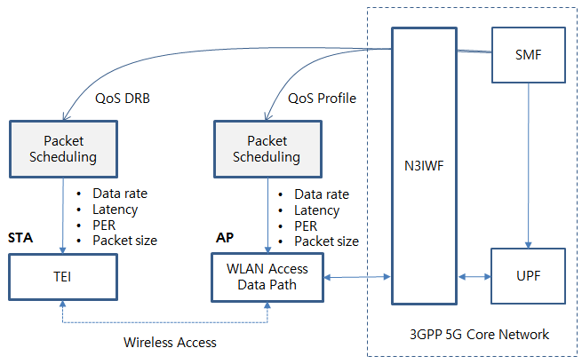
Figure 13. QoS mapping and scheduling example of WLAN

  - Technical Recommendations

WLAN supports high data rate to meet the performance of 5G network vision in the low mobility scenario and it is integrated as one of access networks for 3GPP 5G network. Therefore, 802.11 should consider adding new functional entities and signaling procedures to support interworking with the 3GPP 5G network. The following 802.11 services and facilities should be enhanced:
- Active scanning facility
- Association
- Authentication
- QoS facility

The key considerations on WLAN to interwork 5G core network as follows;

- Radio scanning and association process is well specified in WLAN 802.11 and is capable of supporting WLAN interworking with the 5G core network.

- IKEv2, EAP-5G and IPsec protocol for registration and authentication support should be added in the TEC of the STA and ANC of WLAN access network.

- NAS signaling to connect AMF should be added in the TEC of the STA and ANC of the WLAN access network.

- Packet session initiation/modification/termination to connect SMF should be added in TEC of the STA and ANC of WLAN access network.

- Packet data QoS management of WLAN shall specify QoS identification, profile and DRB to guarantee packet delay and PER for the required service types.
  - QoS mapping to WLAN is necessary to support more granularity of QoS ID and parameters
  - Packet scheduling in the STA and AP should meet data rate, latency and PER
  - Timing scheduling and the introduction of a Hybrid ARQ scheme are very important
  - 802.11ax, as implemented, cannot support 3GPP service QoS, and improved version (11be EHT, 11bd NGV) should consider MAC enhancement to support the service requirements.

The WLAN interworking model and terminal types will give an impact on interworking system design and implementation. For example, the terminal STA type should support both data and control functions to interwork with 5G core network. The terminal UE will support all the control functions to interwork with 5G core network and WLAN access function of UE can be used for radio data forwarding.

  - TSN topics

3GPP 5G System can be integrated with the external TSN as a TSN bridge. The TSN bridge includes TSN Translator functionality for interoperation between TSN System and 5G System both for user plane and control plane. 5G system TSN translator functionality consists of Device-side TSN translator (DS-TT) and Network-side TSN translator (NW-TT). 5G system specific procedures in a 5G core network and RAN, wireless communication links, etc. remain hidden from the TSN network [8]

As for TSN applications such as smart factory and automation field, TSN bridges can be configured in three different types. The first type is to use 5G system as a TSN bridge in Figure 14. 3GPP domain needs to consider the timing synchronization and TSN translator (TT) function in UE and 5G CN. The second type is to use WLAN and 5G CN interworking as a TSN bridge in Figure 15. The third type is to use WLAN only as a TSN bridge in Figure 16.

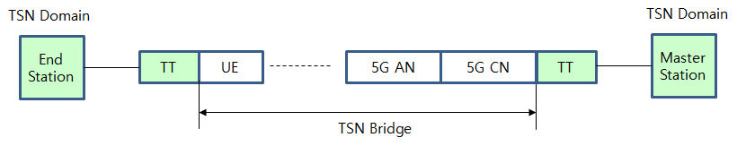
Figure 14. TSN Bridge using 5G AN and CN
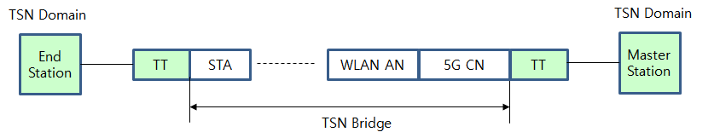

Figure 15. TSN Bridge using WLAN and 5G CN interworking
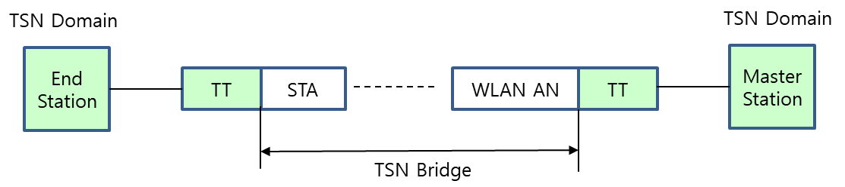

Figure 16. TSN Bridge using WLAN only

