IEEE P802.11
Wireless LANs
Proposed Spec Text
Multi-link Channel Access: General-STR
Date: 2020-09-01
Author(s):
Name | Affiliation | Address | Phone | email
Insun Jang | LG Electronics | 19, Yangjae-daero 11gil, Seocho-gu, Seoul 137-130, Korea |  | Insun.jang@lge.com
Namyeong Kim |  |  |  | namyeong.kim@lge.com
Jeongki Kim |  |  |  | jeongki.kim@lge.com

Abstract
This submission proposes spec text for multi-lijnk channel access: General-STR to be incorporated into 801.11be D0.1

Revisions:
- Rev 0: Initial version of the document.
- Rev 1: Divided into two subcluases and Updated texts based on comments by some members
- Rev 2: Updated texts based on comments by some members
- Rev 3: Added the definition of STR link set and Updated texts based on comments by some members
- Rev 4: Changed STR link set to a pair of links and then updated the corresponding texts.
- Rev 5: Clarified the texts regarding the example and Added a text meaning that the receiver is also an MLD capable of STR over a pair of links.

The texts are based on the following motion
802.11be shall allow the following asynchronous multi-link channel access:
- Each of STAs belonging to a MLD performs a channel access over their links independently in order to transmit frames.
- Downlink and uplink frames can be transmitted simultaneously over the multiple links.
[Motion 20, [5] and [144]]

Editing instructions formatted like this are intended to be copied into the TGbe Draft (i.e. they are instructions to the 802.11 editor on how to merge the text with the baseline documents).

TGbe Editor: Editing instructions preceded by “TGbe Editor” are instructions to the TGbe editor to modify existing material in the TGbe draft. As a result of adopting the changes, the TGbe editor will execute the instructions rather than copy them to the TGbe Draft.

TGbe editor: Add new subclauses 33.x.y.1 (General), 33.x.y.2 (Simultaneous transmission and reception (STR)) under clause 33 as follows:
33. Extreme High Throughput (EHT) MAC specification
33.x. Multi-link operation
33.x.y. Multi-link channel access
33.x.y.1. General
[Motion 20]
An STA, which is affiliated with an MLD, is allowed to contend for the WM on its link independently from the other STA(s) affiliated with the same MLD, unless explicitly stated otherwise in the subclause below.
33.x.y.2. Simultaneous transmission and reception (STR)
[Motion 20]
An STA that is affiliated with an MLD capable of simultaneous transmission and reception (STR) over a pair of links and that is operating on a link in that pair of links may contend for access to WM or transmit a frame to another MLD capable of STR over that pair of links on that link regardless of any activity occurring on the other link within that pair of links.
An MLD shall announce whether the MLD is capable of STR over a pair of links as defined in 33.x.y.a (Capability signaling)
Figure 33-x shows an example of an AP MLD and a non-AP MLD that are operating as STR over a pair of links and that are contenting for access to the WM and subsequent frame exchanges between two MLDs on those links. After the AP MLD has set up link 1 and link 2 with the non-AP MLD, then AP 2 may receive data frames from STA 2 on link 2, while AP 1 contends for the WM and then transmits data frames to STA 1 on link 1.

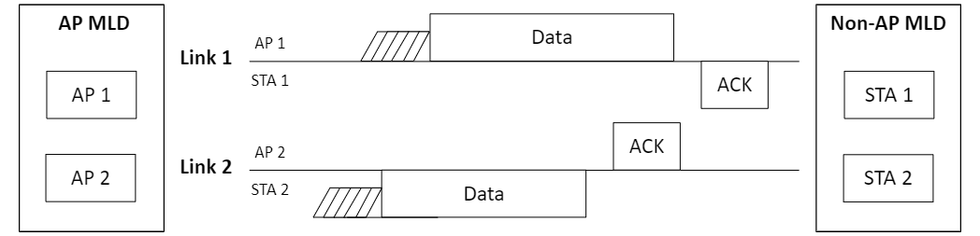
Figure 33-x. Channel access of two MLDs operating as STR over a pair of links

