IEEE P802.11
Wireless LANs
Proposed Spec Text
Multi-link Channel Access: General-STR
Date: 2020-09-01
Author(s):
Name | Affiliation | Address | Phone | email
Insun Jang | LG Electronics | 19, Yangjae-daero 11gil, Seocho-gu, Seoul 137-130, Korea |  | Insun.jang@lge.com
Namyeong Kim |  |  |  | namyeong.kim@lge.com
Jeongki Kim |  |  |  | jeongki.kim@lge.com

Abstract
This submission proposes spec text for multi-lijnk channel access: General-STR to be incorporated into 801.11be D0.1

Revisions:
- Rev 0: Initial version of the document.
- Rev 1: Divided into two subcluases and Updated texts based on comments by some members
- Rev 2: Updated texts based on comments by some members
- Rev 3: Added the definition of STR link set and Updated texts based on comments by some members

The texts are based on the following motion
802.11be shall allow the following asynchronous multi-link channel access:
- Each of STAs belonging to a MLD performs a channel access over their links independently in order to transmit frames.
- Downlink and uplink frames can be transmitted simultaneously over the multiple links.
[Motion 20, [5] and [144]]

Editing instructions formatted like this are intended to be copied into the TGbe Draft (i.e. they are instructions to the 802.11 editor on how to merge the text with the baseline documents).

TGbe Editor: Editing instructions preceded by “TGbe Editor” are instructions to the TGbe editor to modify existing material in the TGbe draft. As a result of adopting the changes, the TGbe editor will execute the instructions rather than copy them to the TGbe Draft.

TGbe editor: Add a new definition in an appropriate location within subclause 3.1 Definitions, as follows:
3.1 Definitions
Simultaneous transmit and receive (STR) link set: A set of links of a multi-link device (MLD) for which the transmission of a PPDU on one of the links does not cause the inability to receive or transmit on the other link(s) in the set.

TGbe editor: Add new subclauses 33.x.y.1 (General), 33.x.y.2 (Simultaneous transmission and reception (STR)) under clause 33 as follows:

33. Extreme High Throughput (EHT) MAC specification
33.x. Multi-link operation
33.x.y. Multi-link channel access
33.x.y.1. General
An STA, which is affiliated with an MLD, is allowed to contend for the WM on its link independently from the other STA(s) affiliated with the same MLD, unless explicitly stated otherwise in the subclause below.

33.x.y.2. Simultaneous transmission and reception (STR)
An STA that is affiliated with an MLD and that is operating on a link that is a part of an STR link set may contend for access to WM or transmit a frame on that link regardless of any activity occurring on any other link within that STR link set.
NOTE - An MLD announces zero or more STR link set as defined in 33.x.y.a (Capability signaling)

Figure 33-x shows an example of an AP MLD and a non-AP MLD contenting for access to the WM on two links as an STR link set for the AP MLD and the non-AP MLD and subsequent frame exchanges between two MLDs on that links. After the AP MLD has set up link 1 and link 2 with the non-AP MLD, then AP 2 may receive data frames from STA 2 on link 2, while AP 1 contends for the WM and then transmits data frames to STA 1 on link 1.

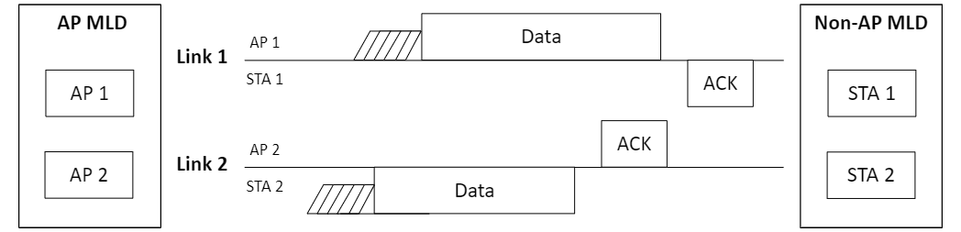
Figure 33-x. Channel access of STR MLD

