IEEE P802.11
Wireless LANs
Proposed Spec Text
Multi-link Channel Access: General-STR
Date: 2020-09-01
Author(s):
Name | Affiliation | Address | Phone | email
Insun Jang | LG Electronics | 19, Yangjae-daero 11gil, Seocho-gu, Seoul 137-130, Korea |  | Insun.jang@lge.com
Namyeong Kim |  |  |  | namyeong.kim@lge.com
Jeongki Kim |  |  |  | jeongki.kim@lge.com

Abstract
This submission proposes spec text for multi-lijnk channel access: General-STR to be incorporated into 801.11be D0.1

Revisions:
- Rev 0: Initial version of the document.
- Rev 1: Divided into two subcluases and Updated texts based on comments by some members
- Rev 2: Updated texts based on comments by some members

The texts are based on the following motion
802.11be shall allow the following asynchronous multi-link channel access:
- Each of STAs belonging to a MLD performs a channel access over their links independently in order to transmit frames.
- Downlink and uplink frames can be transmitted simultaneously over the multiple links.
[Motion 20, [5] and [144]]

Editing instructions formatted like this are intended to be copied into the TGbe Draft (i.e. they are instructions to the 802.11 editor on how to merge the text with the baseline documents).

TGbe Editor: Editing instructions preceded by “TGbe Editor” are instructions to the TGbe editor to modify existing material in the TGbe draft. As a result of adopting the changes, the TGbe editor will execute the instructions rather than copy them to the TGbe Draft.

TGbe editor: Add new a subclause 33.x.y.1 (General), 33.x.y.2 (Simultaneous transmission and reception (STR)) under clause 33 as follows:

33. Extreme High Throughput (EHT) MAC specification
33.x. Multi-link operation
33.x.y. Multi-link channel access
33.x.y.1. General
Multi-link channel access allows STAs that are affiliated with an MLD to contend for the WM on their respective links independently, unless explicitly stated in the subclause below.
33.x.y.2. Simultaneous transmission and reception (STR)
An STA that is affiliated with an MLD, which is capable of supporting simultaneous transmission and reception (STR) over a set of links, may contend for WM or transmit a frame on its link at the same time that another STA that is affiliated with the same MLD is receiving a frame on its link.
An STA that is affiliated with an MLD, which is not capable of supporting STR over a set of links shall follow the rules defined in 33.x.y.3 (General: Non-STR). When an STA that is affiliated with an MLD which is capable of supporting STR transmits a frame to another MLD not capable of supporting STR over the set of links, the STA shall follow the rules defined in 33.x.y.5. (PPDU ending time alignment).

Figure 33-x shows an example of contention for gaining access to WM and subsequent frame exchanges between two STR MLDs on two links. After an STR AP MLD has set up link 1 and link 2 with an STR non-AP MLD, then AP 2 may receive data frames from STA on link 2, while AP 1 contends for the WM and then transmits data frames to STA 1 on lin receives a data frame from STA 2 on link 2, AP 1 can transmit a data frame to STA 1 on link 1.

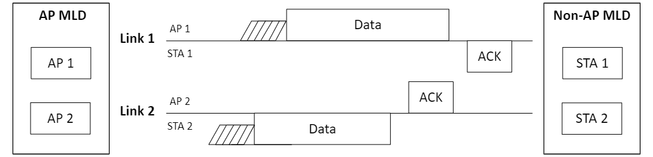
Figure 33-x. Channel access of STR MLD

