IEEE P802.11
Wireless LANs
Proposed Spec Text
Multi-link Channel Access: General-STR
Date: 2020-09-01
Author(s):
Name | Affiliation | Address | Phone | email
Insun Jang | LG Electronics | 19, Yangjae-daero 11gil, Seocho-gu, Seoul 137-130, Korea |  | Insun.jang@lge.com
Namyeong Kim |  |  |  | namyeong.kim@lge.com
Jeongki Kim |  |  |  | jeongki.kim@lge.com

Abstract
This submission proposes spec text for multi-lijnk channel access: General-STR to be incorporated into 801.11be D0.1

Revisions:
- Rev 0: Initial version of the document.

The texts are based on the following motion
802.11be shall allow the following asynchronous multi-link channel access:
- Each of STAs belonging to a MLD performs a channel access over their links independently in order to transmit frames.
- Downlink and uplink frames can be transmitted simultaneously over the multiple links.
[Motion 20, [5] and [144]]

Editing instructions formatted like this are intended to be copied into the TGbe Draft (i.e. they are instructions to the 802.11 editor on how to merge the text with the baseline documents).

TGbe Editor: Editing instructions preceded by “TGbe Editor” are instructions to the TGbe editor to modify existing material in the TGbe draft. As a result of adopting the changes, the TGbe editor will execute the instructions rather than copy them to the TGbe Draft.

TGbe editor: Add new a subclause 33.x.y.1 (General: Simultaneous transmission and reception (STR)) under clause 33 as follows:

33. Extreme High Throughput (EHT) MAC specification
33.x. Multi-link operation
33.x.y. Multi-link channel access
33.x.y.1 General: Simultaneous transmission and reception (STR)
Each of STAs belonging to a MLD capable of supporting simultaneous transmission and reception (STR) over their links shall perform a medium access over their links independently. While an STA of the MLD receives a frame, another STA of the MLD can transmit a frame simultaneously.
If an STA of the MLD knows that a receiving frame is intended to itself on a link and is from another MLD not capbable of supporting STR over a set of links including the link (see 33.x.y.2. General: Non-STR), the MLD should not transmit a frame on another link in the set of links because of an interference signal caused by the transmission of the MLD.
Figure 33-x shows a channel access example of STR MLD. When an STR AP MLD setups link 1 and link 2 with an STR non-AP MLD, while AP 2 receives a data frame from STA 2, AP 1 can transmit a data frame to STA 1.

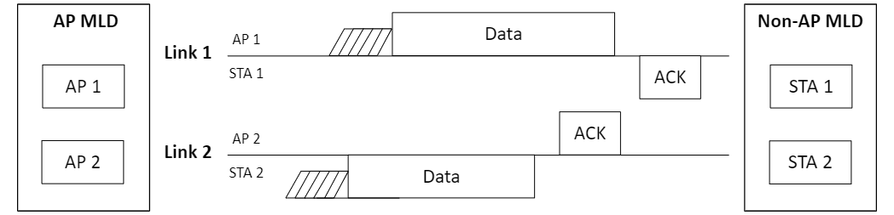
Figure 33-x. Channel access of STR MLD

