IEEE P802.11
Wireless LANs

Proposed Draft Text for
MLO Multi-Link Channel Access: PPDU Ending Time Alignment
Date: 2020-08-26
Author(s):
Name | Affiliation | Address | Phone | email
Yongho Seok | MediaTek Inc. | 2840 Junction Ave, San Jose, CA 95134 |  | yongho.seok@mediatek.com

Abstract

This submission proposes draft text for MLO Multi-Link Channel Access: End PPDU Alignment based on the following portions of the SFD:

Revisions:
- Rev 0: Initial version of the document.
- Rev 1: Updated based on the comment from Laurent, Dmitry, Tomo and Yunbo.

- 802.11be supports the following PPDU transmission restriction for the constrained multi-link operation:
- If an AP MLD intends to align the ending time of DL PPDUs carrying a frame soliciting an immediate response simultaneously sent to the same non-STR non-AP MLD on multiple links, the AP MLD shall ensure that the difference between the ending times of transmitting DL PPDUs is less than or equal to 8 μs ((aSIFSTime + aSignalExtension)/2).
  - Where the reference of the ending time of the PPDU is not including the Signal Extension field.
[Motion 111, #SP0611-31, [15] and [169]]
[Motion 122, #SP152, [8] and [170]]

- 802.11be supports the following Trigger frame transmission rule in the MLO:
- An AP in the AP MLD shall not send a Trigger frame with the CS Required subfield set to 1 to a STA in a non-STR non-AP MLD, when at least one PPDU from other STAs affiliated to the same non-STR non-AP MLD is scheduled for transmission before (aSIFSTime + aSignalExtention – aRxTxTurnaroundTime) has expired after the PPDU containing the Trigger frame.
  - Note– In the above, aRxTxTurnaroundTime is 4 μs.
  - Note– The ending time of a first PPDU that carrying a frame soliciting an immediate response frame cannot be earlier more than aRxTxTurnaroundTime of the ending time of a second PPDU containing a Trigger frame with the CS Required subfield set to 1.
  - Note– The AP STA still follows the CS Required rule defined in 802.11ax.
[Motion 122, #SP153, [8] and [171]]

- 802.11be supports the following Trigger frame transmission rule in the MLO in R1:
- When an AP MLD triggers simultaneously TB PPDUs from more than one STAs affiliated to the same non-STR non-AP MLD and allows the frames in the TB PPDUs to solicit control response frames from the AP MLD, then the UL Length subfield values in the soliciting Trigger frames shall be set to the same value.
[Motion 122, #SP154, [8] and [171]]

- An AP MLD shall align the end of DL PPDUs (that contain QoS data soliciting an immediate UL response) that are sent simultaneously on multiple links to the same non-STR non-AP MLD, in such a way that the response to any of the PPDUs will not overlap with any of the DL PPDUs in R1.
An exception is that a high priority DL PPDU sent on one link may not be aligned with another DL PPDU sent on the other link.
[Motion 122, #SP159, [8] and [172]]

- 802.11be supports that the padding procedures of 802.11ax can be used when transmitting a Trigger frame to extend the frame length to meet the ending time requirement of the PPDU carrying the Trigger frame in the MLO.
- NOTE- The Padding field in the Trigger frame is also included in the padding procedure.
[Motion 122, #SP168, [8] and [173]]

Editing instructions formatted like this are intended to be copied into the TGbe Draft (i.e. they are instructions to the 802.11 editor on how to merge the text with the baseline documents).

TGbe Editor: Editing instructions preceded by “TGbe Editor” are instructions to the TGbe editor to modify existing material in the TGbe draft. As a result of adopting the changes, the TGbe editor will execute the instructions rather than copy them to the TGbe Draft.
Insert new Clause 33 following Clause 32 as follows:
33. Extremely High Throughput (EHT) MAC specification
33.x Multi-link channel access
33.x.y1 PPDU ending time alignment
In this subclause “simultaneously transmit” means more than one PPDUs are transmitted on different links and those transmissions are overlapped in time during a period of time. Likewise “simultaneously trigger” means more than one PPDUs are triggered on different links and those transmissions are overlapped in time during a period of time. If a non-STR MLD that is receiving a PPDU on a first link simultanenously transmits another PPDU on a second link, the non-STR MLD might fail to receive the PPDU on the first link because of an interference signal caused by the transmission on the second link. To help reduce the chances of the occurance of such self-interference among STAs affiliated to the same non-STR MLDs, this subclause specifies a mechanism to align the ending time of DL PPDUs that simultaneously transmitted to the same non-STR non-AP MLD.

When an AP MLD simultaneously transmits more than one DL PPDUs on different links to the same non-STR non-AP MLD and at least one of DL PPDUs carries a frame soliciting an immediate UL response from the non-STR non-AP MLD, it shall align the ending time of transmitting DL PPDUs except when one of the DL PPDUs carries a high priority frame that meets TBD conditions, subject to the rules defined in this subclause. The DL PPDU carrying a high priority frame may not be aligned with another DL PPDU sent simultaneously on the other link.

NOTE1- In such a way that the response PPDU to any of the DL PPDUs will not overlap with any of the DL PPDUs.

When an AP MLD is required to align the ending time of simultaneously transmitting DL PPDUs on different links, it shall satisfy the following conditions:
- The AP MLD shall ensure that the difference between the ending times of transmitting DL PPDUs is less than or equal to 8 μs (see NOTE2), where the ending time of the PPDU is the end of the last OFDM symbol.
- The AP MLD shall ensure that the ending time of one or more DL PPDUs that carry a frame soliciting an immediate response frame cannot be earlier more than 4 μs (see NOTE3) of the ending time of any of DL PPDUs containing a Trigger frame with the CS Required subfield set to 1.

NOTE2- The difference between the ending times of transmitting DL PPDUs needs to be less than SIFS – timing margin (≤16 μs). To balance an implementation complexity at a transmitter side and a receiver side, the timing margin is set to a half of 16 μs. So 8 μs is derived from SIFS – 8 μs.
NOTE3- 4 μs is aRxTxTurnaroundTime.

An AP may use any type of padding to align the ending time of transmitting DL PPDU, such as using the Padding field in a Trigger frame, post-EOF A-MPDU padding, aggregating other MPDUs in the A-MPDU, or a packet extension.

When an AP MLD simultaneously solicits one or more TB PPDUs on different links from the same non-STR non-AP MLD, each AP affiliated to the AP MLD that transmits a Trigger frame or frame carrying a TRS Control field shall independently set the Trigger frame fields and TRS Control subfield following the rules defined in 26.5.2.2.4 (Allowed settings of the Trigger frame fields and TRS Control subfield) with the following exceptions:
- An AP affiliated to the AP MLD that transmits a Trigger frame to a STA in a non-STR non-AP MLD shall not set the CS Required subfield in the Trigger frame to 1, when at least one PPDU from other STAs affiliated to the same non-STR non-AP MLD is scheduled for transmission before 12 μs (see NOTE4) has expired after the PPDU containing the Trigger frame.
- When the AP MLD allows the frames in the TB PPDUs to solicit control response frames from the AP MLD, then the UL Length subfield values in the soliciting Trigger frames shall be set to the same value.

NOTE4- 12 μs is derived from aSIFSTime + aSignalExtention – aRxTxTurnaroundTime, where aRxTxTurnaroundTime is 4 μs.

An example showing the relationship between the ending times of DL PPDUs sent over link 1, link 2, and link 3 between an AP MLD and a STA MLD is shown in Figure 33-xy (PPDU ending time alignment timing relationships). An AP in the AP MLD operating on link 1 solicits a TB PPDU requiring the carrier sense from a STA in the STA MLD. In such case the difference between the ending time of the soliciting PPDU and the starting time of the first solicited PPDU (in the figure, ACK on link 2) that is sent from any STA in the same STA MLD immediately after the soliciting DL PPDU is greater than or equal to 12 μs. Accordingly, the ending time of PPDU sent on link 2 cannot be earlier more than 4 μs of the ending time of the soliciting PPDU sent on link 1. To avoid overlapping in time between any of the DL PPDUs and the response PPDU to any of the DL PPDUs, the difference between the ending times of the DL PPDUs on link 2 and link 3 cannot be greater than 8 μs.

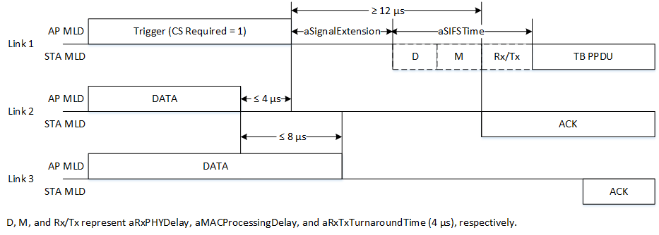Figure 33-xy—PPDU ending time alignment timing relationships
9.3.1.22 Trigger frame format
9.3.1.22.1 General
Change the last paragraph as follows:
The Padding field is optionally present in a Trigger frame to extend the frame length for the following purposes:
- Toto give the recipient STAs enough time to prepare a response for transmission a SIFS after the frame is received.
- To align the ending time of simultaneously transmitting PPDU as described in 33.x.y1 (PPDU ending time alignment).
The Padding field, if present, is at least two octets in length and is set to all 1s. If the Padding field is present in a Trigger frame, its length is computed as described in 26.5.2.2.3 (Padding for Trigger frame or frame containing TRS Control subfield).

Straw Poll: Do you support to incorporate the proposed draft text in this document 11-20/1271r0 to the TGbe Draft 0.1?
Result: Yes/No/Abstain

