IEEE P802.11
Wireless LANs
Proposed Resolution for CID 24102
5.9 GHz (5.850-5.895 GHz) for Unlicensed Use
Date: 2020-08-20
Author(s):
Name | Company | Address | Phone | email
Lili Hervieu | CableLabs |  |  | l.hervieu@cablelabs.com
Dorin Viorel | CableLabs |  |  | d.viorel@cablelabs.com
Roy Sun | CableLabs |  |  | r.sun@cablelabs.com
Thomas Derham | Broadcom |  |  | thomas.derham@broadcom.com
Carol Ansley | Self |  |  | carol@ansley.com
Hedayat, Reza | Charter |  |  | reza.Hedayat@charter.com
Payam Torab | Facebook |  |  | torab@ieee.org
Chunyu Hu | Facebook |  |  | chunyuhu@fb.com

Abstract

On December 12th, 2019, the FCC adopted a Notice of Proposed Rulemaking proposing the lower 45 megahertz of the 5.9 GHz band for unlicensed uses (not under DFS rules). This contribution proposes the addition of the corresponding channels to the channels listing in Annex E - Table E-4 - Global operating classes

Revision Notes

R0 | Initial revision – CID 24102

CID | P.L | Clause | Comment | Proposed Change | Resolution
4108 |  |  | On December 12th 2019, the FCC issued a Notice of Proposed Rulemaking proposing the lower 45 megahertz of the 5.9 GHz band for unlicensed uses (not under DFS rules). | The Annex E Table E-1 and Table E-4 shall be updated to take into account the additional 169, 173, and 177 channels, providing 2 additional 40 MHz channels, 1 additional 80 MHz channel and 1 additional 160 MHz channels. | Revised-  Update Table E-4 with new channels corresponding to the 5.9 GHz unlicensed spectrum (US)  Instructions to the editor, please make the changes shown in doc 11-20/1249r0  under all headings that include CID 24102.

Discussion:

On December 12th, 2019, the FCC adopted a Notice of Proposed Rulemaking [1] proposing the lower 45 megahertz of the 5.9 GHz band (5.850-5.895 GHz) for unlicensed uses (not under DFS rules). This additional 45 MHz spectrum, depicted below in the proposed U-NII-4 band, accommodates an additional three 20 MHz channels, two 40 MHz channels, one 80 MHz channel, and one 160 MHz channel.

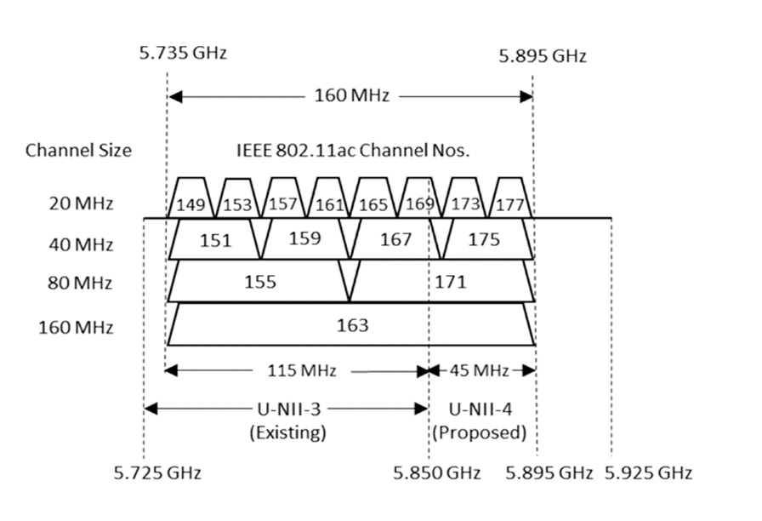

The NPRM also proposes that U-NII-4 devices be subject to similar technical and operational rules that apply to the U-NII-3 band and that U-NII-4 devices be permitted to operate at the same power levels as U-NII-3 devices.

From FCC DOC-364138A1: 5.9 GHz BAND BOOSTS CONSUMER INTERNET ACCESS DURING COVID-19 PANDEMIC
WASHINGTON, May 4, 2020—The Federal Communications Commission announced today that its decision to grant wireless Internet service providers (WISPs) temporary access to 5.9 GHz spectrum is helping them keep Americans connected during the coronavirus pandemic. In late March, the FCC’s Wireless Telecommunications Bureau began granting temporary access, called Special Temporary Authority (STA), to 5.9 GHz spectrum for WISPs serving largely rural and suburban communities. The STAs allow WISPs to use the lower 45 megahertz of the band to help serve their customers. To date, the FCC has granted STAs to more than 100 WISPs, and many of those providers have reported that the spectrum is helping to address the increased demand for broadband associated with the COVID-19 pandemic.

From Communications Daily, July 17: Comm Daily® Notebook 5.9 GHz FCC Item Expected This Year
The agency will act on an order changing the allocation of the 5.9 GHz band “certainly by the end of the year,” Chairman Ajit Pai answered our query in speaking with the media. Commissioner Mike O’Rielly said he’s not sure why an order isn’t on the Aug. 6 agenda. “I don’t think we’re that far away,” he said in response to our question: “A month or two here or there doesn’t cause me that much concern.” The FCC is expected to reallocate the band in coming months, with 45 MHz set aside for unlicensed use (see 2004300032). “I’m very excited about the potential for the 5.9 GHz band,” though he hasn’t reached a decision yet, Commissioner Brendan Carr said. “We kind of let 5.9 sit out there for a long time,” he said: “I’m glad that it’s on the table and that we’re working on it.”

Proposed changes for CID24102:

Instructions to the editor
Please make the changes to Annex E p771 as shown below in red:

Update row appropriately in Table E-4 as shown in red below

Annex E – Table E-4 - Global operating classes Operating classes

Operating class | Nonglobal operating class(es) | Channel starting frequency (GHz) | Channel spacing (MHz) | Channel set | Channel center frequency index | Behavior limits set
125 | E-1-5,  E-2-17,  E-5-3 | 5 | 20 | 149, 153, 157, 161, 165, 169, 173, 177 | — | LicenseExemptBehavior, UseEirpForVHTTxPowEnv
126 | E-1-25,26,  E-5-6 | 5 | 40 | 149, 157, 165, 173 | — | PrimaryChannelLowerBehavior, UseEirpForVHTTxPowEnv
127 | E-1-30,31 | 5 | 40 | 153, 161, 169, 177 | — | PrimaryChannelUpperBehavior, UseEirpForVHTTxPowEnv
128 | E-1-128,  E-2-128,  E-3-128  E-5-128 | 5 | 80 | — | 42, 58, 106, 122, 138, 155, 171 | UseEirpForVHTTxPowEnv
129 | E-1-129,  E-2-129,  E-3-129  E-5-129 | 5 | 160 | — | 50, 114, 163 | UseEirpForVHTTxPowEnv
130 | E-1-130,  E-2-130,  E-3-130  E-5-130 | 5 | 80 | — | 42, 58, 106, 122, 138, 155, 171 | 80+,  UseEirpForVHTTxPowEnv

Reference:
[1] https://mentor.ieee.org/802.18/dcn/19/18-19-0163-00-0000-fcc19-138-nprm-revisiting-use-of-the-5-850-5-925-ghz-band.docx

