IEEE P802.11
Wireless LANs
D6.0 Misc CR
Date: 2020-08-18
Author(s):
Name | Affiliation | Address | Phone | email
Robert Stacey | Intel |  |  | robert.stacey@intel.com
Abstract
Proposed resolutions for 24002, 24033, 24526, 24527, 24302, 24541, 24374, 24540, 24418, 24417, 24429, 24425, 24426, 24083, 24566, 24567, 24408, 24404

Revision History
R0 – initial version
R1 – highlighted resolutions discussed on 13 August telecon. Green = general agreement/no comments. Yellow = changes discussed. Additional resolutions developed.
R2 – incorporated Mark Rison’s comments (emailed privately) with some responses. Addition work on “work in progress” section.
R3 – After August 18 telecon. Marked resolutions without further discussion in green. Comments reviewed with more discussion needed in yellow.

CID 24002
comments
 | CID | Page | Clause |  | Comment | Proposed Change
 | 24002 | 773.28 | G.1 |  | The attribute "mu-user-not-respond" should be consistent with the 11ax text change to Section G.4 that adds "HE MU PPDU" | modify the Description field of the attribute "mu-user-not-respond" by changing the text "is part of a VHT MU PPDU" to "is part of a VHT MU PPDU or HE MU PPDU"

Context
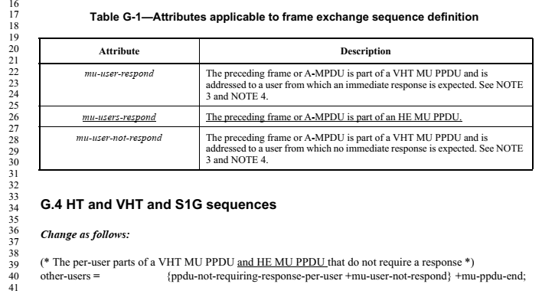

Proposed Resolution
REVISED
Agree in principle. Change the Description for mu-user-not-respond in Table G-1 to read:
“The preceding frame or A-MPDU is part of a VHT MU PPDU or HE MU PPDU and is addressed to a user from which no immediate response is expected. See NOTE 3 and NOTE 4.”

CID 24033
comments
 | CID | Page | Clause |  | Comment | Proposed Change
 | 24033 | 38.39 | 3.2 |  | There are references to "6 GHz STA" in the mainbody of the draft specification. However, 6 GHz STA is not defined in the subclause 3. | Please define 6 GHz STA in either subclause 3.1 or 3.2. Alternatively, replace 6 GHz STA and 6 GHz AP with something else.

Discussion
The comment points out that the term 6 GHz STA is used in the main body of the spec, but that the term has not been defined. This was true in D6.0, but the resolution to #24254 adds such a definition (42.53 in D6.1):

Proposed Resolution
REVISED
Agree in principle. TGax editor to add the definition for a 6 GHz STA from 11-20/0450r4 (https://mentor.ieee.org/802.11/dcn/20/11-20-0450-04-00ax-mac-cr-miscellaneous-cids-in-subclause-26dot17.docx).

Note to TGax editor: this change has been made with the resolution to #24254

CID 24526
comments
 | CID | Page | Clause |  | Comment | Proposed Change
 | 24526 | 458.13 | 26.17.2.2 |  | The use of "HE AP 6G" occurs only here and is undefined. | Replace with the more commonly used "6 GHz HE AP".

On page 458 in D6.0:
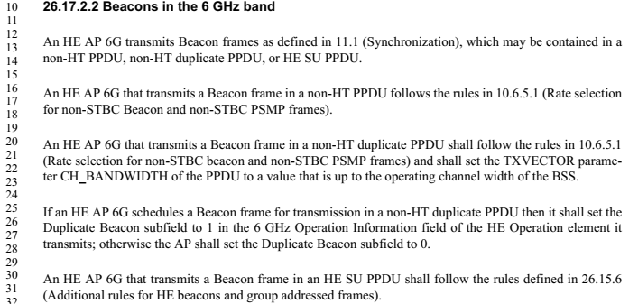

Since fixed with #24254 in D6.1:
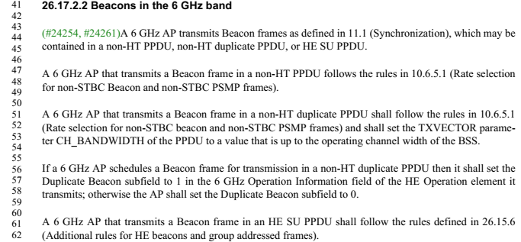

Proposed Resolution
REVISED
For the reasons suggested, replace all occurences of “HE AP 6G” in 26.17.2.2 with “6 GHz AP”.

Note to editor: This change is also made with the resolution to #24254.

CID 24527
comments
 | CID | Page | Clause |  | Comment | Proposed Change
 | 24527 | 456.35 | 26.17.2.1 |  | The labels "6 GHz HE AP", "6 GHz HE STA", "6 GHz AP", "6 GHz non-AP HE STA" and other variants are awkward typographically since they start with a single numeral. | Throughout the document, modify such labels by shortening "6 GHz" to "6GHz" and moving the "6 GHz" to before the last word. For example, replace "6 GHz STA" with "6GHz STA" and "6 GHz HE AP" with "HE 6GHz AP".

Proposed Resolution
REJECTED
Most readers would see “6 GHz” as a term and not as six of something called GHz. Also, the typographic suggestion (contracting 6 GHz to 6GHz) is unnecessary and inconsistent with naming elsewhere in the standard and this amendment (e.g., the “20 MHz In 160/80+80 MHz HE PPDU field in the HE Capabilities element). 802.11 style uses a space between numbers and their unit, whether they are part of a name or not (although in the superscript and subscript of some varaibles we have remove the space, e.g., N_{20MHz}).

CID 24302
comments
 | CID | Page | Clause |  | Comment | Proposed Change
 | 24302 |  | 9 |  | "The Rx HE-MCS Map <= 80 MHz subfield is  always present in the Supported HE-MCS And  NSS Set field." and "The Tx HE-MCS Map <= 80 MHz subfield is  always present in the Supported HE-MCS And  NSS Set field." in Table 9-321c--Subfields of the Supported HE-MCS And NSS Set field duplicate Figure 9-787d--Supported HE-MCS And NSS Set field format. "The HE MIMO Control field is always present in the frame. " in 9.6.31.2 HE Compressed Beamforming/CQI frame format duplicates Table 9-526b--HE Compressed Beamforming/CQI frame Action field format. "The TIM element and OPS element are always present in the frame." in 9.6.31.4 OPS frame format duplicates Table 9-526d--OPS frame Action field format. "A BSS Color Change Announcement element is always present in the frame." in 9.6.32.2 HE BSS Color Change Announcement frame format duplicates Table 9-526f--HE BSS Color Change Announcement frame Action field format. | Delete the cited texts

Proposed Resolution
REVISED.
Change the title of 9.6.1 from Introduction to General.

Add the following sentence as the last paragraph of 9.6.1: “In the Action field formats defined in 9.6, the fields and elements listed are always present unless stated otherwise.”

Delete the sentences “The Rx HE-MCS Map ≤ 80 MHz subfield is always present in the Supported HE-MCS And NSS Set field.” and “The Tx HE-MCS Map ≤ 80 MHz subfield is always present in the Supported HE-MCS And NSS Set field.” in Table 9-321c.

Delete the sentence “The HE MIMO Control field is always present in the frame” at 228.37

Delete the sentence “The TIM element and OPS element are always present in the frame” at 229.40

Delete the sentence “A BSS Color Change Announcement element is always present in the frame” at 230.29

In REVmd D3.4, delete the sentence “The VHT MIMO Control field is always present in the frame” at 1663.32.

CID24541
comments
 | CID | Page | Clause |  | Comment | Proposed Change
 | 24541 | 42.42 | 3.2 |  | REVmd has deleted the term "user". It seems unnecessary (and causes conflicts in the text with other uses, beyond SU/MU). | Delete the definition "replacement" for the term "user"

Context
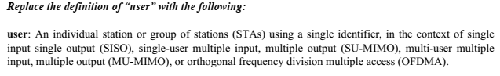

Proposed Resolution
ACCEPTED

CID 24374
comments
 | CID | Page | Clause |  | Comment | Proposed Change
 | 24374 |  | 10.6.12 |  | [Resubmission of comment withdrawn on D5.0] An HE STA in 2G4 should not be allowed to send a frame with a bw-signalling TA in a DSSS/CCK PPDU (in the baseline this is disallowed because only VHT STAs can send BSTAs but VHT STAs do not operate in the 2G4 band), since DSSS/CCK PPDUs do not carry signalling in the scrambler init | Insert as the third sentence of 10.6.12 Channel Width in non-HT and non-HT duplicate PPDUs in the baseline the sentence "The TA field shall not be set to a bandwidth signaling TA in a frame carried in a DSSS/CCK PPDU."

Proposed Resolution
ACCEPTED

CID 24540
comments
 | CID | Page | Clause |  | Comment | Proposed Change
 | 24540 | 764.38 | C.3 |  | Error in baseline text. REVmd has dot11SMTbase15 (not dot11SMTbase13) in this location. | Change the struck-through text to "dot11SMTbase15". Also dot11MACbase and dot11CountersGroup have also incremented in REVmd, beyond those shown here. Probably need to scrub the whole MIB for accuracy of quoted baseline text.

Discussion
In D6.0 we have:
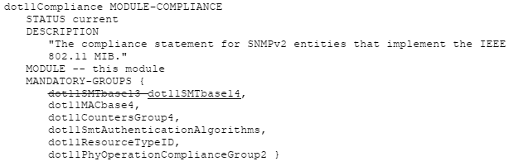
In REVmd/D3.4 we have:
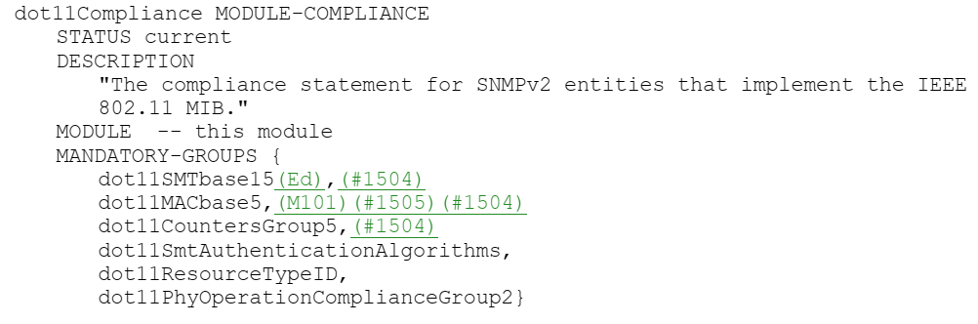
The resolution to #24539 has brought D6.0 up to date and the relavant changes are as follows:
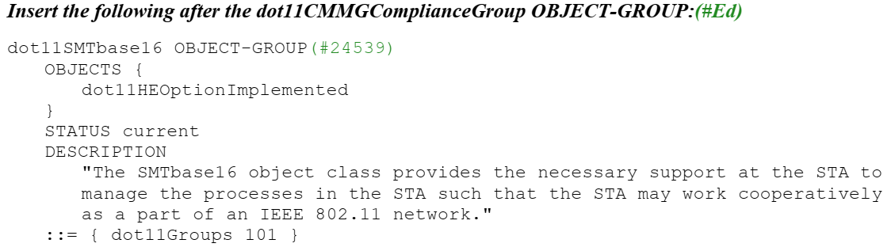
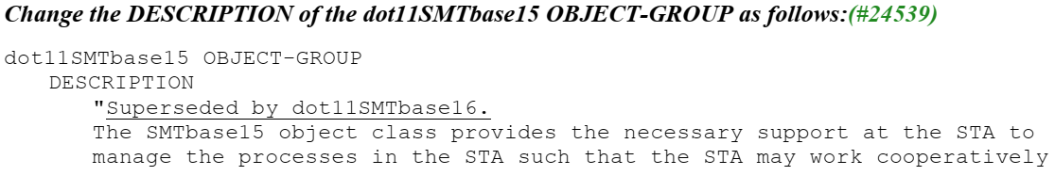
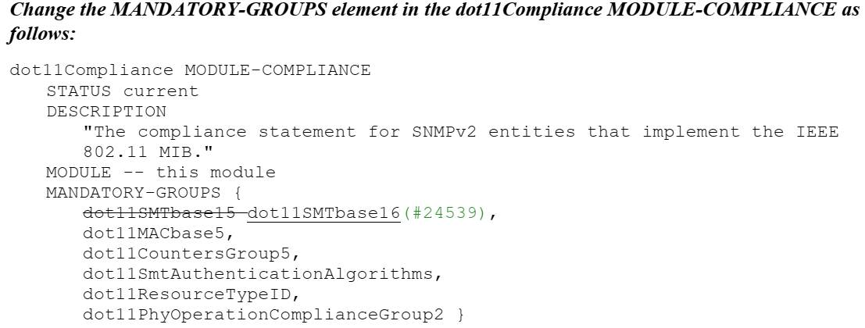

So, dot11Compliance is up to date.

Proposed Resolution
REVISED
Update the dot11Compliance object so that it correctly quotes REVmd/D3.4.

Note to editor: Changes associated with the resolution to #24539 have brought the draft up to date and no further changes are needed.

CID 24418
comments
 | CID | Page | Clause |  | Comment | Proposed Change
 | 24418 |  |  |  | [Resubmission of comment withdrawn on D5.0] Re CID 20522. It is still not sufficiently clear that it's not over the PPDU bandwidth, it's over the RU width | Make the changes proposed in CID 20522

Discussion
For reference, #20522 is included below
comments
 | CID | Page | Clause |  | Comment | Proposed Change | Resolution
 | 20522 | 111.26 | 9.3.1.22.1 |  | "The UL Target RSSI subfield of the User Info field indicates the expected receive signal power, averaged over the AP's antenna connectors, for the HE TB PPDU transmitted on the assigned RU." needs to be clearer that this is about the RSSI over the PPDU bandwidth (unlike AP Tx Power) [powerprecorr] | Change the cited text at the referenced location to "The UL Target RSSI subfield of the User Info field indicates the expected RSSI, in dBm, over the PPDU bandwidth, averaged over the AP's antenna connectors, for the HE TB PPDU transmitted on the assigned RU."At 76.26 change "The UL Target RSSI subfield indicates, in units of dBm, the expected receive power at the AP (i.e., averaged RSSI over all the AP's antennas) for the HE TB PPDU transmitted on the assigned RU." to "The UL Target RSSI subfield indicates the expected RSSI, in dBm, over the PPDU bandwidth, averaged over the AP's antenna connectors, for the HE TB PPDU transmitted on the assigned RU." and in the next sentence change "The target receive power" to "The target RSSI, TargetRSSI," | REJECTED (EDITOR: 2019-07-19 20:45:48Z) - A Trigger frame can be sent in non-HT DUP format and hence AP Tx Power normalized to 20 MHz bandwidth. On the other hand, an AP is aware of the bandwidth (corresponding to the allocated RUs) of the solicited HE TB PPDU thereby normalization to bandwidth is not relevant.  Furthermore, the HE TB PPDU bandwidth is greater than or equal to the bandwidth corresponding to the allocated RUs. Hence, an UL Target RSSI that is normalized to HE TB PPDU bandwidth changes the meaning of this subfield.

The relavant text now reads as follows (with changes from #24297):
The UL Target RSSI subfield of the User Info field indicates the expected receive signal power, measured at the AP’s antenna connector and averaged over the antennas, for the HE portion of the HE TB PPDU transmitted on the assigned RU.

The problem identified by the commenter is that the bandwidth over which the signal is measured is not sufficiently clear. However, it is not clear why the commenter feels this is important. The objective of the measurement and associated signalling is to equalize receive power from the various transmitters. This objective is not necessarily met by prescribing exactly how the measurement is to be made. The receiver receives signals from multiple transmitters. It needs to seperate the signals and identify the signal strength contributed by each transmitter. And then indicates adjustements back to the transmitters. How the receiver spearates the signals is implementation specific and includes control over RU allocation, etc., in the Trigger frame.

The UL Target RSSI subfield of the User Info field indicates
the expected receive signal power,
averaged over the AP's antenna connectors, for the HE TB PPDU transmitted on the assigned RU.
->
The UL Target RSSI subfield of the User Info field indicates
the expected RSSI, in dBm, over the PPDU bandwidth,
averaged over the AP's antenna connectors, for the HE TB PPDU transmitted on the assigned RU.

The UL Target RSSI subfield indicates
, in units of dBm, the expected receive power at the AP (i.e.,
averaged RSSI over all the AP's antennas) for the HE TB PPDU transmitted on the assigned RU.
->
The UL Target RSSI subfield indicates
the expected RSSI, in dBm, over the PPDU bandwidth,
averaged over the AP's antenna connectors, for the HE TB PPDU transmitted on the assigned RU."

and in the next sentence change "The target receive power" to "The target RSSI, TargetRSSI,"

Mark’s proposed text:
The UL Target RSSI subfield of the User Info field indicates the expected RSSI, in dBm, over the RU bandwidth, measured at the AP’s antenna connector and averaged over the antennas, for the HE portion of the HE TB PPDU transmitted on the assigned RU.
Existing text:
The UL Target RSSI subfield of the User Info field indicates the expected receive signal power, measured at the AP’s antenna connector and averaged over the antennas, for the HE portion of the HE TB PPDU transmitted on the assigned RU.
Do you prefer the existing text or Mark’s text?
Strawpoll result: 6 favor existing text, 3 favor Marks proposed text, about 9 do not care.

Proposed Resolution
REJECTED
Defining the bandwidth over which the signal strength is measured is unnecessary.

CID 24417
comments
 | CID | Page | Clause |  | Comment | Proposed Change
 | 24417 |  |  |  | [Resubmission of comment withdrawn on D5.0] Re CIDs 20521, 20522. Various editorial consistency improvements were proposed but not addressed | Make the editorial consistency improvements proposed for CIDs 20521, 20522

Discussion
The commenter is pointing to, largely non-technical, changes proposed in #20521 and #20522. Specifically, these seem to be adding the units (“in dBm”) and, in the case of #20522 aligning the Target RSSI desciptions for Trigger frame and TRS Control.

In the Trigger frame definition:
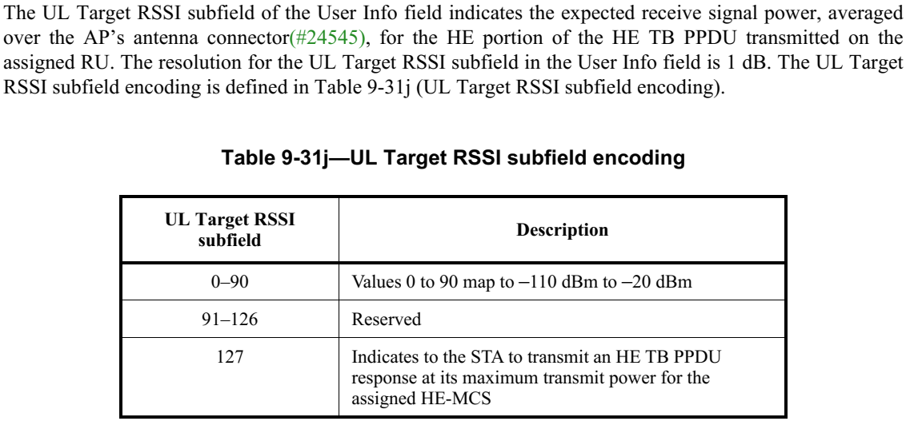
In the TRS Control frame definition:
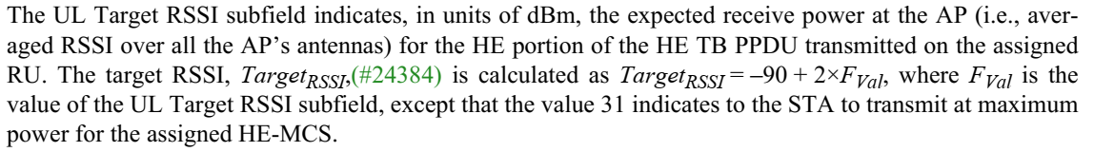

Proposed Resolution
REVISED
Add units and align the descipritions of the UL Target RSSI subfield in the Trigger frame and TRS Control field as follows:
At 126.32 (D6.0) delete the following (leaving the sentence that references the table):
“The UL Target RSSI subfield of the User Info field indicates the expected receive signal power, averaged
over the AP’s antenna connector, for the HE portion of the HE TB PPDU transmitted on the assigned RU.
The resolution for the UL Target RSSI subfield in the User Info field is 1 dB.”
In Table 9-31i replace the description for 0-90 with the following:
“Indicates the expected receive signal power, measured at the AP’s antenna connector and averaged over the antennas, for the HE portion of the HE TB PPDU transmitted on the assigned RU. The expected receive signal power, in units of dBm, is Target_RSSI = F_val – 110, where F_val is the subfield value.”
At 92.15 replace the paragraph with the following:
“The UL Target RSSI subfield is set to a value, F_val, between 0 and 30 to indicate the expected receive signal power, measured at the AP’s antenna connector and averaged over the antennas, for the HE portion of the HE TB PPDU transmitted on the assigned RU. The expected receive signal power, in units of dBm, is Target_RSSI = -90 + 2 x F_val. The UL Target RSSI subfield is set to 31 to indicate that the STA transmit at the maximum power for the assigned HE-MCS.”
Note to editor: F_val is a variable, F in italics with subscript val. Target_RSSI is a variable, Target in italics with subscript RSSI. x in the equation is multiple.

CID 24429
comments
 | CID | Page | Clause | Resn Status | Comment | Proposed Change
 | 24429 |  |  |  | [Resubmission of comment withdrawn on D5.0] CID 20769. The resolution is not responsive to the comment, which was a technical comment rather than an editorial comment | Make the changes proposed by CID 20769

Discussion
comments
 | CID | Page | Clause |  | Comment | Proposed Change | Resolution
 | 20769 |  |  |  | Re CID 16239: the stuff quoted in the resolution explains what an SU beamformer may do, but it does not justify the STA advertising that it is capable of doing these things. There needs to be something at the receiving STA that relies on the setting of this bit, otherwise it's useless | In Figure 9-772c change "SU Beamformer" to "Reserved". In Table 9-321b delete the "SU Beamformer" row; delete " if the SU Beamformerfield is 1 and", "If the SU Beamformer subfield is1:" (2x), ; change "Reserved if the SU Beamformer subfield is 0" to "Reserved if operation as an SU beamformer is not supported" (2x). In 27.6.2 delete the first para and delete " and shall set the SU Beamformer subfield to 1" in the third para | REJECTED (EDITOR: 2019-07-19 18:45:12Z) - A precedent exists for defining Tx capability in previous amendments.

Proposed Resolution
REJECTED
The comment fails to identify a problem with the draft. Regarding the responsiveness of the resolution, the point being made is that transmit capabilities that have no defined recipeint behavior are plentiful in 802.11 and addresses the problem identified by the commenter: “There needs to be something at the receiving STA that relies on the setting of this bit, otherwise it's useless.” Transmit capabilities might be used by a receiver in implementation specific ways, for example, deciding which AP to associate with or which capabilities to declare. The capability does influence behavior it is just that the spec does not define the behavior.

CIDs 24425 and 24426
comments
 | CID | Page | Clause |  | Comment | Proposed Change
 | 24425 |  |  |  | [Resubmission of comment withdrawn on D5.0] CID 20646. The resolution is "the spec will not list all the cases that are not allowed" -- but that is exactly what the spec needs to do! Otherwise there will be interop problems (because someone will do the undocumented not allowed thing, and then someone else will not know how to deal with this) | At the end of 9.2.4.6a.7 add a para "A CAS Control field is not present in a PPDU that is not an HE PPDU."
 | 24426 |  |  |  | [Resubmission of comment withdrawn on D5.0] CID 20646. The resolution is "the spec will not list all the cases that are not allowed" -- but that is exactly what the spec needs to do! Otherwise there will be interop problems (because someone will do the undocumented not allowed thing, and then someone else will not know how to deal with this) | As it says in the comment

Discussion
comments
 | CID | Page | Clause |  | Comment | Proposed Change | Resolution
 | 20646 | 74.45 | 9.2.4.6.3a |  | It is not clear which Confrol fields may be included in a non-HE PPDU (Liwen indicated not all may be) | At the end of 9.2.4.6a.7 add a para "A CAS Control field is not present in a PPDU that is not an HE PPDU." | REJECTED (EDITOR: 2019-07-19 17:20:20Z) - Discussion: the spec will not list all the cases that are not allowed.

Proposed Resolution for 24425 and 24426
REJECTED
While the comment discusses the responsiveness of the resolution to a comment in the previous ballot, the issue is whether CAS can be sent in a PPDU that is not an HE PPDU. Since the spec does not prohibit this behavior, a compliant implementation may send CAS in a PPDU that is not an HE PPDU. An explicit statement prohibiting this would be necessary if that was the expected behavior, but an explicit may statement, while possibly helpful, is not needed to permit the behavior.

CID 24083

comments
 | CID | Page | Clause |  | Comment | Proposed Change
 | 24083 | 232.10 | 9.7.1 |  | It is no longer just an EOF (end-of-frame) field. | This field should be changed such as to "EOF/Solicit Ack" field. Also, it is better to change EOF MPDU to Ack-Soliciting MPDU, and non-EOF MPDU to Not-Ack-Soliciting MPDU, accordingly. (Suggestions for better terms are welcomed.)

Discussion
In the baseline, an EOF=1 delimiter means “end of frame.” It is either used on the padding delimiters that occur at the end of the A-MPDU or it occurs on the one and only MPDU (which is necessarily the last MPDU) in the A-MPDU.

In 11ax, this is no longer the case. It is possible to have an EOF=1 delimiter (MPDU Length > 0) followed by delimiters with EOF=0.

The EOF field in an A-MPDU subframe that carries an MPDU serves the following purposes:
- It helps identify the ack policy for a QoS Data frame. A QoS Data frame with Ack Policy Indicator = 0 sent in an A-MPDU subframe with EOF = 1 has ack policy Normal Ack. The same QoS Data frame sent in an A-MPDU subframe with EOF = 0 has ack policy Implicit BAR.
- For a receiving STA that is a non-HE STA or an HE STA that does not support ack-enabled single-TID operation, it identifies a non-aggregated context. If the first A-MPDU delimiter with a nonzero MPDU length has the EOF field equal to 1, then the receiving STA can handle the frame as it would any other non-aggregated case (non-HT PPDUs and HT PPDUs where the AGGREGATION field is 0). No additional frames will be present in the A-MPDU to modify the response.
- For a receiving STA that is an HE STA that does support ack-enabled single TID operation but does not support ack-enabled multi-TID operation, it either identifies a non-aggregated context or it identifies a frame that solicits an Ack frame response and that might be present with other frames in the A-MPDU. If it identifies a frame that solicits an Ack frame response, then an Ack frame will be the response. If it identifies a non-aggregated context, then the response will depend on the frame type (and other information). Either way, the response is determined by the frame in the EOF=1 subframe and there can only be one frame in the A-MPDU soliciting an ack/block ack response.
- For an HE STA that supports ack-enabled multi-TID operation, it identifies the non-aggregated context and it identifies a frame that solicits an Ack frame response. This case differs from the previous case in the sense that there might be multiple ack and/or block ack soliciting frames in the A-MPDU. The response will depend on the combinations of ack and/or block ack soliciting frames received.

Capturing all the above nuances in renaming the field is difficult. It is proposed that we call it the EOF/Tag field and to use the terms “tagged MPDU” when referring to an MPDU carried in an A-MPDU subframe where the EOF/Tag field is set to 1. The term “untagged MPDU” would refer to an MPDU carried in an A-MPDU subframe with the EOF/Tag field set to 0.

Other options considered:
modified-MPDU and non-modified-MPDU
ack-modified-MPDU and non-ack-modified-MPDU
flagged-MPDU and non-flagged-MPDU
SM-MPDU and non-SM-MPDU (SM=subframe modified)
M-MPDU (like S-MPDU, but too close to MMPDU)

The commenters suggested name and terms (Solicit Ack and ack-soliciting MPDU/non-ack-soliciting MPDU) are not used because the terms do not accurately reflect its use; EOF=1 does not always cause an Ack frame to be sent. For example, in the S-MPDU context, it can be any frame, including BlockAckReq, Beacon frames and Action No Ack frames:
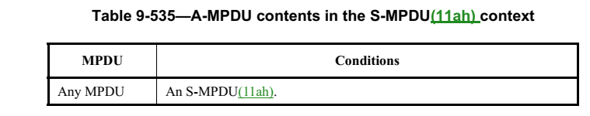

In fact, the HE beacon and HE ER beacon (and any other group addressed frame) are required to be sent as an S-MPDU, so this is not just a legacy issue.

In reviewing all this, the comment resolver has identified an additional issue with the draft:

In 10.12.7, there is a statement for creating an S-MPDU in a VHT PPDU and S1G PPDU:
The EOF field may be set to 1 in an A-MPDU subframe carried in a VHT PPDU or S1G PPDU if the subframe’s MPDU Length field is nonzero and the subframe is the only subframe that has a nonzero MPDU Length field.
But there is no equivalent statement for creating an S-MPDU in an HE PPDU, even though this explicitly required for group addressed Management frames and dynamic fragmentation.

Proposed Resolution
REVISED
Change the name of the EOF field in the MPDU delimiter to “EOF/Tag field.” Use the terms “tagged MPDU” and “untagged MPDU” to identify the cases where an MPDU is carried in an A-MPDU subframe with the EOF/Tag field set to 1 or 0, respectively.

These terms are preferred over “ack soliciting” because the EOF/Tag field can be set to 1 for an MPDU that does not solicit an acknowledgement.

TGax Editor: implement the changes under the heading “Editing instructions for CID 24083” in <this document>

Editing instructions for CID 24083

TGax editor: At 43.62 change as follows (and move definition to maintain alphabetic order):

tagged media access control (MAC) protocol data unit (MPDU) (tagged MPDU): An MPDU carried in an aggregate MPDU (A-MPDU) subframe that has the EOF/Tag field in the MPDU delimiter set to 1.

TGax editor: At 45.19 change as follows (and move definition to maintain alphabetic order):

untagged medium access control (MAC) protocol data unit (MPDU) ( untagged MPDU): An MPDU carried in an aggregate MPDU (A-MPDU) subframe that has the EOF/Tag field in the MPDU delimiter set to 0.

TGax editor: In Table 9-528 (MPDU delimiter fields (non-DMG)), change the field name “EOF” to “EOF/Ack Modifier” and change the description as follows:

End of frame indication if the MPDU Length field is 0. Set to 1 in an A-MPDU subframe that has 0 in the MPDU Length field and that is used to pad the A-MPDU as described in 10.12.6 (A-MPDU padding for VHT, HE and S1G PPDU). Set to 0 in an A-MPDU subframe that has 0 in the MPDU Length field and that is not used to pad the A-MPDU.

Tagged/untagged indication if the MPDU Length field is nonzero. Set to 1 in the MPDU delimiter of an S-MPDU as described in 10.12.7 (Setting the EOF field of the MPDU delimiter)) and set to 1 in an MPDU delimiter preceding a QoS Data frame or Management frame soliciting an Ack or Per AID TID Info field with Ack Type field set to 1 in a Multi-STA BlockAck frame in a response that is contained in an ack-enabled multi-TID A-MPDU as described in 26.6.3.4 (Ack enabled multi-TID A-MPDU operation) and ack-enabled single-TID A-MPDU as described in 26.6.3.2 (Ack-enabled single-TID A-MPDU operation)(#24084). Set to 0 otherwise.

TGax editor: change the title of 10.12.7 as follows:

10.12.7 Setting the EOF/Tag field of the MPDU delimiter

TGax editor: change as follows:
The EOF/Tag field may be set to 1 in an A-MPDU subframe carried in a VHT PPDU, HE PPDU or S1G PPDU if the subframe’s MPDU Length field is nonzero and the subframe is the only subframe that has a nonzero MPDU Length field. The EOF/Tag field of each A-MPDU subframe with an MPDU Length field with a nonzero value that is not the only A-MPDU subframe with MPDU Length field with a nonzero value in the A-MPDU carried in a VHT PPDU or S1G PPDU shall be set to 0. The EOF/Tag field shall be set to 0 in all A-MPDU subframes
that are carried in an HT PPDU.
An MPDU that is the only MPDU in an A-MPDU and that is carried in an A-MPDU subframe with 1 in the
EOF/Tag field is called an S-MPDU.
An MPDU that is carried in an A-MPDU subframe wth the EOF/Tag field in the MPDU delimiter set to 1 is called a tagged MPDU. An S-MPDU is a tagged MPDU, but a tagged MPDU is not necessarily an S-MPDU.

An MPDU that is carried in an A-MPDU subframe with the EOF/Tag field in the MPDU delimiter set to 0 is called an untagged MPDU.

Change the term “EOF MPDU” to “tagged MPDU” throughout (including plural “EOF MPDUs” to “tagged MPDUs”).

Change the term “non-EOF MPDU” to “untagged MPDU” throughout (including plural “EOF MPDUs” to “tagged MPDUs”)

CID 24566
comments
 | CID | Page | Clause |  | Comment | Proposed Change
 | 24566 | 369.27 | 26.5.6 |  | If the PPDU carrying BQRP is not occupying 160MHz, there should be no requirement for non-AP STA to report channel availability info for the entire 160MHz. Reporting those 20MHz subchannels occupied by the PPDU carrying BQRP should be sufficient | relax the STA reporting requirement

Discussion

The statement referenced in the comment is in 26.5.6 (Bandwidth query report operation)
The STA shall include in the HE TB PPDU one or more QoS Null frames containing the BQR Control subfield with the channel availability information of the STA.

For reference, 6.2.4.6a.6 states:

The Available Channel Bitmap subfield contains a bitmap indicating the subchannels available at the STA
transmitting the BQR. Each bit in the bitmap corresponds to a 20 MHz subchannel within the operating
channel width of the BSS in which the STA is associated, with the LSB corresponding to the lowest numbered operating subchannel of the BSS. The bit in position X in the bitmap is set to 1 to indicate that the subchannel X + 1 is idle; otherwise it is set to 0 to indicate that the subchannel is busy or unavailable.
Availability of each 20 MHz subchannel is based on the ED-based CCA defined in 27.3.20.6.5 (Per 20 MHz CCA sensitivity) and is reported for the 20 MHz subchannels located in the operating channel of the reporting STA when the WM is idle as defined in 10.3.2.1 (CS mechanism) and in 26.5.2.5 (UL MU CS mechanism).

Proposed Resolution
REJECTED
The commenter is suggesting that the 20 MHz subchannel CCA state reported in the BQR be limited to the subchannels comprising the PPDU bandwidth. No justification is provided other than this is more “relaxed.” However, it would be more relaxed (easier to implement) if the report always comprised the subchannels of the STA’s operating channel width since 1) the BQR Control field has space for the full report and 2) the non-AP STA would not need to tailor the report based on the PPDU bandwidth of the BQR Trigger frame, i.e., add zeros where useful information could be sent.

This is the current design, and a change to this behavior is not justified.

CID 24567
comments
 | CID | Page | Clause |  | Comment | Proposed Change
 | 24567 | 369.15 | 26.5.6 |  | Can AID12=0 or 2045 in BQRP? | Clarify whether STA needs to respond to such BQRP

Discussion
AID12=0 allocates one or more contiguous RA-RUs for associated STAs
AID12=2045 allocates one or more contiguous RA-RUs for unassociated STAs
The commenter suggests that there is a clarity problem with regard to a UORA response to a BQRP Trigger frame.

At the cited location it states:

A non-AP STA that supports generating a BQR responds (solicited BQR) as defined below:
- The STA that receives a BQRP Trigger frame shall follow the rules defined in 26.5.2.3 (Non-AP
STA behavior for UL MU operation) to generate the HE TB PPDU if the Trigger frame contains the
STA’s AID in any of the User Info fields; otherwise the STA shall follow the rules defined in 26.5.4
(UL OFDMA-based random access (UORA)) to gain access to an RA-RU and generate the HE TB
PPDU if the Trigger frame contains one or more RA-RUs.
- The STA shall include in the HE TB PPDU one or more QoS Null frames containing the BQR Control subfield with the channel availability information of the STA. The HE STA shall not solicit an
immediate response for the frames carried in the HE TB PPDU. The Ack Policy Indication subfield
of the frame shall be set to No Ack.

Proposed Resolution

REVISED
Clearly, the intent of the paragraph at the cited location is that a STA that receives a BQRP Trigger frame and that is not directly addressed by a User Info field in the BQRP Trigger frame (first part of sentence) must generate an HE TB PPDU following the rules for UORA operation.

If there are clarity issues, they are the following:
- There is no antecedent to “the HE TB PPDU”
- “Shall follow the rules” must not require a STA that does not support UORA to respond. As written, it seems to imply that the non-AP STA has no choice; it must respond using UORA.
- Is a non-AP STA on a neighboring BSS or OBSS required to respond? This seems overly prescriptive if the non-AP STA has no interest in communicating with the soliciting AP.

Replace the cited paragraph with the following:

“An AP shall not transmit a BQR Trigger frame with the User Info field addressed to a non-AP STA unless it has received from the non-AP STA an HE Capabilties element with the BQR Support subfield equal to 1.

A non-AP STA that supports BQR operation and that receives a BQRP Trigger frame with a User Info field addressed to the non-AP STA, shall respond with an HE TB PPDU following the procedure in 26.5.2.3.1.

A non-AP STA that supports both BQR operation and the UORA procedure and that receives a BQRP Trigger frame from the AP with which it is associated where the BQRP Trigger frame allocates RA-RUs for associated STAs but that does contain a User Info field addressed to the non-AP STA, shall respond with an HE TB PPDU using the procedure defined in 26.5.4 (UL OFDMA-based random access (UORA)).

A non-AP STA that supports both BQR operation and the UORA procedure and that receives a BQRP Trigger frame from an AP with which it is not associated and where the BQR Trigger frame allocates RA-RUs for unassociated STAs, may respond with an HE TB PPDU using the procedure defined in 26.5.4 (UL OFDMA-based random access (UORA)).

If the non-AP STA responds with an HE TB PPDU using one of the above procedures, then the A-MPDU carried in the HE TB PPDU shall include one or more QoS Null frames containing a BQR Control subfield with the channel availability information of the STA. The ack policy of the QoS Null frames shall be No Ack and additional frames in the A-MPDU (if any) shall not solicit an immediate response.”

CID 24408
comments
 | CID | Page | Clause |  | Comment | Proposed Change
 | 24408 |  |  |  | [Resubmission of comment withdrawn on D5.0] Re CID 20068 said "Avoid reference to magic numbers (2045). TGax has discussed this topic before and had decided to replace all references to AID12=0 or AID12=2045 with RA-RU for associated or unassociated STA." and was not rejected, but there are still lots of references to 2045 | Fix explicit 2045s in 26.4.1 Overview, 26.4.2 Acknowledgment context in a Multi-STA BlockAck frame, 26.5.2.2.1 General, 26.5.2.2.3 Padding for Trigger frame or frame containing TRS Control subfield, 26.5.2.3.1 General, 26.5.2.4 A-MPDU contents in an HE TB PPDU, 26.5.4.1 General, 26.5.4.5 Additional considerations for unassociated STAs, 26.11.1 STA_ID

Proposed Resolution
REVISED
Make the changes in <this document> CID 24408

Editing instructions for CID 24408

At 345.61, change as follows:

An AP that transmits a PPDU may solicit an HE TB PPDU from one or more non-AP STAs through one of
the following mechanisms:
- Including in the PPDU one or more Trigger frames that include one or more User Info fields with
one of the following AID12 subfield settings:
  - The AID12 subfield is set to the 12 LSBs of the AID of the non-AP STA if the User Info field is
addressed to a STA that is associated with the AP.
  - The AID12 subfield is set to the 12 LSBs of the AID of the non-AP STA if the User Info field is
addressed to a STA that is associated with an AP corresponding to a nontransmitted
BSSID in a multiple BSSID set to which the AP belongs, the TA field of the Trigger
frame is set to the transmitted BSSID and the non-AP STA has set the Rx Control Frame To MultiBSS subfield in the HE Capabilities element it transmits to 1.
  - The AID12 subfield indicates that one or more contiguous RA-RUs are allocated
  - (see 26.5.4 (UL OFDMA-based
random access (UORA)).
- Including in the PPDU one or more individually addressed frames that include a TRS Control subfield and that:
  - Are carried in an S-MPDU format that solicits an immediate Ack frame (see 10.12.8 (Transport
of S-MPDUs))
  - Are carried in an A-MPDU format that solicits an immediate BlockAck frame (see 10.25.6.7
(Originator’s behavior))
  - Are carried in a multi-TID A-MPDU format that solicits an immediate Multi-STA BlockAck
frame (see 26.6.3 (Multi-TID A-MPDU and ack-enabled single-TID A-MPDU)

At 348.6, change as follows:

An AP transmitting a Trigger frame that contains at least one User Info field with AID12 subfield indicating allocation of one or more contiguous RA-RUs for associated STAs shall ensure that the number of bits following the last bit of SCH is at least LPAD,MAC as defined in Equation (26-1), which is based on the largest MinTrigProcTime of all associated non-AP STAs, where SCH is the last User Info field with AID12 subfield equal to either 0 or 2046.

An AP transmitting a Trigger frame that contains at least one User Info field with AID12 subfield indicating allocation of one or more contiguous RA-RUs for unassociated STAs should ensure that the number of bits following the last bit of SCH is at least 4 × NDBPS for a non-HT PPDU, HT PPDU or VHT PPDU, or NDBPS for an HE PPDU, where SCH is the last User Info field with AID12 subfield equal to either 2045 or 2046.

An AP transmitting an NFRP Trigger frame shall ensure that the number of bits following the last User Info
field with an AID12 subfield not equal to 4095 is at least 4 × NDBPS for a non-HT PPDU, HT PPDU or VHT PPDU, or NDBPS for an HE PPDU.
An AP may use any type of padding to satisfy the MinTrigProcTime requirement of a non-AP STA, such as
using the Padding field in a Trigger frame, post-EOF A-MPDU padding, or aggregating other MPDUs in the
A-MPDU.

If a Trigger frame or frame containing a TRS Control subfield is LDPC encoded, then the transmitting AP
ensures that TTrigProc meets the following requirements:
— TTrigProc shall be greater than or equal to the MinTrigProcTime specified by the non-AP STAs that
are the recipients of the Trigger frame.
— For a Trigger frame that contains at least one User Info field with an AID12 subfield indicating allocation of one or more contiguous RA-RUs for associated STAs, TTrigProc shall be greater than or equal to the largest MinTrigProcTime of all associated non-AP STAs.
— For a Trigger frame that contains at least one User Info field with an AID12 subfield indicating allocation of RA-RUs for one or more contiguous RA-RUs for unassociated STAs, TTrigProc should be at least 16 µs.
— For an NFRP Trigger frame, TTrigProc shall be at least 16 µs.

At 352.57, change as follows:
A non-AP STA shall not transmit an HE TB PPDU if all of the conditions in 26.5.2.3.2 (Conditions for not
responding with an HE TB PPDU) are satisfied. Otherwise, a non-AP STA shall transmit an HE TB PPDU a
SIFS after a received PPDU if all of the following conditions are met:
- The received PPDU contains either a Trigger frame (that is not an MU-RTS variant) with a User Info
field addressed to the non-AP STA, or a frame addressed to the non-AP STA that contains an TRS
Control subfield. A User Info field in the Trigger frame is addressed to a non-AP STA if one of the
following conditions are met:
  - The AID12 subfield is equal to the 12 LSBs of the AID of the non-AP STA and the Trigger
frame is sent by the AP with which the non-AP STA is associated with or by the AP corresponding to the transmitted BSSID if the non-AP STA is associated with a nontransmitted BSSID and has indicated support for receiving Control frames with TA field set to the transmitted BSSID by setting the Rx Control Frame To MultiBSS subfield to 1 in the HE Capabilities element that the STA transmits.
  - The AID12 subfield indicates allocation of one or more contiguous RA-RUs for associated STAs, the non-AP STA is associated with the AP that sent the Trigger frame,
the non-AP STA supports the UORA procedure, and the conditions the conditions in 26.5.4 (UL
OFDMA-based random access (UORA)) are satisfied.
  - The AID12 subfield indicates allocation of one or more contiguous RA-RUs for unassocaited STAs, the non-AP STA is not associated with the AP that sent the Trigger
frame, the non-AP STA supports the UORA procedure, the conditions in 26.5.4 (UL OFDMA-based random access (UORA)) are satisfied, and the resource that the non-AP STA gains access
to is sufficient for the non-AP STA to include the pending frame.
- The CS Required subfield in the Trigger frame is 1 and the UL MU CS condition described in
26.5.2.5 (UL MU CS mechanism) indicates the medium is idle, or the CS Required subfield in a
Trigger frame is 0 or the response was solicited by a frame containing a TRS Control subfield.
- The UL MU Disable subfield is 0 and the UL MU Data Disable subfield is 0 in the most recent OM
Control subfield (if any) sent by the non-AP STA to the AP or the UL MU Disable subfield is 0 and
the UL MU Data Disable subfield is 1 in the most recent OM Control subfield (if any) sent by the
non-AP STA to the AP and the frame that is being triggered is an acknowledgment (see 26.9.3
(Transmit operating mode (TOM) indication)).

Delete the paragraph at 362.27:

Change the paragraph at 362.34 as follows:
An HE AP may transmit a Basic Trigger frame, BQRP Trigger frame or BSRP Trigger frame that contains
one or more RUs for random access. An AP that transmits a Basic Trigger frame may set the AID12 subfield
of any User Info field of the frame to indicate allocation of one or more RA-RUs for unassociated STAs. An AP that transmits a Trigger frame that is not a Basic Trigger frame, BQRP Trigger frame or BSRP Trigger frame shall not set the AID12 subfield of any User Info field of the frame to indicate allocation of one or more RA-RUs for associated STAs.

CID 24404
comments
 | CID | Page | Clause |  | Comment | Proposed Change
 | 24404 |  | 10.23.4.2.3 |  | [Resubmission of comment withdrawn on D5.0] The baseline says "Frame exchange sequences for Management frames are excluded from the used_time update.", but it is not clear how HE TB PPDUs count for used_time. The answer is that TXOPs involving HE TB PPDUs should be excluded from used_time the AP can account for them when it allocates the admitted_time to the non-AP STA; any other unfairness is addressed by other mechanisms (e.g. the MU EDCA parameter set). | In the referenced subclause, change "Frame exchange sequences for Management frames are excluded from the used_time update." to "Frame exchange sequences for Management frames and frame exchange sequences that include HE TB PPDU transmission are excluded from the used_time update."

Discussion
If the proposed change seems reasonable. The cited text would change as follows:

(#2459) The MPDUExchangeTime is the duration of the frame exchange sequence. For the case of an MPDU transmitted with Normal Ack ack policy(#1415) and without RTS/CTS protection, this equals the time required to transmit the MPDU plus the time required to transmit the expected response frame plus one SIFS. Frame exchange sequences for Management frames and frame exchange sequences that include HE TB PPDU transmission are excluded from the used_time update. (#4508)Any RD transmission granted by the AP is excluded from the used_time update. If the used_time value reaches or exceeds the admitted_time value, the corresponding EDCAF shall no longer transmit QoS Data frames or QoS Null frames(#1444) using the EDCA parameters for that AC as specified in the QoS Parameter Set element. However, a STA may choose to temporarily replace the EDCA parameters for that EDCAF with those specified for an AC of lower priority, if no admission control is required for those ACs.

Proposed Resolution
ACCEPTED

The remainder of this document is work in progress…

CID 24371
comments
 | CID |  |  |  | Comment | Proposed Change
 | 24371 |  |  |  | [Resubmission of comment withdrawn on D5.0] Per the definition of an antenna connector there is only ever one for tx and one for rx | In 9.2.4.6a.1 TRS Control change "combined transmit power at the antenna connectors of all the transmit antennas" to "power at the transmit antenna connector". In 9.3.1.22.1 General change "combined transmit  power at the antenna connectors of all the transmit antennas used to transmit the Trigger frame" to "power at the transmit antenna connector"; "averaged  over the AP's antenna connectors" to "averaged  over the AP's antennas". In 9.3.1.22.9 NDP Feedback Report Poll (NFRP) variant change "receiver's antenna connector(s)" to "receiver's receive antenna connector". In 3.2 (2x) and 9.4.2.248 HE Operation element and 26.17.7 Co-hosted BSSID set change "antenna connectors" to "receive and transmit antenna connectors". In 11.10.14 Multiple BSSID set (5x) change "antenna connector" to "receive and transmit antenna connectors". In 26.10.2.4 Adjustment of OBSS PD and transmit power and 26.10.2.5 OBSS PD SR transmit power restriction period (2x) and 26.10.3.3 SRP-based spatial reuse backoff procedure change "output of the antenna connector" to "transmit antenna connector". In 26.10.3.2 PSR-based spatial reuse initiation change "RSSI at the antenna connector(s)" to "RSSI at the receive antenna connector". In 26.10.3.4 UL Spatial Reuse subfield of Trigger frame change "total power at the antenna connector(s)" to "total power at the transmit antenna connector". In 27.3.15.2 Power pre-correction change "target receive signal power of the HE TB PPDU averaged over the AP's antenna  connectors" to "target receive signal power of the HE TB PPDU at the AP's receive antenna  connector" and "antenna connector(s)" to "receive antenna connector". In 27.3.14.3 Pre-correction accuracy requirements change "support per chain max(P-32, -10) dBm as the minimum trans-  mit power, where P is the maximum power, in dBm, that the STA can transmit at the antenna connector of  that chain" to "support max(P-32, -10) dBm as the minimum transmit power, where P is the maximum power, in dBm, that the STA can transmit at the transmit antenna connector" and "at the STA's antenna connector" to "at the STA's receive antenna connector". In 27.3.20.1 General change "the antenna connectors" to "the receive antenna connector"

Discussion
Some changes have been made with #24297

In REVmd, we have the following definition:
antenna connector: The measurement point of reference for radio frequency (RF) measurements in a
station (STA). The antenna connector is the point in the STA architecture representing the input of the
receiver (output of the antenna) for radio reception and the input of the antenna (output of the transmitter)
for radio transmission. In systems using multiple antennas or antenna arrays, the antenna connector is a
virtual point representing the aggregate output of (or input to) the multiple antennas. In systems using active
antenna arrays with processing, the antenna connector is the output of the active array, which includes any
processing gain of the active antenna subsystem.

The proposed changes appear to:
- Change “antenna connectors” to “antenna connector” to align with definition
- Distinguish between receive antenna connector and transmit antenna connector were appropriate

Taking each proposal in turn…

Proposed change:
In 9.2.4.6a.1 TRS Control change "combined transmit power at the antenna connectors of all the transmit antennas" to "power at the transmit antenna connector".

Applied to current text (unchanged by #24297):
The AP Tx Power subfield indicates the AP’s power at the transmit antenna connector used to transmit the triggering PPDU in units of dBm / 20 MHz(#24414).

In 9.3.1.22.1 General change "combined transmit power at the antenna connectors of all the transmit antennas used to transmit the Trigger frame" to "power at the transmit antenna connector"; "averaged over the AP's antenna connectors" to "averaged over the AP's antennas".

Applied to current text:
(#24414)The AP Tx Power subfield of the Common Info field indicates the AP’s power at the transmit attenna connector used to transmit the Trigger frame in units of dBm / 20 MHz.

This text is as modified by #24297 (20/0717r10) and #24417:
The UL Target RSSI subfield of the User Info field indicates the expected receive signal power, measured at the AP’s antenna connector and averaged over the antennas, for the HE portion of the HE TB PPDU transmitted on the assigned RU. The resolution for the UL Target RSSI subfield in the User Info field is 1 dB. The UL Target RSSI subfield encoding is defined in Table 9-31j (UL Target RSSI subfield encoding).

Proposed change:
In 9.3.1.22.9 NDP Feedback Report Poll (NFRP) variant change "receiver's antenna connector(s)" to "receiver's receive antenna connector".

This text as modified by #24297:
The UL Target RSSI subfield indicates the target RSSI at the receiver's antenna connector, over the subcarriers assigned to a scheduled STA within the PPDU bandwidth, from the HE portion of the HE TB feedback NDP, averaged over all antennas used to receive the PPDU for each of the scheduled STAs. The resolution for the UL Target RSSI subfield is 1 dB. The UL Target RSSI subfield encoding is defined in Table 9-31j (UL Target RSSI subfield encoding).

Proposed change:
In 3.2 (2x) and 9.4.2.248 HE Operation element and 26.17.7 Co-hosted BSSID set change "antenna connectors" to "receive and transmit antenna connectors".

Proposed change:
In 11.10.14 Multiple BSSID set (5x) change "antenna connector" to "receive and transmit antenna connectors".

In 26.10.2.4 Adjustment of OBSS PD and transmit power and 26.10.2.5 OBSS PD SR transmit power restriction period (2x) and 26.10.3.3 SRP-based spatial reuse backoff procedure change "output of the antenna connector" to "transmit antenna connector".

In 26.10.3.2 PSR-based spatial reuse initiation change "RSSI at the antenna connector(s)" to "RSSI at the receive antenna connector".

In 26.10.3.4 UL Spatial Reuse subfield of Trigger frame change "total power at the antenna connector(s)" to "total power at the transmit antenna connector".

In 27.3.15.2 Power pre-correction change "target receive signal power of the HE TB PPDU averaged over the AP's antenna connectors" to "target receive signal power of the HE TB PPDU at the AP's receive antenna connector" and "antenna connector(s)" to "receive antenna connector".

In 27.3.14.3 Pre-correction accuracy requirements change
"support per chain max(P-32, -10) dBm as the minimum transmit power, where P is the maximum power, in dBm, that the STA can transmit at the antenna connector of that chain"
to
"support max(P-32, -10) dBm as the minimum transmit power, where P is the maximum power, in dBm, that the STA can transmit at the transmit antenna connector"
and
"at the STA's antenna connector" to "at the STA's receive antenna connector".

In 27.3.20.1 General change "the antenna connectors" to "the receive antenna connector"
References:

