IEEE P802.11
Wireless LANs
D6.0 Misc CR
Date: 2020-08-12
Author(s):
Name | Affiliation | Address | Phone | email
Robert Stacey | Intel |  |  | robert.stacey@intle.com
Abstract
Proposed resolutions for 24002, 24033, 24526, 24527, 24302, 24541

CID 24002
comments
 | CID | Page | Clause |  | Comment | Proposed Change
 | 24002 | 773.28 | G.1 |  | The attribute "mu-user-not-respond" should be consistent with the 11ax text change to Section G.4 that adds "HE MU PPDU" | modify the Description field of the attribute "mu-user-not-respond" by changing the text "is part of a VHT MU PPDU" to "is part of a VHT MU PPDU or HE MU PPDU"

Context
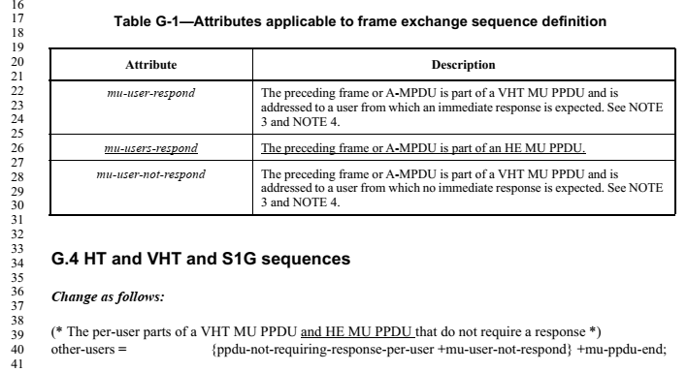

Proposed Resolution
REVISED
Agree in principle. Change the Description for mu-user-not-respond in Table G-1 to read:
“The preceding frame or A-MPDU is part of a VHT MU PPDU or HE MU PPDU and is addressed to a user from which no immediate response is expected. See NOTE 3 and NOTE 4.”

CID 24033
comments
 | CID | Page | Clause |  | Comment | Proposed Change
 | 24033 | 38.39 | 3.2 |  | There are references to "6 GHz STA" in the mainbody of the draft specification. However, 6 GHz STA is not defined in the subclause 3. | Please define 6 GHz STA in either subclause 3.1 or 3.2. Alternatively, replace 6 GHz STA and 6 GHz AP with something else.

Discussion
The comment points out that the term 6 GHz STA is used in the main body of the spec, but that the term has not been defined. This was true in D6.0, but the resolution to #24254 adds such a definition (42.53 in D6.1):

Proposed Resolution
REVISED
Agree in principle. The resolution to #24254 adds a definition for a 6 GHz STA to 3.2. No futher changes required.

CID 24526
comments
 | CID | Page | Clause |  | Comment | Proposed Change
 | 24526 | 458.13 | 26.17.2.2 |  | The use of "HE AP 6G" occurs only here and is undefined. | Replace with the more commonly used "6 GHz HE AP".

On page 458 in D6.0:
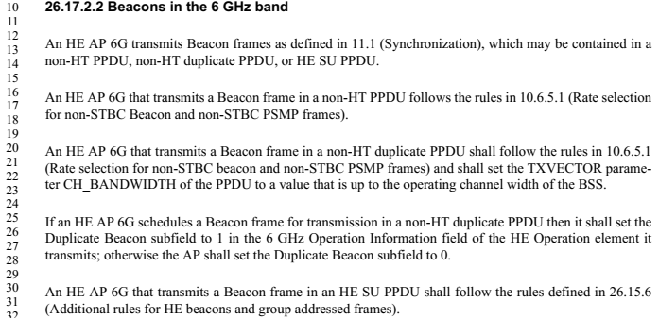

Since fixed with #24254 in D6.1:
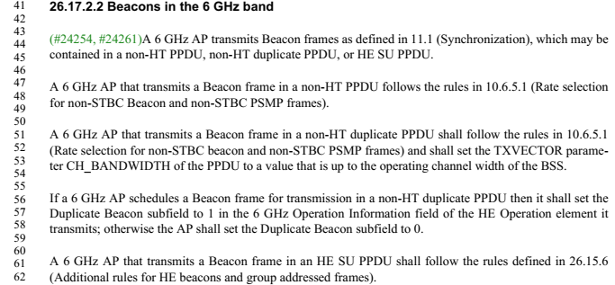

Proposed Resolution
REVISED
For the reasons suggested, replace with the term 6 GHz AP. This change has been made with the resolution to #24254 and no further changes are needed.

CID 24527
comments
 | CID | Page | Clause |  | Comment | Proposed Change
 | 24527 | 456.35 | 26.17.2.1 |  | The labels "6 GHz HE AP", "6 GHz HE STA", "6 GHz AP", "6 GHz non-AP HE STA" and other variants are awkward typographically since they start with a single numeral. | Throughout the document, modify such labels by shortening "6 GHz" to "6GHz" and moving the "6 GHz" to before the last word. For example, replace "6 GHz STA" with "6GHz STA" and "6 GHz HE AP" with "HE 6GHz AP".

Proposed Resolution
REJECTED
The commenter has not clearly identifiued a problem with the draft. Most readers would see “6 GHz” as a term and not as six of something called GHz. Also, the typographic suggestion (contracting 6 GHz to 6GHz) is unnecessary and inconsistent with naming elsewhere in the standard and this amendment (e.g., the “20 MHz In 160/80+80 MHz HE PPDU field in the HE Capabilities element). 802.11 style uses a space between numbers and their unit, whether they are part of a name or not (although in the superscript and subscript of some varaibles we remove the space to avoid ambiguities separating variables, e.g., N_{20MHz}).

CID 24302
comments
 | CID | Page | Clause |  | Comment | Proposed Change
 | 24302 |  | 9 |  | "The Rx HE-MCS Map <= 80 MHz subfield is  always present in the Supported HE-MCS And  NSS Set field." and "The Tx HE-MCS Map <= 80 MHz subfield is  always present in the Supported HE-MCS And  NSS Set field." in Table 9-321c--Subfields of the Supported HE-MCS And NSS Set field duplicate Figure 9-787d--Supported HE-MCS And NSS Set field format. "The HE MIMO Control field is always present in the frame. " in 9.6.31.2 HE Compressed Beamforming/CQI frame format duplicates Table 9-526b--HE Compressed Beamforming/CQI frame Action field format. "The TIM element and OPS element are always present in the frame." in 9.6.31.4 OPS frame format duplicates Table 9-526d--OPS frame Action field format. "A BSS Color Change Announcement element is always present in the frame." in 9.6.32.2 HE BSS Color Change Announcement frame format duplicates Table 9-526f--HE BSS Color Change Announcement frame Action field format. | Delete the cited texts

Discussion
The implied problem is that the “is always present” statements are unnecessary because this is clear for the element/field format.

Figure 9-788d clearly shows that the Rx HE-MCS Map <= 80 MHz field and Tx HE-MCS Map <= 80 MHz field are always present.
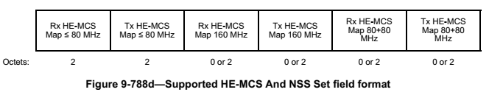

However, Table 9-525b does not clearly identify which fields as always present:
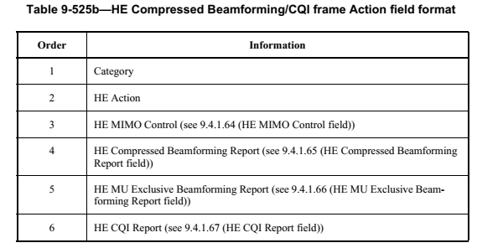
Only the following statement does that:
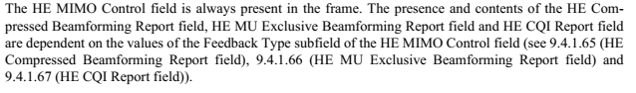
To err on the side of caution, the proposed resolution does not remove the statement for HE MIMO Control.

Similarly, for the TIM and OPS elements in the OPS frame; keep the statement.

Similarly, for the BSS Color Change Announcement element in the HE BSS Color Change Announcement frame; keep the statement.

Proposed Resolution
REVISED. Figure 9-788d clearly shows that the Rx HE-MCS Map <= 80 MHz field and Tx HE-MCS Map <= 80 MHz field are always present. However, there is no clear indication that certain elements are necessarily always present in certain Action frames.

TGax editor to delete the statements “The Rx HE-MCS Map ≤ 80 MHz subfield is always present in the Supported HE-MCS And NSS Set field.” and “The Tx HE-MCS Map ≤ 80 MHz subfield is always present in the Supported HE-MCS And NSS Set field.” From Table 9-321c.

CID24541
comments
 | CID | Page | Clause |  | Comment | Proposed Change
 | 24541 | 42.42 | 3.2 |  | REVmd has deleted the term "user". It seems unnecessary (and causes conflicts in the text with other uses, beyond SU/MU). | Delete the definition "replacement" for the term "user"

Context
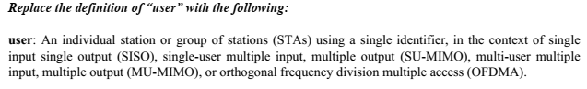

Proposed Resolution
ACCEPTED

CID 24374
comments
 | CID | Page | Clause |  | Comment | Proposed Change
 | 24374 |  | 10.6.12 |  | [Resubmission of comment withdrawn on D5.0] An HE STA in 2G4 should not be allowed to send a frame with a bw-signalling TA in a DSSS/CCK PPDU (in the baseline this is disallowed because only VHT STAs can send BSTAs but VHT STAs do not operate in the 2G4 band), since DSSS/CCK PPDUs do not carry signalling in the scrambler init | Insert as the third sentence of 10.6.12 Channel Width in non-HT and non-HT duplicate PPDUs in the baseline the sentence "The TA field shall not be set to a bandwidth signaling TA in a frame carried in a DSSS/CCK PPDU."

Proposed Resolution
ACCEPTED

The remainder of this document is work in progress…

CID 24371
comments
 | CID |  |  |  | Comment | Proposed Change
 | 24371 |  |  |  | [Resubmission of comment withdrawn on D5.0] Per the definition of an antenna connector there is only ever one for tx and one for rx | In 9.2.4.6a.1 TRS Control change "combined transmit power at the antenna connectors of all the transmit antennas" to "power at the transmit antenna connector". In 9.3.1.22.1 General change "combined transmit  power at the antenna connectors of all the transmit antennas used to transmit the Trigger frame" to "power at the transmit antenna connector"; "averaged  over the AP's antenna connectors" to "averaged  over the AP's antennas". In 9.3.1.22.9 NDP Feedback Report Poll (NFRP) variant change "receiver's antenna connector(s)" to "receiver's receive antenna connector". In 3.2 (2x) and 9.4.2.248 HE Operation element and 26.17.7 Co-hosted BSSID set change "antenna connectors" to "receive and transmit antenna connectors". In 11.10.14 Multiple BSSID set (5x) change "antenna connector" to "receive and transmit antenna connectors". In 26.10.2.4 Adjustment of OBSS PD and transmit power and 26.10.2.5 OBSS PD SR transmit power restriction period (2x) and 26.10.3.3 SRP-based spatial reuse backoff procedure change "output of the antenna connector" to "transmit antenna connector". In 26.10.3.2 PSR-based spatial reuse initiation change "RSSI at the antenna connector(s)" to "RSSI at the receive antenna connector". In 26.10.3.4 UL Spatial Reuse subfield of Trigger frame change "total power at the antenna connector(s)" to "total power at the transmit antenna connector". In 27.3.15.2 Power pre-correction change "target receive signal power of the HE TB PPDU averaged over the AP's antenna  connectors" to "target receive signal power of the HE TB PPDU at the AP's receive antenna  connector" and "antenna connector(s)" to "receive antenna connector". In 27.3.14.3 Pre-correction accuracy requirements change "support per chain max(P-32, -10) dBm as the minimum trans-  mit power, where P is the maximum power, in dBm, that the STA can transmit at the antenna connector of  that chain" to "support max(P-32, -10) dBm as the minimum transmit power, where P is the maximum power, in dBm, that the STA can transmit at the transmit antenna connector" and "at the STA's antenna connector" to "at the STA's receive antenna connector". In 27.3.20.1 General change "the antenna connectors" to "the receive antenna connector"

CID 24404
comments
 | CID | Page | Clause |  | Comment | Proposed Change
 | 24404 |  | 10.23.4.2.3 |  | [Resubmission of comment withdrawn on D5.0] The baseline says "Frame exchange sequences for Management frames are excluded from the used_time update.", but it is not clear how HE TB PPDUs count for used_time. The answer is that TXOPs involving HE TB PPDUs should be excluded from used_time the AP can account for them when it allocates the admitted_time to the non-AP STA; any other unfairness is addressed by other mechanisms (e.g. the MU EDCA parameter set). | In the referenced subclause, change "Frame exchange sequences for Management frames are excluded from the used_time update." to "Frame exchange sequences for Management frames and frame exchange sequences that include HE TB PPDU transmission are excluded from the used_time update."

CID 24408
comments
 | CID | Page | Clause |  | Comment | Proposed Change
 | 24408 |  |  |  | [Resubmission of comment withdrawn on D5.0] Re CID 20068 said "Avoid reference to magic numbers (2045). TGax has discussed this topic before and had decided to replace all references to AID12=0 or AID12=2045 with RA-RU for associated or unassociated STA." and was not rejected, but there are still lots of references to 2045 | Fix explicit 2045s in 26.4.1 Overview, 26.4.2 Acknowledgment context in a Multi-STA BlockAck frame, 26.5.2.2.1 General, 26.5.2.2.3 Padding for Trigger frame or frame containing TRS Control subfield, 26.5.2.3.1 General, 26.5.2.4 A-MPDU contents in an HE TB PPDU, 26.5.4.1 General, 26.5.4.5 Additional considerations for unassociated STAs, 26.11.1 STA_ID

CID 24417
comments
 | CID | Page | Clause |  | Comment | Proposed Change
 | 24417 |  |  |  | [Resubmission of comment withdrawn on D5.0] Re CIDs 20521, 20522. Various editorial consistency improvements were proposed but not addressed | Make the editorial consistency improvements proposed for CIDs 20521, 20522

CID 24418
comments
Selected | CID | Page | Clause | Resn Status | Comment | Proposed Change | Resolution | Owning Ad-hoc
0 | 24418 |  |  |  | [Resubmission of comment withdrawn on D5.0] Re CID 20522. It is still not sufficiently clear that it's not over the PPDU bandwidth, it's over the RU width | Make the changes proposed in CID 20522 |  | EDITOR

CIDs 24425 and 24426
comments
 | CID | Page | Clause |  | Comment | Proposed Change
 | 24425 |  |  |  | [Resubmission of comment withdrawn on D5.0] CID 20646. The resolution is "the spec will not list all the cases that are not allowed" -- but that is exactly what the spec needs to do! Otherwise there will be interop problems (because someone will do the undocumented not allowed thing, and then someone else will not know how to deal with this) | At the end of 9.2.4.6a.7 add a para "A CAS Control field is not present in a PPDU that is not an HE PPDU."
 | 24426 |  |  |  | [Resubmission of comment withdrawn on D5.0] CID 20646. The resolution is "the spec will not list all the cases that are not allowed" -- but that is exactly what the spec needs to do! Otherwise there will be interop problems (because someone will do the undocumented not allowed thing, and then someone else will not know how to deal with this) | As it says in the comment

CID 24429
comments
 | CID | Page | Clause | Resn Status | Comment | Proposed Change
 | 24429 |  |  |  | [Resubmission of comment withdrawn on D5.0] CID 20769. The resolution is not responsive to the comment, which was a technical comment rather than an editorial comment | Make the changes proposed by CID 20769

CID 24540
comments
 | CID | Page | Clause |  | Comment | Proposed Change
 | 24540 | 764.38 | C.3 |  | Error in baseline text. REVmd has dot11SMTbase15 (not dot11SMTbase13) in this location. | Change the struck-through text to "dot11SMTbase15". Also dot11MACbase and dot11CountersGroup have also incremented in REVmd, beyond those shown here. Probably need to scrub the whole MIB for accuracy of quoted baseline text.

CID 24083

NOTE. The author of this document is still working on the resolution for 24083.

comments
 | CID | Page | Clause |  | Comment | Proposed Change
 | 24083 | 232.10 | 9.7.1 |  | It is no longer just an EOF (end-of-frame) field. | This field should be changed such as to "EOF/Solicit Ack" field. Also, it is better to change EOF MPDU to Ack-Soliciting MPDU, and non-EOF MPDU to Not-Ack-Soliciting MPDU, accordingly. (Suggestions for better terms are welcomed.)

Discussion
In the baseline, EOF to some extent does mean “end of frame;” it is either used on the padding delimiters that occur at the end of the A-MPDU or it occurs on the one and only MPDU (which is necessarily the last MPDU) in the A-MPDU.
In 11ax, this is no longer the case. It is possible to have an EOF=1 delimiter followed by delimiters with EOF=0.
The suggestion here is to call it the EOF/Ack Modifier field and to use the term ack modified MPDU when referring to an MPDU carried in an A-MPDU subframe where the EOF/Ack Modifier field is set to 1. The term non-ack-modified MPDU would refer to an MPDU carried in an A-MPDU subframe with the EOF/Ack Modifier field set to 0.

Proposed Resolution
REVISED
Change the name EOF field in the MPDU delimiter to “EOF/Ack Modifier.” Use the term ack modified MPDU and non-ack modified MPDU for the cases where an MPDU is carried in an A-MPDU subframe with the EOF/Ack Modifier field set to 1 and 0 respectively.

The term “ack modifying” is preferred over “ack soliciting” because the EOF/Ack Modifier field may be set to 1 for an MPDU that does not solicit an acknowledgement. If we use the term “ack soliciting” we end up with strange constructs such as “

TGax Editor: implement the changes under the heading Editing Instructions for CID 24083 in <this document>

Editing instructions for CID 24083

At 43.62 change as follows (and move to maintain alphabetic order):

end of frame (EOF) ack modified media access control (MAC) protocol data unit (MPDU) (EOF ack modified MPDU): An MPDU carried in an aggregate MPDU (A-MPDU) subframe that has the EOF/Ack Modifier field in the MPDU delimiter set to 1.”

At 45.19 change as follows (and move to maintain alphabetic order):
non-end of frame (non-EOF) non-ack modified medium access control (MAC) protocol data unit (MPDU) (non-EOF non-ack modified MPDU): An MPDU carried in an aggregate MPDU (A-MPDU) subframe that has the EOF/Ack Modifier field in the MPDU delimiter set to 0.

In Table 9-528 (MPDU delimiter fields (non-DMG)), change the field name “EOF” to “EOF/Ack Modifier” and change the description as follows:
End of frame indication and/or ack modifying indication in combination with the
MPDU Length field. Set to 1 in an A-MPDU subframe that has 0 in the MPDU
Length field and that is used to pad the A-MPDU in a VHT or HE PPDU as
described in 10.13.6 (A-MPDU padding for VHT PPDU). Set to 1 in the MPDU
delimiter of an S-MPDU as described in 10.13.7 (Setting the EOF field of the
MPDU delimiter)) and set to 1 in an MPDU delimiter preceding a QoS Data
frame or Management frame soliciting an Ack or Per AID TID Info field with
Ack Type field set to 1 in a Multi-STA BlockAck frame in a response that is con
tained in an ack-enabled multi-TID A-MPDU as described in 26.6.3.4 (Ack
enabled multi-TID A-MPDU operation) and ack-enabled single-TID A-MPDU
as described in 26.6.3.2 (Ack-enabled single-TID A-MPDU operation)(#24084).
Set to 0 otherwise.

Change the term “EOF MPDU” to “ack modified MPDU” throughout (including plural version “EOF MPDUs” to “ack modified MPDUs).

Change the term “non-EOF MPDU” to “non-ack modified MPDU” throughout

References:

