IEEE P802.11
Wireless LANs
REVmd backoff procedure correction
Date: 2020-07-19
Author(s):
Name | Affiliation | Address | Phone | email
Mark Hamilton | Ruckus/CommScope | 350 W Java Dr  Sunnyvale, CA 94089 | +1.303.818.8472 | mark.hamilton2152@gmail.com
Abstract

Discusses a glitch in REVmc, and proposed a correction, for REVmd consideration.

R0 – initial version.

Background:

REVmc, through document 11-16/0268r2 made the following changes to the rules for when an EDCA backoff is invoked:

From:
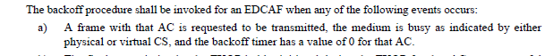

To:
At 1350.12 Make changes as shown (Editor please fix the indents and punctuation)
“The backoff procedure shall be invoked by an EDCAF when any of the following events occurs:
- An MA-UNITDATA.request primitive is received that causes a frame with that AC to be queued for transmission such that one of the transmit queues associated with that AC has now become non-empty and any other transmit queues associated with that AC are empty; the medium is busy on the primary channel as indicated by any of the following:
- physical CS,
- virtual CS,
- a non-zero TXNAV timer value;
- a mesh STA that has dot11MCCAActivated true and a non-zero RAV timer value,
and the backoff timer has a value of 0 for that AC.”

However, it seems that in the process of creating the sub-bullet list, a glitch happened somewhere, and the last new-line was lost, which turns out to important to understanding the paragraph. This is the result in REVmd D3.4:

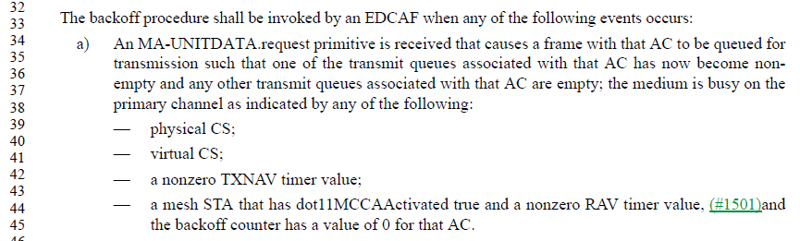

Without the new-line, it now appears that the requirement for the backoff counter to be 0 for the AC only applies to the mesh case. This requirement for a 0 backoff counter needs to apply to all the cases, to keep the original (and correct) intent for EDCA backoff.

A simple fix could be to restore the new-line. This might lead to future error, or perhaps a misunderstanding for the reader. So, some alternative suggestions are:

- An MA-UNITDATA.request primitive is received that causes a frame with that AC to be queued for transmission such that one of the transmit queues associated with that AC has now become non-empty and any other transmit queues associated with that AC are empty;, the backoff timer has a value of 0 for that AC, and the medium is busy on the primary channel(11ac) as indicated by any of the following:
- physical CS,
- virtual CS,
- a non-zero TXNAV timer value;
- for a mesh STA that has dot11MCCAActivated true, and a non-zero RAV timer value,
and the backoff timer has a value of 0 for that AC.

Or you could be even more explicit:

- An MA-UNITDATA.request primitive is received that causes a frame with that AC to be queued for transmission such that all of the following are true:
- one of the transmit queues associated with that AC has now become non-empty and
- any other transmit queues associated with that AC are empty;
- the backoff timer has a value of 0 for that AC
- (#1439) the medium is busy on the primary channel(11ac), as indicated by any of the following:
    - physical CS,
    - virtual CS,
    - a non-zero TXNAV timer value;
    - for a mesh STA that has dot11MCCAActivated true, and a non-zero RAV timer value,
and the backoff timer has a value of 0 for that AC.

Recommend the last option as the most explicit and unlikely to cause confusion.

Proposed change:

Request the REVmd Editor to replace bullet (a) of 10.23.2.2 (EDCA backoff procedure, P1817L34 of D3.4):L

From:
- An MA-UNITDATA.request primitive is received that causes a frame with that AC to be queued for transmission such that one of the transmit queues associated with that AC has now become nonempty and any other transmit queues associated with that AC are empty; the medium is busy on the primary channel as indicated by any of the following:
— physical CS;
— virtual CS;
— a nonzero TXNAV timer value;
— a mesh STA that has dot11MCCAActivated true and a nonzero RAV timer value, (#1501)and the backoff counter has a value of 0 for that AC.

To:
- An MA-UNITDATA.request primitive is received that causes a frame with that AC to be queued for transmission such that all of the following are true:
  - one of the transmit queues associated with that AC has now become nonempty and
  - any other transmit queues associated with that AC are empty,
  - the backoff timer has a value of 0 for that AC,
  - the medium is busy on the primary channel as indicated by any of the following:
— physical CS;
— virtual CS;
— a nonzero TXNAV timer value;
— for a mesh STA that has dot11MCCAActivated true and a nonzero RAV timer value and the backoff counter has a value of 0 for that AC

