IEEE P802.11
Wireless LANs
IEEE 802.11bd Teleconference Meeting Minutes –
July, Aug, Sept 2020
Date: 2019-08-04
Author(s):
Name | Affiliation | Address | Phone | email
James LEPP | BlackBerry | 1001 Farrar Road, Ottawa, Canada |  | jlepp@blackberry.com
Joseph LEVY | InterDigital Communication, Inc. | 111 W 33rd Street  New York, NY 10120 | +1.631.622.4139 | joseph.levy@interdigital.com
Abstract

This document includes minutes of all IEEE 802.11bd teleconferences between the July and September IEEE 802.11 meetings.

Version Tracking:
R0: uploaded after July 17 and 21 teleconferences
R1: uploaded after Aug 4 teleconference

Friday, July 17, 2020

Opening (IEEE 802.11-20/0774r10)
  - Call to order 10:02 AM EDT
  - Chair instructed members on how to use webex and to record attendance in IMAT.
  - Chair introduced the patent policy and meeting rules.
  - No response to the call for patents.
  - Chair introduced the task group leadership

Agenda (IEEE 802.11-20/0774r10)
  - Chair presented the agenda as emailed to the mailing list http://www.ieee802.org/11/email/stds-802-11-tgbd/msg00297.html.
  - Discussion about document 1086 title not being correct. Presenter will obtain a new document number with the correct title before presenting this morning.
  - Agenda for this session has been adopted without objection

Technical Contribution (802.11-20/1061r1)
  - Presented by Donggkuk Lim (LGE), continuing the presentation from July 14.
  - Comment resolution for CID 334
  - Discussion about note on phase rotation being normative or not.
  - All CIDs presented
  - Strawpoll on accepting these changes to D0.3 will be run in the next meeting.

Technical Contribution (802.11-20/1110r1)
  - Presented by Jianhan Liu (MediaTek)
  - Specification text contribution for DCM
  - Presenter made small editorial changes to the equations as he presented
  - Discussion
    - Comment about how this is shown in the MCS table
    - Comment that it should be “revised” as opposed to “accepted”
    - Editorial comment, but sentence being questioned is the same as 11ax
  - Presenter will upload r2 and be ready for a strawpoll in the next meeting.

Technical Contribution (802.11-20/1101r1)
  - Presented by Donggkuk Lim (LGE)
  - Comment resolution for CID 117
  - Discussion
    - Comment that this CID is also in another document 845r1.
    - The resolution in this document is intended to replace the resolution proposed in 845r1
  - This will be strawpolled in the next meeting.

Closing
  - The agenda is complete for this meeting session.
  - Meeting is adjourned at 12:00pm EDT
Attendance from IMAT
An, Song-Haur | INDEPENDENT
Andersdotter, Amelia | None - Self-funded
Cao, Rui | NXP Semiconductors
Edelmayer, Andras | Commsignia
Kain, Carl | USDoT
Kim, Youn-Kwan | The Catholic University of Korea
Lansford, James | Qualcomm Incorporated
Lepp, James | BlackBerry
Levy, Joseph | InterDigital, Inc.
Lim, Dong Guk | LG ELECTRONICS
Liu, Jianhan | MediaTek Inc.
Motozuka, Hiroyuki | Panasonic Corporation
noh, yujin | Newracom Inc.
Schiessl, Sebastian | u-blox
Sun, Bo | ZTE Corporation
SURACI, FRANK | U.S. Department of Homeland Security
YANG, RUI | InterDigital, Inc.
yi, yongjiang | Futurewei Technologies

Tuesday, July 21, 2020

Opening (IEEE 802.11-20/0774r11)
  - Call to order 10:02 AM EDT
  - There are 18 people on the webex call.
  - Chair instructed members on how to use webex and to record attendance in IMAT.
  - Chair introduced the patent policy and meeting rules.
  - No response to the call for patents.
  - Chair introduced the task group leadership

Agenda (IEEE 802.11-20/0774r10, r11 will be uploaded after the meeting)
  - Chair presented the agenda as emailed to the mailing list http://www.ieee802.org/11/email/stds-802-11-tgbd/msg00297.html.
  - Agenda for this session has been adopted without objection

Straw Poll 1 (802.11-20/0774r10)
  - Straw poll on Dongguk Lim (LGE) comment resolutions for clause 32.3.7.3
  - Discussion
    - none
  - Straw poll for 11-20/1061, the comment resolution for clause 32.3.7.3 NGV portion of NGV format preamble, Donggkuk Lim (LGE) [Continue] –
Straw Poll: Do you agree on the comment resolutions to following 39 CIDs and the proposed spec text modification to IEEE P802.11bd D0.3 as in 11-20/1061r1? CID 6, 17, 118, 119, 120, 148, 149, 150, 168, 169, 291, 292, 293, 294, 295, 296, 297, 298, 300, 301, 302, 303, 304, 305, 306, 307, 308, 309, 310, 311, 312, 313, 315, 316, 317, 318, 319, 322, 323
  - Straw poll taken with webex tool
  - Yes 14/No 0/Abstain 2/No response 3

Straw Poll 2 (802.11-20/0774r10)
  - Straw poll for Jianhan Liu (MediaTek) comment resolutions on clause 32.3.8.6
  - Discussion
    - none
  - Straw poll for 11-20/1110, Comment Resolution for CID334 in Section 32.3.8.6, Jianhan Liu (MediaTek)
Straw Poll: Do you agree on the comment resolutions to CID 334 and the proposed spec text modification to IEEE P802.11bd D0.3 as in 11-20/1110r2?
  - Straw poll taken with webex tool
  - Yes 15 / No 0 / Abstain 2 / No response 4

Straw Poll 3 (802.11-20/0774r10)
  - Straw poll on Dongguk Lim (LGE) comment resolutions for CID 117
  - Discussion
    - none
  - Straw poll for 11-20/1101r2, the-comment-resolution-for-cid-117, Dongguk Lim (LGE)
Do you agree on the comment resolutions to CID 117 and the proposed spec text modification to IEEE P802.11bd D0.3 as in 11-20/1101r2 which will replace the comment resolution to CID 117 as in 11-20/0845r1?
  - Straw poll taken with webex tool
  - Yes 16 / No 0 / Abstain 0 / No response 5

Technical Contribution (802.11-20/0682r2)
  - Presented by Miquel Lopez (Ericsson)
  - Discussion
    - Comment on the use of the term “time domain waveforms” – the specification should not forbid other implementations.
    - Ans – agreed, will update the text
    - Question the intent to apply this to both spatial streams or to all midambles?
    - Ans – all midambles, will update the text
    - Motion text updated to (uploaded as 802.11-20/0682r3):
Move to include the following text to section 3 of the 11bd SFD
“PPDUs with midambles shall be randomized in order to suppress discrete spectrum components. The midambles symbols shall be multiplied by pseudo-random values plus/minus one. The data symbols immediately following any given midamble shall be multiplied by the same pseudo-random value as said midamble. In the case of MIMO PPDUs, the same pseudo-random values shall be applied to both symbols of the midamble. The pseudo-random values are defined in (17-25) of IEEE 802.11-2016”
    - Question – is the randomization applied to each carrier or the whole symbol and which symbols is it applied to?
    - Ans – the symbol and all midamble symbols
    - Question – how will the receiver know the sequence?
    - Ans – the receiver will know, as the sequence will be specified.
    - Comment it is the same sequence as is used by the pilots
  - Motion will be run the TGbd teleconference on Tuesday, 4 August 2020.

Closing
  - There are 23 people on the webex call, at end of the meeting.
  - Adjourned 11:05 AM ET
Attendance from IMAT
An, Song-Haur | INDEPENDENT
Cao, Rui | NXP Semiconductors
Edelmayer, Andras | Commsignia
Kain, Carl | USDoT
Kenney, John | TOYOTA InfoTechnology Center U.S.A.
Kim, Youn-Kwan | The Catholic University of Korea
Levy, Joseph | InterDigital, Inc.
Lim, Dong Guk | LG ELECTRONICS
Lopez, Miguel | Ericsson AB
Motozuka, Hiroyuki | Panasonic Corporation
noh, yujin | Newracom Inc.
Sadeghi, Bahareh | Intel Corporation
Sand, Stephan | German Aerospace Center (DLR)
Singh, Gurdev | SAMSUNG ELECTRONICS
Smely, Di Dieter | Kapsch TrafficCom AG
Sun, Bo | ZTE Corporation
SURACI, FRANK | U.S. Department of Homeland Security
Yee, Peter | NSA-CSD
yi, yongjiang | Futurewei Technologies

Friday, July 31, 2020

Opening (IEEE 802.11-20/0774r11)
  - Call to order 10:02 AM EDT
  - Chair instructed members on how to use webex and to record attendance in IMAT.
  - Chair introduced the patent policy.
  - No response to the call for patents.
  - Chair introduced meeting rules, including the teleconference motion rules. The first motion in this TG will be run at the August 4.
  - Chair showed task group teleconference schedule and announced that more meetings will be added next week to complete the comment resolution and next draft in time for the Sept meeting.
  - Chair introduced the task group leadership.
  - James Lepp (BlackBerry) the 802.11bd secretary announced his resignation from the position due to taking a new position that doesn’t involve

Agenda (IEEE 802.11-20/0774r11)
  - Chair presented the agenda as displayed on IEEE 802.11-20/0774r11 slide 71.
  - Discussion:
    - Typo corrected on the slide (date of next teleconference
  - Agenda for this session has been adopted without objection

Updated of ARC SC topic
  - 802.11 ARC SC chair has sent an email to the 11bd mailing list about impact of 802.11bd amendment on the architecture. (http://www.ieee802.org/11/email/stds-802-11-tgbd/msg00303.html)
  - Chair encourages 11bd members who are interested to join ARC teleconference if this agenda is being discussed.
  - Chair’s preliminary opinion is there is no impact, and he will share that.
  - Call for further input to the ARC group
    - Member suggested that 11bd should provide a summary (a couple slides) to explain the 11bd position to the ARC SC meeting about 11bc and 11bd.
    - Member suggests that this has been discussed, but there isn’t yet consensus on the spec text. Hard to make a presentation.
    - Member suggests we’re impacting the architecture of 1609 more than 802.11
  - Joseph Levy and Liwen Chu volunteered to contribute to a presentation. Will use the reflector to ensure the process is open to the whole group.

Technical Contribution (802.11-20/1155r0)
  - Presented by Rui Cao (NXP).
  - Comment resolution for five comments on 32.3.5
  - CID 139
    - No discussion
  - CID 268
    - No discussion
  - CID 269
    - No discussion
  - CID 270
    - Discussion about big “X” vs small “x” in the left column of the table.
    - Editorial change will be made to the T_NGV-LTF-2X-Repeat and uploaded as r1
  - CID 271
    - No discussion
  - All CIDs presented. Strawpoll will be run in the next teleconference.

Technical Contribution (802.11-20/0973r1)
  - Presented by Rui Cao (NXP).
  - No discussion or comments on the presentation
  - Strawpoll: Do you agree that the pre-NGV cyclic shift, 𝑻_𝑪𝑺^(𝒊_𝑻𝑿 ), uses the values defined in Table 21-10 (Cyclic shift values for L-STF, L-LTF, L-SIG, and VHT-SIG-A fields of the PPDU)?
  - Chair called for any objection to the strawpoll and there was none. Chair declared consensus agreement with the proposal.

Technical Contribution (802.11-20/0897r1)
  - Presented by Rui Cao (NXP).
  - Presenter is highlighting the two changes made in response to the discussion in a previous meeting.
    - Initial transmission follows clause 17, repetition transmissions have a new branch defined in the figure.
    - Change suggested: “PPDU is stored in memory” to “PPDU may be stored in memory”
    - Comment that there is a lot of change in the text and the figure and suggestion to run the strawpoll on Tuesday to give members time to review the text.

Closing
  - Chair reminded the group of the next call on Aug 4, when a motion will be run.
  - Other business
    - Question to the editor about the proposed text on the MAC SAP that was agreed but not included in the Draft 0.3. Do we need to review this again, or will it be included by the editor.
    - Editor response that there is a comment submitted about the omitted text that is tracking this. The CID is assigned to the editor and the original text will be submitted as the resolution to the comment.
  - Chair reminded the group about the members developing a presentation from 11bd to ARC and the use of the reflector for this.
  - Chair announced the call for members to volunteer for the open secretary position.
  - Chair adjourned the meeting at 11:00am EDT
Attendance from IMAT
An, Song-Haur | INDEPENDENT
Cao, Rui | NXP Semiconductors
Dong, Xiandong | Xiaomi Inc.
Edelmayer, Andras | Commsignia
Goto, Fumihide | Self
Kim, Youn-Kwan | The Catholic University of Korea
Lepp, James | BlackBerry
Levy, Joseph | InterDigital, Inc.
Motozuka, Hiroyuki | Panasonic Corporation
Sadeghi, Bahareh | Intel Corporation
Sand, Stephan | German Aerospace Center (DLR)
Schiessl, Sebastian | u-blox
Sun, Bo | ZTE Corporation

Tuesday, Aug 4, 2020

Opening (IEEE 802.11-20/1164r1)
  - Call to order 10:15 AM EDT after some difficulty getting the webex started. 25 participants are on the call.
  - Chair instructed members on how to use webex and to record attendance in IMAT.
  - Chair introduced the patent policy.
  - No response to the call for patents.
  - Chair introduced the task group leadership.
  - Chair verified that the outgoing secretary James Lepp (BlackBerry) is taking the minutes for this session. There was an announcement for a volunteer to take over this position.
  - Chair reviewed TG motion teleconference rules for motions.
  - Chair reviewed the teleconference plan.

Agenda (IEEE 802.11-20/1164r1)
  - Chair presented the agenda as displayed on IEEE 802.11-20/1164r1 slide 16.
  - Discussion:
    - No discussion
  - Agenda for this session has been adopted without objection

Motion on midamble randomization (802.11-20/0682)
  - Motion: Move to include the following text to section 3 of the 11bd SFD:
  - “PPDUs with midambles shall be randomized in order to suppress discrete spectrum components. The midambles symbols shall be multiplied by pseudo-random values plus/minus one. The data symbols immediately following any given midamble shall be multiplied by the same pseudo-random value as said midamble. In the case of MIMO PPDUs, the same pseudo-random values shall be applied to both symbols of the midamble. The pseudo-random values are defined in (17-25) of IEEE 802.11-2016”
  - Moved: Miguel Lopez
  - Seconded: Joseph Levy
  - Discussion: No discussion
  - Motion accepted unanimously (20 participants on the call)

Update on ARC presentation (802.11-20/1166r0)
  - Presented by Joseph Levy (Interdigital).
  - The presenter showed this working copy of the presentation being prepared to deliver to ARC SC next month.
  - Comment on the word broadcast slide 3. Text changes suggested.
  - Presenter encouraged to email him directly (email address in the document) or email the reflector additional updates to this initial draft.
  - Question about whether its worth involving the ARC SC in the discussion about the 802.11 WAVE MAC? Presenter agrees that this is WAVE MAC architecture is what should be discussed. Commenter volunteers to help with 1609 MLME and MAC interfaces.

Strawpoll (802.11-20/1155r0)
  - Straw Poll: Do you agree on the comment resolutions to the following 5 CIDs and the proposed spec text modification to IEEE P802.11bd D0.3 as in 11-20/1155r1? CID 139, 268, 269, 270 and 271
  - No Discussion
  - Straw Poll called with unanimous consent

Strawpoll (802.11-20/0897r2)
  - Straw Poll: Do you agree to add the proposed spec text as in 11-20/0897r2 based on IEEE P802.11 D0.3 and included in next revision?
  - Discussion led to the rewording of the strawpoll.
  - Straw Poll conducted using the webex tool
  - Yes 16 / No 0 / Abstain 6 / No response 2

Technical Contribution (802.11-20/1175r1)
  - Presented by Rui Cao (NXP).
  - Comment resolution for five comments on 32.3.5
  - CID 35
    - Discussion about reason for rejection, though all speakers are in agreement with rejecting the comment. Text in the document was revised.
  - CID 259
    - No discussion
  - CID 264
    - Question about section number for the proposed change. Checking for a collision with another section with the same title.
  - Presenter will upload R2 for strawpoll at the next meeting

CID 139 Technical Contribution (802.11-20/1177r0)
  - Presented by Dongguk Lim (LG).
  - Comment resolution for CID 279
  - Discussion
    - Typo corrected in the resolution box
    - No further discussion
  - Presenter will upload R1 for strawpoll at the next meeting.

Closing
  - Chair reminded the group of the next call on Aug 11.
  - Discussion about agenda for next meeting.
    - No due date yet for the ARC presentation, meeting has not been scheduled.
    - Member announced a presentation and strawpoll on the 20MHz mandatory/optional decision.
  - No other business
  - Chair adjourned at 11:15am
Attendance from IMAT
Was not immediately available and will be added in next revision
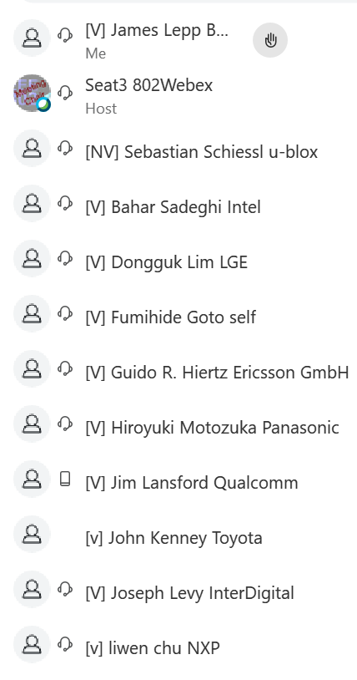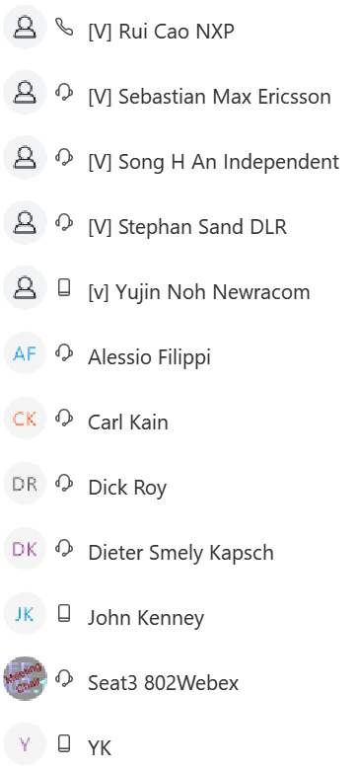

Next Meetings
Plenary:
Online, Sept 14, 2020
http://www.ieee802.org/11/Meetings/Meeting_Plan.html
Teleconferences:
July 17, 21, 24, 28, 31, Aug 4, 11, 18, 25 | Time 10-11:59am EDT | Webex
Meeting Documents:
https://mentor.ieee.org/802.11/documents
Task Group Email reflector:
http://www.ieee802.org/11/email/stds-802-11-tgbd/index.html
Website:
http://www.ieee802.org/11/Reports/tgbd_update.htm

