IEEE P802.11
Wireless LANs
IEEE 802.11bd Task Group Meeting Minutes –
July 2020
Date: 2019-07-14
Author(s):
Name | Affiliation | Address | Phone | email
James Lepp | BlackBerry | 1001 Farrar Road, Ottawa, Canada |  | jlepp@blackberry.com
Abstract

This document includes minutes of all IEEE 802.11bd during the July IEEE 802.11 meeting.

Tuesday, July 14, 2020

Opening (IEEE 802.11-20/0774r8)
  - Call to order 10:02 AM EDT
  - There are 52 people on the webex call.
  - Chair instructed members on how to use webex and to record attendance in IMAT.
  - Chair introduced the patent policy and meeting rules.
  - No response to the call for patents.
  - Chair introduced the task group leadership

Agenda (IEEE 802.11-20/0774r8)
  - Chair presented the agenda on slide 53.
  - Agenda for this session has been adopted without objection

Motion to approve previous meeting minutes
  - Motion: Move to approve the TGbd meeting minutes for Jan f2f meeting (11-20/016r0) and teleconferences from Feb 2020 to Jul 10th 2020 (11-20/0276r11)
  - Moved: James Lepp (BlackBerry)
  - Seconded: Dongguk Lim (LGE)
  - No discussion
  - Result: Motion passed with unanimous consent.

Motion to update task group timeline
  - Motion: Move to approve the TGbd timeline update as below:
  - 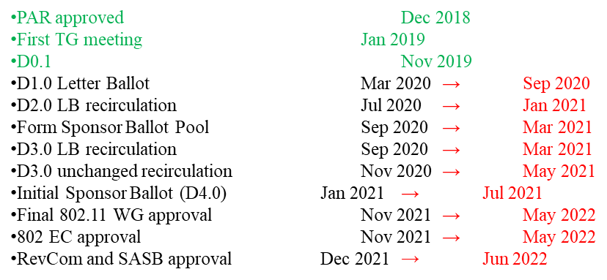
  - Moved: James Lepp (BlackBerry)
  - Seconded: Joseph Levy (Interdigital)
  - No Discussion
  - Result: Motion passed with unanimous consent.

Technical Editors Report (802.11-19/2045r5)
  - Presentation by Bahar Sadeghi (Intel) the task group editor
  - Presentation didn’t proceed due to technical difficulties. Moved to later in the agenda.

Strawpoll for comment resolution 1
  - Straw Poll: Do you agree on the comment resolutions to following 2 CIDs and the proposed spec text modification to IEEE P802.11bd D0.3 as in 11-20/0721r3? CID 152 and 154
  - No discussion
  - Strawpoll taken using the webex polling tool
  - Preliminary result from the polling tool: Yes 16 /No 1 /Abstain 10/No response 29
  - Comment that a member was unable to cast their vote using the tool. Suggestion to make the time window more than one minute.
  - Chair will rerun the strawpoll with 3-minute timer. It is also acceptable to vote using the chat window if the voting tool is inaccessible.
  - Yes 23 /No 1 /Abstain 16 /No response 15

Strawpoll for comment resolution 2
  - Do you agree on the comment resolutions to CID 350 and the proposed spec text modification to IEEE P802.11bd D0.3 as in 11-20/0722r1?
  - No discussion
  - Strawpoll taken using the webex polling tool
  - Yes 22 /No 0 /Abstain 12 /No response 18

Strawpoll for comment resolution 3
  - Do you agree on the comment resolutions to following 5 CIDs and the proposed spec text modification to IEEE P802.11bd D0.3 as in 11-20/0723r1? CID 353, 354, 355, 356 and 357
  - No discussion
  - Strawpoll taken using the webex polling tool
  - Yes 22 /No 0 /Abstain 11 /No response 19

Technical Editors Report (802.11-19/2045r5)
  - Presentation by Bahar Sadeghi (Intel) the task group editor
  - Presentation
    - Comment database is updated to revision 2 (11-20/0701r2) with resolutions and strawpolls up to last week.
  - Discussion
    - Discussion about momentum needed to resolve all comments as soon as possible to meet out timeline.

Strawpoll for 802-11/20-682r1
  - Presented by Miguel Lopez (Ericsson)
  - Discussion
    - Question about where randomization starts? Response that preamble is not randomized, but first midamble is where it starts. Makes it easier to specify. This applies to whichever mechanism is chosen.
    - Question about pseudorandom size adjusted per data length. Comment that this was studied in 11ba, but it was found that longer than 126 doesn’t make a measurable difference. Suggestion that 126 is already specified in 11ba so reuse that value.
    - Straw Poll 2
    - Which randomization method for PPDUs with midambles do you prefer?
    - A) Each LTF in a midamble is multiplied by a pseudo-random value $±1$.
In the case of MIMO PPDUs, the same pseudo-random value is applied to both spatial streams.
The data part of the PPDU is not randomized
The method is illustrated in slides 4 and 5
B) All LTFs in a midamble are multiplied by a pseudo-random value $±1.$ The data symbols immediately following any given midamble are multiplied by the same pseudo-random value as said midamble
In the case of MIMO PPDUs, the same pseudo-random value is applied to both spatial streams.
The method is illustrated in slide 8
  - Strawpoll taken using the webex polling tool
  - Result of Strawpoll 2: A 5 /B 8 /Abstain 23 /No response 13
  - Straw Poll 3
    - Which method to generate the PN sequence used to randomize the midambles do you prefer?
    - A) Use the PN sequence defined in (17-25) of IEEE 802.11-2016 (this is the sequence used to randomize the pilots)
    - B) Some other method
    - Discussion:
      - Comment that there is already a sequence to multiply the pilots, and then there is another sequence to multiply by. Are there any issues? See no issues here.
  - Strawpoll taken using the webex polling tool
  - Result of Straw Poll 3: A 18 /B 0 /abstain 15 /no response 19

Technical Presentation 802-11/20-1061r0
  - Presented by Dongguk Lim (LGE)
  - Presenter went through proposed comment resolutions for section 32.3.7.3 of the draft
  - Discussion about m or n in equation 32-16. Text in 32.3.7.3.2 will be changed to m.
  - Comment that there shouldn’t be different pilot rotation in NGV-SIG and RNGV-SIG and RL-SIG. Suggestion is that they should be consistent.
  - Comment that the repeated SIG is the same content, but the rotation is different.
  - Commenter says that as long as its aligned with 11ax style then he is ok with the solution
  - Time has run out. Presenter will continue at a future call.

Closing
  - Time has runout for this meeting session.
  - Meeting is adjourned at 12:00pm EDT
Attendance will be published in the IEEE 802.11 July Plenary minutes (IEEE 802.11-20/1019).

Next Meetings
Plenary:
Online, Sept 14, 2020
http://www.ieee802.org/11/Meetings/Meeting_Plan.html
Teleconferences:
July 14, 17, 21, 24, 28, 31, Aug 4, 11, 18, 25 | Time 10-11:59am EDT | Webex
Meeting Documents:
https://mentor.ieee.org/802.11/documents
Task Group Email reflector:
http://www.ieee802.org/11/email/stds-802-11-tgbd/index.html
Website:
http://www.ieee802.org/11/Reports/tgbd_update.htm

