IEEE P802.11
Wireless LANs
SA1 Miscellaneous CR
Date: 2020-07-13
Author(s):
Name | Affiliation | Address | Phone | email
Youhan Kim | Qualcomm |  |  | youhank@qti.qualcomm.com

Abstract
This submission proposes resolutions for the following comments from the SA1 on P802.11ax D6.0:

24168, 24420, 24424

NOTE – Set the Track Changes Viewing Option in the MS Word to “All Markup” to clearly see the proposed text edits.

Revision History:

R0: Initial version.

CID 24168

CID | Page.Line | Clause | Comment | Proposed Change
24168 | 344.15 | 26.5.1.3 | It seems to me that the condition in this item and sub-items are not quite accurate for the HE MU PPDU to contain the RU-26. If the OBSS Narrow Bandwidth RU in OFDMA Tolerance Support Field is not present or is set to 1, then RU-26 should not be allocated. All other contexts of the usage of this field appear to be correct. | Clarify. I can suggest some text if there are any changes needed.

Background

D6.0 P344:
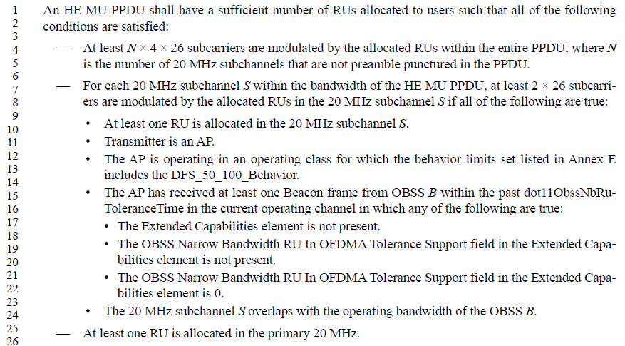

Proposed Resolution: CID 24168
Rejected
If a Beacon frame from an OBSS AP does not contain an Extended Capabilities element or the OBSS Narrow Bandwidth RU In OFDMA Tolerance Support field is not present in the Extended Capabilities element, then the AP is a ‘pre-11ax’ AP, and the default assumption is that the OBSS AP cannot tolerate HE MU PPDUs with less than 2*26 subcarriers per 20 MHz.
If a Beacon frame from an OBSS AP indicates a value 0 for the OBSS Narrow Bandwidth RU In OFDMA Tolerance Support field in the Extended Capabilities element, then either the AP is a ‘pre-11ax’ AP or the AP is explicitly indicating that the AP does not tolerate HE MU PPDUs with less than 2*26 subcarriers per 20 MHz.
Hence, the current text is appropriate.

CID 24420

CID | Page.Line | Clause | Comment | Proposed Change
24420 |  |  | [Resubmission of comment withdrawn on D5.0] Re CID 20865/20866/20867. Not all TXVECTOR parameters are always present (e.g. HE_LTF_MODE is only present for full-BW MU-MIMO not using 1x HE-LTF) | Add caveats to all the TXVECTOR parameters that are not always present, per the referenced CIDs

Background

Following were CIDs 20865, 20866, 20877 on 11ax D4.0:
CID | Page.Line | Clause | Comment | Proposed Change | Resolution
20865 | 332.06 | 26.5.3.3 | TXVECTOR parameter HE_LTF_MODE is "Present for full bandwidth MU-MIMO not using 1x HE-LTF  and not present otherwise." | In 26.5.3.3.3 change "The HE_LTF_MODE parameter is set to the value indicated by the MU-MIMO LTF Mode subfield  of the Common Info field of the Trigger frame." to "The HE_LTF_MODE parameter is set to the value indicated by the MU-MIMO LTF Mode subfield  of the Common Info field of the Trigger frame if the HE_LTF_TYPE parameter does not indicate 1x HE-LTF and the Trigger frame indicated full bandwidth MU-MIMO." In 26.5.3.3.4 change "The HE_LTF_MODE, STBC, and NUM_STS parameters are set to 0" to "The STBC and NUM_STS parameters are set to 0" | REJECTED (EDITOR: 2019-09-17 05:03:53Z) - The first proposed change causes more confusion since the else condition of the proposed change is unclear. There is no issue if HE_LTF_MODE is set to the value indicated by the Trigger frame.  The second part of the proposed change is incorrect because HE_LTF_MODE is set to single stream pilots in TXVECTOR parameters for HE TB PPDU response to TRS Control subfield.
20866 | 332.06 | 26.5.3.3.3 | Not all TXVECTOR parameters are always present (e.g. HE_LTF_MODE is only present for full-BW MU-MIMO not using 1x HE-LTF) | Add caveats to the TXVECTOR parameters that are not always present | REJECTED (EDITOR: 2019-09-17 05:04:02Z) - Refer to resolution of CID20865
20867 | 335.58 | 26.5.3.3.4 | Not all TXVECTOR parameters are always present (e.g. HE_LTF_MODE is only present for full-BW MU-MIMO not using 1x HE-LTF) | Add caveats to the TXVECTOR parameters that are not always present | REJECTED (EDITOR: 2019-09-17 05:04:06Z) - Refer to resolution of CID20865

Note that a similar comment was also submitted as CID 24405 to D6.0 with the following resolution.
CID | Page.Line | Clause | Comment | Proposed Change | Resolution
24405 |  | 26.5.2 | [Resubmission of comment withdrawn on D5.0] Re CID 20865. This was rejected in part because "There is no issue if HE_LTF_MODE is set to the value indicated by the Trigger frame". There is an issue because Table 27-1--TXVECTOR and RXVECTOR parameters specifies that HE_LTF_MODE is "Present for full bandwidth MU-MIMO not using 1x HE-LTF  ***and not present otherwise***." | In 26.5.2.3.3 change "The HE_LTF_MODE parameter is set to the value indicated by the MU-MIMO LTF Mode subfield  of the Common Info field of the Trigger frame." to "The HE_LTF_MODE parameter is set to the value indicated by the MU-MIMO LTF Mode subfield  of the Common Info field of the Trigger frame if the HE_LTF_TYPE parameter does not indicate 1x HE-LTF and the Trigger frame indicated full bandwidth MU-MIMO (otherwise the parameter is not present)." In 26.5.3.3.4 change "The HE_LTF_MODE and STBC parameters are set to 0, and the NUM_STS parameter is set to 1" to "The STBC parameter is set to 0 and the NUM_STS parameter is set to 1 (the HE_LTF_MODE parameter is not present)" | ACCEPTED (EDITOR: 2020-05-27 15:52:16Z)

Proposed Resolution: CID 24420
Revised
Note to Commenter: Resolution is ‘Revised’ rather than ‘accepted’ because Proposed Change by the commenter for CID 24420 does not have a specific editing instruction. Note that CID 24405 from the same commenter has already been accepted with the editing instructions covering the same issues raised in this CID 24420.

Note to Editor: There is no specific text change to be made for this CID as relevant changes has been made in CID 24405.

CID 24424

CID | Page.Line | Clause | Comment | Proposed Change
24424 |  | 27.3.2 | [Resubmission of comment withdrawn on D5.0] CID 20619. The baseline has the subcarrier assignments in tables, not in running text. This includes guard bands and DC subcarriers. This helps the reader find the information, since it will be in the table of tables at the start | Put the subcarrier assignments in tables, not in running text. This includes guard bands and DC subcarriers (null subcarriers and pilots are OK -- Tables 27-10 and 27-37)

Background

D6.0 P512:
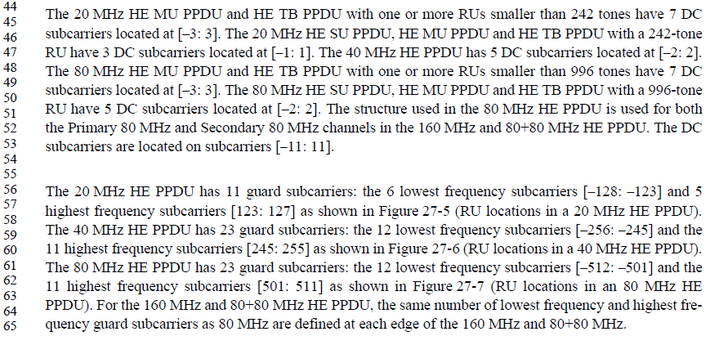

Following was the CID 20619 on 11ax D4.0:
CID | Page.Line | Clause | Comment | Proposed Change | Resolution
20619 | 475.32 | 27.3.2 | All the subcarrier assignments should be in tables, not in running text. This includes guard bands and DC subcarriers (null subcarriers and pilots are OK -- Tables 27-10 and 27-11) | As it says in the comment | REJECTED (EDITOR: 2019-07-19 19:40:32Z) - There is no requirement that subcarrier assignments should be in tables.

Proposed Resolution: CID 24424
Rejected
Neither 11ax D6.0 nor REVmd D3.3 have a requirement that subcarrier assignments should be in tables.

[End of File]

