IEEE P802.11
Wireless LANs
Discussion of comments submitted by 802.3 on the SENS SG PAR
Date: 2020-07-07
Author(s):
Name | Affiliation | Address | Phone | email
Claudio da Silva | Intel |  |  | claudio.da.silva@intel.com
Abstract
A discussion of the comments submitted by the IEEE 802.3 WG on the proposed P802.11bf PAR is presented. Modifications to the PAR are proposed.

Comment 1 | General — This Word version of the PAR form is not current. There are many differences including: no IEEE SA logo, heading title changes, subsection numbering added, deletion of phone numbers, changed beginning boilerplate, Sponsor ballot changed to SA Ballot, etc. These kind of errors are not made, and content is more likely to be correct if the PAR is drafted on myProject and exported for review.
Response: The current P802.11bf PAR draft in the myProject format can be found below. The PAR draft will be revised during the July 2020 802.11 WG electronic plenary to address comments from other WGs, including 802.3, and an updated draft PAR will be generated in the myProject format soon after.

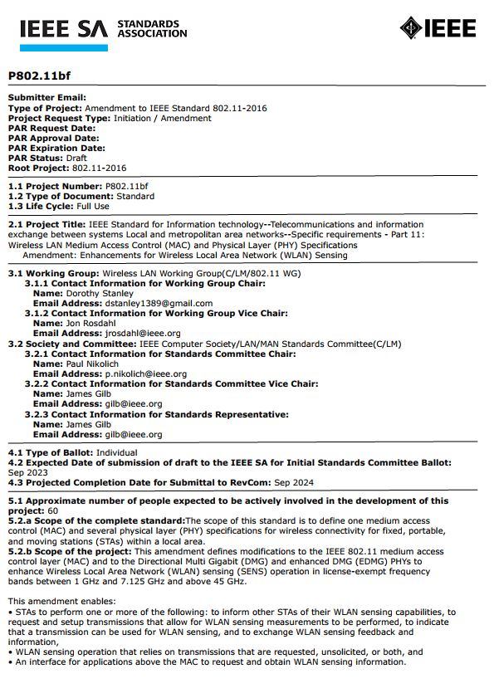

Comment 2 | 5.2b Scope of the Project — The bulleted items in the amendment project scope do not seem to be within the scope of IEEE Std 802.11. Much of the functionality described in the bullets appears to be above the MAC. If the SENS functions though are enabled only by MAC changes and or enhancements to the MAC service interface, that should be made more clear, especially because the supporting documentation indicates the possibility of work on applications. So, if the amendment will be specifying things above the MAC, those types of specifications are not within the scope of IEEE Std 802.11.
Response: As defined in 5.2.b., the scope of the proposed P802.11bf project is to define modifications to:
- the IEEE 802.11 MAC;
- the IEEE 802.11 DMG and IEEE 802.11 EDMG PHYs; and
- the PHY service interface of the IEEE 802.11 HT, IEEE 802.11 VHT, IEEE 802.11 HE and IEEE 802.11 EHT PHYs.
The scope of the proposed P802.11bf project does not include specifications at layers above the MAC.

To clarify the scope of P802.11bf, the following changes in 5.2.b are proposed:
- “This amendment enables: … WLAN sensing operation that relies on WLAN sensing measurements to be obtained using transmissions that are requested, unsolicited, or both, and”
- “This amendment enables: … An A MAC service interface for applications layers above the MAC to request and obtain retrieve WLAN sensing information. measurements.”

Comment 3 | 8.1 Additional explanatory notes — It would be helpful to have better explanation of what SENS is, either here or in 5.2.
Response: To clarify the scope of the proposed P802.11bf project, the following paragraph is proposed to be included in 8.1:

“5.2.b: WLAN sensing is the use of PHY and MAC features of IEEE 802.11 stations to obtain channel measurements that characterize the environment in which the stations operate. Measurements obtained with WLAN sensing are used to enable applications such as presence detection and gesture classification, among others. The specification of such applications is beyond the scope of the project.”

Comment 4 | 5.3 Completion dependent on completion of another standard (contingent is used instead of dependent on current PAR form) — The response does not provide an answer to the question it simply lists current projects.
Comment 5 | 5.3 — Please note P802.11md is not an IEEE SA project and someone searching on myProject will be unable to find it; and 8.1 provides little additional clarity that this 802.11 naming convention is used. The revision PAR number is P802.11.
Comment 6 | 5.3 — While it is likely that the project is contingent on P802.11 because of the three year / three amendment rule, it is not clear if the listed amendments are to be amendments to IEEE Std 802.11-2016 or if they could be amendments to IEEE Std 802.11-20xx. If the listed amendments are to be incorporated into IEEE Std 802.11-20xx, they are not contingencies for this project, only the P802.11 revision need be listed. If it is still uncertain which amendments will be to 2016 and which to 20xx, that should be indicated in an additional sentence in the explanation.
Comment 7 | 8.1 Additional explanatory notes — The list of current drafts is not sufficient to provide the context needed for 5.3, and the draft numbers will quickly become superseded (if they haven’t already been). The PAR is part of SA ballot and therefore content should still be relevant at that time.
Response: To address the four comments above, the following modifications are proposed:
- In 5.3, change from
"The IEEE P802.11ax, IEEE P802.11ay, IEEE P802.11az and IEEE P802.11be amendments and the IEEE P802.11md revision standard are currently under development."
to
"As defined in 5.2.b, to enhance WLAN sensing, this amendment augments PHY and MAC capabilities defined in the IEEE P802.11ax, IEEE P802.11ay, IEEE P802.11az and IEEE P802.11be amendments and the IEEE P802.11 revision standard."
- In 8.1,
· IEEE Std 802.11-2016, Wireless LAN Medium Access Control (MAC) and Physical Layer (PHY) Specifications
· IEEE P802.11-REVmd/D3.1, Part 11: Wireless LAN Medium Access Control (MAC) and Physical Layer (PHY) Specifications
· IEEE P802.11ax/D6.0, Wireless LAN Medium Access Control (MAC) and Physical Layer (PHY) Specifications - Amendment 1: Enhancements for High Efficiency WLAN
· IEEE P802.11ay/D5.0, Wireless LAN Medium Access Control (MAC) and Physical Layer (PHY) Specifications - Amendment 2: Enhanced throughput for operation in license-exempt bands above 45 GHz
· IEEE P802.11az/D2.0, Wireless LAN Medium Access Control (MAC) and Physical Layer (PHY) Specifications - Amendment 3: Enhancements for Positioning
· IEEE P802.11be, Wireless LAN Medium Access Control (MAC) and Physical Layer (PHY) Specifications - Amendment: Enhancements for Extremely High Throughput

Comment 8 | 5.5 Need — The first phrase reads like a tautology. Is it correct that the standardized WLAN sensing capabilities to be specified will provide a framework for the innovation described later in the sentence. The phrase also indicates “Technology enhancements … are needed”, so, the phrase doesn’t address why a standard project is needed. The rest of the sentence doesn’t fall into the purpose of a standard (a standard specifies interoperability for functionalities, not a roadmap for technology development). Would it be correct if the second sentence described the WLAN sensing project as extending proximity sensing, gesture recognition, etc. of WLAN capable devices to other WLAN connected devices that will use those remote sensing capabilities?
Response: We propose to replace the current response to 5.5 with the following paragraph:

“Measurement capabilities defined in the IEEE P802.11 revision standard and in the amendments identified in 5.3, specified as part of features such as beamforming and fine-timing measurement, do not suitably support WLAN sensing. An amendment with the scope defined in 5.2.b is necessary to enhance reliability and efficiency of WLAN sensing and to allow for interoperability of WLAN sensing functionalities.”

