IEEE P802.11
Wireless LANs
Resolution of SA ballot CIDs
Date: 2020-06-18
Author(s):
Name | Affiliation | Address | Phone | email
Solomon Trainin | Qualcomm |  |  | strainin@qti.qualcomm.com
Alecsander Eitan | Qualcomm |  |  | eitana@qti.qualcomm.com
Assaf Kasher | Qualcomm |  |  | akasher@qti.qualcomm.com
Abstract
Resolution of CIDs 6146, 6117, 6190, and 6205

CID | Page | Line | Clause | Comment | Proposed Change | Resolution
6146 | 25.00 | 6 | 4.3.22 | The sentence "A DMG STA has MAC features that include frame aggregation, block ack features, service periods..." is awkward because "features" is used twice and is also used in the previous sentence. | Change to "These features include frame aggregation, block acknowdgement, service periods," | Revised  See below in the document
6117 | 77.00 | 22 | 6.3.122.4.4 | Phase, "if any" is ambiguous as sentence starts with "If" | Remove "if any" from the line and change to:  ... MAC entity. Receipt of this ... | Accept
6190 | 147.00 | 29 | 9.4.2.265 | Text points: "The Allocation subfield is defined in Figure 9-517". There is no such figure in this doc and the one in REVmd is "Figure 9-517--MCCAOP Teardown element format", with a different number of bits. | Need fix! | Revised  See below in the document
6205 | 162.00 | 1 | 9.4.2.273 | In the last row column "meaning"  If the Feedback Type subfield is 1 and the Grouping subfield is less than 3, Nsc is determined by 0.  What does it mean by "determined by 0"? | Nsc is determined by Table9-321ac | Accept  See below in the document

CID6146
Discussion:
Although the commentator is right about the style, the proposed change is not entirely correct - the functions mentioned in the sentences are different.

P25L6
TGay editor, change as follows
A DMG STA supports MAC features that provide channel access in an environment in which transmissions use a directional antenna pattern. MAC entity of the DMG STA provides frame aggregation, block acknowledgement, …

CID6190
Discussion:
The commenter is right; the reference is wrong. The mentioned subfield is defined in Figure 9-563—Allocation field format.

P147L29
TGay editor, replace “Figure 9-517” by “Figure 9-563—Allocation field format”

CID6205
Discussion:

The document 11-20-0554r2 changes the first sentence of the meaning column that makes sense to the proposed change

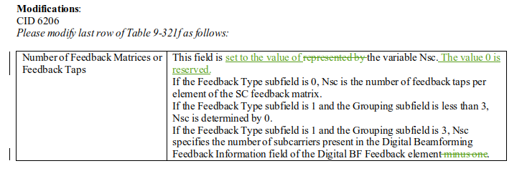

P162 Table 9-321t, last row
TGay editor, replace “Nsc is determined by 0” by “Nsc is determined by Table9-321ac”

