IEEE P802.11  
Wireless LANs

|  |  |  |  |  |
| --- | --- | --- | --- | --- |
| Resolutions to Miscellaneous CIDs | | | | |
| Date: 2020-06-17 | | | | |
| Author(s): | | | | |
| Name | Affiliation | Address | Phone | email |
| Osama Aboul-Magd | Huawei Technologies |  |  | osama.aboulmagd@huawei.com |
|  |  |  |  |  |

Abstract

This submissions contains proposed reolutions to CIDs 24237, 24241, 24566, and 24567

R0: Initial draft

R1: including comments received suring the teleconference June 18, 2020

R2: Includes comments received on the TG mailing list.

R3: Includes comments shared with me.

[place document body text here]

|  |  |  |  |  |  |
| --- | --- | --- | --- | --- | --- |
| **CID** | **Page** | **Clause** | **Comment** | **Proposed Change** | **Resolution** |
| 24237 | 521.27 | 27.3.4 | The caption does not really reflect what is in the figure. It says "The number of...", but I believe much more information is provided. The number could have been a simple table | Update the caption to reflect what is in the figure | Revised  Agree with the commenter. The caption doesn’t refelect the information provided by the Figure.  TGax Editor:  Please make changes in <this document> related to CID 24237. |
| 24241 | 524.47 | 27.3.5 | The figure does not match the corresponding description on page 534. In the figure, the CSD is in the time domain, in the description it is in the frequency domain. | Make sure the description of the figure matches the figure. | Revised  Agree with the commenter.  TGax Editor: Please make changes in <this document> related to CID 24241 |
| 24566 | 369.27 | 26.5.6 | If the PPDU carrying BQRP is not occupying 160MHz, there should be no requirement for non-AP STA to report channel availability info for the entire 160MHz. Reporting those 20MHz subchannels occupied by the PPDU carrying BQRP should be sufficient | relax the STA reporting requirement | Rejected  The PPDU sent by the AP refelects the channel conditions at the AP which has nothing to do with those at the non-AP STA. the AP would want to know as much as possible about the channel even if the Trigger frame is not using the whole channel |
| 24567 | 369.15 | 26.5.6 | Can AID12=0 or 2045 in BQRP? | Clarify whether STA needs to respond to such BQRP | Rejected  On P362L27 “An HE AP that transmits a Trigger frame for random access shall set the AID12 subfield of a User Info field in the Trigger frame to 0 to indicate that one or more RA-RUs are available for non-AP STAs associated with it, and shall set the AID12 subfield in a User Info field in the Trigger frame to 2045 to indicate that one or more RA-RUs are available for non-AP STAs not associated with it.”  Since BQRP is a TRiiger frame and there is no exception mentioned elsewhere then BQRP can set AID12 to 0 or to 2045.  The response of the receiving STA follows the rules on P269L20 |

**CID 24237**

The commenter is referring to Figure 27-12

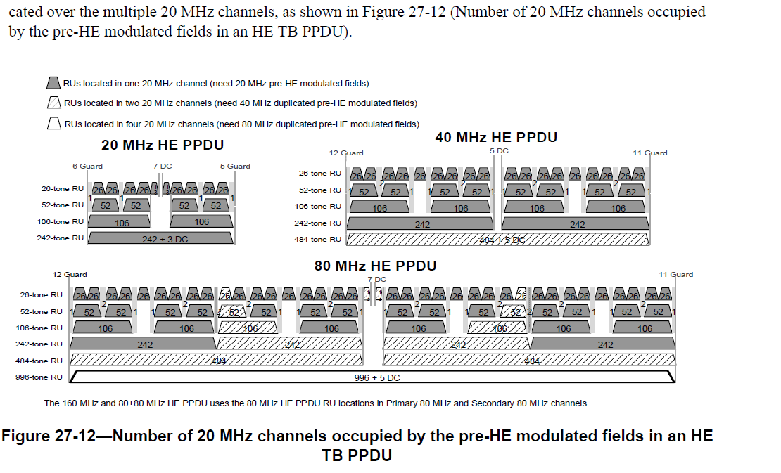

***TGax Editor:***

***Please make the following changes:***

PP520L40 (draft 6.0)

The RL-SIG, HE-SIG-A, HE-STF, HE-LTF, and PE fields are present in all HE PPDU formats. The HE-SIG-B field is present only in the HE MU PPDU. The PE field is defined in 27.3.12 (Packet extension).

The L-STF, L-LTF, L-SIG, RL-SIG, HE-SIG-A, and HE-SIG-B fields are referred to as pre-HE modulated fields, while the HE-STF, HE-LTF and Data fields are referred to as the HE modulated fields.

In the HE TB PPDU, the pre-HE modulated fields, which include L-STF, L-LTF, L-SIG, RL-SIG and HE-SIG-A fields, are sent only on the 20 MHz channels where the STA’s HE modulated fields are located. If the HE modulated fields are located in more than one 20 MHz channel, the pre-HE modulated fields are duplicated over the multiple 20 MHz channels.Figure 27-12 shows how many 20 MHz channels need to be modulated for the pre-HE modulated fields for each RU size and location in an HE TB PPDU. (#24237)

***Change the caption of Figure 27-12 from***

To;

**Figure 27-12— Number of 20 MHz channels that need to be modulated for the pre-HE modulated fields for each RU size and location in an HE TB PPDU (#24237)**

**CID 24241**

The commenter seems to refer to Figure 27-16



On page 534 (D6.0) 27.3.6.7 it is stated:

g) CSD: Apply CSD for each transmit chain and frequency segment as described in 27.3.11.2.1 (Cyclic shift for pre-HE modulated fields).

Proposed Resolution: Revised

Agree with the commenter

TGax Editor

**27.3.6.7 Construction of HE-SIG-B**

For an HE MU PPDU, the HE-SIG-B field consists of a Common field followed by a User Specific field as defined in 27.3.11.8 (HE-SIG-B) and is constructed as follows:

a) Obtain the HE-SIG-B field values from the TXVECTOR. Add the reserved bits, append the calcu-lated CRC, and then append the *Ntail* tail bits as shown in 27.3.11.8 (HE-SIG-B).

b) BCC encoder: Encode the Common field data and each User Block field data individually by a con-volutional encoder as described in 27.3.12.5.1 (BCC coding and puncturing).

c) BCC interleaver: Interleave as described in 27.3.12.8 (BCC interleavers).

d) Constellation mapper: Obtain MCS_SIG_B from the TXVECTOR and use it to modulate the inter-leaved bits as described in 27.3.12.9 (Constellation mapping) to form the HE-SIG-B OFDM sym-bols.

e) Pilot insertion: Insert pilots as described in 17.3.5.9 (Pilot subcarriers).

f) Duplicate and phase rotation: Duplicate HE-SIG-B OFDM symbols as described in 27.3.11.8.5 (Encoding and modulation). Apply the appropriate phase rotation for each 20 MHz subchannel as described in 27.3.10 (Mathematical description of signals) and 21.3.7.5 (Definition of tone rotation).

g) IDFT: Compute the inverse Fourier transform.

h) CSD per chain: Apply CSD per chain for each transmit chain and frequency segment as described in 27.3.11.2.1 (Cyclic shift for pre-HE modulated fields). (#24241)

i) Insert GI and apply windowing: Prepend a GI (*TGI*,Pre-HE) and apply windowing as described in 27.3.10 (Mathematical description of signals).

j) Analog and RF: Upconvert the resulting complex baseband waveform associated with each transmit chain to an RF signal according to the center frequency of the desired channel and transmit. Refer to 27.3.10 (Mathematical description of signals) and 27.3.11 (HE preamble) for details.

**References:**