IEEE P802.11  
Wireless LANs

|  |  |  |  |  |
| --- | --- | --- | --- | --- |
| Resolutions to Miscellaneous CIDs | | | | |
| Date: 2020-06-17 | | | | |
| Author(s): | | | | |
| Name | Affiliation | Address | Phone | email |
| Osama Aboul-Magd | Huawei Technologies |  |  | osama.aboulmagd@huawei.com |
|  |  |  |  |  |

Abstract

This submissions contains proposed reolutions to CIDs 24237, 24241, 24566, and 24567

R0: Initial draft

[place document body text here]

|  |  |  |  |  |  |
| --- | --- | --- | --- | --- | --- |
| **CID** | **Page** | **Clause** | **Comment** | **Proposed Change** | **Resolution** |
| 24237 | 521.27 | 27.3.4 | The caption does not really reflect what is in the figure. It says "The number of...", but I believe much more information is provided. The number could have been a simple table | Update the caption to reflect what is in the figure |  |
| 24241 | 524.47 | 27.3.5 | The figure does not match the corresponding description on page 534. In the figure, the CSD is in the time domain, in the description it is in the frequency domain. | Make sure the description of the figure matches the figure. |  |
| 24566 | 369.27 | 26.5.6 | If the PPDU carrying BQRP is not occupying 160MHz, there should be no requirement for non-AP STA to report channel availability info for the entire 160MHz. Reporting those 20MHz subchannels occupied by the PPDU carrying BQRP should be sufficient | relax the STA reporting requirement |  |
| 24567 | 369.15 | 26.5.6 | Can AID12=0 or 2045 in BQRP? | Clarify whether STA needs to respond to such BQRP |  |

CID 24237

The commenter is referring to Figure 27-12

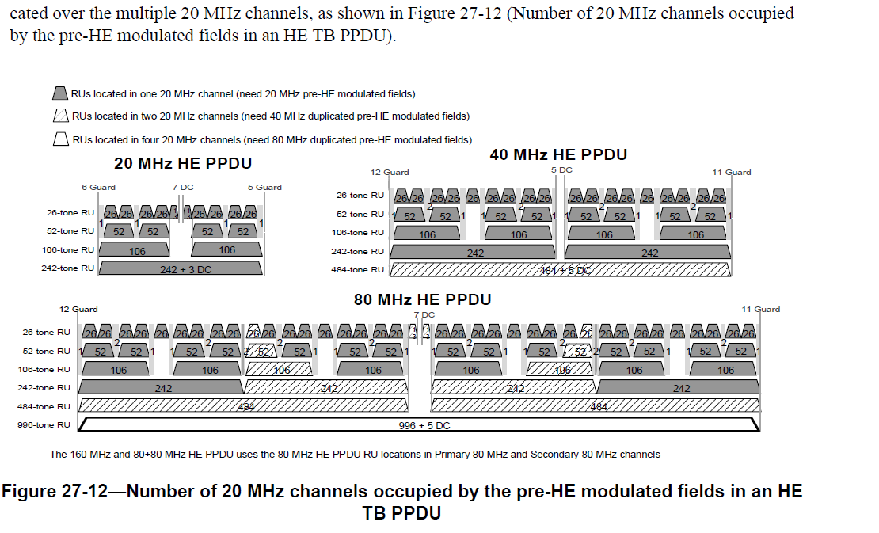

This Figure was added to draft D2.0. The comment spreadsheet <https://mentor.ieee.org/802.11/dcn/17/11-17-0010-14-00ax-comments-on-tgax-d1-0.xlsx> is not clear how this Figure was added to draft D2.0 and which submission is responsible for this addition. This Figure replaces what was in draft D1.0:

Proposed Resolution: Revised

TGax Editor: Please delete Figure 27-12 and its caption.

CID 24241

The commenter seems to refer to Figure 27-16



On page 534 (D6.0) 27.3.6.7 it is stated:

g) CSD: Apply CSD for each transmit chain and frequency segment as described in 27.3.11.2.1 (Cyclic shift for pre-HE modulated fields).

Proposed Resolution: Rejected

The Construction of HE SIG-B in clause 27.3.6.7 doesn’t refer to Figure 27-16.

CID 24566

The commenter seems to refer to:

An AP may solicit BQRs from a non-AP STA only if the non-AP STA has indicated support by setting the BQR Support field in the HE Capabilities element it transmits to 1; otherwise the AP shall not solicit BQRs from the non-AP STA. An AP may solicit BQRs from one or more non-AP HE STAs that support generat-ing BQRs, by sending a BQRP Trigger frame (see 9.3.1.22.8 (Bandwidth Query Report Poll (BQRP) vari-ant)). A non-AP STA that supports generating a BQR responds (solicited BQR) as defined below:

— The STA that receives a BQRP Trigger frame shall follow the rules defined in 26.5.2.3 (Non-AP STA behavior for UL MU operation) to generate the HE TB PPDU if the Trigger frame contains the STA’s AID in any of the User Info fields; otherwise the STA shall follow the rules defined in 26.5.4 (UL OFDMA-based random access (UORA)) to gain access to an RA-RU and generate the HE TB PPDU if the Trigger frame contains one or more RA-RUs.

— The STA shall include in the HE TB PPDU one or more QoS Null frames containing the BQR Control subfield with the channel availability information of the STA. The HE STA shall not solicit an immediate response for the frames carried in the HE TB PPDU. The Ack Policy Indication subfield of the frame shall be set to No Ack. NOTE—An AP does not send a BQRP Trigger frame addressed to a STA that has set the UL MU Disable field to 1.

Proposed Resolution: Rejected

The current text does not mandate the

CID 24567

The commenter seems to be referring to:

An AP may solicit BQRs from a non-AP STA only if the non-AP STA has indicated support by setting the BQR Support field in the HE Capabilities element it transmits to 1; otherwise the AP shall not solicit BQRs from the non-AP STA. An AP may solicit BQRs from one or more non-AP HE STAs that support generating BQRs, by sending a BQRP Trigger frame (see 9.3.1.22.8 (Bandwidth Query Report Poll (BQRP) variant)). A non-AP STA that supports generating a BQR responds (solicited BQR) as defined below:

— The STA that receives a BQRP Trigger frame shall follow the rules defined in 26.5.2.3 (Non-AP

STA behavior for UL MU operation) to generate the HE TB PPDU if the Trigger frame contains the

STA’s AID in any of the User Info fields; otherwise the STA shall follow the rules defined in 26.5.4

(UL OFDMA-based random access (UORA)) to gain access to an RA-RU and generate the HE TB

PPDU if the Trigger frame contains one or more RA-RUs.

— The STA shall include in the HE TB PPDU one or more QoS Null frames containing the BQR Control

subfield with the channel availability information of the STA. The HE STA shall not solicit an

immediate response for the frames carried in the HE TB PPDU. The Ack Policy Indication subfield

of the frame shall be set to No Ack.

Resolution: Rejected

The AID subfield encoding of the User Info field are given in Table 9-31g (Draft 6.0 pp 123) including the use of the values 0 and 2045.

**References:**