IEEE P802.11
Wireless LANs
MCS32 Deprecation
Date: 2020-06-12
Author(s):
Name | Affiliation | Address | Phone | email
Youhan Kim | Qualcomm |  |  | youhank@qti.qualcomm.com

Abstract
This submission proposes resolutions for the following comments from the SA ballot on P802.11-REVmd D3.0:

4513

NOTE – Set the Track Changes Viewing Option in the MS Word to “All Markup” to clearly see the proposed text edits.

Revision History:

R0: Initial version.
R1: Updated proposed resolution

CID 4513

CID | Clause | Page.Line | Comment | Proposed Change
4513 | 19.3.11.11.5 | 3043.00 | 40 MHz non-HT duplicate and HT-MCS 32 will both achieve 3 dB power gain; typically, non-HT will have better PER performance because the L-LTF density [xxft] | Deprecate HT-MCS 32

Note:
After r0 was uploaded, it was reported that there are some devices using HT MCS 32 in the field, but not widely adopted

Proposed Resolution: CID 4513
Revised
Note to Commenter:
HT MCS 32 is an optional feature and is not widely adopted by WLAN products. Since two WLAN generations (11ac/ax) have already passed since the introduction of the HT MCS 32, the use of HT MCS 32 is anticipated to only decrease even further in the future. Hence, HT MCS 32 is proposed to be deprecated.

Instruction to Editor:
Add the following sentence at D3.3 P3035L26:
“The use of MCS 32 format is deprecated.”

[End of Proposed Resolution]

FYI: D3.3 P3035L26
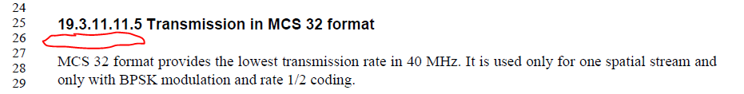

[End of File]

