IEEE P802.11
Wireless LANs
MCS32 Deprecation
Date: 2020-06-11
Author(s):
Name | Affiliation | Address | Phone | email
Youhan Kim | Qualcomm |  |  | youhank@qti.qualcomm.com

Abstract
This submission proposes resolutions for the following comments from the SA ballot on P802.11-REVmd D3.0:

4513

NOTE – Set the Track Changes Viewing Option in the MS Word to “All Markup” to clearly see the proposed text edits.

Revision History:

R0: Initial version.

CID 4513

CID | Clause | Page.Line | Comment | Proposed Change
4513 | 19.3.11.11.5 | 3043.00 | 40 MHz non-HT duplicate and HT-MCS 32 will both achieve 3 dB power gain; typically, non-HT will have better PER performance because the L-LTF density [xxft] | Deprecate HT-MCS 32

Proposed Resolution: CID 4513
Revised
Note to Commenter:
Non-HT duplicate does not necessarily perform better than HT MCS 32 because HT MCS 32 can use LDPC coding, while non-HT duplicate can only use BCC. However, HT MCS 32 is believed to be not used in IEEE 802.11 based WLAN products. Since two WLAN generations (11ac/ax) have already passed since the introduction of the HT MCS 32, it is not anticipated that there would not be any new products making use of HT MCS 32 either in the future. Hence, HT MCS 32 is proposed to be deprecated in this resolution as suggested by the commenter.

Instruction to Editor:
Add the following sentence at D3.3 P3035L26:
“The use of MCS 32 format is deprecated.”

[End of Proposed Resolution]

FYI: D3.3 P3035L26
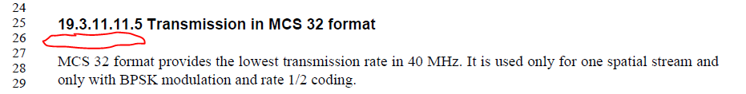

[End of File]

