IEEE P802.11  
Wireless LANs

|  |  |  |  |  |  |  |  |  |  |  |  |  |  |  |  |  |  |  |  |  |  |  |  |  |  |  |  |  |  |  |  |  |  |  |  |  |  |  |  |  |  |  |  |  |  |  |  |  |  |  |
| --- | --- | --- | --- | --- | --- | --- | --- | --- | --- | --- | --- | --- | --- | --- | --- | --- | --- | --- | --- | --- | --- | --- | --- | --- | --- | --- | --- | --- | --- | --- | --- | --- | --- | --- | --- | --- | --- | --- | --- | --- | --- | --- | --- | --- | --- | --- | --- | --- | --- | --- |
| |  |  |  |  |  | | --- | --- | --- | --- | --- | | D3.0 PHY CR – Part 2 | | | | | | Date: 2020-06-24 | | | | | | Author(s): | | | | | | Name | Affiliation | Address | Phone | email | | Youhan Kim | Qualcomm |  |  | youhank@qti.qualcomm.com | |  |  |  |  |  | |  |  |  |  |  | |  |  |  |  |  | |  |  |  |  |  | |  |  |  |  |  | |

Abstract

This submission proposes resolutions for the following comments from the SA ballot on P802.11-REVmd D3.0:

4538, 4296

NOTE – Set the Track Changes Viewing Option in the MS Word to “All Markup” to clearly see the proposed text edits.

**Revision History:**

R0: Initial version.

R1:

CID 4538: Changed “DATA part” to “bits transmitted in the Data field” (instead of “bits transmitted in the DATA field) at D3.3 P2993L43.

CID 4296: Added correction for Figure 19-24 as well.

R2:

CID 4296: Added two more corrections in Figure 19-24.

# CID 4538

|  |  |  |  |  |
| --- | --- | --- | --- | --- |
| **CID** | **Clause** | **Page.Line** | **Comment** | **Proposed Change** |
| 4538 |  |  | There are references to "data part"s (with various capitalisations) but this term is not defined | Change "data part" (case-insensitively) to "Data field" throughout, except in Clause 17 where it should be "DATA field" |

**Background**

D3.3 has 22 instances of “data part”.

Clause 17 has two.

D3.3 P2921L42

|  |
| --- |
| The RATE and LENGTH fields are required for decoding the DATA part of the PPDU. |

Agree that this should be “DATA field”.

D3.3 P2922L55

|  |
| --- |
| Append the PSDU to the SERVICE field of the TXVECTOR. Extend the resulting bit string with zero bits (at least 6 bits) so that the resulting length is a multiple of NDBPS. The resulting bit string constitutes the DATA part of the PPDU. |

Disagree that this should be “DATA field” as these are not ‘modulated’ OFDM symbols, but rather a ‘bit string’. Suggest changing to “bits transmitted in the DATA field”.

Clause 19 has one.

D3.3 P2993L43

|  |
| --- |
| The number of resulting symbols is given by Equation (19-41), and the number of repeated coded bits used for padding is given by Equation (19- 42). The resulting bit string constitutes the DATA part of the packet. |

Disagree that this should be “DATA field” as these are not ‘modulated’ OFDM symbols, but rather a ‘bit string’. Suggest changing to “bits transmitted in the Data field”.

Clause 20 has six.

D3.3 P3083L45

|  |
| --- |
| TRN-R indicates either a PPDU whose data part is followed by one or more TRN subfields, |

D3.3 P3083L49

|  |
| --- |
| TRN-T indicates a PPDU whose data part is followed by one or more TRN subfields |

D3.3 P3101L26

|  |
| --- |
| indicates either a PPDU whose data part is followed by one or more TRN subfields |

D3.3 P3101L34

|  |
| --- |
| indicates a PPDU whose data part is followed by one or more TRN subfields |

D3.3 P3124L51

|  |
| --- |
| BRP-RX PPDUs are PPDUs that have an AGC field and a TRN field following the data part. |

D3.3 P3124L56

|  |  |
| --- | --- |
| BRP-TX PPDUs are PPDUs that have an AGC field and a TRN field following the data part. |  |

Agree that all these should be “Data field”.

Clause 24 has six.

D3.3 P3464L33

|  |
| --- |
| TRN-R indicates either a PPDU whose data part is followed by one or more TRN subfields, |

D3.3 P3464L35

|  |
| --- |
| TRN-T indicates a PPDU whose data part is followed by one or more TRN subfields |

D3.3 P3475L21

|  |
| --- |
| indicates either a PPDU whose data part is followed by one or more TRN subfields |

D3.3 P3475L29

|  |
| --- |
| indicates a PPDU whose data part is followed by one or more TRN subfields |

D3.3 P3484L46

|  |
| --- |
| BRP-RX PPDUs are PPDUs that have an AGC field and a TRN field following the data part. |

D3.3 P3484L51

|  |  |
| --- | --- |
| BRP-TX PPDUs are PPDUs that have an AGC field and a TRN field following the data part. |  |

Agree that all these should be “Data field”.

Clause 25 has seven.

D3.3 P3492L37

|  |
| --- |
| A value of zero indicates a packet in which no data part follows the SIG. |

D3.3 P3494L55

|  |
| --- |
| TRN-R indicates either a PPDU whose data part is followed by one or more TRN subfields, |

D3.3 P3494L59

|  |
| --- |
| TRN-T indicates a PPDU whose data part is followed by one or more TRN subfields |

D3.3 P3512L11

|  |
| --- |
| indicates either a PPDU whose data part is followed by one or more TRN subfields |

D3.3 P3512L17

|  |
| --- |
| indicates a PPDU whose data part is followed by one or more TRN subfields |

D3.3 P3551L14

|  |
| --- |
| BRP-RX PPDUs are PPDUs that have an AGC field and a TRN field following the data part. |

D3.3 P3551L18

|  |  |
| --- | --- |
| BRP-TX PPDUs are PPDUs that have an AGC field and a TRN field following the data part. |  |

Agree that all these should be “Data field”.

**Proposed Resolution: CID 4538**

**Revised**

Note to Commenter:

There are 22 instances of “data part” in REVmd D3.3. These are modified to appropriate terms in the instruction below.

Instruction to Editor:

Change “DATA part” to “DATA field” at D3.3 P2921L42.

Change “DATA part” to “bits transmitted in the DATA field” at D3.3 P2922L55.

Change “DATA part” to “bits transmitted in the Data field” at D3.3 P2993L43.

Change “data part” to “Data field” at D3.3 P3083L45, P3083L49, P3101L26, P3101L34, P3124L51, P3124L56, P3464L33, P3464L35, P3475L21, P3475L29, P3484L46, P3484L51, P3492L37, P3494L55, P3494L59, P3512L11, P3512L17, P3551L14, P3551L18.

# CID 4296

|  |  |  |  |  |  |
| --- | --- | --- | --- | --- | --- |
| **CID** | **Clause** | **Page.Line** | **Comment** | | **Proposed Change** |
| 4296 |  |  | There are references to "HT training" and "non-HT training fields" and "HT-Training" and "HT-Training part I". Ditto "VHT training" | At the end of 19.3.9.3.1 add a para "The HT training fields are the HT-STF and HT-LTF fields.".  In Figure 19-23 add " Part II" after the middle "HT-Training".  In Figure 19-24 add " Part II" after the "HT-Training" at line 20 and change "TX HT Training Symbols" to "TX HT Training".  At the end of 21.3.8.3.1 Introduction add a para "The VHT training fields are the VHT-STF and VHT-LTF fields.".  In 21.3.19 PHY transmit procedure change first "VHT Training Symbols" to "VHT training" and second to "of symbols for the VHT training".  In Figure 21-34--PHY transmit procedure for SU transmission change "VHT Training Symbols" to "VHT-Training".  In Figure 21-35--PHY transmit state machine for SU transmission change "TX VHT Training Symbols" to "TX VHT Training".  In 21.3.20 PHY receive procedure change "receiving the VHT training symbols" to "receiving the VHT training" | |

**Proposed Resolution: CID 4296**

**Revised**.

Note to Commenter:

There are not many places in REVmd using the terms “non-HT/HT/VHT training”. For example, “non-HT training” is used only once in REVmd D3.3. Instruction to Editor below replaces “non-HT/HT/VHT training” with other defined terminologies.

Instruction to Editor:

Implement the proposed text updates for CID 4296 in <https://mentor.ieee.org/802.11/dcn/20/11-20-0891-02-000m-d3-0-phy-cr-part-2.docx>

**Proposed Text Updates: CID 4296**

*Instruction to Editor: Update D3.3 P2980L53 as shown below:*

|  |  |  |  |  |
| --- | --- | --- | --- | --- |
| * TXVECTOR and RXVECTOR parameters(#2560) | | | | |
| Parameter | Condition | Value | TXVECTOR | RXVECTOR |
| NUM_EXTEN_SS | FORMAT is HT_MF or HT_GF | Indicates the number of extension spatial streams that are sounded during the extension HT-LTFs in the range 0 to 3. | Y | Y |
| Otherwise | Not present | N | N |

19.3.9.3 Non-HT portion of the HT-mixed format preamble

19.3.9.3.1 Introduction

*Instruction to Editor: Update D3.3 P3002L47 as shown below:*

The transmission of the L-STF, L-LTF and the L-SIG as part of an HT-mixed format packet is described in 19.3.9.3.2 (Cyclic shift definition) to(#240) 19.3.9.3.5 (L-SIG definition).

*Instruction to Editor: Update Table 19-11 at D3.3 P3007L55 as shown below:*

|  |  |  |
| --- | --- | --- |
| Table 19-11 - HT-SIG fields | | |
| Field | Number of bits | Explanation and coding |
| Short GI | 1 | Set to 1 to indicate that the short GI is used after the HT-LTFs.  Set to 0 otherwise. |

*Instruction to Editor: Split the box named “HT-Training” to two boxes, with the left one named “HT-STF” and the right one named “HT-LTFs” in Figure 19-22 at D3.3 P3059.*

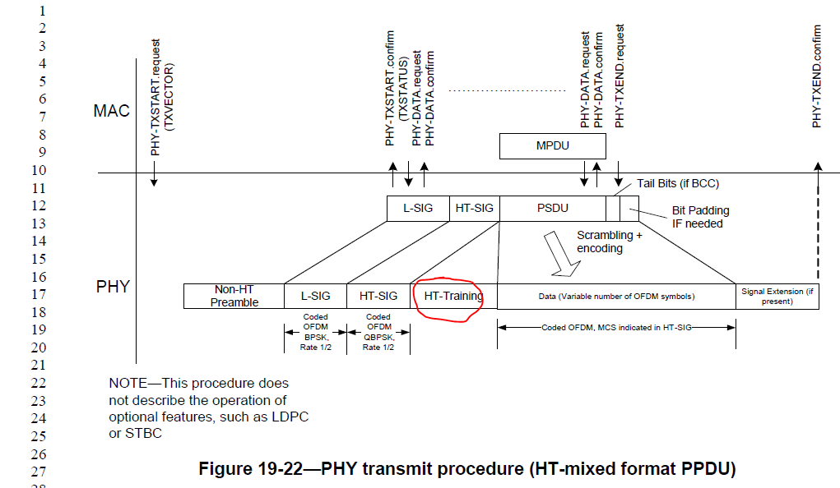

*Instruction to Editor: Split the box named “HT-Training Part I” to two boxes, with the left one named “HT-GF-STF” and the right one named “HT-LTF1” in Figure 19-23. Also, change “HT-Training” to “HT-LTFs” in Figure 19-23 at D3.3 P3059.*

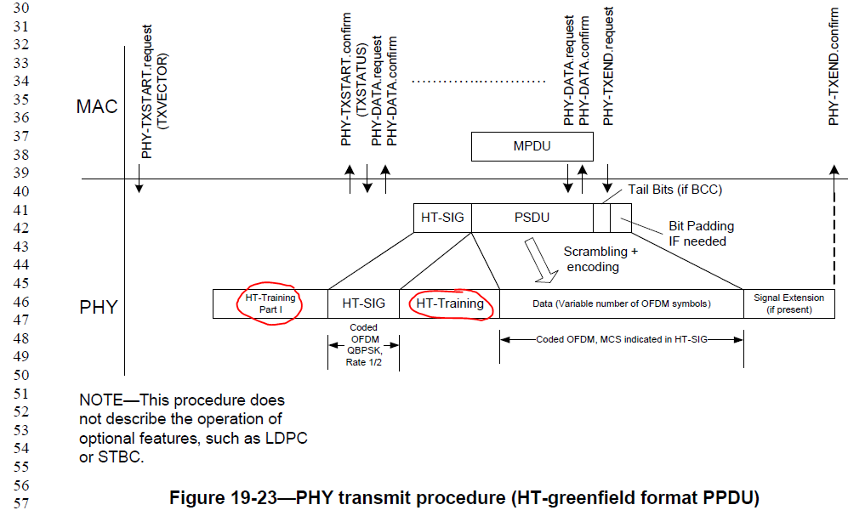

*Instruction to Editor: Change “TX HT Training Part I” to “TX HT-STF” (line change) “TX HT-LTF1” in Figure 19-24 at D3.3 P3061L18.*

*Instruction to Editor: Change “TX HT Training” to “TX HT-LTFs” in Figure 19-24 at D3.3 P3061L20.*

*Instruction to Editor: Change “TX HT Training Symbols” to “TX HT-STF” (line change) “TX HT-LTFs” in Figure 19-24 at D3.3 P3061L26.*

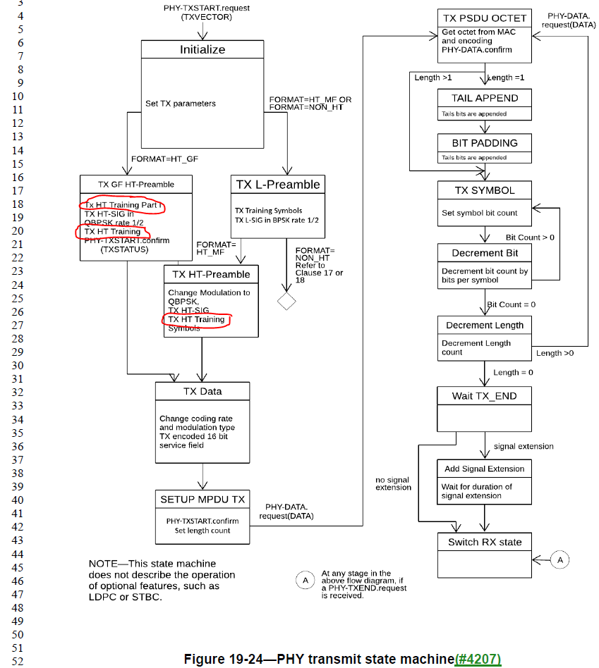

*Instruction to Editor: Update D3.3 P3070L25 as shown below:*

*THT_TRAINING* is the duration of the HT-STF and HT-LTFs in HT-mixed format, given by (#2711)

*TGF_HT_TRAINING* is the duration of the HT-GF-STF, HT-LTF1 and HT-LTFs in HT-greenfield format, given by (#2711)

*Instruction to Editor: Update D3.3 P3235L54 as shown below:*

NOTE 1—For a VHT MU PPDU the A-MPDU is per user in the MAC sublayer and the VHT-STF, VHT-LTFs, VHT-SIG-B, and Data are per user in the PHY in Figure 21-34, with the number of VHT-LTF symbols depending on the total number of space-time streams across all users.

*Instruction to Editor: Split the box named “VHT Training Symbols” to two boxes, with the left one named “VHT-STF” and the right one named “VHT-LTFs” in Figure 21-34.*

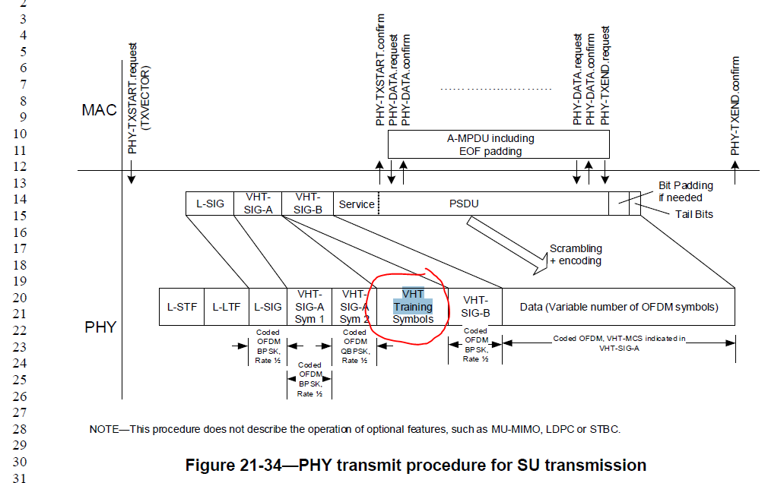

*Instruction to Editor: Change “TX VHT Training Symbols” to “TX VHT-STF” (line change) “TX VHT-LTFs” in Figure 21-35.*

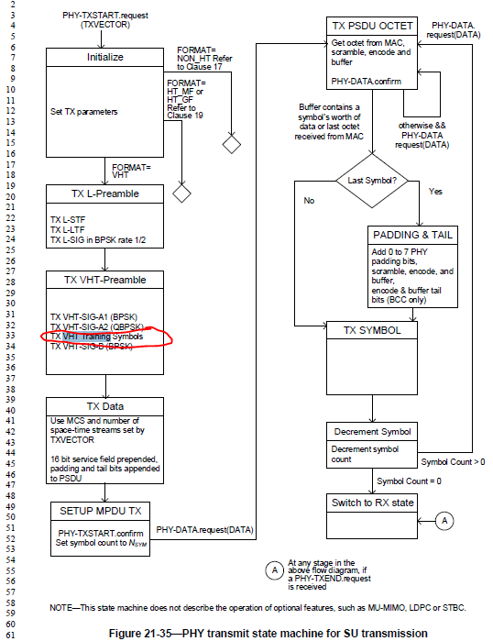

*Instruction to Editor: Update D3.3 P3241L2 as shown below:*

After receiving a valid L-SIG and VHT-SIG-A indicating a supported mode, the PHY entity shall begin receiving the VHT-STF, VHT-LTFs and VHT-SIG-B. If the received group ID in VHT-SIG-A has a value indicating a VHT SU PPDU (see 10.19 (Group ID and partial AID in VHT and CMMG PPDUs)), the PHY entity may choose not to decode VHT-SIG-B. If VHT-SIG-B is not decoded, subsequent to an indication of a valid VHT-SIG-A CRC, a PHY-RXSTART.indication(RXVECTOR) primitive shall be issued.

[End of File]