IEEE P802.11  
Wireless LANs

|  |  |  |  |  |
| --- | --- | --- | --- | --- |
| Resolutions to 32.3.8.12 NGV receive procedure | | | | |
| Date: 2020-06-16 | | | | |
| Author(s): | | | | |
| Name | Affiliation | Address | Phone | email |
| Yujin Noh | Newracom |  |  | yujin.noh at newracom.com |
|  |  |  |  |  |

Abstract

This submission shows

* Resolutions for comments from TGbd draft 0.3
* 5 CIDs: 353, 354, 355, 356 and 357
* The related visio file is uploaded with DCN 423r1

Revisions:

* Rev 0: Initial version of the document.
* Rev 1: added linked DCN for updated viso document

|  |  |  |  |  |
| --- | --- | --- | --- | --- |
| **CID** | **P.L** | **Comment** | **Proposed Change** | **Resolution** |
| 353 | 62.58 | fill TBD | as in comment | Revised.  TGbd Editor: make changes according to this document 11-20-0723-01-00bd Resolutions to 32.3.8.12 NGV receive procedure. |

***To TGbd Editor:*** ***P62L51*** *update the description as below.*

***------------- Begin Text Changes ---------------***

**32.3.12 NGV receive procedure**

A typical PHY receive procedure is shown in Figure 32-14 (PHY receive procedure for NGV transmission) for NGV format. A typical state machine implementation of the receive PHY is given in Figure 32-15 (PHY receive state machine). This receive procedure and state machine do not describe the operation of optional features, such as SU MIMO ~~<TBD>~~.

***------------- End Text Changes ------------------***

|  |  |  |  |  |
| --- | --- | --- | --- | --- |
| **CID** | **P.L** | **Comment** | **Proposed Change** | **Resolution** |
| 354 | 63.29 | fill TBD in Figure 32-14 | as in comment | Revised.  TGbd Editor: make changes according to this document 11-20-0723-01-00bd Resolutions to 32.3.8.12 NGV receive procedure. Please refer to DCN 423r1 for visio file |

***Discussion***

* Since BCC is not supported for data portion, the part corresponding to tail bits is removed.
* Given in subclause 9.7.1 (A-MPDU format) as below, 11bd has decided to support A-MPDU format not including EOF padding. TBD in MAC layer in the figure is updated to A-MPDU.

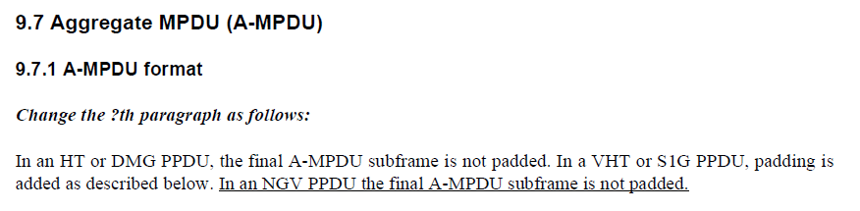

***To TGbd Editor:*** ***P63L06*** *delete the original Figure 32-12 (PHY transmit procedure for NGV transmission) and add the new one as below.*

***------------- Begin Text Changes ---------------***

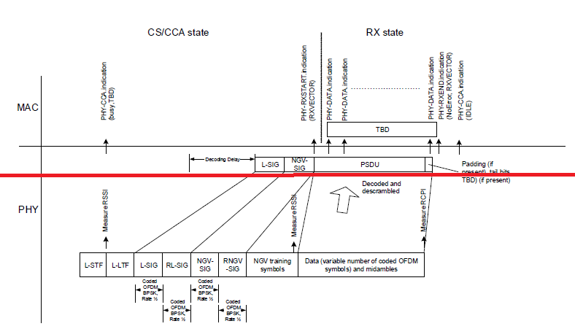



**Figure 32-14—PHY receive procedure for NGV transmission**

***------------- End Text Changes ------------------***

|  |  |  |  |  |
| --- | --- | --- | --- | --- |
| **CID** | **P.L** | **Comment** | **Proposed Change** | **Resolution** |
| 355 | 65.13 | fill TBD | as in comment | Revised.  TGbd Editor: make changes according to this document 11-20-0723-01-00bd Resolutions to 32.3.8.12 NGV receive procedure. |
| 356 | 65.18 | refer the wrong Equation | as in comment | Revised.  TGbd Editor: make changes according to this document 11-20-0723-01-00bd Resolutions to 32.3.8.12 NGV receive procedure. |

***To TGbd Editor:*** ***P65L13*** *update the description as below.*

***Discussion***

At P65L17,

*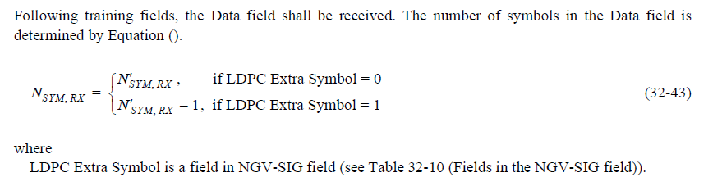****------------- Begin Text Changes ---------------***

~~The PHY optionally filters out the PPDU based on <TBD>.~~

~~If the PPDU is filtered out, the PHY shall issues a PHY-RXEND.indication(Filtered).primitive.~~

The PHY entity shall check the PHY Version in the NGV-SIG field. If the PHY Version does not contain an

intended value, the PHY entity shall issue a PHY-RXSTART.indication(RXVECTOR) then issue a PHYRXEND.

indication(Filtered).

Following training fields, the Data field shall be received. The number of symbols in the Data field is determined by Equation (32-43).

***------------- End Text Changes ------------------***

|  |  |  |  |  |
| --- | --- | --- | --- | --- |
| **CID** | **P.L** | **Comment** | **Proposed Change** | **Resolution** |
| 357 | 66.02 | fill TBD | as in comment | Revised.  TGbd Editor: make changes according to this document 11-20-0723-01-00bd Resolutions to 32.3.8.12 NGV receive procedure. |

***To TGbd Editor:*** ***P65L64*** *update the description as below.*

***------------- Begin Text Changes ---------------***

The received PSDU bits are assembled into octets, decoded, and presented to the MAC using a series of PHY-DATA.indication(DATA) primitive exchanges. Any final bits that cannot be assembled into a complete octet are considered pad bits and discarded. After the reception of the final bit of the last PSDU octet, and possible padding ~~and tail bits <TBD>~~, the receiver shall be returned to the RX IDLE state, as shown in Figure 32-15 (PHY receive state machine). A PHY-RXEND.indication(NoError) primitive shall be issued on entry to the RX IDLE state.

***------------- End Text Changes ------------------***