IEEE P802.11  
Wireless LANs

|  |  |  |  |  |
| --- | --- | --- | --- | --- |
| Resolutions to 32.3.8.11 NGV transmit procedure | | | | |
| Date: 2020-06-15 | | | | |
| Author(s): | | | | |
| Name | Affiliation | Address | Phone | email |
| Yujin Noh | Newracom |  |  | yujin.noh at newracom.com |
|  |  |  |  |  |

Abstract

This submission shows

* Resolutions for comments from TGbd draft 0.3
* 8 CIDs: 345, 346, 347, 348, 349, 350, 351 and 352
* The related visio file is uploaded with DCN 724

Revisions:

* Rev 0: Initial version of the document.

|  |  |  |  |  |
| --- | --- | --- | --- | --- |
| **CID** | **P.L** | **Comment** | **Proposed Change** | **Resolution** |
| 345 | 60.23 | fill TBD | as in comment | Revised.  TGbd Editor: make changes according to this document 11-20-0722-00-00bd Resolutions to 32.3.8.11 NGV transmit procedure. |

***To TGbd Editor:*** ***P60L16*** *update the description as below.*

***------------- Begin Text Changes ---------------***

* + 1. **NGV transmit procedure**
* There are two paths for the transmit PHY procedure:The first path, for which typical transmit procedures are shown in Figure 32-12 (PHY transmit procedure for NGV transmission), is selected if the FORMAT parameter of the PHY-TXSTART.request(TXVECTOR) primitive is NGV. These transmit procedures do not describe the operation of optional features, such as SU MIMO~~<TBD>~~.(#345)

***------------- End Text Changes ------------------***

|  |  |  |  |  |
| --- | --- | --- | --- | --- |
| **CID** | **P.L** | **Comment** | **Proposed Change** | **Resolution** |
| 346 | 60.51 | Figure 32-12 is something wrong..it seems two figures overlapped. | as in comment | Revised.  TGbd Editor: make changes according to this document 11-20-0722-00-00bd Resolutions to 32.3.8.11 NGV transmit procedure |
| 347 | 60.51 | fill TBD in Figure 32-12 | as in comment | Revised.  TGbd Editor: make changes according to this document 11-20-0722-00-00bd Resolutions to 32.3.8.11 NGV transmit procedure. The related visio file is uploaded with DCN 724 |

***Discussion***

* Since BCC is not supported for data portion, the part corresponding to tail bits is removed.
* Given in subclause 9.7.1 (A-MPDU format) as below, 11bd has decided to support A-MPDU format not including EOF padding. TBD in MAC layer in Figure 32-12 is updated to A-MPDU.

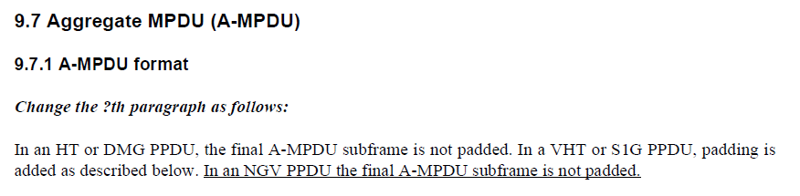

***To TGbd Editor:*** ***P60L50*** *delete the original Figure 32-12 (PHY transmit procedure for NGV transmission) and add the new one as below.*

***------------- Begin Text Changes ---------------***

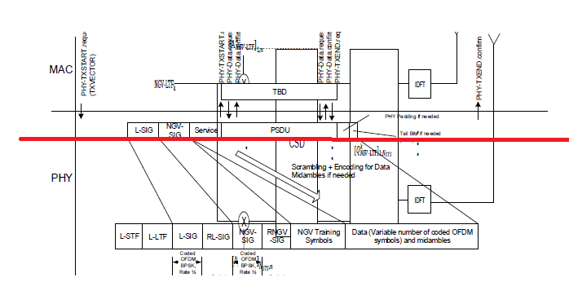



**Figure 32-12—PHY transmit procedure for NGV transmission**

***------------- End Text Changes ------------------***

|  |  |  |  |  |
| --- | --- | --- | --- | --- |
| **CID** | **P.L** | **Comment** | **Proposed Change** | **Resolution** |
| 348 | 60.56 | fill TBD and fix the reference number (33.xx) | as in comment | Revised.  TGbd Editor: make changes according to this document 11-20-0722-00-00bd Resolutions to 32.3.8.11 NGV transmit procedure |

***To TGbd Editor:*** ***P60L53*** *update the description as below.*

***------------- Begin Text Changes ---------------***

In both paths, in order to transmit data, the MAC generates a PHY-TXSTART.request primitive, which

causes the PHY entity to enter the transmit state. Further, the PHY is set to operate at the appropriate frequency

through station management via PLME ~~<TBD>~~, as specified in 32.4 (NGV PLME)~~33.xx~~.

***------------- End Text Changes ------------------***

|  |  |  |  |  |
| --- | --- | --- | --- | --- |
| **CID** | **P.L** | **Comment** | **Proposed Change** | **Resolution** |
| 349 | 61.17 | fill TBD | as in comment | Revised.  TGbd Editor: make changes according to this document 11-20-0722-00-00bd Resolutions to 32.3.8.11 NGV transmit procedure |
| 350 | 61.24 | fill TBD. N_sym should be N_SYM. | as in comment | Revised.  TGbd Editor: make changes according to this document 11-20-0722-00-00bd Resolutions to 32.3.8.11 NGV transmit procedure |

***To TGbd Editor:*** ***P61L11*** *update the description as below.*

***------------- Begin Text Changes ---------------***

The SERVICE field and PSDU are encoded as described in Clause 32.3.2 (Transmitter block diagram). The data shall be exchanged between the MAC and the PHY through a series of PHY-DATA.request(DATA) primitives issued by the MAC, and PHY-DATA.confirm primitives issued by the PHY. PHY padding bits are appended to the PSDU to make the number of bits in the coded PSDU an integer multiple of the number of coded bits per OFDM symbol. Midambles are inserted every *M* OFDM symbols if present, where *M* is indicated by the Midamble Periodicity field in NGV-SIG field~~<TBD>~~.

Transmission can be prematurely terminated by the MAC through the PHY-TXEND.request primitive. PSDU transmission is terminated by receiving a PHY-TXEND.request primitive. Each PHYTXEND.request primitive is acknowledged with a PHY-TXEND.confirm primitive from the PHY. Normal termination occurs after the transmission of the final bit of the last PSDU octet, according to the number of OFDM symbols indicated by *NSYM ~~Nsym~~* (see ~~<TBD>~~ Clause 21.3.10.5.4 (LDPC coding) (computed using Equation (19-41) in step d) of Clause

19.3.11.7.5 (LDPC PPDU encoding process))).

***------------- End Text Changes ------------------***

|  |  |  |  |  |
| --- | --- | --- | --- | --- |
| **CID** | **P.L** | **Comment** | **Proposed Change** | **Resolution** |
| 351 | 62.04 | fill TBD | as in comment | Revised.  TGbd Editor: make changes according to this document 11-20-0722-00-00bd Resolutions to 32.3.8.11 NGV transmit procedure |
| 352 | 62.49 | fill TBDs in Figure 32-13 | as in comment | Revised.  TGbd Editor: make changes according to this document 11-20-0722-00-00bd Resolutions to 32.3.8.11 NGV transmit procedure. The related visio file is uploaded with DCN 724 |

***To TGbd Editor:*** ***P62L1*** *update the description and delete the original Figure 21-35 and the new one as below.*

***------------- Begin Text Changes ---------------***

A typical state machine implementation of the transmit PHY is provided in Figure 32-13 (PHY transmit state machine). Request (.request) and confirmation (.confirm) primitives are issued once per state as shown. This state machine does not describe the operation of optional features, such as SU MIMO~~<TBD>~~.

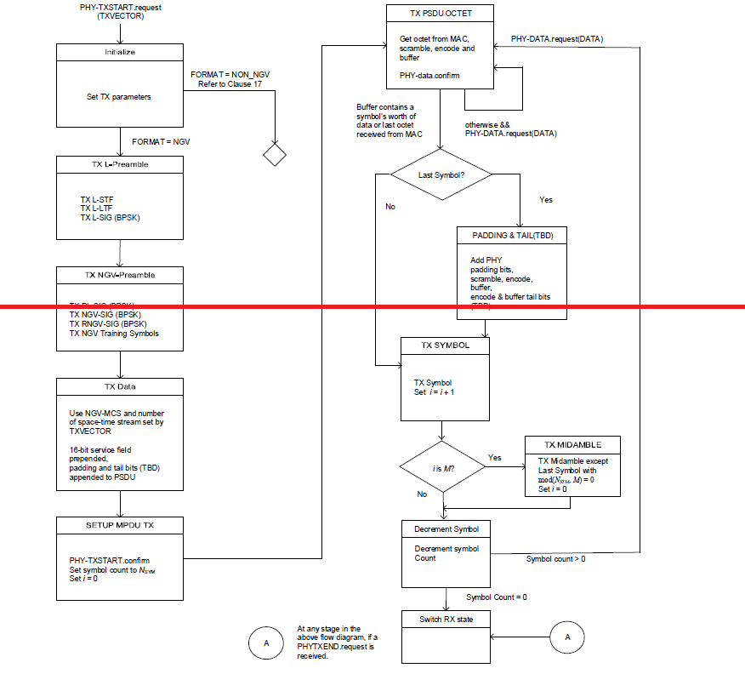



**Figure 32-13—PHY transmit state machine**

***------------- End Text Changes ------------------***