IEEE P802.11
Wireless LANs
CR for MISC. PHY
Date: 2020-05-13
Author(s):
Name | Affiliation | Address | Phone | email
Xiaogang Chen | Intel | 2111 NE 25th Ave, Hillsboro, OR, 97124 |  | Xiaogang.c.chen@Intel.com

Abstract
This submission proposes text changes of TGax Draft 6.0 for CID 24020, 24045, 24208, 24288, 24290, 24297, 24304, 24312, 24313, 24321, 24326, 24346, 24347, 24363, 24385, 24405, 24406, 24407, 24564, 24282.
In addition, this submission proposes text change for the power normalization issue in the Pre-HE portion.

Revisions:

- Rev 0: Initial version of the document.
- Rev 1: Updated based on feedback from Mark.
- Rev 2: updated CR for 24282

Interpretation of a Motion to Adopt

A motion to approve this submission means that the editing instructions and any changed or added material are actioned in the TGax Draft. This introduction is not part of the adopted material.

Editing instructions formatted like this are intended to be copied into the TGax Draft (i.e. they are instructions to the 802.11 editor on how to merge the text with the baseline documents).

TGax Editor: Editing instructions preceded by “TGax Editor” are instructions to the TGax editor to modify existing material in the TGax draft. As a result of adopting the changes, the TGax editor will execute the instructions rather than copy them to the TGax Draft.

CID | Clause | P/L | Comment | Proposed change | Resolution
24020 | 27.3.22 | 674.08 | "...the PHY entity shall maintain PHY-CCA.indication(BUSY, channellist)  primitive for the predicted duration of the transmitted PPDU, as defined by RXTIME in Equation (27-133),..."  Current spec texts (page 674, lines 6- 18) is correct only for the HE SU PPDU.  When the receiving PPDU is an HE TB PPDU, it can't calculate the RXTIME as in Equation (27-133) if the STA (3rd party STA) has not solicited this HE TB PPDU before SIFS.  Because 27.3.22 (HE receive procedure) is a general behavior of a PHY in a STA, the spec has to state two cases, i) when the TRIGVECTOR parameters are present in a PHY, ii) when TRIGVECTOR parameters are not present in a PHY. | Please include the missing PHY receive procedure for an HE TB PPDU, i) when the TRIGVECTOR parameters are present in a PHY, ii) when TRIGVECTOR parameters are not present in a PHY. | Rejected.  HE receive procedure is intended to specify the Rx behaviour of a HE STA. if 3rd party STA is HE STA, it could predict the PPDU duration either based on 27-133 or 27-134. 27-133 can be used for SU/MU/ER PPDU. 27-134 can be used for TB PPDU.
24045 | 9.3.1.22.1 | 126.33 | The UL Target RSSI value is also normalized to 20 MHz bandwidth.  But, current text is missing this. | Please change as the following:  "averaged over the AP's antenna connectors and normalized to 20 MHz bandwidth," | Revised  -TGax editor to make the changes shown in 11-20/0717r2 under all headings that include CID 24045.
24208 | 27.3.21 | 665.27 | Figure 27-54 shows the post-FEC padding as part of the scrambling and encoding. By definition, post-FEC padding should not be encoded. See other figures as well. | Correct | Revised  -TGax editor to make the changes shown in 11-20/0717r2 under all headings that include CID 24208.
24288 | 26.5.2.2.4 | 349.56 | "A non-AP STA obtains the information required to prepare an HE TB PPDU explicitly and implicitly. Explicit  information is obtained in the Common Info field of a Trigger frame, or in the UL Data Symbols and AP Tx Power sub-  fields of the TRS Control subfield contained in the soliciting PPDU" is a bit weird: explicit information is obtained from other fields in both Trigger frames and TRS Controls, and the PPDU is normally referred to as a triggering PPDU not a soliciting PPDU | Change to "A non-AP STA obtains the information required to prepare an HE TB PPDU explicitly and implicitly. Explicit  information is obtained in the Trigger frame or TRS Control subfield contained in the triggering PPDU" | Accepted
24290 | 27.3.22 | 670.17 | PHY-RXEND.ind is defined to be sent after any signal extension (" When a Signal Extension is present, the primitive is  generated at the end of the Signal Extension."; "When receiving a signal extended PPDU, the PHY-  RXEND.indication primitive shall be emitted a period of aSignalExtension after the end of the last symbol  of the PPDU."). So the PHY receive procedures need to show the PHY-RXEND.ind as being at/after the end of the signal extension | Figure 27-59--PHY receive procedure for an HE SU PPDU to Figure 27-62--PHY receive procedure for an HE TB PPDU | Revised  -TGax editor to make the changes shown in 11-20/0717r2 under all headings that include CID 24290.
24297 | 9.3.1.22.1 | 122.17 | "The AP Tx Power subfield of the Common Info field indicates, in units of dBm, the AP's combined transmit  power at the antenna connectors of all the transmit antennas used to transmit the Trigger frame and normal-  ized to 20 MHz bandwidth. The transmit power is reported with a resolution of 1 dB, with values in the  range 0 to 60 representing -20 dBm to 40 dBm, respectively." is not clear in the case the Trigger frame is not transmitted over the full bandwidth (i.e. when DL OFDMA is used). Better to explicitly say it is the transmit power density of the PPDU the Trigger frame is in, in dBm / 20 MHz. Also there's only one transmit antenna connector | Change to "The AP Tx Power subfield of the Common Info field indicates the AP's transmit  power spectral density at the transmit antenna connector used to transmit the triggering PPDU, in units of dBm / 20 MHz. The transmit power is reported with a resolution of 1 dB / 20 MHz, with values in the  range 0 to 60 representing -20 dBm / 20 MHz to 40 dBm / 20 MHz, respectively." | Rejected  - The proposed change is “normal-  ized to 20 MHz bandwidth.” Which has been reflected in the original text. And the text has been used in couple places in spec.
24304 |  | 125.65 | In the Trigger frame should require that Starting Spatial Stream and Number Of Spatial Streams make sense, i.e. Starting Spatial Stream + Number Of Spatial Streams - 1 <= 8 | At the end of the para at 125.65 add "The starting spatial stream plus the number of spatial streams does not exceed 9." | Rejected  Spec doesn’t need to list all of the invalide cases.  Also the proposed change is incorrect. Should be <=7.
24312 | 26.5.2.2.4 | 349.44 | "The Pre-FEC Padding Factor subfield is set to the default PE duration value, which is indicated  by the AP in the Default PE Duration subfield of the HE Operation element it transmits and the  pre-FEC padding factor is set to 4" -- well, is the PFPF subfield set to the default or to 4? | As it says in the comment | Revised  Same CID as 24312. Refer to the resolution of CID 24312
24313 | 26.5.2.2.4 | 349.44 | "The Pre-FEC Padding Factor subfield is set to the default PE duration value, which is indicated  by the AP in the Default PE Duration subfield of the HE Operation element it transmits and the  pre-FEC padding factor is set to 4" -- the Default PE Duration subfield is a 3-bit field that indicates 0 to 16 us, while the Pre-FEC Padding Factor subfield is a 2-bit field that indicates a PFPF of 1 to 4 | Change to "The Pre-FEC Padding Factor subfield is set to indicate a pre-FEC padding factor of 4" | Revised  -TGax editor to make the changes shown in 11-20/0717r2 under all headings that include CID 24313.
24321 | 9.3.1.22.1 | 121.34 | "The MU-MIMO LTF Mode subfield of the Common Info field indicates the LTF mode of the non-OFDMA  MU-MIMO HE TB PPDU response when the GI And LTF Type subfield of the Common Info field indi-  cates either 2x LTF + 1.6 us GI or 4x LTF + 3.2 us GI, as defined in Table 9-31d (GI And LTF Type sub-  field encoding)." needs to be restricted to full-BW MU-MIMO ("a Trigger frame that allocates an RU that spans the entire HE TB PPDU bandwidth and  assigns the RU to more than one non-AP STA (i.e., for UL MU-MIMO)" later on) | Change to "The MU-MIMO LTF Mode subfield of the Common Info field indicates the LTF mode of the non-OFDMA  MU-MIMO HE TB PPDU response for an RU that spans the entire HE TB PPDU bandwidth and  assigns the RU to more than one non-AP STA (i.e., for UL MU-MIMO) when the GI And LTF Type subfield of the Common Info field indi-  cates either 2x LTF + 1.6 us GI or 4x LTF + 3.2 us GI, as defined in Table 9-31d (GI And LTF Type sub-  field encoding)." (obviously us -> <micro>s but even this spanking new myBallot STILL can't properly cope with Unicode!) | Revised  -TGax editor to make the changes shown in 11-20/0717r2 under all headings that include CID 24321.
24326 | 9.3.1.22.1 | 122.13 | It is not clear what the LDPC Extra Symbol Segment field should be set to. The answer is that it should be set to 1 if any of the STAs need it | In 27.3.12.5.5 change " and LDPC Extra Symbol Segment fields" to " field" in the NOTE, and above this NOTE add a para:  "The AP shall set the LDPC Extra Symbol Segment field in the Common Info field of the Trigger frame to 1 if the calculations in 27.3.12.5.4 (Encoding process for an HE MU PPDU) indicate the need for an LDPC extra symbol segment for any STA triggered for HE TB PPDU transmission using LDPC." | Rejected  - 27.3.12.5.4 and 27.3.12.5.5 are clear already on how to set the LDPC extra symbol for both MU PPDU and TB PPDU
24346 | 9.3.1.22.1 | 119.42 | There is no need for the LDPC extra symbol segment setting to be the same for all STAs, since other settings such as HE-MCS are different, so each STA will have to do independent LDPC codeword generation | Move the LDPC extra symbol segment from the Common Info field to the User Info field | Rejected  Client shall follow AP’s indication on the LDPC extra symbol. Otherwise AP cannot decode.
24347 | 9.3.1.22.1 | 119.42 | There is no need for the LDPC extra symbol segment setting to be the same for all STAs, since other settings such as HE-MCS are different, so each STA will have to do independent LDPC codeword generation. In turn, this means both sides can determine whether it is to be used based on the usual equations | Remove the LDPC extra symbol segment from the Common Info field to the User Info field, and specify that the use of an LDPC extra symbol segment for HE TB PPDUs follows the rules for its use for HE MU PPDUs | Rejected  See CID 24346
24363 | 9.3.1.22.1 | 124.01 | "The mapping of B7-  B1 of the RU Allocation subfield is defined in Table 9-31h (B7-B1 of the RU Allocation subfield)." -- not for MU-RTS | Change to "The mapping of B7-  B1 of the RU Allocation subfield for all Trigger frame variants except the MU-RTS Trigger frame is defined in Table 9-31h (B7-B1 of the RU Allocation subfield)." | Rejected  - Not necessary. TF variation has nothing to do with the mapping table…also there are other TF don’t have RU allocations e.g. NFRP
24385 | 26.5.2.4 | 359.36 | [Resubmission of comment withdrawn on D5.0] It is not clear enough that the UL power headroom is the total power across whatever the RU happens to be, i.e. the UL power headroom does not depend on the RU size (though it does depend on the MCS), unlike e.g. the AP tx power, which is normalised to 20M | Renumber the referenced NOTE to NOTE 1 and add after it a "NOTE 2---The uplink power headroom is the transmit power at the transmit antenna connector used to transmit the HE TB PPDU; it is not normalised to 20 MHz bandwidth, unlike the value in the AP Tx Power subfield." | Accepted
24405 | 26.5.2 |  | [Resubmission of comment withdrawn on D5.0] Re CID 20865. This was rejected in part because "There is no issue if HE_LTF_MODE is set to the value indicated by the Trigger frame". There is an issue because Table 27-1--TXVECTOR and RXVECTOR parameters specifies that HE_LTF_MODE is "Present for full bandwidth MU-MIMO not using 1x HE-LTF  ***and not present otherwise***." | In 26.5.2.3.3 change "The HE_LTF_MODE parameter is set to the value indicated by the MU-MIMO LTF Mode subfield  of the Common Info field of the Trigger frame." to "The HE_LTF_MODE parameter is set to the value indicated by the MU-MIMO LTF Mode subfield  of the Common Info field of the Trigger frame if the HE_LTF_TYPE parameter does not indicate 1x HE-LTF and the Trigger frame indicated full bandwidth MU-MIMO (otherwise the parameter is not present)." In 26.5.3.3.4 change "The HE_LTF_MODE and STBC parameters are set to 0, and the NUM_STS parameter is set to 1" to "The STBC parameter is set to 0 and the NUM_STS parameter is set to 1 (the HE_LTF_MODE parameter is not present)" | Rejected  - The proposed text are reflected in P.L. 121.34  26.5.3.3.4. no such subclause.
24406 | 26.5.2 |  | [Resubmission of comment withdrawn on D5.0] Re CID 20865. This was rejected in part because "the proposed change is incorrect because HE_LTF_MODE is set to single stream pilots in TXVECTOR parameters for HE TB PPDU response to TRS Control subfield". That is what is signalled over the air, but it is not signalled over the TXVECTOR because Table 27-1--TXVECTOR and RXVECTOR parameters specifies that HE_LTF_MODE is "Present for full bandwidth MU-MIMO not using 1x HE-LTF  ***and not present otherwise***." | In 26.5.2.3.3 change "The HE_LTF_MODE parameter is set to the value indicated by the MU-MIMO LTF Mode subfield  of the Common Info field of the Trigger frame." to "The HE_LTF_MODE parameter is set to the value indicated by the MU-MIMO LTF Mode subfield  of the Common Info field of the Trigger frame if the HE_LTF_TYPE parameter does not indicate 1x HE-LTF and the Trigger frame indicated full bandwidth MU-MIMO (otherwise the parameter is not present)." In 26.5.3.3.4 change "The HE_LTF_MODE and STBC parameters are set to 0, and the NUM_STS parameter is set to 1" to "The STBC parameter is set to 0 and the NUM_STS parameter is set to 1 (the HE_LTF_MODE parameter is not present)" | Rejected  Duplicated with 24405.
24407 | 9.3.1.22.1 | 122.12 | [Resubmission of comment withdrawn on D5.0] Re CID 20725 (and before that CID 16043). The rejection here is  Section 27.3.11.5.2 (LDPC coding) describes setting of LDPC Extra symbol segment bit by the AP.  but as the comment explicitly said, the comment was about the setting in the  Trigger frame. 27.3.11.5.2 is all about the setting in HE-SIG-A:  then the LDPC Extra Symbol Segment field of HE-SIG-A shall be set to 1  then the LDPC Extra Symbol Segment field in HE-SIG-A shall be set to 0  then the LDPC Extra Symbol Segment field in HE-SIG-A shall be set to 1  then the LDPC Extra Symbol Segment field in HE-SIG-A shall be set to 0 | After "The LDPC Extra Symbol Segment subfield of the Common Info field indicates the status of the LDPC extra  symbol segment. It is set to 1 if the LDPC extra symbol segment is present in the solicited HE TB PPDUs  and set to 0 otherwise." add "NOTE---The LDPC Extra Symbol Segment subfield of the Common Info field can be set to a random value by the AP." | Rejected  122.12 itself has no issue.  -P.L. 617.42 reflected the proposed change.  “NOTE—The AP might select any value for the pre-FEC padding factor and LDPC Extra Symbol Segment fields for the  solicited HE TB PPDU regardless of the respective values derived from the calculations described in the BCC or LDPC  encoding process.”
24564 | 26.5.2.2.3 | 348.24 | The sentence in L49 should also be applicable to LDPC encoded trigger frame or frame containing TRS | Move the paragraph to the end of the section and add T_TrigProc to the requirement | Rejected  The sentence is applicable to LDPC even in current position.  “An AP may use any type of padding to satisfy the MinTrigProcTime requirement of a non-AP STA, such as  using the Padding field in a Trigger frame, post-EOF A-MPDU padding, or aggregating other MPDUs in the  A-MPDU”
24282 | 634.57 | 27.3.13 | "A PE field of duration 4 us, 8 us, 12 us, or 16 us may be present in an HE PPDU."  This is conflicted with the following:  "The duration of the PE field, TPE, may take values of 0, 4, 8, 12 or 16 us."  Please change the as the following:  "A PE field of duration 0 us, 4 us, 8 us, 12 us, or 16 us may be present in an HE PPDU." | As in the comment. | Revised  -TGax editor to make the changes shown in 11-20/0717r2 under all headings that include CID 24282.

Proposed changes for CID 24045:
To the TGax Editor: change the text in P.L.126.33 as below:

The UL Target RSSI subfield of the User Info field indicates the expected receive signal power, averaged
over the AP’s antenna connectors and normalized to 20 MHz bandwidth, for the HE portion of the HE TB PPDU transmitted on the assigned RU.
The resolution for the UL Target RSSI subfield in the User Info field is 1 dB. The UL Target RSSI subfield
encoding is defined in Table 9-31i (UL Target RSSI subfield encoding).

Proposed changes for CID 24321:
To the TGax Editor: change the text in P.L.121.34 as below:
The MU-MIMO HE-LTF Mode subfield of the Common Info field indicates the HE-LTF mode for the HE TB PPDU which has an RU spans the entire bandwidth and the RU is assigned to more than one non-AP STA (i.e., for UL MU-MIMO) has of the non-OFDMA MU-MIMO HE TB PPDU response when the GI And HE-LTF Type subfield of the Common Info field indicates either 2x HE-LTF + 1.6 µs GI or 4x HE-LTF + 3.2 µs GI, as defined in Table 9-31d (GI And
HE-LTF Type subfield encoding). Otherwise, this subfield is set to indicate HE single stream pilot HE-LTF
mode.

Proposed changes for CID 24208:

To the TGax Editor: replace the figures 27-54,27-55,27-56 and 27-57 with the figures below respectively
Figure 27-54—PHY transmit procedure for an HE SU PPDU

Figure 27-55—PHY transmit procedure for an HE ER SU PPDU
Figure 27-56—PHY transmit procedure for an HE MU PPDU
Figure 27-57—PHY transmit procedure for an HE TB PPDU

Proposed changes for CID 24290:
To the TGax Editor: replace the figures 27-60,27-61 and 27-62 with the figures below respectively

Figure 27-60—PHY receive procedure for an HE ER SU PPDU
Figure 27-61—PHY receive procedure for an HE MU PPDU
Figure 27-62—PHY receive procedure for an HE TB PPDU

Proposed changes for CID 24313:

To the TGax Editor: change the text in P.L. 349.44 as below

An AP that transmits one or more Trigger frames in one or more A-MPDUs and frames carrying a TRS Control subfield in one or more other A-MPDUs in an HE MU PPDU shall set the Common Info field of the
Trigger frames and the TRS Control subfields in each A-MPDU as follows:
— The UL Length subfield in the Common Info field of the Trigger frames and the UL Data Symbols
subfield in the TRS Control subfields indicate the same HE TB PPDU duration
— The AP Tx Power subfield in the Common Info field of the Trigger frames and the AP Tx Power
subfield in the TRS Control subfields indicate the same transmit power
— In the Common Info field of the Trigger frames:
• The MU-MIMO HE-LTF Mode and UL STBC subfields are set to 0
• The Number Of HE-LTF Symbols And Midamble Periodicity subfield is set to 0
• The Doppler subfield is set to 0
• The Pre-FEC Padding Factor subfield is set to the default PE duration value, which is indicated by the AP in the Default PE Duration subfield of the HE Operation element it transmits. and the
pre-FEC padding factor is set to 4

Proposed changes for CID 24282:

To the TGax Editor: change the text in P.L. 634.58 as below

A PE field of duration 0 µs, 4 µs, 8 µs, 12 µs, or 16 µs may be is present in an HE PPDU.

In addition, replace figure 27-46 with the figure below
Figure 27-46—HE TB feedback NDP format

In addition, change the text in P.L. 644.60 as below:

The HE TB feedback NDP has the following properties:
— Uses the HE TB PPDU format but without the Data field and PE field
- The PE field has a PE duration of 0 us.

Power normalization issue:

The power normalization in the Pre-HE portion didn’t consider the case of preamble puncturing. Also in the TB PPDU the power normalization in the Pre-HE portion is not accurate. The N_Field^Tone, according to table 27-16, is only associated with PPDU BW. E.g. N_Field^Tone is always equals to 224 for L-SIG regardless of puncturing.

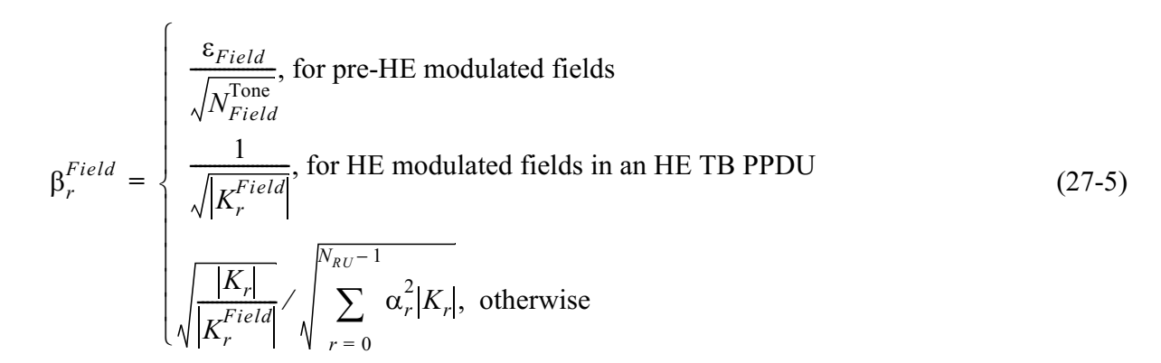

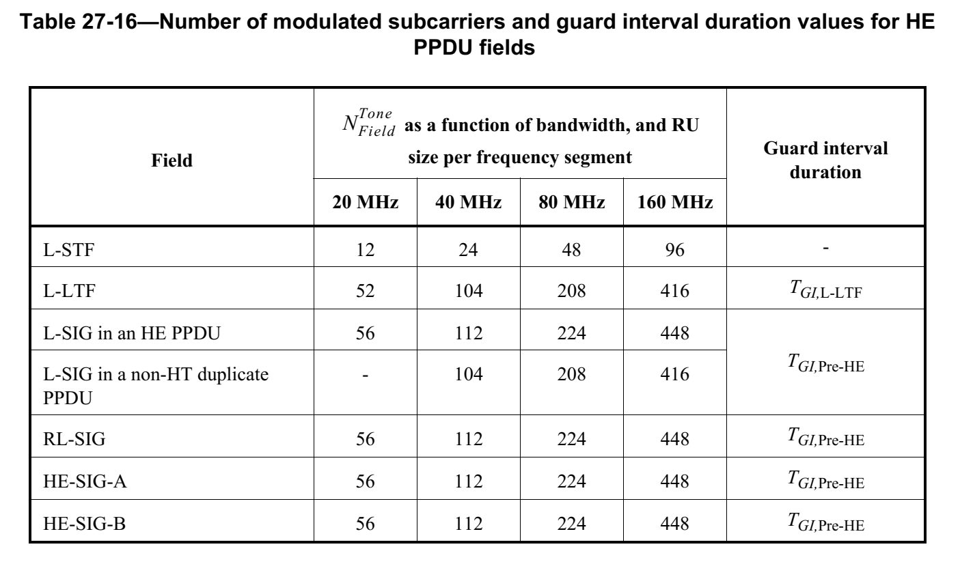

Proposed change:

in equation 27-5 (copied below), Change the $\sqrt{N_{Field}^{Tone}}$ to $\sqrt{N_{Field}^{Tone}∙\frac{Ω_{20MHz}}{N_{20MHz}}}$
Move the definition of Ω20MHz and N20MHz (copied pasted below) from P.L. 550.60 to P.L.549.32 (After Table 27-17)
Ω20MHz is a set of 20 MHz channels where pre-HE modulated fields are located. The set of 20 MHz channels contains one or more values in the range 0 to N20MHz – 1 for an HE TB PPDU, HE sounding NDP or HE MU PPDU with preamble puncturing, and it contains all values in the range 0 to N20MHz – 1 for other HE PPDU formats.

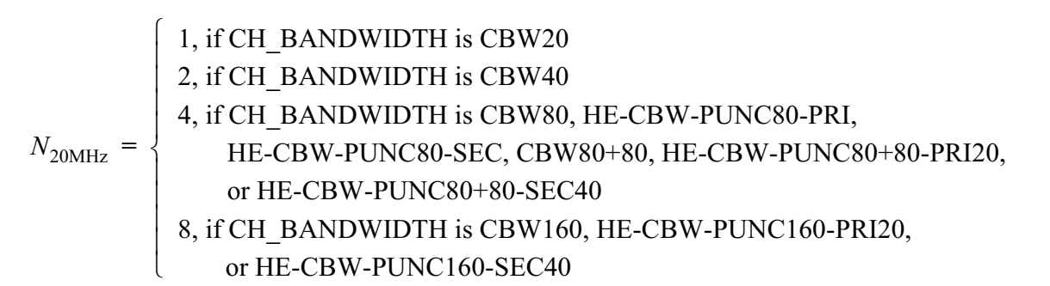

In addition, change the equations for each field in the Pre-HE portion as indicated below:

In equation 27-6 (P.L. 550.26 copied below as example) and equation 27-8 (P.L. 551.22), Change the $N_{L-STF}^{Tone}$, to $N_{L-STF}^{Tone}∙\frac{Ω_{20MHz}}{N_{20MHz}}$
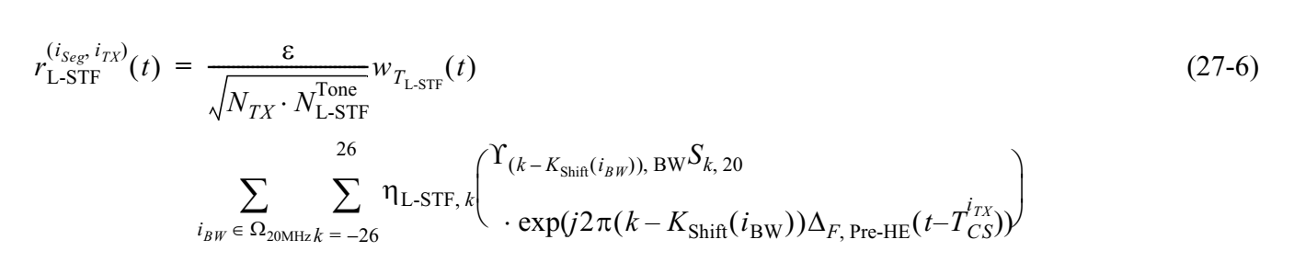
In equation 27-9 (P.L. 551.60) and equation 27-10 (P.L. 552.28), Change the $N_{L-LTF}^{Tone}$, to $N_{L-LTF}^{Tone}∙\frac{Ω_{20MHz}}{N_{20MHz}}$

In equation 27-12 and equation 27-13 (copied below), Change the $N_{L-SIG}^{Tone}$, to $N_{L-SIG}^{Tone}∙\frac{Ω_{20MHz}}{N_{20MHz}}$

In equation 27-14 (P.L. 555.1) and equation 27-15 (P.L. 555.16), Change the $N_{RL-SIG}^{Tone}$, to $N_{RL-SIG}^{Tone}∙\frac{Ω_{20MHz}}{N_{20MHz}}$

In equation 27-18 (P.L. 571.55) and equation 27-19 (P.L. 572.7), Change the $N_{HE-SIG-A}^{Tone}$, to $N_{HE-SIG-A}^{Tone}∙\frac{Ω_{20MHz}}{N_{20MHz}}$

In equation 27-21 (P.L. 27-21), Change the $N_{HE-SIG-B}^{Tone}$, to $N_{HE-SIG-B}^{Tone}∙\frac{Ω_{20MHz}}{N_{20MHz}}$

