IEEE P802.11
Wireless LANs
11ax D6.0 CR for CID 24292
Date: 2020-05-05
Author(s):
Name | Affiliation | Address | Phone | email
Po-Kai Huang | Intel Corporation | 2200 Mission College Blvd, Santa Clara, CA 950542200 |  | po-kai.huang@intel.com
Abstract
This submission proposes resolutions for the following CIDs:

24292

Revisions:

- Rev 0: Initial version of the document.
- Rev 1: Revision based on the offline discussion.
- Rev 2: Further revision based on the discussion in the teleconference call.

Interpretation of a Motion to Adopt

A motion to approve this submission means that the editing instructions and any changed or added material are actioned in the TGax D6.0 Draft. This introduction is not part of the adopted material.

Editing instructions formatted like this are intended to be copied into the TGax D6.0 Draft (i.e. they are instructions to the 802.11 editor on how to merge the text with the baseline documents).

TGax Editor: Editing instructions preceded by “TGax Editor” are instructions to the TGax editor to modify existing material in the TGax draft. As a result of adopting the changes, the TGax editor will execute the instructions rather than copy them to the TGax Draft.

CID | Commenter | P.L | Clause | Comment | Proposed Change | Resolution
24292 | Mark RISON |  |  | Various places assume an HE TB PPDU is sent in response to a Trigger frame, but this is not true for MU-RTS | As it says in the comment | Revised –  The commenter only provides vague instructions on suggestion to resolve the comment.  We search “in response to a trigger” and change “HE TB PPDU in response to a Trigger frame” with “HE TB PPDU in response to a Trigger frame that is not an MU-RTS Trigger frame” across the spec (354.15, 356.64, 358.21, 365.52, 367.9, 370.48 ).  We also propose revision when there may have confusion in 26.8.2 Individual TWT agreements and 26.8.3.1 General. Specifically, to have PS-Poll from one STA in response to a Trigger frame and have QoS Null from another STA in response to the same Trigger frame, the Trigger frame must be Basic Trigger frame.  TGax editor to make the changes shown in 11-20/0705r2 under all headings that include CID 24292

Discussion:

We study the 11ax specification and conclude that PS-Poll response to Trigger frame is only allowed for Basic Trigger frame. U-APSD trigger frame response to Trigger frame is allowed for MU-BAR, GCR-MU BAR, BSRP, BQRP. PS-Poll or U-APSD trigger like response to NFRP is allowed.

We revise the sentence inline with the understanding above.

 | PS-Poll | U-APSD Trigger
Basic Trigger | Yes | Yes
BFRP | No | No
MU-BAR | No | Yes
MU-RTS | No | No
GCR MU-BAR | No | Yes
BQRP | No | Yes
BSRP | No | Yes
NFRP | Yes with not exact PS-Poll frame | Yes with not exact QoS Null or QoS Data frame

A non-AP STA that responds to a BFRP Trigger frame addressed to it shall construct an A-MPDU carried in the HE TB PPDU with one or more HE Compressed Beamforming/CQI frames (see 26.7 (HE sounding protocol)); other frames shall not be allowed in the A-MPDU.

A non-AP STA that responds to an MU-BAR Trigger frame addressed to it shall construct the A-MPDU carried in the HE TB PPDU as defined in Table 9-532 (A-MPDU contents in the control response context). The non-AP STA includes either a BlockAck frame or a Multi-STA BlockAck frame in the A-MPDU as defined in 26.4 (HE acknowledgment procedure).

A non-AP STA that responds to a GCR MU-BAR Trigger frame addressed to it shall construct the A-MPDU carried in the HE TB PPDU as defined in Table 9-532 (A-MPDU contents in the control response context).The non-AP STA includes a GCR BlockAck frame in the A-MPDU as defined in 10.25.9 (GCR and GLKGCR block ack).

A non-AP STA that responds to a BSRP or BQRP Trigger frame addressed to it and that is not aggregated with any MPDUs that solicit an immediate acknowledgment shall construct the A-MPDU carried in the HE TB PPDU as defined in Table 9-531 (A-MPDU contents in the data enabled no immediate response context) with the exception that the A-MPDU does not contain QoS Data frames. The non-AP STA shall include in the A-MPDU at least one QoS Null frame.

A non-AP STA that responds to a BSRP or BQRP Trigger frame addressed to it and that is aggregated with at least one MPDU that solicits an immediate acknowledgment, shall construct the A-MPDU carried in the HE TB PPDU as defined in Table 9-532 (A-MPDU contents in the control response context).
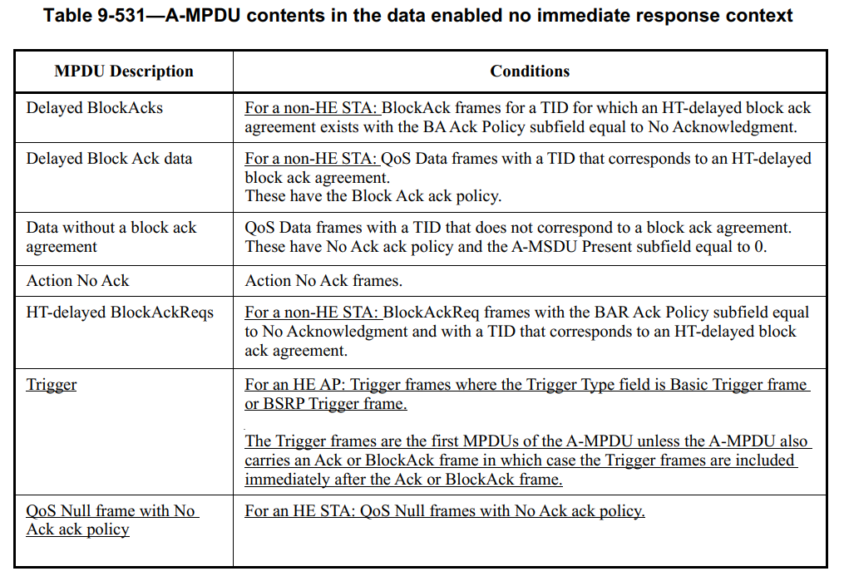

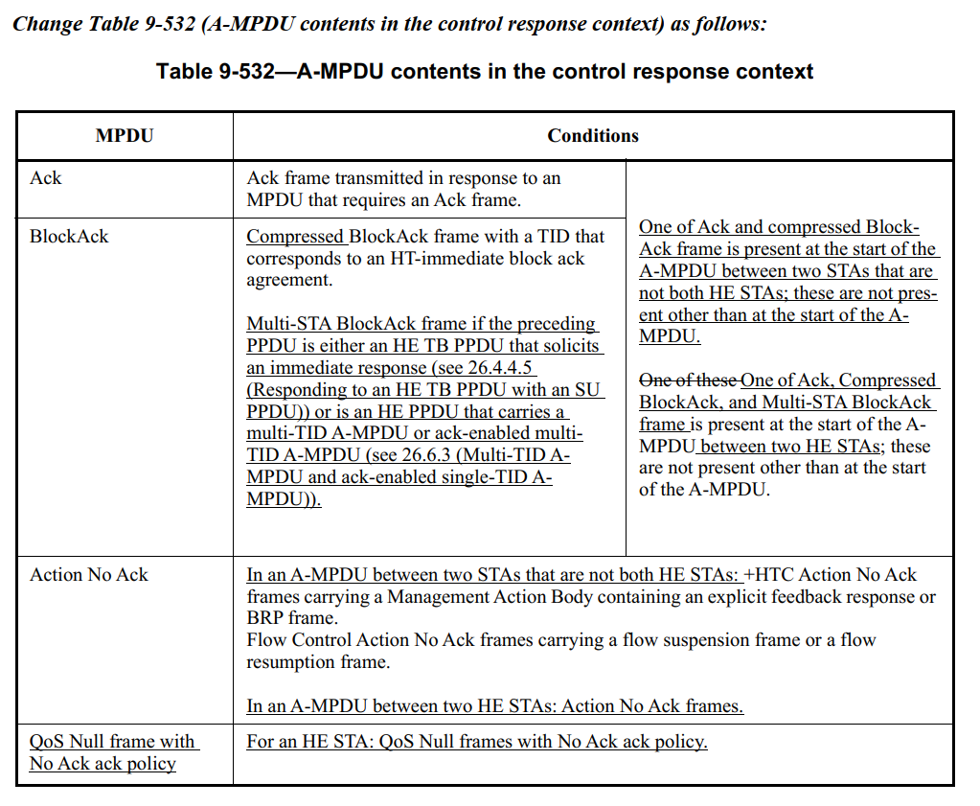
If a non-AP STA receives an MU-RTS Trigger frame, the non-AP STA shall commence the transmission of a CTS frame response at the SIFS time boundary after the end of a received PPDU when all the following conditions are met:

Propose:

TGax editor: Change 9.4.2.199 TWT element as follows: (Track change on)

9.4.2.199 TWT element

(…existing texts…)

NOTE—The TWT requesting STA is expected to send the PS-Poll or APSD trigger frame
if the TWT is a trigger-enabled TWT.(24292)

(…existing texts…)

TGax editor: Change 26.8.2 Individual TWT agreements as follows: (Track change on)

TGax editor:Change “Trigger frame” in Figure 26-9—Example of individual TWT operation to “Basic Trigger frame”(#24292)
(…existing texts…)

In this example, STA 1 sends a TWT request to the TWT responding STA to setup a trigger-enabled TWT
agreement. The TWT responding STA accepts the TWT agreement with STA 1 and confirms the acceptance
in the TWT response sent to STA 1. Subsequently, the TWT responding STA sends an unsolicited TWT
response to STA 2 to setup a trigger-enabled TWT agreement with STA 2. Both these TWT agreements are
setup as announced TWTs. During the trigger-enabled TWT SP, the TWT responding STA sends a Basic Trigger
frame to which the TWT requesting STAs indicate that they are awake during the TWT SP. STA 1 indicates
that it is awake by sending a PS-Poll frame and STA 2 indicates that it is awake by sending a QoS Null
frame in response to the Basic Trigger frame. STA 1 and STA 2 receive their DL BUs in a subsequent exchange
with the TWT responding STA and go to doze state outside of this TWT SP. (#24292)

(…existing texts…)

TGax editor: Change 26.8.3.1 General as follows: (Track change on)

TGax editor:Change “Trigger frame” in Figure 26-10—Example of broadcast TWT operation with optional TBTT negotiation to “Basic Trigger frame”(#24292)

(…existing texts…)

The TWT scheduling AP includes a broadcast TWT element in the Beacon frame that indicates a broadcast
TWT SP during which the AP intends to send Trigger frames, or DL BUs to the TWT scheduled STAs. STA
1 and STA 2 wake to receive the Beacon frame to determine the broadcast TWT. During the trigger-enabled
TWT SP the AP sends a Basic Trigger frame to which STA 1 and STA 2 indicate that they are awake during the
TWT SP. STA 1 indicates that it is awake by sending a PS-Poll and STA 2 indicates that it is awake by sending a QoS Null frame in response to the Basic Trigger frame. STA 1 and STA 2 receive their DL BUs in a subsequent exchange with the AP and go to doze state outside of this TWT SP. (#24292)

(…existing texts…)

TGax editor: change “HE TB PPDU in response to a Trigger frame” with “HE TB PPDU in response to a Trigger frame that is not an MU-RTS Trigger frame” across the spec (354.15, 356.64, 358.21, 365.52, 367.9, 370.48 ) (#24292)

