IEEE P802.11
Wireless LANs
Delete HT-Delayed Block Ack
Date: 2020-4-23
Author(s):
Name | Affiliation | Address | Phone | email
Graham Smith | SR Technologies |  | 916 799 9563 | gsmith@srtrl.com
Menzo Wentink | Qualcomm

Abstract

CIDs 4438 and 4439 propose deletion of HT-Delayed Block Ack.

This document provides the instructions for the deletion from 11md based on D3.0.

RESOLUTION

REVISED

The following are the instructions for removal of HT-Delayed Block Ack from 11md D3.0.

185.52 delete

“high-throughput (HT) delayed (HT-delayed) block acknowledgment (Ack): A delayed block ack mechanism that requires the use of the compressed BlockAck frame and the No Acknowledgment ack policy setting within both BlockAckReq and BlockAck frames. This block ack scheme is negotiated between two HT stations (STAs) that both support HT-delayed block ack.”

250.37 edit as shown

“A DMG STA does not use any of the following: HCCA, power save multi-poll (PSMP), TDLS, GCR.”

829.28

In Figure 9-36 (BAR Control field format), Replace “BAR Ack Policy” in B0 with “Reserved”

829.37 delete

“For BlockAckReq frames sent under HT-delayed agreements, the BAR Ack Policy subfield of the BAR Control field has the meaning shown in Table 9-27 (BAR Ack Policy subfield). For BlockAckReq frames sent under other types of agreement, the BAR Ack Policy subfield is reserved.”

829.42 delete Table 9-27 (BAR Ack Policy subfield)

These edits are related to the following:

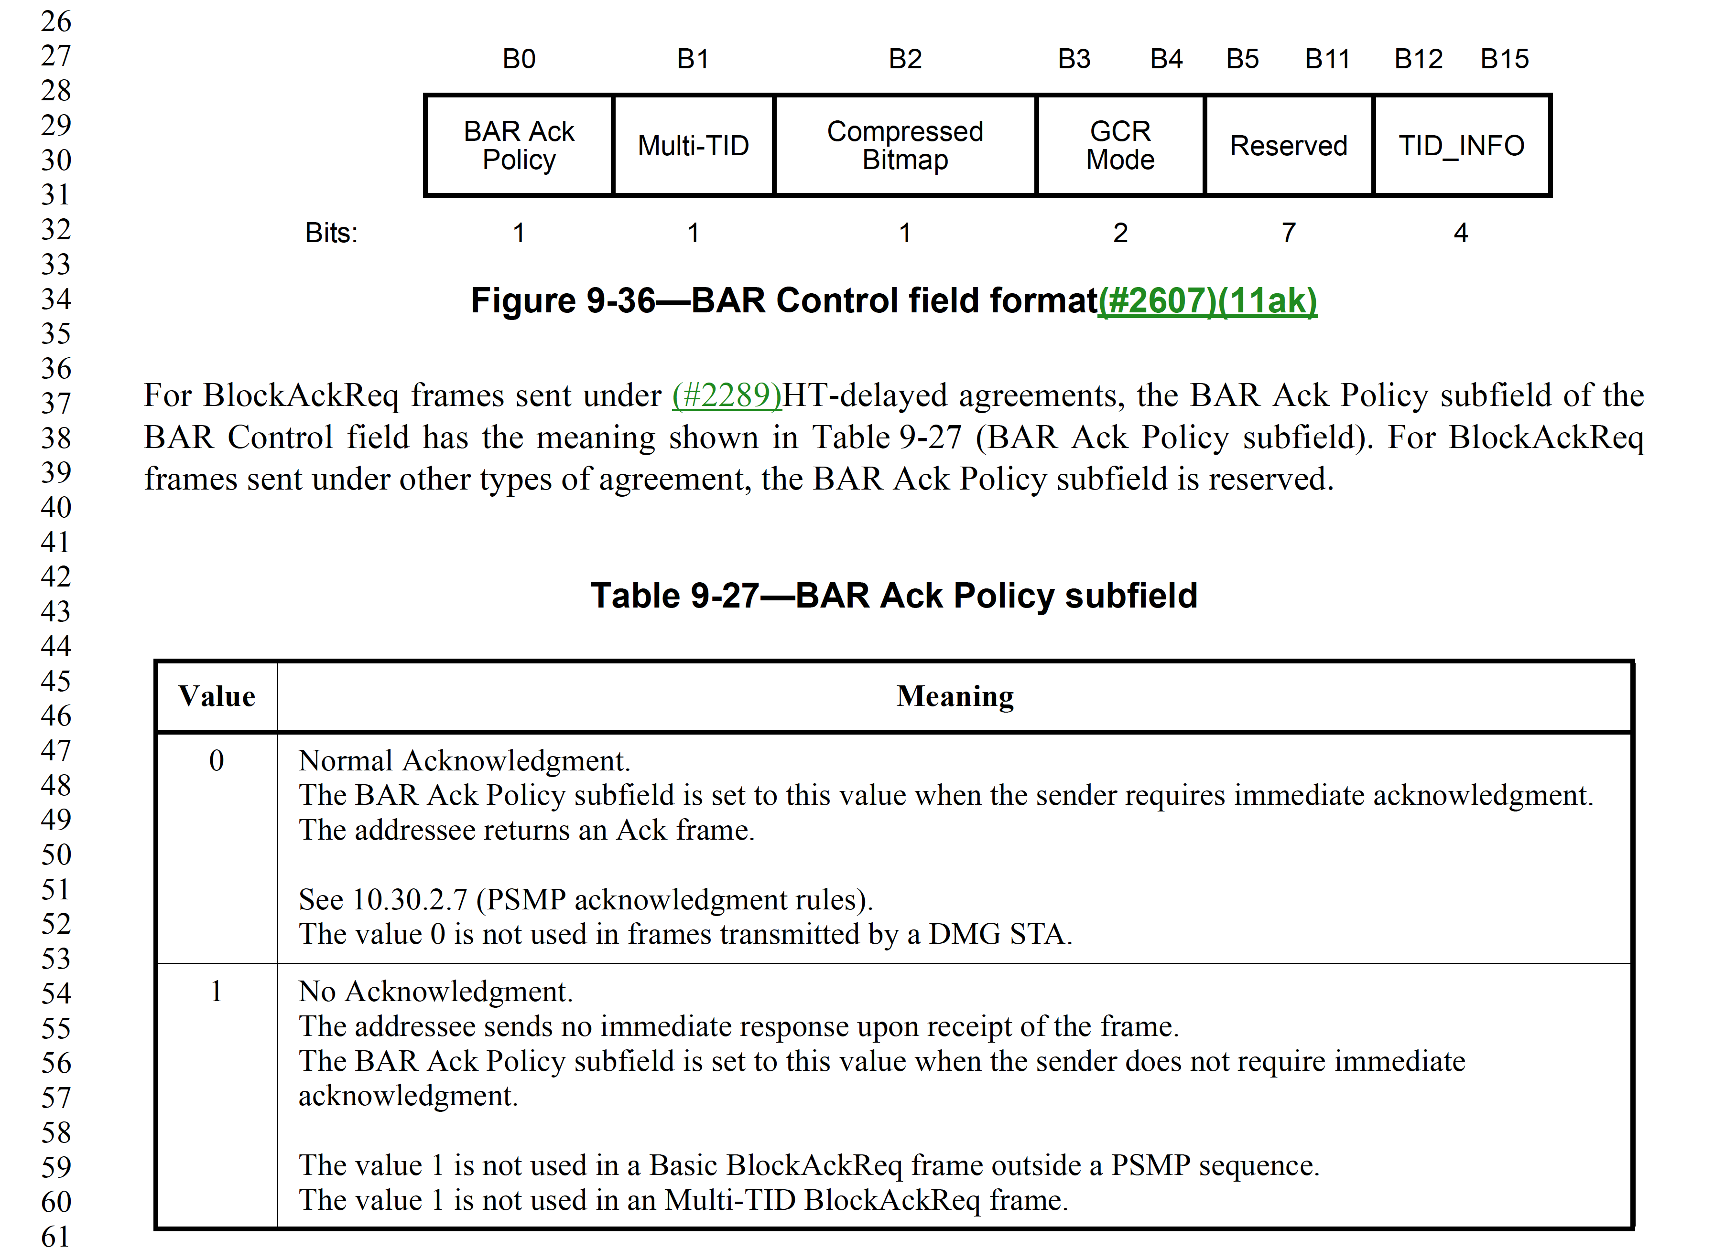

There might be three issues with these edits:

- "The value 0 is not used in frames transmitted by a DMG STA." -- does DMG use value 1? This would imply that the BAR Ack Policy field can not be made reserved.

- "The value 1 is not used in a Basic BlockAckReq frame outside a PSMP sequence." -- therefore, for the regular BAR, this field is always 0. This information would be lost when deleting this table and making the BAR Ack Policy subfield reserved, because the subfield could be set to 1 at some later time.

- "The value 1 is not used in an Multi-TID BlockAckReq frame." -- therefore, for the Multi-TID, this field is always 0. This information would be lost when deleting this table and making the BAR Ack Policy subfield reserved, because the subfield could be set to 1 at some later time.

833.11 edit as shown

“The TA field value is the address of the STA transmitting the BlockAck frame. In a BlockAck frame transmitted in the context of non-HT duplicate format and where the scrambling sequence carries the TXVECTOR parameter CH_BANDWIDTH_IN_NON_HT, the TA field value is a bandwidth signaling TA.”

833.22 in Figure 9-42 (BA Control field format), replace “BAR Ack Policy” in B0 with “Reserved”

833.31 delete

“For BlockAck frames sent under HT-delayed agreements, the BA Ack Policy subfield of the BA Control field has the meaning shown in Table 9-29 (BA Ack Policy subfield). For BlockAck frames sent under other types of agreement, the BA Ack Policy subfield is reserved.”

833.38 delete Table 9-29 (BA Ack Policy subfield)

Similar issues here:

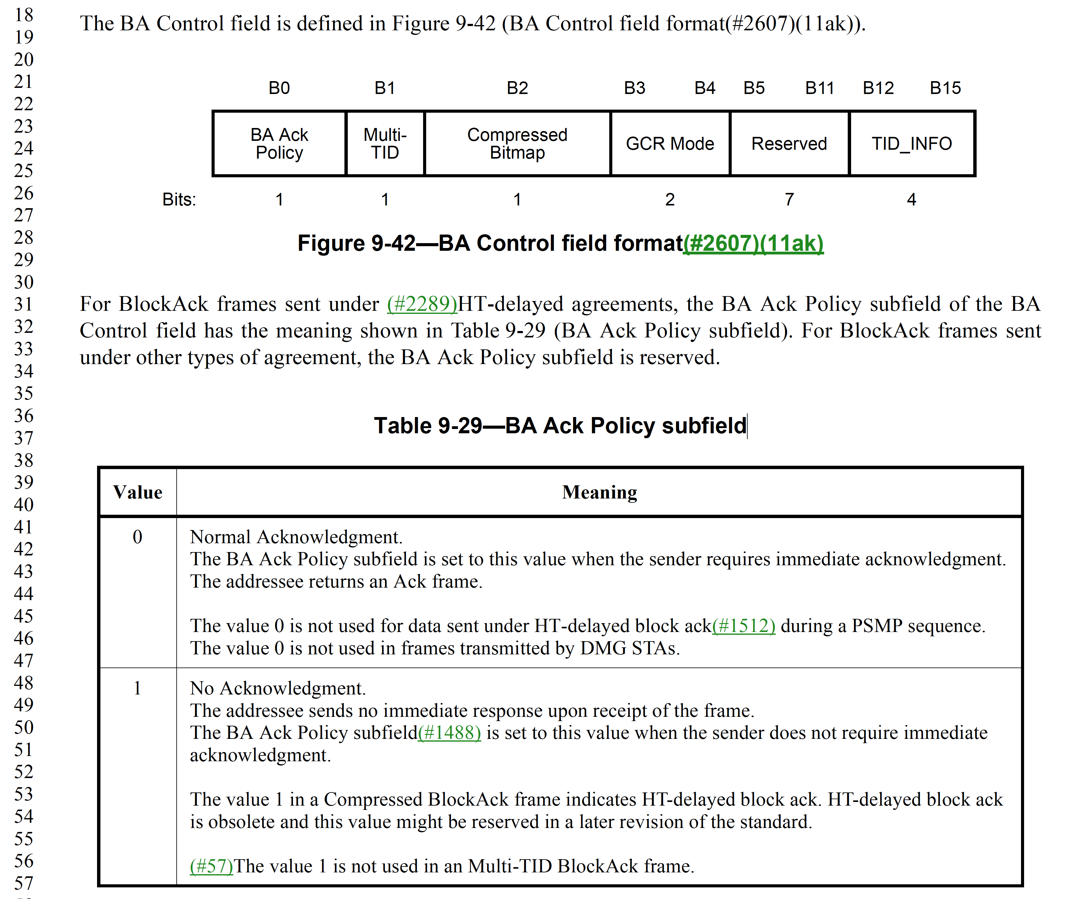

917.1 change as shown

“The Block Ack Policy subfield is set to 1 for immediate block ack”

Aside – Would it be OK to delete “for immediate block ack”? We only have one type now?

1173.44 in Figure 2-375 (HT Capability Information field format), change B10 from “HT-Delayed Block Ack“ to “Reserved”

1175.6 in Table 9-184 (Subfields of the HT Capability Information field), delete entire Row “HT-delayed block ack”

1400.27 in Figure 9-692 (S1G Capabilities Information field format), change change B25 from “HT-Delayed Block Ack“ to “Reserved”

1403.49 in Table 9-300 (Subfields of the S1G Capabilities Information field), delete entire Row “HT-delayed block ack”

1685.57 Change NOTE as follows

“NOTE—This context includes cases when no response is generated.

1686.32 in Table 9-529 (A-MPDU contents in the data enabled immediate response context), delete entire row “HT-delayed block ack”

1686.35 in Table 9-529 (A-MPDU contents in the data enabled immediate response context), delete entire row “HT-delayed block ack data”

1686.40 in Table 9-529 (A-MPDU contents in the data enabled immediate response context), delete entire row “HT-delayed BlockAckReqs”

1687.7 in Table 9-530 (A-MPDU contents in the data enabled no immediate response context) delete entire row “DelayedBlockAcks”

1687.9 in Table 9-530 (A-MPDU contents in the data enabled no immediate response context) delete entire row “Delayed Block Ack data”

1687.18 in Table 9-530 (A-MPDU contents in the data enabled no immediate response context) delete entire row HT-delayed BlockAckReqs”

1687.35 in Table 9-531 (A-MPDU contents in the PSMP context), change “Conditions” entry as shown

“BlockAck frames with the BA Ack Policy subfield equal to No Acknowledgment.”

1687.43 delete entry in first column, “Delayed Block Ack data” and delete corresponding entry in second column:

"QoS Data frames with a TID that corresponds to an HT-delayed block ack agreement. These have Block Ack ack policy."

1687.56 delete entire row "HT-delayed BlockAckReqs"

1691.28 change as shown

The addressed recipient returns a BlockAck or BAT frame, either individually or as part of an A-MPDU starting a SIFS after the PPDU carrying the frame, according to the procedures defined in
10.3.2.11 (Acknowledgment procedure), and 10.47.2 (TWT acknowledgment procedure).

1721.62 delete ”or HT-delayed block ack”

1722.17 delete ”or HT-delayed block ack”

1750.27 change as shown

“NOTE 1—A BlockAck frame or an Ack frame is sent in immediate response to the BlockAckReq frame for HTimmediate block ack. “

1786.34 delete “HT-delayed block ack”

1874.56 change as shown

“The block ack mechanism improves channel efficiency by aggregating several acknowledgments into one frame. There is one type of block ack mechanism: immediate.”

Aside – Do we want to wordsmith this ?

1875.41 delete

“An S1G STA that sets the HT-delayed Block Ack field in the S1G Capabilities element to 1 shall support the HT-delayed block ack extension.”

1877.59 delete from Title 10.25.3

“and HT-delayed block ack policy”

1878.61 delete “and 10.25.7”

1886.44 delete

"A BlockAckReq frame sent using HT-delayed operation may be transmitted within an A-MPDU provided that its BAR Ack Policy subfield is set to No Acknowledgment."

1888.17 delete entire Clause 10.25.7 (HT-delayed block ack extensions)

1916.40 delete

"— BlockAckReq under HT-delayed policy with the BAR Ack Policy subfield set to 1 (representing
No Acknowledgment)
— BlockAck under HT-delayed policy with the BA Ack Policy subfield set to 1 (representing
No Acknowledgment)"

1918.55 delete
“— A QoS Data frame transmitted under an HT-delayed block ack agreement during either a PSMPDTT or a PSMP-UTT shall have Block Ack ack policy.”

1919.48 delete

“If a BlockAckReq frame for an HT-delayed block ack agreement is transmitted during a PSMP sequence, the BAR Ack Policy subfield of the BlockAckReq frame shall be set to the value representing No Acknowledgment.”

2268.36 in Table 11-5, delete entire row “Both STAs are HT STAs, and both of the STAs set the HT-delayed Block Ack subfield of the HT Capabilities element to 1.”

2268.47 delete entire row "Both STAs are S1G STAs and support HT-delayed Block Ack"

2268.49 delete “NOTE—HT-delayed block ack agreement is obsolete. Support for this mechanism might be removed in a later revision of the standard.”

3698.53 change entries for HTM5.4 to “Reserved” in column 2 and delete entries in columns 3, 4 and 5.

Aside- Is this right for the PICS?

4013.14 Change Status from “current” to “deprecated”

4152.31 Delete “or HT-delayed block ack”

4404.23 delete “HT-delayed or”

4404.30 delete

“BlockAck | (*HT-delayed*)
BlockAckReq | (*HT-delayed*)”

