IEEE P802.11
Wireless LANs
Resolutions to CID4022 and CID4023
Date: 2020-04-16
Author(s):
Name | Affiliation | Address | Phone | email
Yujin Noh | Newracom |  |  | yujin.noh at newracom.com
Abstract
This submission shows
- Resolutions for comments from REVmd draft 3.0
- 2 CIDs: 4022 and 4023

Revisions:
- Rev 0: Initial version of the document.
  - Keep the original resolution corresponding to 11ac from 11-20/0536
  - Add the resolution corresponding to 11ah

CID 4022

CID | Clause | Page.Line | Comment | Proposed Change
4022 | 21.3.8.2.2 | 3185.12 | For CBW20, N_SR is 28.  And, Sk for CBW20 refers Equation 19-8.  But, Sk in 19-8 is specifying {-26,26}.  Values for -28, -27, 27, and 28 are not defined. | Please define Sk for -28, -27, 27, and 28.

Background

As for 11ac,

D3.2 P3172
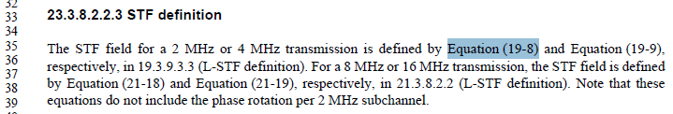

D3.2 P2999
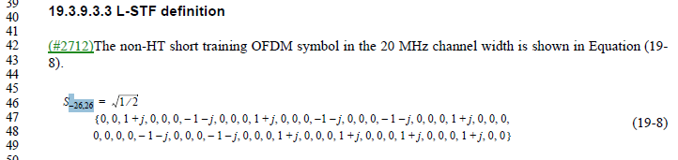

D3.2 P3173
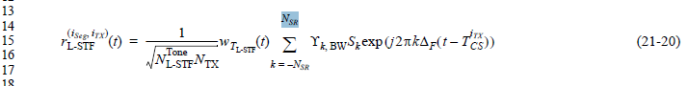

P3.2 P3161
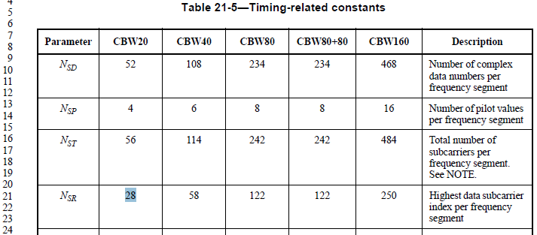

Note that L-SIG and VHT-SIG-A uses summation over +-26, not +-N_SR to avoid the same issue.

D3.2 P3174
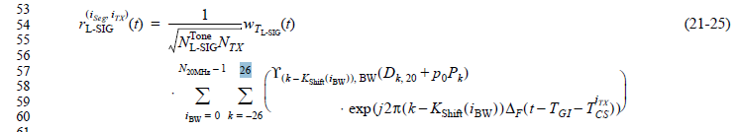

D3.2 P3177
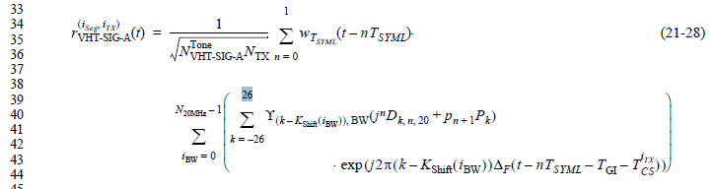

As for 11ah,
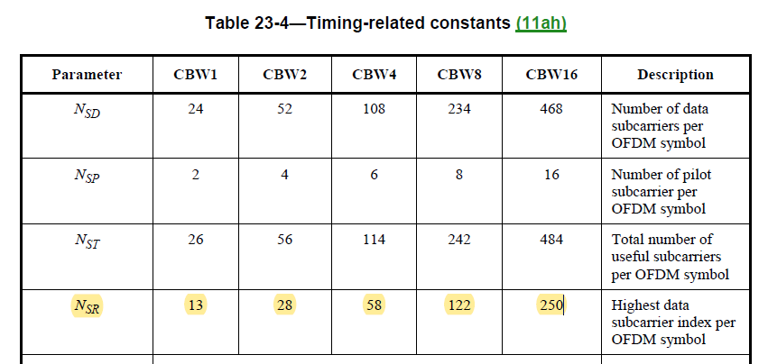

There are three STF field signals defined in S1G_SHORT preamble (Equation 23-14), S1G_LONG preamble (Equation 23-23) and S1G_1M preamble (Equation 23-37), respectively as followings.

For S1G_SHORT preamble,
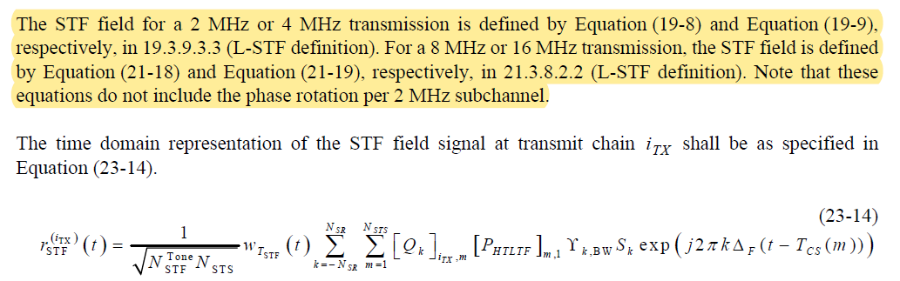

Considering Equation (19-8) with k = [-26:26], Equation (19-9) with k = [-58:58], Equation (21-18) with k = [-122:122], and Equation (21-19) with k = [-250:250], N_{SR} in 2 MHz is not matched to subcarrier ranges of Equation (19-8) for S1G_SHORT preamble.

For S1G_LONG preamble,
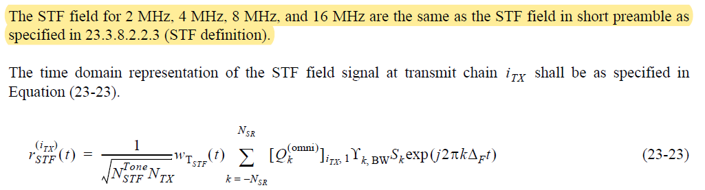

Since 23.3.8.2.2.3 describes the STF definition of S1G_SHORT preamble, N_{SR} in 2 MHz is not matched to subcarrier ranges of Equation (19-8) for S1G_LONG preamble.

For S1G_1M preamble,

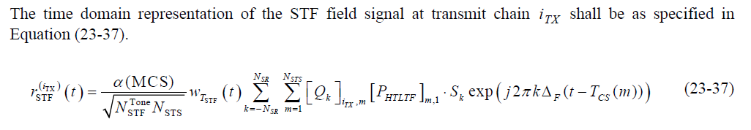

Since the new definition of S_{k} is shown only for Equation (23-37) and N_{SR} in 1 MHz is 13, there is no issue to use N_{SR} for S1G_1M preamble.

Proposed Resolution: CID 4022
Revised.
Note to Commenter: Commenter is correct about the issue. Note that L-SIG and VHT-SIG-A avoids similar issue by not use the variable N_SR, but rather using “26” in Equations (21-25) and (21-28), respectively. Hence changing N_SR to 26 in Equation (21-20) is more appropriate. Similar change should also be made for S1G in Equation (23-14).

Instruction to Editor:
At D3.2 P3173L15 Equation (21-20), change “N_SR” to “26”, and “k = -N_SR” to “k = -26”.

At D3.2 P3353L51, modify the original text as below
------------- Begin Text Changes ---------------
N_{SR} is 26 for a 2 MHz transmission or defined in Table 23-4 (Timing-related constants (11ah)) for a 4 MHz,
8 MHz, or 16 MHz transmission.
S_{k} is defined in Equation (19-8), Equation (19-9), Equation (21-18), or Equation (21-19) for a 2 MHz, 4 MHz,
8 MHz, or 16 MHz transmission, respectively.
------------- End Text Changes ------------------

At D3.2 P3361L58, modify the original text as below
------------- Begin Text Changes ---------------
N_{SR} is 26 for a 2 MHz transmission or defined in Table 23-4 (Timing-related constants (11ah)) for a 4 MHz,
8 MHz, or 16 MHz transmission.
S_{k} is defined in Equation (19-8), Equation (19-9), Equation (21-18), or Equation (21-19) for a 2 MHz, 4 MHz,
8 MHz, or 16 MHz transmission, respectively.
------------- End Text Changes ------------------

CID 4023

CID | Clause | Page.Line | Comment | Proposed Change
4023 | 21.3.8.2.3 | 3185.60 | For CBW20, N_SR is 28.  And, Lk for CBW20 refers Equation 19-11.  But, Lk in 19-11 is specifying {-26,26}.  Values for -28, -27, 27, and 28 are not defined. | Please define Lk for -28, -27, 27, and 28.

Discussion

As for 11ac,

D3.2 P3173
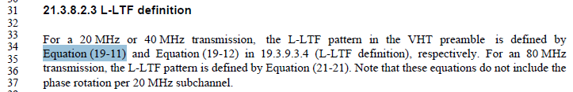

D3.2 P3000

D3.2 P3173
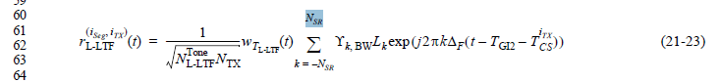

P3.2 P3161

Note that L-SIG and VHT-SIG-A uses summation over +-26, not +-N_SR to avoid the same issue.

D3.2 P3174

D3.2 P3177

As for 11ah,
There are several LTF field signals defined in S1G_SHORT preamble (Equation 23-16 and 23-17), S1G_LONG preamble (Equation 23-24) and S1G_1M preamble (Equation 23-38 and 23-39), respectively as followings.

For S1G_SHORT preamble,
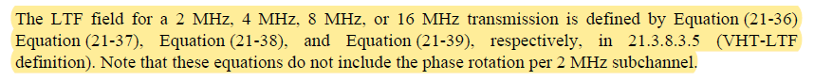
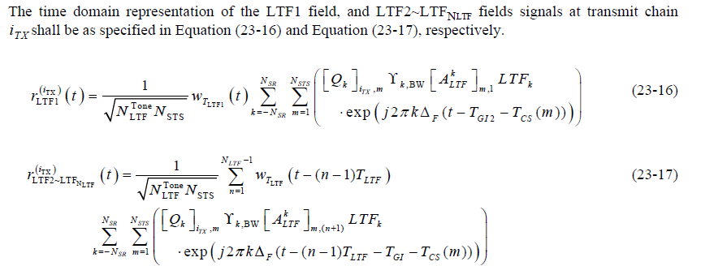

Considering Equation (21-36) with k = [-28:28], Equation (21-37) with k = [-58:58], Equation (21-38) with k = [-122:122], and Equation (21-39) with k = [-250:250], all values of N_{SR} are matched to corresponding Equations. There is no issue for S1G_SHORT preamble.

For S1G_LONG preamble,
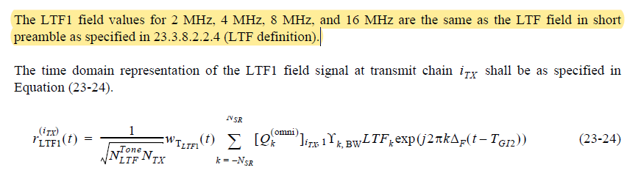

Since 23.3.8.2.2.4 describes the LTF definition of S1G_SHORT preamble, all values of N_{SR} are matched to corresponding Equations. There is no issue for S1G_LONG preamble.

For S1G_1M preamble,

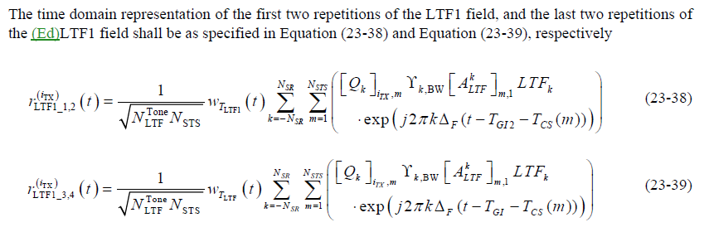
Since the new definition of LTF_{k} is shown only for Equation (23-38) and (23-39) and N_{SR} in 1 MHz is 13, there is no issue to use N_{SR} for S1G_1M preamble.

Proposed Resolution: CID 4023
Revised.
Note to Commenter: Commenter is correct about the issue. Note that L-SIG and VHT-SIG-A avoids similar issue by not use the variable N_SR, but rather using “26” in Equations (21-25) and (21-28), respectively. Hence changing N_SR to 26 in Equation (21-23) is more appropriate.

Instruction to Editor:
At D3.2 P3173L62 Equation (21-23), change “N_SR” to “26”, and “k = -N_SR” to “k = -26”.

At D3.2 P3355L42, add definition of LTF_{k} as below
------------- Begin Text Changes ---------------
LTF_{k} is defined in Equation (21-36), Equation (21-37), Equation (21-38), or Equation (21-39) for a 2 MHz,
4 MHz, 8 MHz, or 16 MHz transmission, respectively.
------------- End Text Changes ------------------

At D3.2 P3362L21, definition of LTF_{k} as below
------------- Begin Text Changes ---------------
LTF_{k} is defined in Equation (21-36), Equation (21-37), Equation (21-38), or Equation (21-39) for a 2 MHz,
4 MHz, 8 MHz, or 16 MHz transmission, respectively
------------- End Text Changes ------------------

