IEEE P802.11
Wireless LANs
Proposed Resolution for CID 24101
Date: 2020-04-28
Author(s):
Name | Company | Address | Phone | email
Lili Hervieu | CableLabs |  |  | l.hervieu@cablelabs.com
Dorin Viorel | CableLabs |  |  | d.viorel@cablelabs.com
Ruoyu Sun | CableLabs |  |  | r.sun@cablelabs.com

Abstract

Comment resolution with proposed changes to TGax D6.0 for CID 24101

Revision Notes

R0 | Initial revision
R1 | Modification based on SPs ran on April 23rd, 2020 and captured in the agenda (20/0538r13), corresponding to Mark Rison’s Option A1.
R2 | Deleted “No more than two adjacent 20 MHz subchannels are punctured across 160 MHz” for 80+80 MHz HE MU PPDU following offline comment.

CID | P.L | Clause | Comment | Proposed Change | Resolution
24101 |  |  | The preamble puncture feature in its current definition can cause harmful interferences to legacy (victim) devices when continuous puncturing is larger than 40MHz, as demonstrated in IEEE 802.11-19/2087r0. | It is proposed, for 160 or 80+80 MHz MU PPDUs, to support preamble puncture with no continuous puncturing larger than 40MHz. No change is required for 80 MHz MU PPDU. | Revised-  The proposed change aligns with the SPs ran on April 23rd, 2020 and captured in the agenda (20/0538r13), corresponding to Mark Rison’s Option A1  Instructions to the editor, please make the changes as shown under CID 24101 in doc 11-20/0618r2

Discussion:

In 802.11ax D6.0:
- One 20 MHz subchannel can be punctured in 80 MHz MU PPDUs
- Multiple contiguous 20 MHz subchannels can be punctured in 160 MHz or 80+80 MHz MU PPDUs

Contiguous 20 MHz punctured subchannels can cause harmful interferences to legacy (victim) devices. The simulation results presented in 802.11-19/2087r0 show that the victim SINR degradation can be higher than 11 dB when 3 channels are punctured and the victim is at the edge of the punctured subchannels.

Simulation result for 3 contiguous punctured channels:

Simulations were run for various conditions to compare SINR of an 11ac victim on channel 6,7 or 8 (figure below) when:
- Aggressor is an 11ax 160 MHz frame with channels 6, 7, 8 punctured - Blue SEM
- Aggressor is an 11ac 20 MHz frame on Channel 5 - Green SEM (reference)

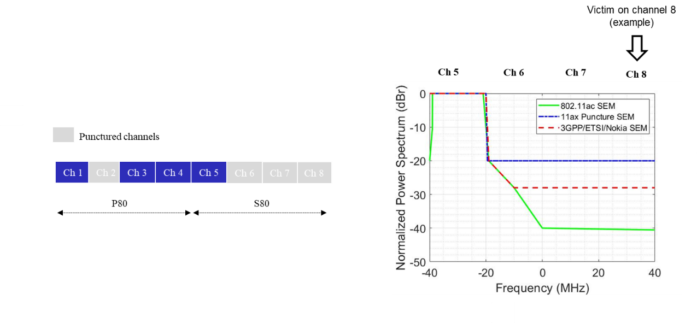
Figure 1 Example of 160 MHz MU PPDU with preamble puncture (802.11-19/2087r0)

The impact on the 802.11ac victim varies from minor to severe depending on the scenarios:
- SINR degradation can be higher than 11dB when the victim is on channel 8

The proposed changes align with the SPs ran on April 23rd, 2020 and captured in the agenda (20/0538r13):

SP1) For 160M/80+80M, should having all the 20M subchannels in the secondary 80M channel punctured be allowed?
Y/N/A = 0/23/6

SP3) For 160M/80+80M, should D6.0 be interpreted as allowing having no 20M subchannels in the primary 80 MHz channel punctured (only in the secondary 80 MHz channel)?
Y/N/A = 6/9/18

SP4) Do you agree that for 160M/80+80M, allow only a maximum of two adjacent 20 MHz subchannels to be punctured?
• When puncturing 40 MHz in secondary 80, only puncturing either the lower 40 MHz or the upper 40 MHz
Y/N/A = 19/5/8

Proposed changes for CID 24101

Instructions to the editor
Please make the changes to L57, P192 as shown below:
Table 9-321b—Subfields of the HE PHY Capabilities Information field

B2 indicates support for the reception of a 160 MHz or 80+80 MHz preamble where the only punctured subchannels are the secondary 20 MHz channel and zero to two of the 20 MHz subchannels in the secondary 80 MHz channel. If two of the 20 MHz subchannels in the secondary 80 MHz channel are punctured, these are either the lower two or the higher two. No more than two adjacent 20 MHz subchannels are punctured across 160 MHz.

B3 indicates support for the reception of a 160 MHz or 80+80 MHz preamble where the only punctured subchannels are one or both of the 20 MHz subchannels in the secondary 40 MHz channel and zero to two of the 20 MHz subchannels in the secondary 80 MHz channel. If two of the 20 MHz subchannels in the secondary 80 MHz channel are punctured, these are either the lower two or the higher two. No more than two adjacent 20 MHz subchannels are punctured across 160 MHz.

Please make the changes to L38, P274 as shown below:
10.23.2.5 EDCA channel access in a VHT, HE or TVHT BSS

k) Transmit an 160 MHz or 80+80 MHz HE MU PPDU where in the preamble the only punctured subchannels are the secondary 20 MHz channel and zero to two of the 20 MHz subchannels in the secondary 80 MHz channel, if all of the 20 MHz subchannels that are not punctured were idle during an interval of PIFS immediately preceding the start of the TXOP. If two of the 20 MHz subchannels in the secondary 80 MHz channel are punctured, these are either the lower two or the higher two. No more than two adjacent 20 MHz subchannels are punctured across 160 MHz.

l) Transmit an 160 MHz or 80+80 MHz HE MU PPDU where in the preamble the only punctured subchannels are one or both of the 20 MHz subchannels in the secondary 40 MHz channel and zero to two of the 20 MHz subchannels in the secondary 80 MHz channel, if all of the 20 MHz subchannels that are not punctured were idle during an interval of PIFS immediately preceding the start of the TXOP. If two of the 20 MHz subchannels in the secondary 80 MHz channel are punctured, these are either the lower two or the higher two. No more than two adjacent 20 MHz subchannels are punctured across 160 MHz.

Please make the changes to L38, P484 as shown below:
Table 27-1—TXVECTOR and RXVECTOR parameters (continued)

HE-CBW-PUNC160-PRI20 for preamble puncturing in 160 MHz, where in the preamble the only punctured subchannels are the secondary 20 MHz channel and zero to two of the 20 MHz subchannels in the secondary 80 MHz channel. If two of the 20 MHz subchannels in the secondary 80 MHz channel are punctured, these are either the lower two or the higher two. No more than two adjacent 20 MHz subchannels are punctured across 160 MHz.

HE-CBW-PUNC80+80-PRI20 for preamble puncturing in 80+80 MHz, where in the preamble the only punctured subchannels are the secondary 20 MHz channel and zero to two of the 20 MHz subchannels in the secondary 80 MHz channel. If two of the 20 MHz subchannels in the secondary 80 MHz channel are punctured, these are either the lower two or the higher two.

HE-CBW-PUNC160-SEC40 for preamble puncturing in 160 MHz, where in the preamble the only punctured subchannels are one or both of the 20 MHz subchannels in the secondary 40 MHz channel and zero to two of the 20 MHz subchannels in the secondary 80 MHz channel. If two of the 20 MHz subchannels in the secondary 80 MHz channel are punctured, these are either the lower two or the higher two. No more than two adjacent 20 MHz subchannels are punctured across 160 MHz.

HE-CBW-PUNC80+80-SEC40 for preamble puncturing in 80+80 MHz, where in the preamble the only punctured subchannels are one or both of the 20 MHz subchannels in the secondary 40 MHz channel and zero to two of the 20 MHz subchannels in the secondary 80 MHz channel. If two of the 20 MHz subchannels in the secondary 80 MHz channel are punctured, these are either the lower two or the higher two.

Please make the changes to L8, P498 as shown below:
Table 27-3— Interpretation of FORMAT, NON_HT Modulation and CH_BANDWIDTH parameters (continued)

FORMAT | NON_HT_ MODULATION | CH_BANDWIDTH | CH_OFFSET | PPDU format
 |  | HE-CBWPUNC160- PRI20 |  | The STA transmits an 160 MHz HE PPDU where the only punctured subchannels are the secondary 20 MHz channel and zero to two of the 20 MHz subchannels in the secondary 80 MHz channel. If two of the 20 MHz subchannels in the secondary 80 MHz channel are punctured, these are either the lower two or the higher two. No more than two adjacent 20 MHz subchannels are punctured across 160 MHz.
 |  | HE-CBWPUNC80+ 80-PRI20 |  | The STA transmits an 80+80 MHz HE PPDU where the only punctured subchannels are the secondary 20 MHz channel and zero to two of the 20 MHz subchannels in the secondary 80 MHz channel. If two of the 20 MHz subchannels in the secondary 80 MHz channel are punctured, these are either the lower two or the higher two.
 |  | HE-CBWPUNC160-  SEC40 |  | The STA transmits an 160 MHz HE PPDU where the only punctured subchannels are one or both of the 20 MHz subchannels in the secondary 40 MHz channel and zero to two of the 20 MHz subchannels in the secondary 80 MHz channel. If two of the 20 MHz subchannels in the secondary 80 MHz channel are punctured, these are either the lower two or the higher two. No more than two adjacent 20 MHz subchannels are punctured across 160 MHz.
 |  | HE-CBWPUNC80+  80-SEC40 |  | The STA transmits an 80+80 MHz HE PPDU where the only punctured subchannels are one or both of the 20 MHz subchannels in the secondary 40 MHz channel and zero to two of the 20 MHz subchannels in the secondary 80 MHz channel. If two of the 20 MHz subchannels in the secondary 80 MHz channel are punctured, these are either the lower two or the higher two.

Instructions to the editor
Please make the changes to L20, P561 as shown below:
Table 27-20—HE-SIG-A field of an HE MU PPDU, Bandwidth field

Set to 6 for preamble puncturing in 160 MHz or 80+80 MHz, where in the preamble the only punctured subchannels are the secondary 20 MHz channel and zero to two of the 20 MHz subchannels in the secondary 80 MHz channel. If two of the 20 MHz subchannels in the secondary 80 MHz channel are punctured, these are either the lower two or the higher two. No more than two adjacent 20 MHz subchannels are punctured across 160 MHz.

Set to 7 for preamble puncturing in 160 MHz or 80+80 MHz, where in the preamble the only punctured subchannels are one or both of the 20 MHz subchannels in the secondary 40 MHz channel and zero to two of the 20 MHz subchannels in the secondary 80 MHz channel. If two of the 20 MHz subchannels in the secondary 80 MHz channel are punctured, these are either the lower two or the higher two. No more than two adjacent 20 MHz subchannels are punctured across 160 MHz.

Please make the changes to L47, P754 as shown below:
C.3 MIB Detail
dot11HEPuncturedPreambleRxImplemented OBJECT-TYPE
SYNTAX OCTET STRING(SIZE(1))
MAX-ACCESS read-only
STATUS current
DESCRIPTION
"This is a capability variable. Its value is determined by device capabilities.

This attribute is a bitmap that indicates the preamble puncturing support, where bit 0 is set to 1 to indicate support for the reception of an 80 MHz preamble where the only punctured subchannel is the secondary 20 MHz channel, bit 1 is set to 1 to indicate support for the reception of an 80 MHz preamble where the only punctured subchannel is one of the two 20 MHz subchannels in the secondary 40 MHz channel, bit 2 is set to 1 to indicate support for the reception of a 160 MHz or 80+80 MHz preamble where the only punctured subchannels are the secondary 20 MHz channel and zero to two of the 20 MHz subchannels in the secondary 80 MHz channel, and bit 3 is set to 1 to indicate support for the reception of a 160 MHz or 80+80 MHz preamble where the only punctured subchannels are one or both of the 20 MHz subchannels in the secondary 40 MHz channel and zero to two of the 20 MHz subchannels in the secondary 80 MHz channel. For bits two and three, if two of the 20 MHz subchannels in the secondary 80 MHz channel are punctured, these are either the lower two or the higher two. No more than two adjacent 20 MHz subchannels are punctured across 160 MHz."

