IEEE P802.11
Wireless LANs
Proposed Resolution for CID 24101
Date: 2020-04-22
Author(s):
Name | Company | Address | Phone | email
Lili Hervieu | CableLabs |  |  | l.hervieu@cablelabs.com
Dorin Viorel | CableLabs |  |  | d.viorel@cablelabs.com

Abstract

Comment resolution with proposed changes to TGax D6.0 for CID 24101

Interpretation of a Motion to Adopt

A motion to approve this submission means that the editing instructions and any changed or added material are actioned in the TGax Draft. This introduction is not part of the adopted material.

Editing instructions formatted like this are intended to be copied into the TGax Draft (i.e. they are instructions to the 802.11 editor on how to merge the text with the baseline documents).

TGax Editor: Editing instructions preceded by “TGax Editor” are instructions to the TGax editor to modify existing material in the TGax draft. As a result of adopting the changes, the TGax editor will execute the instructions rather than copy them to the TGax Draft.

CID | P.L | Clause | Comment | Proposed Change | Resolution
24101 |  |  | The preamble puncture feature in its current definition can cause harmful interferences to legacy (victim) devices when continuous puncturing is larger than 40MHz, as demonstrated in IEEE 802.11-19/2087r0. | It is proposed, for 160 or 80+80 MHz MU PPDUs, to support preamble puncture with no continuous puncturing larger than 40MHz. No change is required for 80 MHz MU PPDU. | Revised-

Discussion:

In 802.11ax D6.0:
- One 20 MHz subchannel can be punctured in 80 MHz MU PPDUs
- Multiple contiguous 20 MHz subchannels can be punctured in 160 MHz or 80+80 MHz MU PPDUs

Contiguous 20 MHz punctured subchannels can cause harmful interferences to legacy (victim) devices. The simulation results presented in 802.11-19/2087r0 show that the victim SINR degradation can be higher than 11 dB when 3 channels are punctured and the victim is at the edge of the punctured subchannels.

Simulation result for 3 contiguous punctured channels:

Simulations were run for various conditions to compare SINR of an 11ac victim on channel 6,7, or 8 (figure below) when:
- Aggressor is an 11ax 160 MHz frame with channels 6, 7, 8 punctured - Blue SEM
- Aggressor is an 11ac 20 MHz frame on Channel 5 - Green SEM (reference)

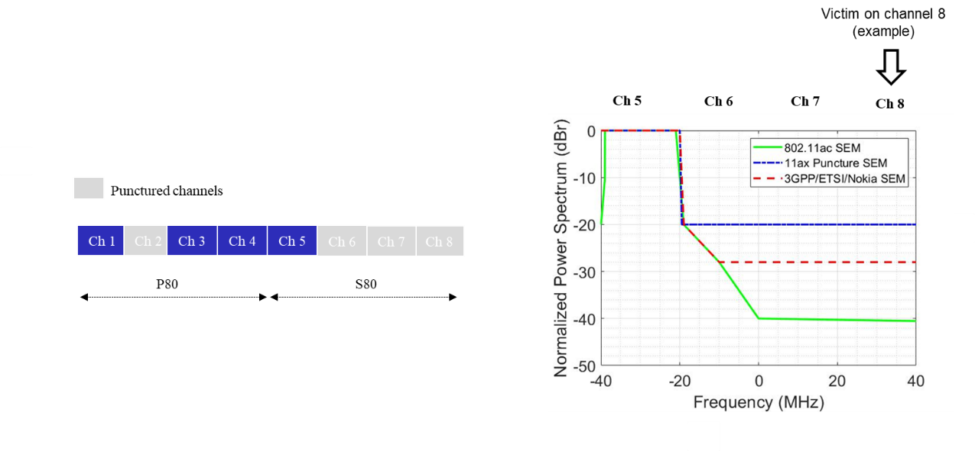
Figure 1 Example of 160 MHz MU PPDU with preamble puncture (802.11-19/2087r0)

The impact on the 802.11ac victim varies from minor to severe depending on the scenarios:
- SINR degradation can be higher than 11dB when the victim is on channel 8

The proposed change is to allow contiguous (adjacent) punctured channels up to two 20 MHz subchannels in order to limit SINR degradation for the victims.

It applies only to 160 MHz or 80+80 MHz MU PPDUs since 80 MHz MU PPDUs do not support more than one 20 MHz punctured subchannel.

Proposed changes (in red):

Item | Page | Row | Initial text | Replacing text
3 | 274 | 38-42 | Transmit an HE MU PPDU with preamble puncturing in 160 MHz or 80+80 MHz where in the primary 80 MHz of the preamble only the secondary 20 MHz is punctured if the secondary 40 MHz channel, and at least one of the four 20 MHz subchannels in the secondary 80 MHz channel were idle during an interval of PIFS immediately preceding the start of the TXOP. | Transmit an HE MU PPDU with preamble puncturing in 160 MHz or 80+80 MHz with no contiguous puncturing larger than two 20MHz subchannels, where in the primary 80 MHz of the preamble only the secondary 20 MHz is punctured if the secondary 40 MHz channel, and at least one of the four 20 MHz subchannels in the secondary 80 MHz channel were idle during an interval of PIFS immediately preceding the start of the TXOP.
4 | 274 | 43-47 | Transmit an HE MU PPDU with preamble puncturing in 160 MHz or 80+80 MHz where in the primary 80 MHz of the preamble only the primary 40 MHz is present if the secondary 20 MHz channel, and at least one of the four 20 MHz subchannels in the secondary 80 MHz channel were idle during an interval of PIFS immediately preceding the start of the TXOP. | Transmit an HE MU PPDU with preamble puncturing in 160 MHz or 80+80 MHz with no contiguous puncturing larger than two 20MHz subchannels, where in the primary 80 MHz of the preamble only the primary 40 MHz is present if the secondary 20 MHz channel, and at least one of the four 20 MHz subchannels in the secondary 80 MHz channel were idle during an interval of PIFS immediately preceding the start of the TXOP.

Additional proposed changes (in red) if initial text doesn’t refer to Primary 80 only:

Item | Page | Row | Initial text | Replacing text
1 | 192 | table 9-321b  row 57 to 60 | B2 indicates support for the reception of a 160 MHz or 80+80 MHz preamble where only the secondary 20 MHz channel in the primary 80 MHz channel is punctured. | B2 indicates support for the reception of a 160 MHz or 80+80 MHz preamble with no contiguous puncturing larger than two 20MHz subchannels where only the secondary 20 MHz channel in the primary 80 MHz channel is punctured.
2 | 192 | table 9-321b  row 62 to 64 | B3 indicates support for the reception of a 160 MHz or 80+80 MHz preamble where the primary 40 MHz channel in the primary 80 MHz channel is present. | B3 indicates support for the reception of a 160 MHz or 80+80 MHz preamble with no contiguous puncturing larger than two 20MHz subchannels where the primary 40 MHz channel in the primary 80 MHz channel is present.
5 | 484 | Table 27-1  39-41 | HE-CBW-PUNC160-PRI20 for preamble puncturing in 160 MHz, where in the primary 80 MHz of the preamble only the secondary 20 MHz channel is punctured. | HE-CBW-PUNC160-PRI20 for preamble puncturing in 160 MHz with no contiguous puncturing larger than two 20MHz subchannels, where in the primary 80 MHz of the preamble only the secondary 20 MHz channel is punctured.
6 | 484 | Table 27-1  42-44 | HE-CBW-PUNC80+80-PRI20 for preamble puncturing in 80+80 MHz, where in the primary 80 MHz of the preamble only the secondary 20 MHz channel is punctured. | HE-CBW-PUNC80+80-PRI20 for preamble puncturing in 80+80 MHz with no contiguous puncturing larger than two 20MHz subchannels, where in the primary 80 MHz of the preamble only the secondary 20 MHz channel is punctured.
7 | 484 | 45-49 | HE-CBW-PUNC160-SEC40 for preamble puncturing in 160 MHz or 80+80 MHz, where in the primary 80 MHz of the preamble the primary 40 MHz is present, and at least one 20 MHz subchannel that is not in the primary 40 MHz is punctured. | HE-CBW-PUNC160-SEC40 for preamble puncturing in 160 MHz or 80+80 MHz with no contiguous puncturing larger than two 20MHz subchannels, where in the primary 80 MHz of the preamble the primary 40 MHz is present, and at least one 20 MHz subchannel that is not in the primary 40 MHz is punctured.
8 | 484 | 50-53 | HE-CBW-PUNC80+80-SEC40 for preamble puncturing in 80+80 MHz, where in the primary 80 MHz of the preamble the primary 40 MHz is present, and at least one 20 MHz subchannel that is not in the primary 40 MHz is punctured. | HE-CBW-PUNC80+80-SEC40 for preamble puncturing in 80+80 MHz with no contiguous puncturing larger than two 20MHz subchannels, where in the primary 80 MHz of the preamble the primary 40 MHz is present, and at least one 20 MHz subchannel that is not in the primary 40 MHz is punctured.
9 | 498 | Table 27-3  8-12 | The STA transmits an HE PPDU on the punctured 160 MHz bandwidth where only the secondary 20 MHz in the primary 80 MHz is punctured. | The STA transmits an HE PPDU on the punctured 160 MHz bandwidth with no contiguous puncturing larger than two 20MHz subchannels where only the secondary 20 MHz in the primary 80 MHz is punctured.
10 | 498 | Table 27-3  14-18 | The STA transmits an HE PPDU on the punctured 80+80 MHz bandwidth where only the secondary 20 MHz in the primary 80 MHz is punctured. | The STA transmits an HE PPDU on the punctured 80+80 MHz bandwidth with no contiguous puncturing larger than two 20MHz subchannels where only the secondary 20 MHz in the primary 80 MHz is punctured.
11 | 498 | Table 27-3  20-26 | The STA transmits an HE PPDU on the punctured 160 MHz bandwidth where the primary 40 MHz in the primary 80 MHz is present, and at least one 20 MHz subchannel that is not in the primary 40 MHz is punctured. | The STA transmits an HE PPDU on the punctured 160 MHz bandwidth with no contiguous puncturing larger than two 20MHz subchannels where the primary 40 MHz in the primary 80 MHz is present, and at least one 20 MHz subchannel that is not in the primary 40 MHz is punctured.
12 | 498 | Table 27-3  28-34 | The STA transmits an HE PPDU on the punctured 80+80 MHz bandwidth where the primary 40 MHz in the primary 80 MHz is present, and at least one 20 MHz subchannel that is not in the primary 40 MHz is punctured. | The STA transmits an HE PPDU on the punctured 80+80 MHz bandwidth with no contiguous puncturing larger than two 20MHz subchannels where the primary 40 MHz in the primary 80 MHz is present, and at least one 20 MHz subchannel that is not in the primary 40 MHz is punctured.
13 | 561 | Table 27-20  20-22 | Set to 6 for preamble puncturing in 160 MHz or 80+80 MHz, where in the primary 80 MHz of the preamble only the secondary 20 MHz is punctured. | Set to 6 for preamble puncturing in 160 MHz or 80+80 MHz with no contiguous puncturing larger than two 20MHz subchannels, where in the primary 80 MHz of the preamble only the secondary 20 MHz is punctured.
14 | 561 | Table 27-20  23-27 | Set to 7 for preamble puncturing in 160 MHz or 80+80 MHz, where in the primary 80 MHz of the preamble the primary 40 MHz is present, and at least one 20 MHz subchannel that is not in the primary 40 MHz is punctured. | Set to 7 for preamble puncturing in 160 MHz or 80+80 MHz with no contiguous puncturing larger than two 20MHz subchannels, where in the primary 80 MHz of the preamble the primary 40 MHz is present, and at least one 20 MHz subchannel that is not in the primary 40 MHz is punctured.

