32.3.2 LC Common Mode

32.3.2.1 Introduction
The LC common mode PHY is based on the OFDM PHY in 17. In the following, the differences to the OFDM PHY in Clause 17 are described.
All LC STAs should support the mandatory features defined in Clause 17, except:
17.3.8.4 – Operating channel frequencies
17.3.8.5 – Transmit and receive in-band and out-of-band spurious emissions
17.3.9.3 – Transmit spectrum mask
17.3.9.7.2 – Transmitter center frequency leakage
17.3.10.3 – Adjacent channel rejection
17.3.10.4 – Nonadjacent channel rejection

32.3.2.2 CM Mode-specific service parameter list
TXVECTOR is the same as in section 17.2.2.

RXVECTOR is the same as in section 17.2.3, except that the parameters RX_ANTENNA, CH_BANDWIDTH _IN_NON_HT and DYN_BANDWIDTH _IN_NON_HT are not used.

TXSTATUS is the same as in section 17.2.4.

32.3.2.3 CM PHY

32.3.2.3.1 Introduction
The CM PHY should be the same as in 17.3 except for the data scrambling which is described in 32.3.2.3.2 PHY DATA scrambler and descrambler, the light interface, which is described in 32.3.2.3.3 Light Interface, operation specification in 32.3.2.3.4 PHY operating specifications (general).

The CM PHY may also support a Relayed CCA mechanism to aid the channel sensing in light communications which is described in 32.3.2.5 Relayed CCA mechanism.

32.3.2.3.2 PHY DATA scrambler and descrambler
Unlike the text in section 17.3.5.5, the scrambler seed should be initialized with a pseudorandom nonzero value. It should not convey any information.

32.3.2.3.3 Light Interface
Figure 1 illustrates how a light emitting diode (LED) is connected to the TX OFDM PHY and a photo diode (PD) to the RX OFDM PHY.

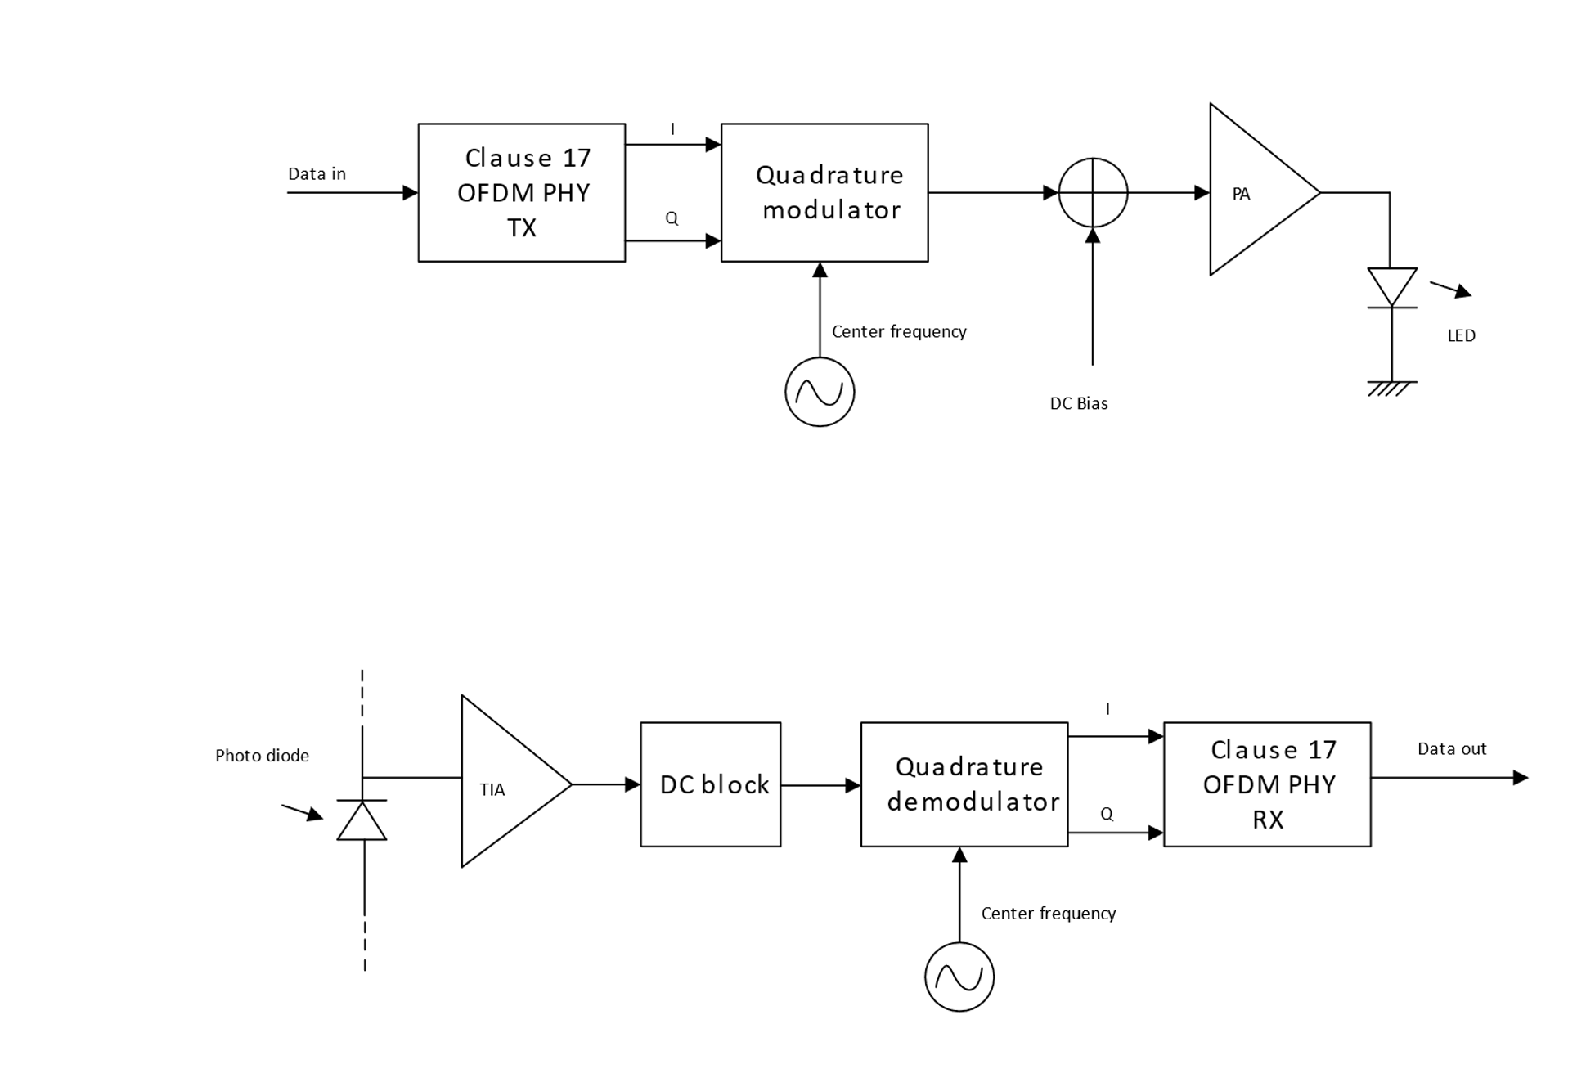
Figure 1: Interfacing OFDM PHY to light emitter and receiver
In the TX chain, the I and Q samples from the baseband should be quadrature modulated, see 32.3.2.3.4 for center frequencies. A DC bias is added before the signal is fed to the LED because the current through a diode can only be positive as illustrated in Figure 2.
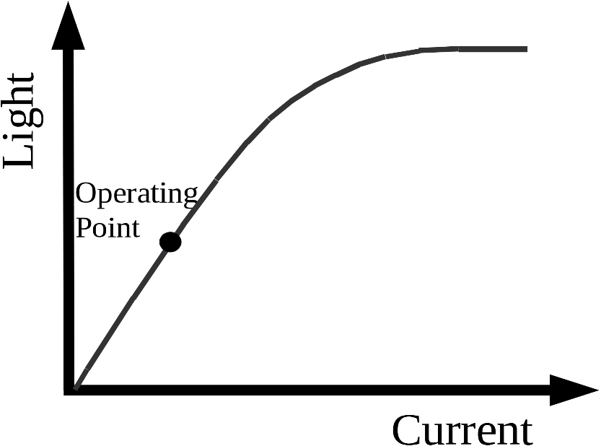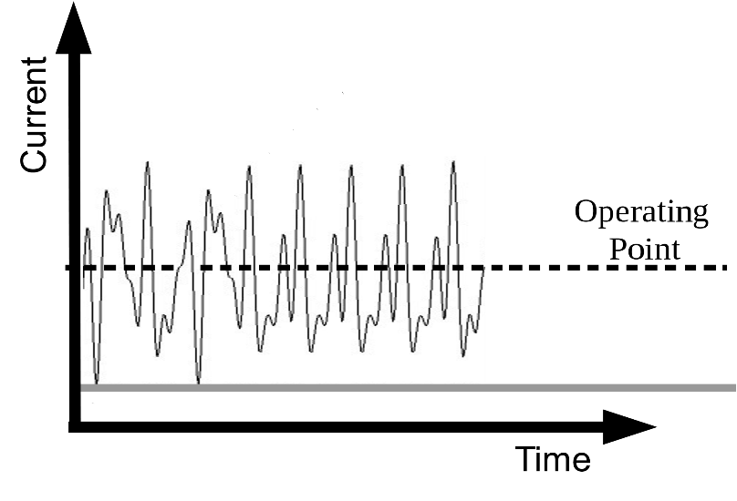
Figure 2: Operation of LED with DC bias
In the RX chain, the light variations produced by the LED are converted into a current by a photo diode (PD) and amplified by a transimpedance amplifier (TIA). The DC component is removed, the signal should be downconverted to baseband and fed to the RX OFDM PHY.

32.3.2.3.4 PHY operating specifications (general)

32.3.2.3.4.1 General
The operating specifications should be the same as in section 17.3.8 except for the changes made to support LC in the following sub-clauses. In addition, 17.3.8.5 is not required in the LC CM PHY.

32.3.2.3.4.2 Outline description
The outline should be the same as in section 17.3.8.2. In Figure 17-12 the antennas should be replaced by optical frontends (OFE)s, for example as described in document IEEE 802.11-19/0087r1.

32.3.2.3.4.3 Regulatory requirements
The IEC 60825-1 laser eye safety regulations should apply to all LC devices.

32.3.2.3.4.4 Operating channel frequencies
The LC common mode should operate at a center frequency of 26 MHz. The common bandwidth should be
20 MHz. This centre frequency should correspond to LC channel 0.

32.3.2.3.4.5 CCA requirements

32.3.2.4 OFDM PLME
This should be the same as in section 17.4, except that the parameter “dot11RegDomainsImplementedValue” in Table 17.20 does not apply to the LC Common Mode.

32.3.2.5 Relayed CCA mechanism
Due to the nature of light communications, the CCA mechanism may not work on STA side. The relayed CCA mechanism could work with the assistance of the AP. In general, the AP could detect the transmission from any STA as described in 32.3.2.3.4.5 CCA requirements. Then, the AP may disseminate the channel occupation information among the STAs within its coverage.

When the AP receives a transmission from a STA or transmissions from multiple STAs, it may retransmit the received packet if it does not have any packet in its queue. The retransmission would be a broadcast to all the STAs within its range, so that the STAs may be able to obtain the occupation status of the uplink channel from the assistance of the AP. STAs that successfully receive the retransmission from the AP would mark the medium ‘busy’ as in the CCA mechanism, except the sender(s) who are using the uplink channel.

When the AP has a packet to transmit, it stops the retransmission in the relayed CCA mechanism, and switches to the transmission of the new packet immediately.

Figure 3 illustrates an example of channel access with relayed CCA mechanism. The AP may retransmit packet received from STA1 and STA2 on the downlink channel. Other STAs could mark the uplink channel as ‘busy’ in the CCA.indication in order to avoid the collisions on the uplink channel. The AP could switch from retransmission of received packet to its own queue as shown in the example of Packet 3 and 4’s switch.

Figure 3 An example of channel access with relayed CCA mechanism
AP
STA1
STA2
Packet 1
Retransmission
Packet 1
Backoff
Relayed CCA Busy
Packet 2
Packet 3
Retransmission Packet 3
Relayed CCA Busy
Delay (ns)
Delay (ns)
Delay (ns)

32.3.3 LC High Efficiency (HE) Mode

32.3.3.1 Introduction
The LC HE Mode PHY should be based on the HE PHY in Clause 27. In the following, the differences to the HE PHY in clause 27 are described.

32.3.3.2 LC HE PHY service interface
The LC HE PHY service interface should be the same as in 27.2 except for the following fields which should be set to zero,
- BEAMFORMED
- BEAM_CHANGE
because beamforming is not supported.

32.3.3.3 LC HE PHY
The subclause should be the same as section 27.3 except for the light interface which is described in 32.3.3.3.1 Light Interface, the channel numbering which is described in 32.3.3.3.2 Channel numbering, regulatory requirements as described in 32.3.3.3.3 Regulatory Requirements.

In addition, the following subclauses in 27.3 may not apply to LC HE PHY:
27.3.16 — SU-MIMO and DL MU-MIMO beamforming
27.3.23 — Channel numbering

The LC HE PHY should support the Relayed CCA mechanism as described in 32.3.2.5 Relayed CCA mechanism.

32.3.3.3.1 Light Interface

32.3.3.3.1.1 Introduction
The light interface should be an extension of the light interface described in 32.3.2.3.3 to multiple TX and RX streams.

32.3.3.3.1.2 Multiple transmitters and receivers
Figure 4 shows multiple LEDs connected to the TX baseband and Figure 5 shows multiple PDs connected to the RX baseband.
The LEDs may all operate at the same wavelength or at different wavelengths.
The TX baseband outputs should be all quadrature modulated to the same common center frequency, see 32.3.3.3.2 Channel numbering for details.
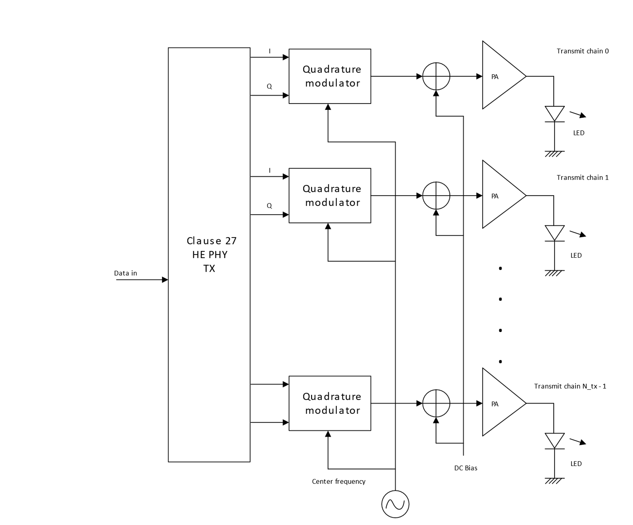
Figure 4: Connecting multiple LEDs to TX baseband
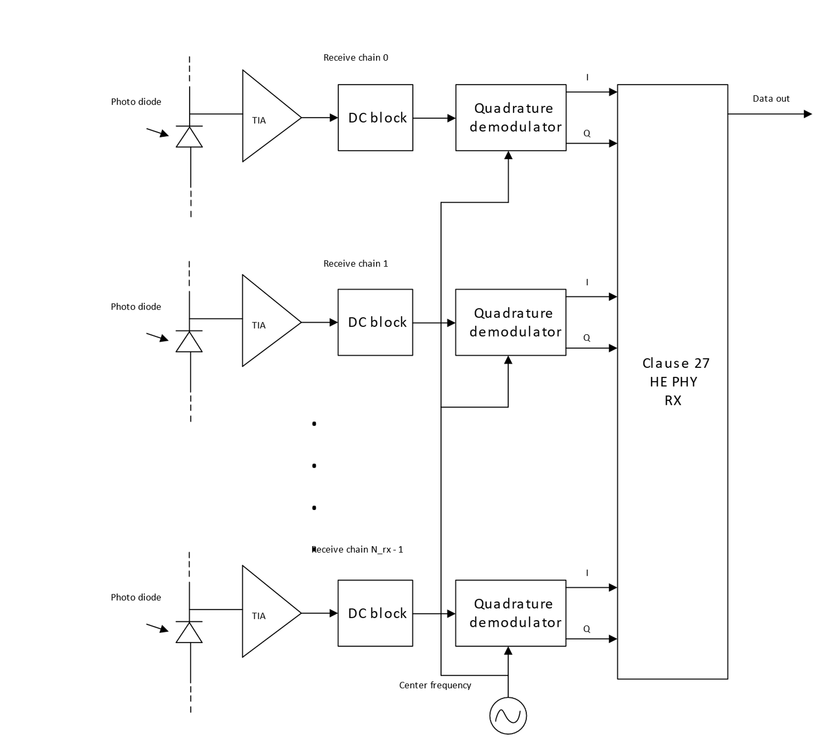
Figure 5: Connecting multiple PDs to RX baseband

32.3.3.3.2 Channel numbering
The centre frequencies and channel numbering depending on the channel bandwidth are shown in Table 1.
Table 1: Channelization
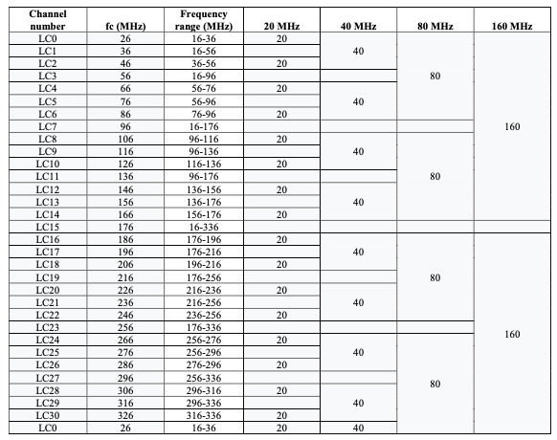

32.3.3.3.3 Regulatory Requirements
The IEC 60825-1 laser eye safety regulations should apply to all LC devices.

32.3.3.4 LC PHY PLME
This section should be the same as section 27.4 except the following changes.

A new value for the PHY MIB attribute “dot11PHYType” should be introduced, LC. LC indicates an LC PHY with the light interface described in 32.3.3.3.1 Light Interface.

32.3.3.5 Parameters for HE-MCSs
This section should be the same as section 27.5.

32.3.3.6 Parameters for HE-SIG-B-MCSs
This section should be the same as section 27.6.

